Jennie Lee’s Birthday  Jennie Lee was born in Lochgelly, Fife, on 3rd November, 1904. She was active in the Labour Party, became an MP in 1929 and following Labour’s win in the 1964 General Election, chaired the Parliamentary Committee convened to investigate the practicability of PM Harold Wilson’s ‘University of the Air’ project, which he had first mooted in 1963.  The concept of an OU had its opponents, one of whom was the controller of BBC television1961-1963, Stuart Hood. He called the idea of an open university an |  | 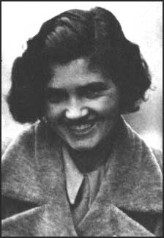

historical fossil from the days of the Workers’ Educational Association and the National Council of Labour College…[its supporters were] obsessed with the days when bright boys like Aneurin Bevan could not obtain an education commensurate with their gifts.

Although she had personal experience of a conventional university as, with the financial support of Fife Education Authority and the Carnegie Trust, she studied at Edinburgh University, perhaps such notions of the past influenced Jennie Lee’s political development and sensibilities. In 1965 she said that Hardy’s Jude the Obscure was ‘one of the formative books for me when I was a young student – the struggle for self-education’.

She also knew about conventional adult education. The WEA was less popular in Scotland than England and less well-regarded by many on the left and the formal adult education of her late husband (Bevan) amounted to two years at the Central Labour College, London, funded by the South Wales Miners’ Federation. She felt that adult education should be more than ‘dowdy and mouldy... old-fashioned night schools ... hard benches’. Lee was mindful of the fact that Adult Education was, as the OU’s first Vice-Chancellor, Walter Perry, put it, to be ‘the patch on the backside of our educational trousers’. Her 1966 White Paper, A University of the Air made it clear that ‘There can be no question of offering to students a makeshift project inferior in quality to other universities. That would defeat its whole purpose’.

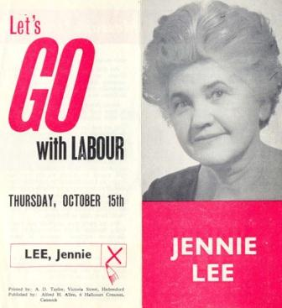 | Jennie Lee layed the foundation stone for the first OU library, which bore her name in April 1973:  Coming down here recalls for me, as it does for many of us, the mud right up to your eyebrows of those first years and I know that around here today there are pioneers, oh pioneers! There are some of you of course who came on later, you’ve had it easier. And of course my particular concern is that this university, which is already great, shall become greater still and that no one, no influence of any kind shall be allowed to reduce its academic status. We have established, you have established by the quality of your scholarship, you have established a university which makes no compromise whatsoever on academic standards, now that’s its glory.
But there it is, a great independent university which does not insult any man or any women whatever their background by offering them the second best, nothing but the best is good enough.

