A Review of Curriculum Design at the Open University 2008-09: OULDI-JISC Project Baseline Report

Report compiled by: Simon Cross
Report contributors: Gráinne Conole,
Paul Mundin, Simon Cross, Rebecca Galley, Paul Clark, Andrew Brasher, Juliette Culver

Baseline period: Autumn 2008-Spring 2009

Report published: November 2009

Contents

1 Introduction 2
Purpose 2
Report structure 2

2 Curriculum Design Process 4
2.1 Process maps 4
2.2 Methodology and process for creating the OU Curriculum Design Process Model 23
2.2.1 Curriculum design “As Is” process review methodology 23
2.3 Review of the Technical Systems Underpinning Curriculum Design 26
2.3.1 PLANET 26
2.3.2 CIRCE 28
2.3.3 Moodle 29
2.4 Learning Design Roles and Responsibilities 30

3 Stakeholder Perspectives 33
3.1 University perspectives 33
3.1.1 Strategic perspectives 33
3.1.2 Stakeholder perspectives 39
3.2 Partner perspectives 41
3.2.1 Brunel University 41

3.2.2 London South Bank University 42
3.2.3 University of Reading 42
3.2.4 University of Cambridge 43

4 Baseline of staff perceptions and practice 44
4.1 Attitudes and perspectives on designing elearning 44
4.2. Visualisation 47
4.3 Sharing designs 49
4.4 Staff Interviews 50

5 Software baseline 54
5.1 Cloudworks 54
5.1.1 Key themes from the Cloudfest workshops 54
5.1.2 Cloudworks Usability Testing 55
5.2 CompendiumLD 58
5.2.1 Analysis of feedback from a workshop on CompendiumLD and Visualisation 58

6 Reflections 60

7 References 62

1 Introduction

Purpose

The purpose of this report is to present a record of curriculum design practice and process at the Open University for the period autumn 2008 to spring 2009. This information will provide a baseline for the work we undertake during our project which begun in September 2008 and ends in spring 2012.

Our approach to learning design consists of four interconnected facets: understanding design, visualising design, guiding design and sharing design. These four interests provide the foundation for our planned work which is outlined fully in our project plan (link).

The content of this baseline report, and the research required to produce this data, relates principally to three of our nine key objectives:

- To review existing curriculum design processes at the OU in the first year of the project including describing and modelling the curriculum design process
- To work with stakeholders at the OU to identify key moments in whch enhancement or change in curriculum design process could lead to improved quality of design, and to work with partner institutions to undertake a similar process.
- To develop working relationships with units in the OU and to explore the transferability of elements of our approach by working with four other UK universities and two pan-communities.

In addition, this report provides baseline data that will support the later evaluation of our other six objectives:

- To pilot learning design methodologies, tools and techniques in at least eight trials and to document and evaluate this experience
- To engage with, build or enhance a range of communities and develop their capacity for self-sustainability focusing on organised events, key topic or subject areas, existing operational units and conferences or special interest groups
- To increase, monitor and evaluate exchanges of learning and teaching ideas and experiences in appropriate communities
- To undertake and review annually enhancements to the website(s) being used to support the community building and enhancement activities planned (e.g. Cloudworks)
- To undertake and review annually enhancements to the visualisation software used to support the pilot and design mapping tasks (e.g. CompendiumLD)
- To continue to broaden the scope, content and definition of the OU learning design methodology.

Report structure

Section 2 presents the outcome of a detailed programme of work that has mapped the university’s curriculum design and approval process. This has involved over 35 interviews with staff and detailed desk-based research including reviewing the technical systems underpinning the curriculum process. The centre piece of this work is a series of process maps and an explanation of the methodology adopted in their preparation.

Section 3 outlines some key stakeholder position statements including those of senior managers. It also identifies the key stakeholders at our partner institutions and briefly outlines the specific context in which our partner working will take place.

Section 4 introduces data from an online survey of staff about their attitudes and perceptions of elearning and sharing and their use of visualisation techniques (n=50). In addition, this section presents an initial analysis, made just prior to the start of the project, of transcripts from twelve in-depth staff interviews about learning design practice. In combination, this work demonstrates how the project is building upon an existing and evolving evidence base.

Section 5 presents some baseline data relating to the software we will develop as part of the project – the Cloudworks website and CompendiumLD visualisation software. Included in this is: a review of transcripts from several workshops that focused on sharing learning design ideas, website usage statistics, feedback from a workshop introducing CompendiumLD and a specially commissioned evaluation report undertaken by a team within the OU’s Institute of Educational Technology.

The final section concludes the report.

2 Curriculum Design Process

Lead author: Paul Mundin

2.1 Process maps

To manage the overall curriculum portfolio, the Open University needs to be assured that the curriculum offered is fit for a particular purpose and helps to deliver institutional priorities. The ‘Stage Gate’ process was introduced in 2005 and is a framework created to support curriculum investment decisions throughout the life cycle of an Award or Course. It has been designed to provide a level of confidence in curriculum choice which is auditable and facilitates regular review.
Awards have three Stage Gates. They are:
- Opportunity Review
- Business Appraisal and Specification
- Annual Review
The first Stage is primarily concerned with business decisions, but academic and strategic fit are essential parts of these decisions. The second Stage is a combined business and academic approval of the award. The final stage is focussed on a quality assurance review.
There are five Stage Gates over the lifecycle of a course. These are:
Development and Design
- Opportunity review
- Business Appraisal
- Specification
Presentation
- Post-launch Review
- Lifecycle Review
The first two Stages are primarily focussed on investment decisions. The Specification is used in the academic approval process of the courses and Stages four and five link specifically to quality assurance and enhancement reviews. Stage five also includes a re-assessment of the business case and course life.
The Stage Gate process embodies a series of decision points (‘gates’) that a project must pass through, each embodying a key question: i.e. ‘how does this project relate to opportunities that are available (in terms of student demand, government policy, professional recognition etc.)?’; ‘what is the business case for this project?’; ‘what is the specification of this project (in terms of learning opportunities and learning outcomes, learning resources, assessment etc.)?’ Standardised forms are used to record the input for each Stage.

At each stage there is a ‘gate-keeper’ who must decide whether the proposal should proceed. By the end of Stage 3, a project will have been considered and approved from an ‘opportunity’ and marketing point of view, as a business proposition and most importantly as a durable and high-quality academic course. Stages 4 and 5 require confirmation that the project meets all appropriate academic standards, is feasible in technical and resource terms, continues to be in line with the University’s strategic objectives, and matches market opportunities.

A set of flowcharts have been produced to provide a visual representation of many text based Stage Gate documents. They cover four levels of curriculum design in the Open University.

- One - Flowcharts 6, 7, 7a, 8 and 9 describe the Stage Gate process for an Award
- Two - Flowcharts 6, 10-14 describe the Stage Gate process for a Course
- Three - As the design and development of an Award or Course takes place in a Programme structure, flowcharts 2, 2a and 3 describe Programme activities around Award and Course development.
- Four – The final level is the annual institutional curriculum design activity into which all programmes via their faculties feed into the curriculum portfolio. This is described in flowchart 1

The flowcharts are organised so the reader drills down from the institutional to Programme level, from the Programme to Award level, and from the Award to Course level. There are two other flowcharts. Flowchart 4 shows the main sources for a Course or Award idea which is then promoted through the Stage Gate process. Finally Flowchart 15 provides a key to the symbols and abbreviations used in the flowcharts. Each flowchart is numbered from 1-14 and this provides a “go to” reference to other flowcharts.

Why do the flowcharts look like they do?:

- The intention was to make them useful and accessible to people in the OU outside of the OULDI project after this activity had finished, and to provide a “resource” in exchange for the time spent by people in validation review meetings
- A limited set of flowcharting symbols was used to make them easy to read and understood by anyone involved in OU curriculum design, without needing to be an expert in Business Process Modelling Notation, and also so that they could then explain them to other people in their faculties
- They were produced in MS Visio as the OU has a corporate licence. This would allow other people to modify them, and allow for easy transfer to PowerPoint for those that didn’t
- In drawing the flowcharts the intention was to keep a single Stage Gate on a page and not to perform stepwise refinement to multiple pages of swim lane business process maps. This meant that users of the flowcharts could print a single piece of A3 paper which would describe a complete Stage. They could then use this to navigate their way around the many intranet screens and document templates required to complete a Stage. It also had the benefit that it revealed the growth in complexity of the process since the inception of the Stage gate process in 2005.
- In this format they are also useful for faculty training and workshops

Other OU projects are now using the “As Is” curriculum design model described in the flowcharts to help them in their Stage Gate improvement reviews.
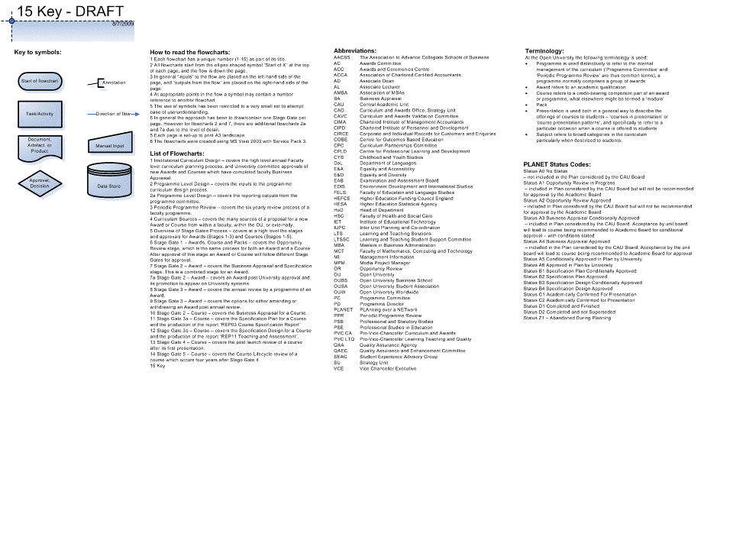
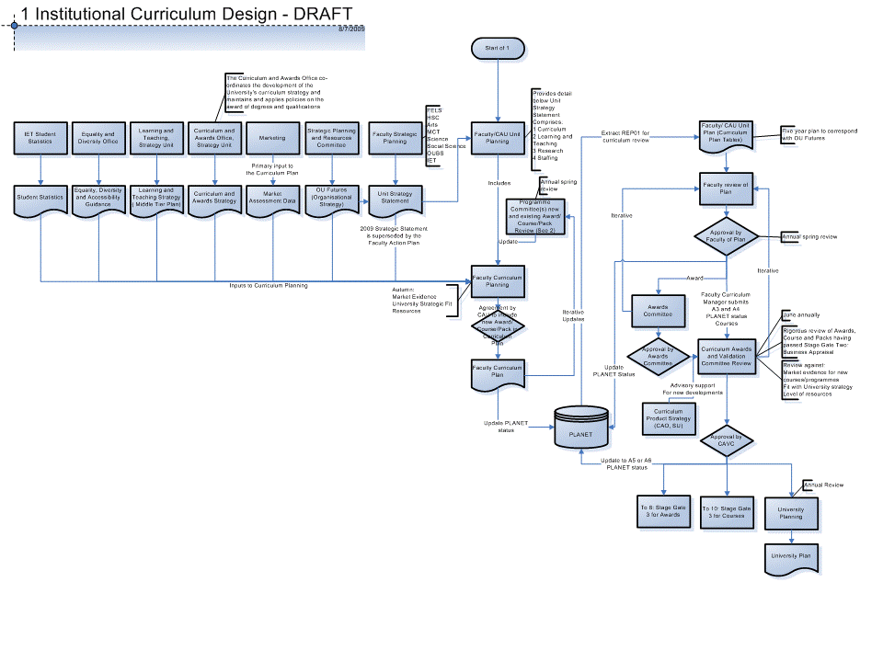
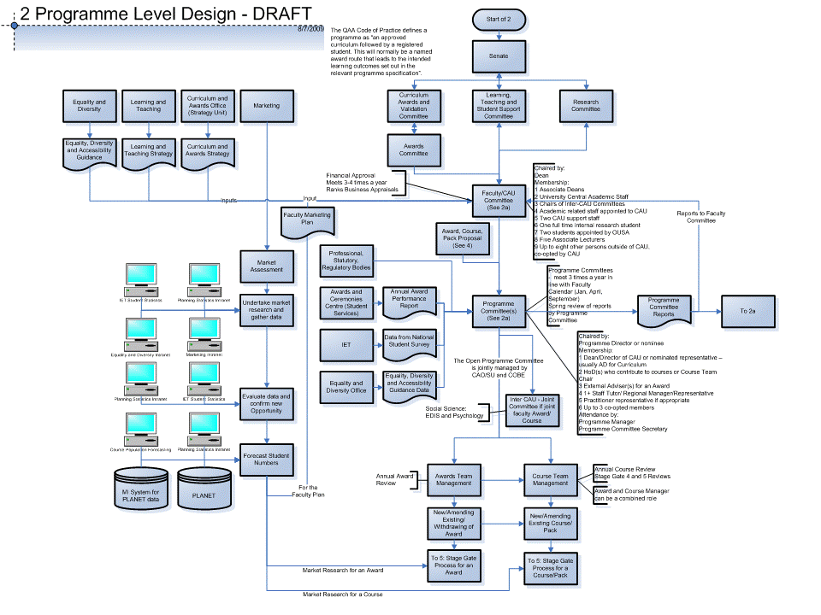
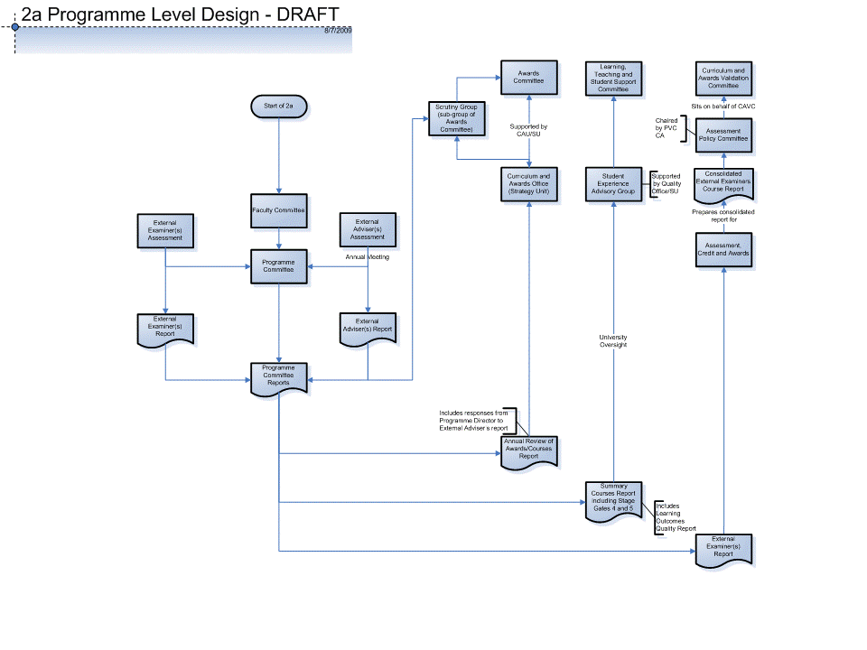
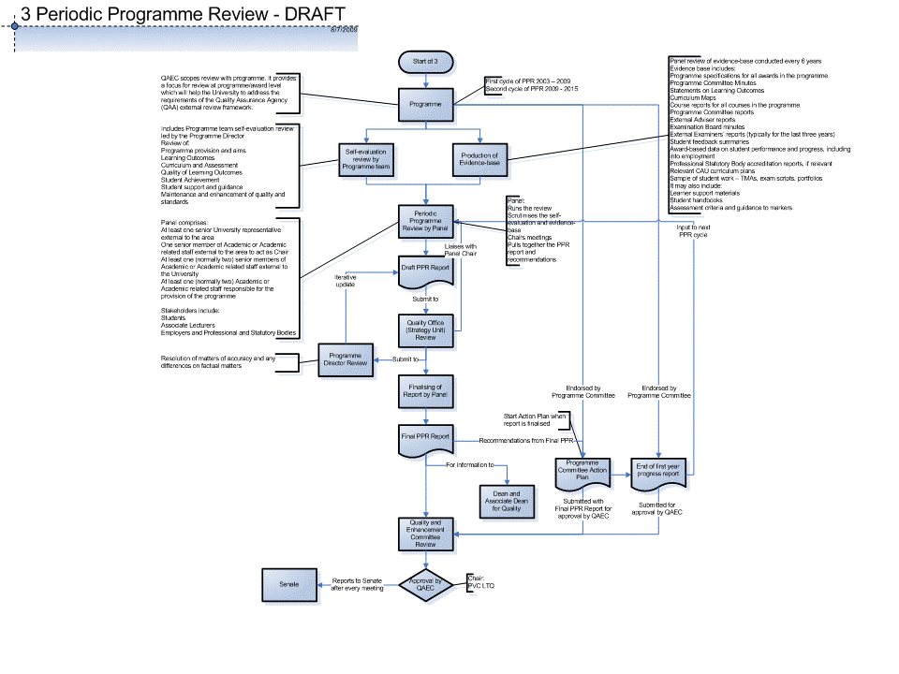
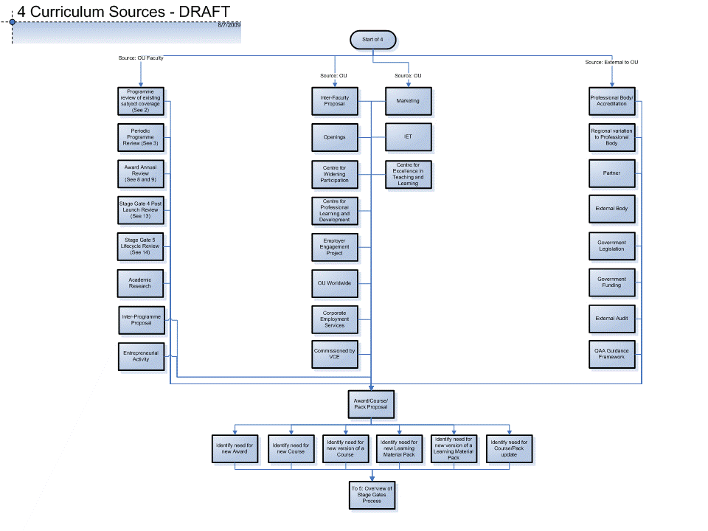
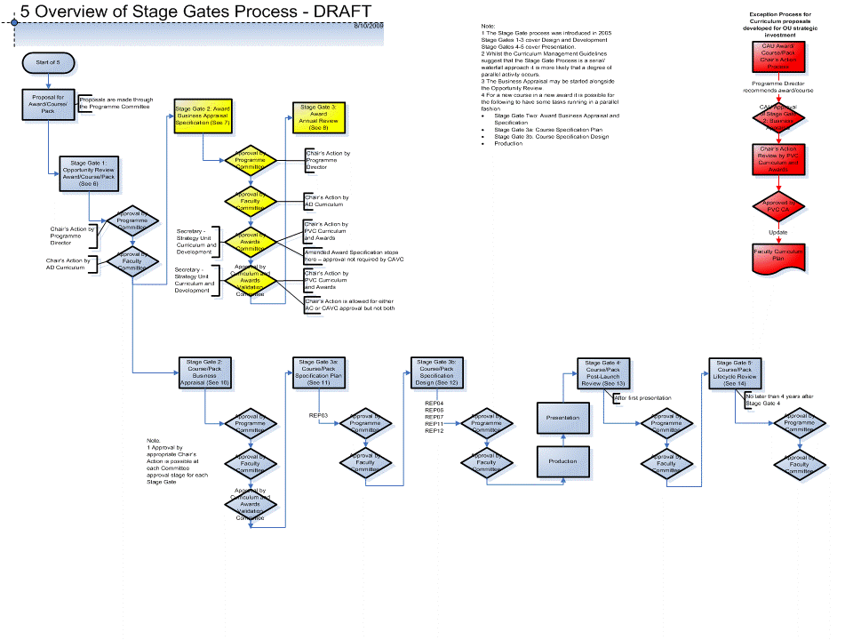
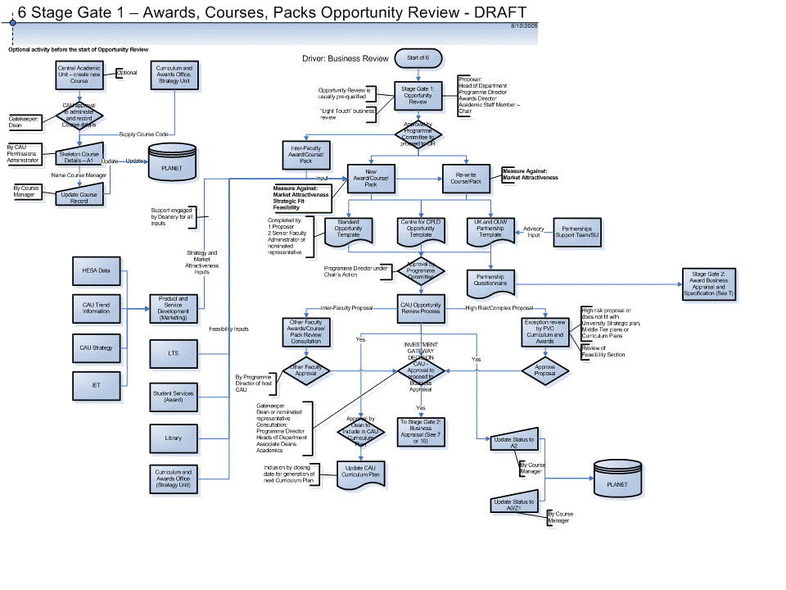
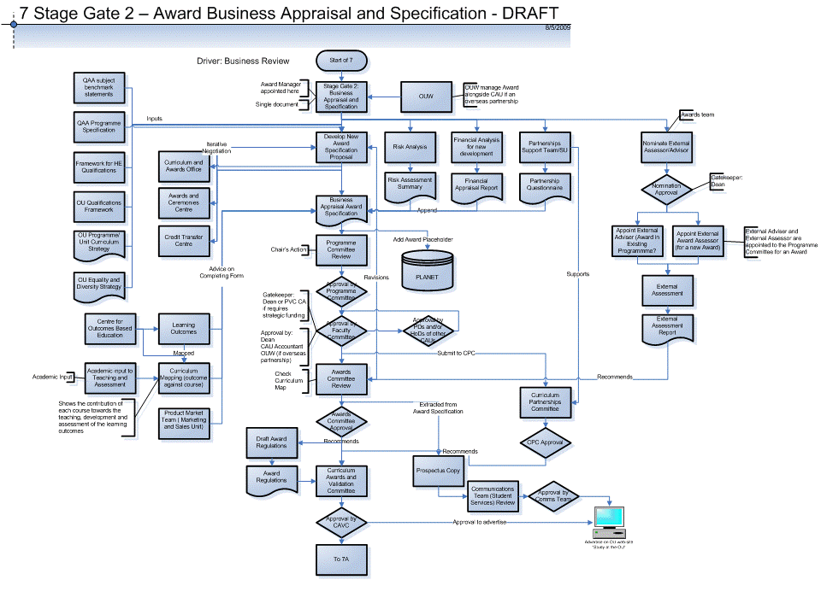
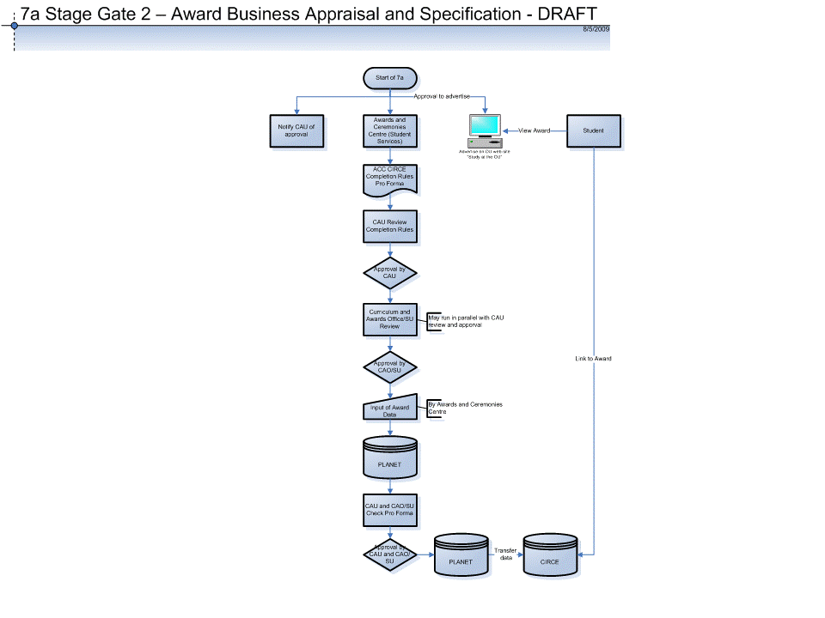
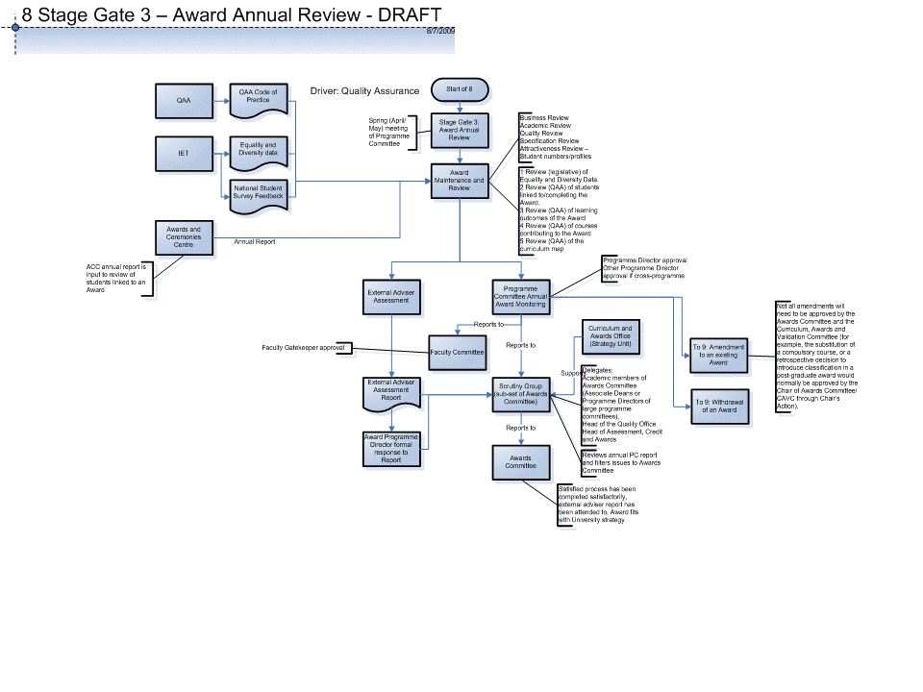
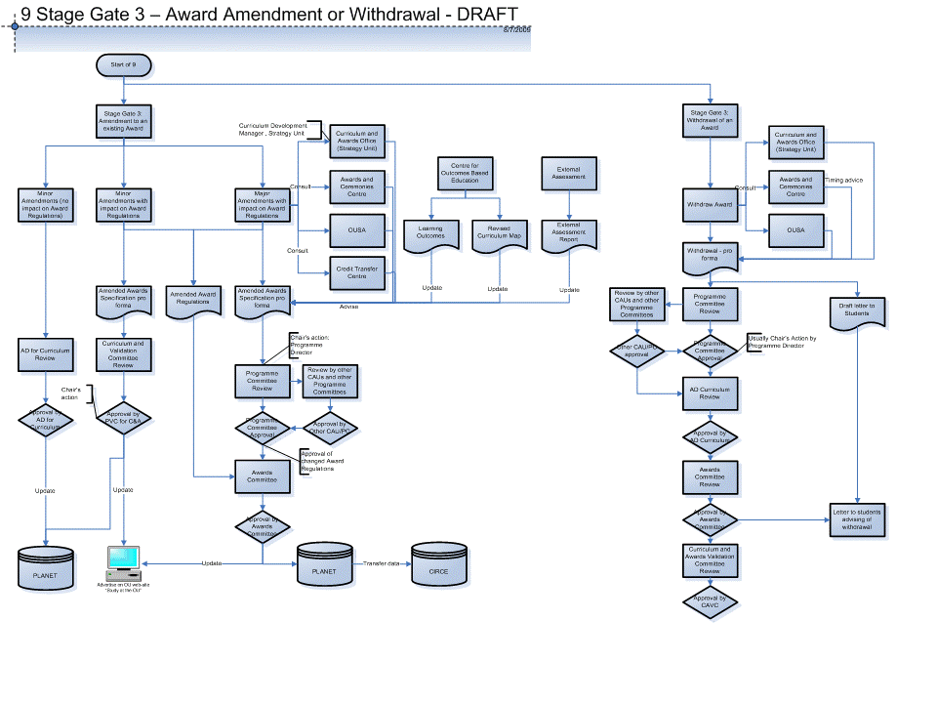
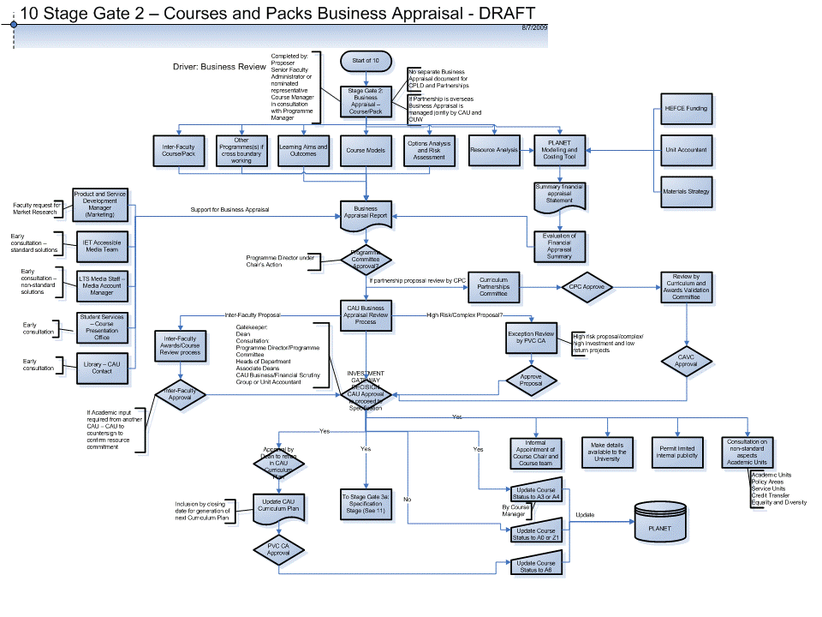
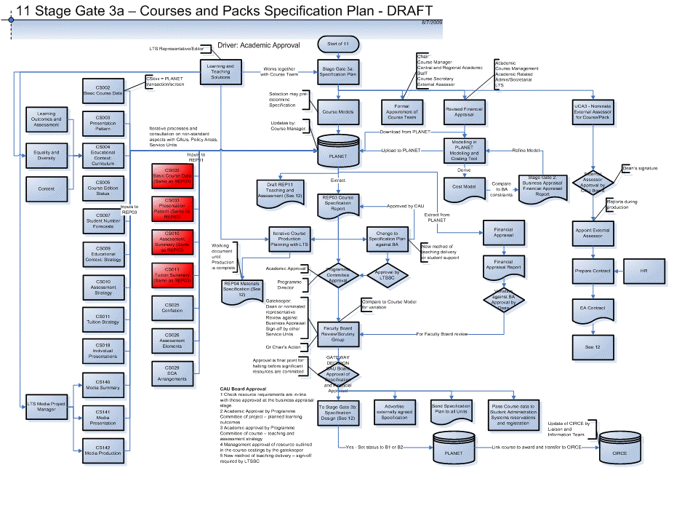
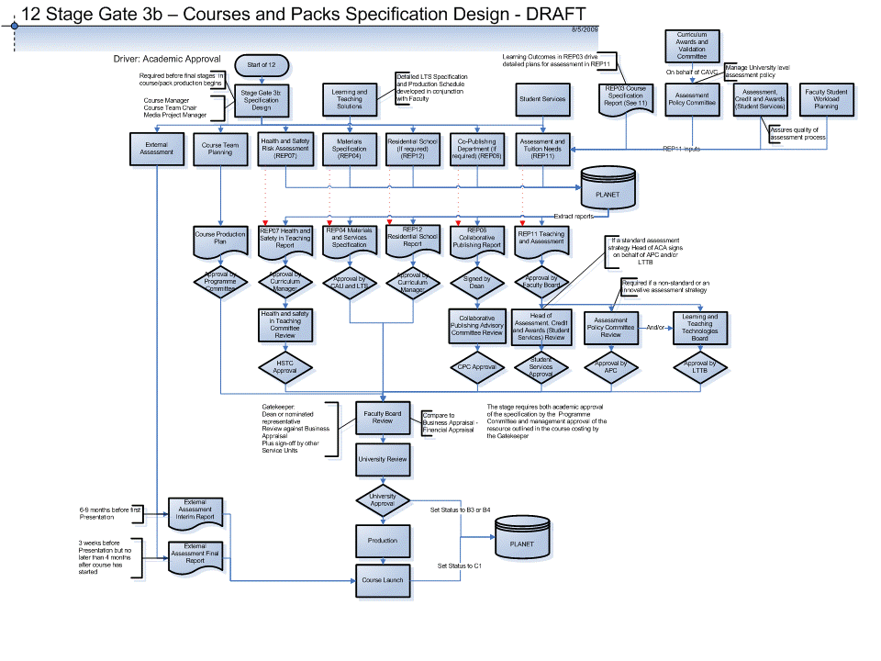
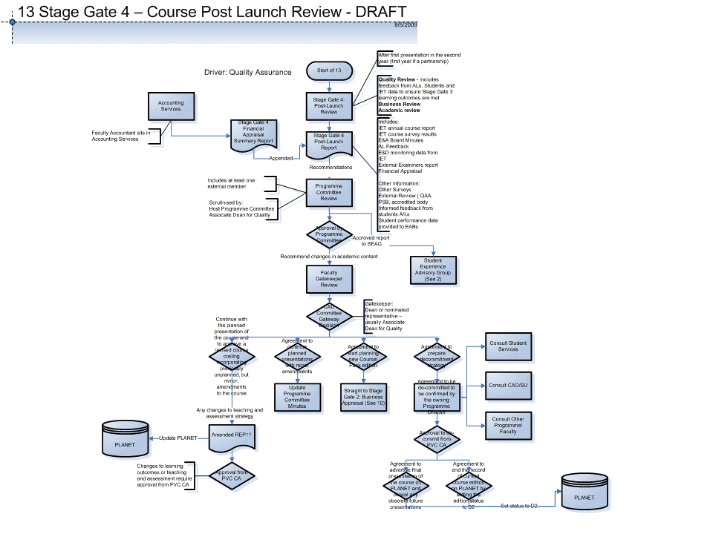
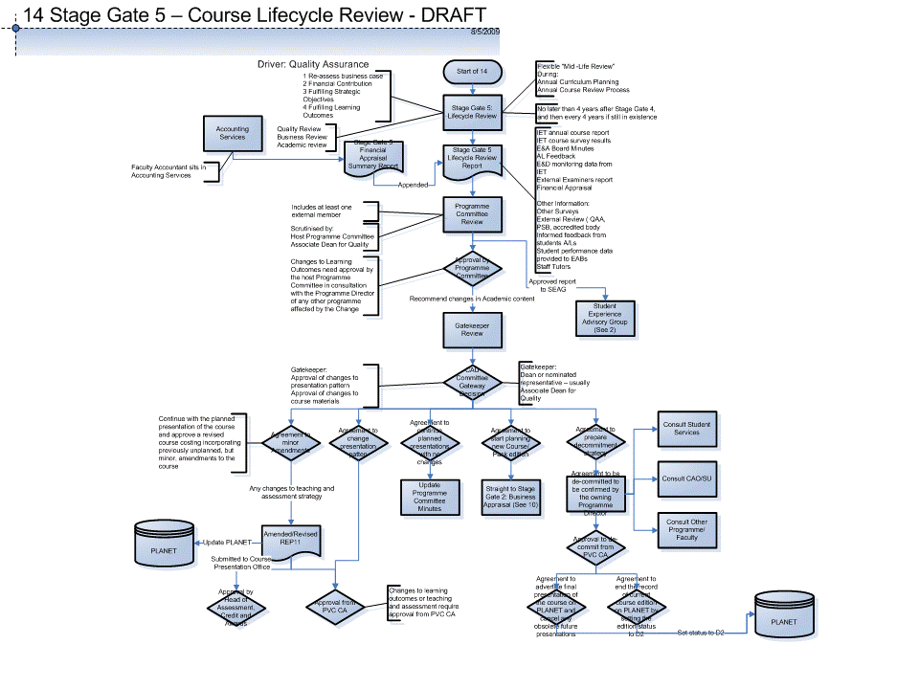

2.2 Methodology and process for creating the OU Curriculum Design Process Model

2.2.1 Curriculum design “As Is” process review methodology

First review of the OU Curriculum Management Guidelines intranet content
18th May 2009 – 8th June 2009 first review of the content of the OU Curriculum Management Guidelines intranet and the Stage Gate Process document set contained therein. The Curriculum Management Guide is a reference site for any member of the OU staff involved in the planning, production or presentation of courses, programmes or awards. It provides information on policies, procedures and practices associated with the lifecycles of these components of the University's curriculum. In addition, the 'Stage Gates' section of the Curriculum Management Guide contains guidance about the curriculum process for:

- The Stage Gate process for Awards
- The Stage Gate process for Courses

Production of the first draft set of flowcharts
Production of a generic (OU level as opposed to faculty level) first draft set of flowcharts using the software tool MS Visio and its basic flowchart template. The purpose of the flowcharts is to provide a visual representation of the “As Is” OU curriculum design process. These flowcharts cover the following parts of the curriculum design process with the intention of detailing one Stage Gate to a printed A3 page.

- Level One - Institution
- Level Two - Faculty
- Level Three - Programme
- Level Four - Awards Stage Gates 1-3 (based on the Curriculum Management Guidelines)
- Level Five - Courses/Packs Stage Gates 1-5 (based on the Curriculum Management Guidelines)

The flowcharts are organised at a number of levels from one to five. They make limited use of the symbols available within MS Visio with the intention of keeping the visual representation simple and easily understandable across the OU.

Staff Interview Consent Form
Construction of an “OU Staff Interview Consent Form” for sign-off by interviewees to allow interview output to be used as part the deliverable to JISC .

Preliminary Interviews
Following the production of the first draft set of the flowcharts, preliminary interviews were held with eight OU staff from three faculties with the purpose of reviewing the Level One to Level Three flowcharts. These staff were from the Open University Business School (OUBS), the Faculty of Health and Social Care (HSC), and the Faculty of Education and Language Studies (FELS) and their positions were:

- Associate Dean Learning and Teaching Technologies
- Courses Office Manager for Curriculum and Awards
- Learning and Teaching Technologies Manager
- Course Chair
- Programme Manager Undergraduate Programme
- Senior Course Manager
- Deputy Director Courses
- Director CETL

The purpose of the interviews was to:

- Elicit any problems with the review approach of the curriculum design process
- Trial the flowcharts to see if the wheel was being re-invented (it wasn’t)
- Trial questions for later interviews
- Identify areas that needed to be covered at interviews
- Identify an appropriate audience within OUBS, HSC, and FELS, for the next round of interviews
- Start the first iteration of updates/corrections to the flowcharts

Issues encountered when creating these documents were:

- The Curriculum Management Guidelines are heavy on formal process such as costing, committees and membership, documentation, use of PLANET (course management system), approvals, gatekeepers
- It was difficult to reverse the text into flowcharts. Information to produce a single flowchart/process map may have to be sourced from several document sources each of which may have a different perception of the process for a particular Stage Gate
- There were some subtle differences in the application of the Stage Gate process between faculties

Second Review of the OU Curriculum Management Guidelines intranet content
Between 10th June 2009 and the 26th June 2009 a second review of the content of the OU Curriculum Management Guidelines intranet and the Stage Gate Process document set contained therein was performed.

Review of Institutional Audit documentation
A review of the following institutional audit documentation supplied by the Quality Office, Strategy Unit was performed:

- The Open University Quality Assurance Agency Institutional Audit 2009 Briefing Paper
- QAA, The Draft Audit Report, The Open University 2009
- QAA, Annex to the Report, The Open University, March 2009

Review of the Strategy Unit Intranet Content
Review of the OU Strategy Unit intranet site contents to provide further detail for the second draft set of curriculum design flowcharts.

Production of the second draft set of flowcharts
Production of a generic (OU level as opposed to faculty level) second draft set of flowcharts using the software tool MS Visio and its basic flowchart template based on the document reviews. These maps cover the curriculum design process with the intention of detailing one Stage Gate to a printed A3 page. They make limited use of the symbols available within MS Visio with the intention of keeping the visual representation simple and easily understandable across the OU.

Identification of interviewees to review and validate the second draft set
From an informal review of faculty roles, the role of faculty Curriculum Manager was identified as an appropriate audience to review and validate the diagrammatic interpretation of the Curriculum Management Guidelines/Stage Gates Process. The selection of Curriculum Managers is based on their provision of guidance and assurance of the Stage Gate process to Programme, Award and Course Managers.

Interview Set-up
An interview time-table was set-up and interviews completed with the three faculties and the Strategy Unit. The purpose of each interview was to review and validate the diagrammatic interpretation of the Curriculum Management Guidelines/Stage Gate process as a visual representation of the “As Is” curriculum design process. Following each meeting iterative updating of the flowcharts occurred, plus the production of new flowcharts as required.

Contact with the OU Strategy Unit
A meeting was held with Head of Curriculum and Awards, Strategy Unit, with the purpose of engaging with the other Stage Gate projects underway in the OU. There are five other OU projects that are working on aspects of the Stage Gate process.

Meetings have also been held with members of the Stage Gate Good Practice Review team and staff from the Strategy Unit who run the Curriculum Management Guidelines intranet site.

Second draft set of flowcharts
The second draft set of flowchart/process maps has been updated as a result of the interviews with the Curriculum Managers, other nominated faculty representatives, and the Strategy Unit.

As interviews have been held with the FELS, HSC and OUBS faculty representatives to validate the “As Is” content, it has become apparent that each faculty operates within the Stage Gate process, but each faculty has its own “flavour” of the process, with e.g. differences in committee structures, working groups and approvals. These differences have begun to be captured as separate faculty based versions of the flowcharts (not included in this report).

Outcomes of process
Although it was not in the scope of the activity (“As Is” baseline mapping) for phase one, a number of early process improvements have been identified as a result of the development of the flowcharts.

- The diagrammatic representations (of the mainly text based content on the Curriculum Management Guidelines) have been well received by all those who have participated in the interview activities, as easy to use reference guides to the Stage Gate process. The production of the flowcharts based on “a Stage Gate per page” has helped achieve this.
- Draft packs of the flowcharts have been issued for faculty training purposes
- The Stage Gate Good Practice project has taken an action to review and re-write the content on the Curriculum Management Guidelines intranet
- The project has proposed that the flowcharts be up-loaded to the new version of the Curriculum Management Guidelines as reference guides to the text content
- The Curriculum Management Guidelines/ Stage Gate Process are text driven processes – only one process map for Awards Approvals was found

2.3 Review of the Technical Systems Underpinning Curriculum Design

This section presents an overview of three key technical systems used at the Open University to support curriculum design.

2.3.1 PLANET (PLAnning over a NETwork) - Introduction

The Open University has progressed from a system involving central decisions about individual courses to one in which authority has been delegated to academic units to determine their own academic provision within an agreed strategy for the curriculum. Each academic unit's curriculum plan is subject to approval by the Curriculum and Awards Validation Committee which reports to the University Senate. This ensures that the University Senate retains its statutory authority over the development of the curriculum and that the curriculum as a whole remains consistent with the University's agreed objectives.

Approval of the detailed plans for individual courses is a matter that needs subject expertise and this has been devolved to faculties for courses that are included in the unit's agreed plans. Decentralised decision-making at the course level has been made difficult in the past by the absence of effective systems for recording, publishing and maintaining the information needed. Holding information on paper forms has not ensured prompt and consistent dissemination of information to all who need it.

PLANET is an OU built web-based database system designed to handle the complex OU information requirements of course planning and approval. The system has been designed so that a complete record of a course is compiled over time. Planning and approval actions then draw on this information as necessary. Statutory powers of approval remain with the Curriculum and Awards Validation Committee, faculty committees and other bodies responsible to the Senate. PLANET provides pre-defined reports to serve as the basis for the approval procedures for which these bodies are responsible, and a means of recording and publicising the decisions that are reached.

The analysis work undertaken in the development of PLANET identified dissatisfaction with a particular aspect of course approval. Many people considered that the process of statutory approval took place independently of those responsible for delivering many of the products or services necessary for implementation. The approach taken in developing PLANET has been to identify and support the information needs of service and policy units as well as academic units and to design features of the system that alert all users to new developments. For this critical aspect of the system to work it must be a condition of approval that the information specified is entered on the PLANET system and available to be viewed.

PLANET stores information about all:
- Courses (or Pack), their approval, individual course editions, and their presentations
- Awards, their approval, and their links/relationships to courses
- Course materials, their schedules, and their relationships to courses
- Course mailings and their contents
- Presentation data is set up on PLANET and passed to CIRCE (see Section 2.3.2)
PLANET stores information about courses in the form of course edition records. When a completely new course (or pack) is proposed by a Central Academic Unit (CAU), a basic record is created on PLANET, so that its early stages can be planned and approved by the appropriate OU approval gatekeeper. A named Contact Person is responsible for updating the course's record on PLANET, and all queries about the record are addressed to the Contact Person. The Contact Person is usually the Course Manager, but in the early planning stages of a course (before a Course Manager has been appointed) it may be someone in a Deanery.

After their first presentation, most courses undergo some form of significant revision, a 'partial remake'. The revised course is then presented to a fresh cohort of students with the same course code and title, but with some change to its materials, tuition or assessment. Course editions allow PLANET to record information about a course in presentation, while at the same time recording information about its partial remakes.

PLANET also uses edition status codes to describe the stage a course edition has reached in its lifecycle, from planning through to completion. Every significant aspect of the course's specification is eventually represented in the course edition record, including details about the course title, first presentation date, materials, tuition and assessment strategy and award links. Different aspects of the course are viewed using different PLANET screens (known as transactions) that are composed of simple fields and embedded Word files. Each screen has its own code and title (e,g, CS005 Course Edition Status).

PLANET stores information about many aspects of the course, pack or award, including approval dates achieved during the planning process. The course information recorded on PLANET is used to create standard reports for curriculum planning (REP01), course specification (REP03), tuition and assessment (REP11) and health and safety (REP07).

Information is taken from PLANET and fed into operational systems such as CIRCE, Learning and Teaching Solutions (LTS) production systems (see Section 2.3.2), and warehouse systems.
Detailed information about course materials scheduling and mailing patterns is stored in other types of PLANET record. Core course product information is regularly taken from PLANET, checked, and then put onto CIRCE on a presentation by presentation basis by the Liaison and Information Team (Student Services). PLANET data is used throughout the university, and depended on by many people, systems and processes.
Each course edition record on PLANET moves through the standard lifecycle of an OU course, which includes the stages of planning, production, presentation and completion. This involves several sub-stages of adding information to the course edition record that is then used for various approval and operational activities around the University.
During specific planning and design stages of a course's lifecycle, different PLANET reports are used to support its approval:
- REP01: Curriculum plan tables. The basic record of the course is included in a plan table so that the Curriculum and Awards Validation Committee can approve it.
- REP03: Specification plan report. A more detailed course record, including the learning outcomes of the course, is produced in the report for approval by a CAU.
- REP12A and REP12B: Residential school reports. If the course has a residential school, both reports are approved by the CAU and then the Residential Schools Office (Student Services).
- REP11A: Tuition and Assessment report. Approved by the CAU and the Course Production Office (Student Services).
- REP07: Health and Safety in teaching report. Signed off by the CAU and the Health and Safety in Teaching Advisory Group.
PLANET data is used by OU units and systems to support course activities in two essential ways.

Approval purposes:
- By CAUs to get early stage-gate approvals from external OU units (e.g. approval from the Curriculum and Awards Office)
- Course Teams: to get other stage-gate approvals from external OU units (e.g. REP11 approval from Student Services)
- CAU deaneries: to get approval for Awards, that are subsequently transferred to CIRCE so students can link their courses to awards
Operational purposes:
- Prospectuses and “Study at the OU” require PLANET course, presentation, subject and award data
- CIRCE: student registrations and award transcripts require PLANET course, presentation, award and specification data.
- Student mailings and contents checklists: the Warehouse requires PLANET course, presentation and mailing data
- Student number forecasts: the Forecasting Team require PLANET course, presentation and initial CAU forecast data
- The Library requires PLANET course, presentation and materials data to check stock.
Every OU course or pack moves through the same basic lifecycle stages from initial planning through to final presentation. At each stage a corresponding course edition status is updated in order to support the necessary approvals and operational information requirements. A simplified summary of the main course edition status codes is:
- Early planning and University approval
- Specification and production
- Course content ready for first presentation
- Course (edition) completed

2.3.2 CIRCE (Corporate and Individual Records for Customers and Enquirers)

CIRCE is the University-wide operational database that stores all course and student information, and uses this to drive relevant operational activities.

Every award and course must have a record on CIRCE. If this record is not set up then no other operational processing (including student registration, tutor allocation, assignment marking or award completion) can take place. The Liaison and Information Team (Student Services) is the only area in the University permitted to set up and amend course information held on CIRCE. This work is often referred to as courses (or products) data. The Curriculum and Awards Office approves the transfer of award data from PLANET to CIRCE, and the Awards and Ceremonies Centre (Student Services) manage the data post-transfer.

It is important that records are set up early and are as accurate as possible. The records must be kept up to date throughout the life of an award or course and information amended as soon as possible.
The course information CIRCE holds is relied upon in many parts of the University and any errors can cause operational problems. The information is also downloaded directly to the Courses and Qualifications website for publicity, online registration and staff information purposes.

When a course is due to be presented for the first time a basic course record is set up. This requires similar information to that on PLANET including:
- Full and abbreviated course titles
- Level and credit points
- First and last presentation dates
- Country availability
- HEFCE data

Such information provides the foundation of the course record and gives staff and students general information about the course. It also enables services like award transcripts and credit points to be provided to students who subsequently register for the course.

For each presentation of a course an individual presentation record must be set up and maintained. This comprises the dates for reservation, registration, presentation start and presentation end which drive student registration, tutor appointments, fee collection, the recording of assessment details/results, and course completion.

The PLANET-CIRCE relationship is a critical one in the context of course set-up and maintenance. PLANET is relied upon heavily as a source of information by the Liaison and Information Team (Student Services). The process by which information is taken from PLANET and transferred to CIRCE is outlined below. A marker is put on the PLANET record to indicate that the transfer has been made.

CIRCE is an operational database, and that once the transfer is made from PLANET, the information becomes active, triggering activities. However this transfer only takes place once in the life of a course. There is no other automatic link between PLANET and CIRCE.

Once courses reach course edition status A6 (Approved in plan by University) on PLANET the core information is transferred to CIRCE. A presentation record is set up to enable presentation-specific operational activities to begin. The PLANET bulletin board is regularly checked for any changes to course/presentation details. Significant changes are verified and CIRCE updated as necessary. Other relevant areas of Student Services are informed.

2.3.3 Moodle

A key element of the OU e-Learning Strategy is the university-wide implementation of a suite of tools that form a technology enhanced learning (TEL) environment for use by all students, based on the Moodle open source platform. The environment also includes a number of additional tools and systems either developed or licensed by the University. Almost all courses offered by the OU now include a substantial online teaching element. The OU Virtual Learning Environment is updated on a quarterly basis.

Moodle is a free, open source tool designed to help educators create online learning resources and activities for students. In other words, it is a course management system. Moodle is one of a number of systems that fall into the category of learning management systems (LMS) or virtual learning environments (VLE), because it provides a set of learning tools and resources to help build online courses or e-learning.

Moodle was created by Martin Dougiamas following his experience as an Australian university system administrator, and he remains the lead developer. As Moodle is an open source tool it is being actively developed by a number of people around the world. The Open University, through the OUVLE project is building a Moodle installation for 200,000 users. The Open University OpenLearn environment uses Moodle too.

Moodle is a software system that runs on a server and is accessed by students and teachers using a web browser. Moodle uses a programming language called PHP and a single database, which can be one of a number of relational databases, although MySQL or PostgreSQL are the most popular. Moodle provides methods to edit and display content to allow educators to create content quickly and easily. Also provided is a set of core functions such as course resources, course calendar, quizzes, forums, and news.. It also has an extensible range of modules that work on top of the core to extend it; for example to allow Adobe Flash content to be created and viewed through Moodle.

Moodle is based on a constructivist approach to learning. This gives users the ability to manipulate resources in ways unlike other VLEs, which tend to be more rigid in their design and are based more on 'pushing content to learners' rather than engaging them. Moodle has a suite of collaborative tools that enable this process. Moodle is significant because it will create an environment that will engage and challenge learners. It will also provide pedagogical aspects that are currently missing from many other elearning or VLE platforms.

Moodle, along with many of the other larger VLE systems, is implementing standards for uploading, launching and tracking courses. In the future, learning resources will be portable between different VLEs and will allow content to be shared more easily between institutions. Moodle offers educators simple and effective ways to create online courses for students. It reduces the course production time compared to bespoke course delivery. It should allow learners to engage and collaborate in new ways and achieve more by allowing them to fully interact with the environment in ways which have not previously been possible.
Moodle is primarily developed in Linux using Apache, MySQL and PHP (also sometimes known as the LAMP platform), but is also regularly tested with PostgreSQL and on Windows XP, Mac OS X and Netware 6 operating systems
The requirements for Moodle are as follows:
- Web server software. Most people use Apache, but Moodle should work fine under any web server that supports PHP, such as IIS on Windows platforms.
- PHP scripting language (version 4.1.0 or later). PHP 5 is supported as of Moodle 1.4.
- a working database server: MySQL or PostgreSQL are completely supported and recommended for use with Moodle.
For more information on Moodle see http://moodle.org

2.4 Learning Design Roles and Responsibilities

The Course Team is a group of academic and other staff appointed by the Central Academic Unit (CAU) to devise and produce an Open University course. Each course is produced and supported by a team that includes a Course Team Chair and a Course Manager (who leads on organisational, budgetary and support issues). Apart from the course content, they also produce the assessment material for each presentation and form the examination board. Course teams may also be involved in briefing tutors, monitoring scripts and evaluating the course, particularly when it is new. The precise nature of course team membership varies between CAUs.

The course team is listed on the Course Specification Plan report (PLANET REP03) for approval by the committee of the CAU. However, in the unusual circumstances where a course manager is to assume the role of Course Team Chair, approval is required from the Curriculum and Awards Validation Committee. Changes to the Course Team Chair must be approved by the committee of the academic unit. Changes to the course team must be approved by the head of unit.

Roles of team members and potential contributors to course production

Course teams might draw on some or all of the following personnel depending on the nature of the course and available resources.

a. Course Team Chair
The Course Team Chair has overall responsibility for the work of the course team and the maintenance of academic standards.

b. Course Manager
Course Manager roles vary between faculties although they all have organisational/ project management responsibilities such as:
- Arranging and servicing meetings
- Negotiating and updating drafting schedules with the academic unit’s production and presentation administrators
- Negotiating production schedules with LTS Media Project Managers
- Ensuring that deadlines are met before handover to LTS
- Acting as a liaison point both for and within the course team
- Managing and monitoring course budgets

Some Course Managers have varying degrees of creative influence, such as:
- Commenting on or preparing various parts of the course material
- Ensuring a proper degree of co-ordination and cohesion between the components of the course
- Briefing consultants and associate lecturers
- Arranging developmental testing and feedback

c. Academic Staff
May be either authors who:
- Write main texts and assessment materials
- Develop the academic content presented in other media such as video and audio
- Devise practical activities where appropriate

Or readers who:
- Critically assess the course materials
- Comment on subject matter, its presentation and educational effectiveness

d. External Assessor
A reputable academic subject specialist is appointed, usually from another University, with responsibility for ensuring that the academic standard of the course is consistent with the rest of the sector and acknowledges current thinking in the subject area.

e. Course Team Secretary
This role will vary between the academic units and between course teams, but may include:
- Responsibility for ensuring that all course materials are keyed in the correct style for electronic publishing
- Attendance at and support of course team meetings
- Provision of other secretarial support for the course team

f. Institute of Educational Technology
The Institute has a client manager who is responsible for liaising with the faculties. IET does not normally work directly with course teams for the duration of the production process but may provide some advice as part of its wider remit on:
- The teaching strategy
- The use and mix of media to be used
- The testing of materials prior to first presentation
- The evaluation of the course during presentation in order to provide data for revising or remaking the course or some of its components

g. Learning and Teaching Solutions
LTS provide a range of media experts, some of whom will work directly with course teams, whilst others have an advisory role.

An LTS Media Project Manager may:
- Advise on the use and mix of media
- Plan and schedule production or buy-in of media components
- Deploy and manage media developers to produce the course
- Manage course production processes to time, cost and quality standards

A Media Developer may:
- Advise the team on the structuring and styling of the text
- Be responsible for the in-depth and detailed editing of the text, ensuring clarity, coherence and accuracy
- Develop educational software to meet course team needs or advise on the availability of appropriate commercial software
- Develop online materials and services
- Design the overall appearance and presentation of course material as a total teaching package
- Produce artwork
- Produce audio-visual components of the course

Media assistants may:
- Search and clear copyright on third party material for use in course layout
- Render text and images to print and interactive media

h. Library
The library has assigned Subject Information Specialists to each CAU. A Subject Information Specialist may:
- Support the information needs of academics writing course materials
- Develop students’ information literacy skills by writing course material or facilitating access to digital information sources such as bibliographic databases and full-text journal and newspaper articles, electronic books and reference works
- Advise on ways to reduce rights costs if existing Library resources are used
- Co-ordinate the clearance of rights on materials sourced through the library

i. Consultants
If the necessary skills and/or staffing resource are not available in-house for academic authoring, consultants of recognised academic standing could be contracted. Consultants produce draft materials under the direction of the Course Team Chair and revise their contributions in line with feedback from the course team members so as to ensure that the learning materials produced by them support the relevant learning outcomes.

3 Stakeholder Perspectives

3.1 University perspectives

Lead author: Gráinne Conole
Rebecca Galley
Paul Mundin

As part of the baseline report we have undertaken a review of the institutional discourse about learning and curriculum design, as well as eliciting a range of stakeholder perspectives. These have been gathered via document analysis of relevant institutional texts and questions to stakeholders.

A range of sources of date were used to comply this section, these include:

Documentation
- Institutional quality audit report 2009
- Educational and Professional Development (EPD) website and documentation
- Curriculum Strategy 2009-2014
- Learning and teaching strategy

Stakeholder groups
- PVC Curriculum Development (Alan Tait)
- PVC teaching and learning (Denise Kirkpatrick)
- Director of IET (Josie Taylor)
- Deputy director of IET (learning and teaching) (Patrick McAndrew)
- The OU community
- Four partner institutions
- Broader academic community

3.1.1 Strategic perspectives

a. Institutional quality audit report

The strategic importance of learning and curriculum design is evident in the recent institutional quality audit report; the university received an excellent report in terms of its teaching and learning design and support. Here are some ways in which learning and curriculum design are weaved into the report

- Through academic research, pedagogic innovation and collaborative partnership it seeks to be a world leader in the design, content and delivery of supported open and distance learning.

- Eighty-ﬁve per cent of the University’s courses now use the VLE, with approximately sixty per cent adopting VLE tools for teaching and learning. Alongside pedagogic developments and equally important - are the robust networks based on the StudentHome and TutorHome portals, which link students to the University, their tutors and each other, and the electronic Tutor Marked Assignment (eTMA) system, which results in more rapid and more ﬂexible feedback to students on their progress. University systems for student records, curriculum design and development, eAssessment, and information management are all linked to the VLE.

- The Curriculum Management Guide provides the core integrative guidelines. It is a comprehensive website managed by the Strategy Unit Information Ofﬁce that brings together policy and guidance on all matters of curriculum design and presentation.26 It is extensively used by staff – each month more than 400 visitors make an average of two visits each.

- The Stage Gate Process is the core integrative approval process. Through it the University marks points in the development and presentation of a course to students where an explicit review is undertaken and an explicit decision made, i.e.:
- Development and design:
  - Stage Gate 1: opportunity review
  - Stage Gate 2: business appraisal
  - Stage Gate 3: course speciﬁcation

- Presentation:
  - Stage Gate 4: post-launch review
  - Stage Gate 5: life-cycle review.

- A similar process is followed for Awards with Stages 2 and 3 being combined and an annual review performing a similar function to Stages 4 and 5.

- The design and implementation of a Course Teaching and Assessment Strategy involves a number of areas of the University, whose work is coordinated through the course manager for the course, and administrators in academic units and Student Services.

A whole section of the report is concerned with enhancements in curriculum design:

Enhancement in curriculum design
- Quality enhancement is embedded within the processes that manage the design and approval of new awards and courses. As outlined in Section 2 these bring together business-related factors (opportunity review and the business case) with academic questions (learning outcomes, teaching and assessment strategy), within the framework of OU Futures and the processes of enhancement in support units and University projects described below. Two other aspects of the University’s ethos and method of working contribute strongly here – research activity and the course team system.

- Academic staff involved in curriculum development and delivery are usually active in research and/or scholarship in a way that contributes to the University’s objectives, and have an annual allocation within their workload plans for this. The contribution may be in the member of staff’s subject area and directed toward publications countable within the Research Assessment Exercise, and/or directed towards new curriculum or pedagogy. This is reﬂected in course design and teaching materials. In some areas, the links will be direct; for example, research in the Design Innovation Research Group fed directly into course T172 Technology for a sustainable future; research for the ‘Art in Theory’ project has fed directly into the teaching of modern art. More often the link will be indirect, particularly embedding the latest thinking about methodology into teaching and student exercises. Pedagogic research is important. For example, course designs can draw on a range of more than thirty investigations associated with the Practice-based Professional Learning Centre for Excellence in Teaching and Learning, ranging from examination of ‘wicked’ (hard to measure) competences through to reﬂective tools of beneﬁt in a social work programme. These links are fostered by the University’s academic staff promotion processes where the University’s criteria expect strong performance in teaching for promotion to senior lecturer.

- Team working is part of Open University life and is evident in curriculum development in the collegial course team culture. The strength of this way of working in the context of quality enhancement lies in the beneﬁts that arise in creative thinking and peer review. The breadth of membership of course teams is important here. A discussion can encompass debate about the value of the latest methodologies led by an RAE-rated expert in the ﬁeld and a debate about student learning led by someone with close experience as an associate lecturer.

b. Curriculum strategy 2009-2012

The university has recently produced a curriculum strategy for 2009-2012. This document provides the higher-level overview of the university’s position in terms of curriculum design. Some extracts help to illustrate the focus of the strategy:

- The purpose of this curriculum strategy is to provide a framework for managing the OU curriculum portfolio over the next 5 years. It must seek to ensure that the curriculum:
  - is an effective vehicle for taking forward the University’s mission and values,
  - actively promotes the University’s key strategic priorities, in particular Widening Participation, Employer Engagement, the Four Nations and International Strategies,
  - is cost effective and sustainable.

- The Open University’s mission states that it is open to people, places, methods and ideas, that it promotes educational opportunity and social justice, and that it seeks to be a world leader in the design, content and delivery of supported open and distance learning.

- There are three strategy priorities that any curriculum designs need to align: widening participation, employer engagement and international reach.
- Action will be taken to strengthen the curriculum’s contribution to the University’s strategic priorities. This will influence the shape of the curriculum by influencing the range of subjects taught and the awards offered.

- The Open University’s innovative approach to pedagogy is at the heart of our distinctiveness. The strategic priority for embedding eLearning and the VLE into new and emerging course models cost effectively is critical to the University’s ability to grow both curriculum revenue and reach. In line with the Learning and Teaching Strategy, the development of the curriculum will need to take place in the context of developing new ways of developing courses and awards and the exploration of new more sustainable models for development and presentation.

- Without successful progression through our curriculum students will fail to attain their initial ambition. Our choice of curriculum in terms of both subject and content is a critical part of the student journey. We require clear and coherent study pathways through our awards designed to meet the target audience needs. This applies at all level of study including our postgraduate programmes. Award Based Services is critical to supporting the achievement of this ambition.

- The overall objectives will be to re-balance the curriculum so that vocational and employer related curriculum is more attractive to students in these categories and that the involvement of employers in curriculum design will help embed employability skills more effectively into the curriculum.

c. Learning and teaching strategy

The Learning and Teaching Strategy is a high level planning document to inform actions and decision making across the University regarding learning and teaching. The Strategy interprets the learning and teaching aspects of OU Futures, and provides the strategic framework to enable progress towards the achievement of its priorities. Key extracts from the strategy:

- Fulfil the OU’s mission to be the world leader in open and distance learning – In an increasingly competitive distance education environment, it is essential that the OU maintains its leadership position and reputation. We will do this through the quality of our learning design, the technical and pedagogic quality of our learning resources and materials, pro-active and responsive student support and high quality tuition. We will support innovation in these areas and encourage the re-use and adaptation of existing resources and materials.

- Learning design is a major heading within the strategy. Building on the work to date undertaken as part of the OULDI is seen as key:

- Section 5.1.2 States “Develop and apply new approaches to learning design. Expand the Learning Design initiative across all CAUs.”
  - Support all staff involved in learning, teaching and student support to develop the skills they need to design and/or teach effectively online.
  - All staff will have expertise to engage in learning design that:
  - creates high quality online learning experiences;
  - makes appropriate use of the digital environment;
  - supports the development of online learning communities;
  - fosters the development of information and digital literacies;
  - is evidence based and scholarly; and
  - is environmentally sustainable.
  - All staff involved in learning and teaching will have expertise in:
  - teaching and supporting online groups; and
  - understanding the relevant online pedagogy and evidence base.
  - There is also a section in the strategy that makes explicit reference to OULDI. Learning Design Initiative (5.1.2a)

- The Learning Design initiative aims to develop and implement a methodology for learning design composed of tools, practice and other innovation that both builds upon, and contributes to, existing academic and practitioner research. The team is based in the Institute of Educational Technology.

- The team is interested in providing support for the entire design process; from gathering initial ideas, through consolidating, producing and using designs, to sharing, reuse and community engagement. Its vision is of a learning design methodology and suite of practical tools and resources that bridge between good pedagogic practice and effective use of new technologies.

d. Educational and Professional Development (EPD) at the OU

The university has a variety of different kinds of support for educational and professional development; from workshops, events and conferences through to paper-based and digital resources.

The university now has a cross-institutional group, which coordinates all EPD activities called the Professional Development Co-ordination Group.

There are a variety of mechanisms for staff development across the university both at institutional level and at faculty and departmental level. Some are generic training opportunities; others are more tailored for specific needs. Many of the service units organise events – such as IET, the library and LTS. There is also a vibrant cross-institutional e-learning community with more that 200 members. Each faculty has its own mechanisms for supporting staff development – many have annual learning and teaching day events. The university also has a two-day learning and teaching conference. The Learn About Fair is another important annual event, with a set of stalls and posters and the paper/electronic Learn About… guides and the learning and teaching guides. An online catalogue provides links to the range of resources and events available from across the university.

The EPD work in the university has been mapped to the UK Professional Standards Framework for teaching and supporting learning in higher education (http://www.heacademy.ac.uk/ourwork/policy/framework). This is grouped under three categories: A. areas of activity, B. core knowledge and C. professional values. The OU has mapped these to learning outcomes and assessment activities within the institution’s professional development programmes. Of these the specific ones under A, B and C, in relation to curriculum design are:

A1. Design and planning of learning activities and/or programmes of study
- General work in production team and associated processes, including:
  - making the case for a course (business appraisal),
  - putting it through the committe cycles;
  - recruitment of course team;
  - general project management

A4. Developing effective environments and student support and guidance
- Ensuring course design is suited to diverse student needs;
- Course websites, course guidance, course conferences
- Work in a production/presentation team.
- Provide course related advice & support via phone or email

A5. Integration of scholarship, research and professional activities with teaching and supporting learning
- Take part in staff development activities
- To inform practice in teaching and supporting learning.
- Attend workshops and courses

K2. Appropriate methods for teaching and learning in the subject area and at the level of the academic programme
- Developments in educational technology and their application is required.
- Course managers are expected to be aware of OU developments and policy decisions and their application to courses

K3. How students learn, both generally and in the subject
- See above, plus course design considerations -components;
- Approach to assessment and exams

K4. The use of appropriate learning technologies
- See above, plus ensuring that tools / technologies are fit for purpose.

K5. Methods for evaluating the effectiveness of teaching
- See above plus taking action points from IET surveys and other feedback from students, including teaching residential school feedback from students and tutors

V1. Respect for individual learners
- Accommodating students' individual enquiries and needs;
- managing relationships

V2. Commitment to incorporating the process and outcomes of relevant research, scholarship and/or professional practice
- Facilitating input by academics and others;
- Co-ordination of input to course content;
- Keeping academics 'grounded' in practice

V3. Commitment to development of learning communities
- Formation of course team and efficient resource usage;
- Ensuring AL involvement; sharing of best communities practice with other course managers

V4. Commitment to encouraging participation in higher education, acknowledging diversity and promoting equality of opportunity
- Reflected in course design and presentation;
- Training / SENDA
- Documentation in course business plan

V5. Commitment to continuing professional development and evaluation of practice
- Creating opportunities for development of own practice and that of others involved in course design and presentation, including career and development planning and engagement in professional development
- Development activities.

e. IET strategy statement 2009-2012

The OU Learning Design Initiative is located within the Institute for Educational Technology within the university. From IET’s website (http://iet.open.ac.uk):

The Institute of Educational Technology (IET) at the Open University provides advice on the use of modern technologies to support effective learning, particularly distance learning and e-learning, in higher education. We are committed to developing expertise in teaching and learning and to applying it, particularly to the benefit of the Open University. As you will see from the list of our research and development activities, we work collaboratively with leading scholars internationally and in the UK.

In addition to studying, evaluating and influencing OU practices, we also carry out basic research into learning and e-learning, and applied research into the use of new technologies. Additionally the Institute works in the field of professional development in HE and has a strong and successful record of postgraduate teaching.

Following the completion of the IET review and agreement of a new structure and ways of working for the unit, IET has now developed a strategically-aligned programme of work that is at the heart of the OU’s mission to be a world leader in the design, content and delivery of supported open and distance learning. The following provide some extracts from the strategy in terms of how it relates to curriculum development:

- Our vision places IET at the hub of the OU, connecting together a network of innovation and expertise in learning and teaching and using this collective power to change the face of education.

- Specifically, IET seeks to further establish its role as:
- A centre of expertise in educational technology, promoting and embedding good practice and driving professional development of staff
- At the heart of the OU, directly influencing the OU’s strategy
- Outward looking and responsive to our clients: CAUs and VCE
- Respected within the OU as providing strategic advice and support
- Delivering a significant volume of high impact, internationally renowned research

- Develop a co-ordinated approach to professional development that models flexible learning and teaching practices in a digital context (L&TS 1.3.c, 2.1.a,b, 2.3.a,c) We will work to:
  - Develop and promote the use of the EPD roadmap
  - Implement a range of professional development interventions at scale to enable staff to design and teach effectively on line
  - Expand EPD services for staff in collaboration with the Library Digilab and KMI to provide hands-on experience with new technologies
  - Develop a new IET website strategy to support professional development and scholarship activity
  - Continue to publish our Learn About Guides and Learning and Teaching Guides for all OU staff
  - Reversion the MAODE for internal staff development, providing bite-size induction level learning on technology and pedagogy that is internally accredited

- OU-wide: Embed innovative pedagogies within courses (L&TS 1.1.a,c,d,f, 1.2.a, 1.4.c, 1.5.b, 2.1.b) We will work to:
  - Further promote the Learning Design initiative across the OU and track its impact on OU courses, piloting tools such as Cloudworks and Compendium LD
  - Continue to deliver accessibility and usability testing to maintain high quality across OU courses
  - Evaluate teaching with the VLE across inter and intra-regional clusters
  - Expand the range of assessment approaches that utilise technologies, in support of more cost effective course delivery

3.1.2 Stakeholder perspectives

A selection of stakeholder perspectives are provide here.

Professor Denise Kirkpatrick – Pro VC (T&L)
Denise has responsibility for a portfolio of units including LTS, Library, IET, KMI and the Learning Innovations Office. All of these intersect with curriculum design to some degree. The Vice Chancellor’s Executive has strategically funded the OU Learning Design Initiative for the past two years. A report summarising OULDI is submitted twice a year. Learning design is seen as an important part of the institutions approach to curriculum change and innovation and is a core theme in the learning and teaching strategy.

Professor Alan Tait – Pro VC (CD)
Alan has responsibility for the overall curriculum development and awards process. In addition he has spearheaded a key initiative in the last couple of years around Course Business Models. The aim of the project is to develop new course models as alternatives to the OU classic model. The project started by outlining five alternative course business models; Wraparound, Brought-in, Disaggregated Assets (Learning Objects), Empty-box and web 2.0. This work is seen as important as a means of enabling the university to adopt a more agile approach to course design, which is pedagogically sound, cost effective, fit for purpose and innovative. Professor James Fleck has been leading a group taking this work forward.

Professor Josie Taylor – Director of IET
A key part of IET’s remit is to research the use of technologies and use this as the basis for helping to improve the learning and curriculum design process. This is achieved in a variety of ways; through institutionally focussed research and development activities and projects, through consultancy and advice, through production of resources and via a range of different kinds of real and virtual events. The institute has recently undergone a major review process and now has a much clearer internal focus and remit. The following is a quote from Professor Josie Taylor, director of IET:

“From IET's point of view, I would say that Learning Design forms the basis of strategically important strands of work around professional development in the CAUs, an area which carries responsibility for in The Open University. The activity is supported by the Deaneries, and forms a critical element of IET's relationship with the faculties. Working with the learning design team has highlighted for them the need for such an approach to move faculty forward in their engagement with technology-enhanced learning. Engaging staff interest in this development has historically been extremely difficult, given competing priorities and workloads, but the learning design approach has helped us to re-conceptualise how we present our development activities, and how we can involve other key players across the University. Cloudworks also features as a key element in the developing Roadmap for Educational Professional Development, a document produced by the Professional Development Co-ordination Group, a group which has been tasked with overseeing staff development by the Pro-Vice Chancellor (Learning, Teaching and Quality) Denise Kirkpatrick.” October 2009

Dr. Patrick McAndrew (Deputy head of IET (L&T))
Patrick has recently taken on a new role of deputy head of IET for learning and teaching. He is also director of the Hewlett funded OLnet initiative, which has learning design as a core component of its approach to improving the use and repurposing of Open Educational Resources (OER). The follow is a quote from Patrick:

“Learning Design has provided an important element in research and teaching and learning projects in IET starting from work in 2002. While earlier work tended to look at the tools and standards that could be applied there has recently been a change in emphasis from experimental to seeing learning design as an approach that can help people understand how learning materials work and how they might be used or reused. Learning design is now a recognised term and so provides an effective way to communicate the idea that we can design the way that people are expected to learn as well as the content and subject area. In the OLnet project learning design is one of the leading strands in considering how people can use Open Educational Resources as a teaching resource or for self learning. Applying the tools and expertise of learning design and the related field of pedagogic patterns has enabled research into representing the learning intent in OER and into approaches for adding collaborative approaches to using OER. IET also works in partnership with other units in the University on Learning and Teaching activities. Learning design provides an important element in helping those working on courses plan and work well with the production processes in place in the University. It has also proved to be an enabler for other aspect such as gathering and sharing case studies, planning for new technology, and identifying issues in advance.” October 2009

The wider OU community

As outlined earlier there are a multitude of channels of communication and support around learning and teaching issues at the OU. The university has a number of central units that provide significant support in terms of curriculum design, as well as having externally funding initiatives involved in this area, such as the Centres of Excellence for Learning and Teaching and our activities around Open Educational Resources (such as Openlearn and OLnet). In addition the way in which design is enacted in the OU – with multidisciplinary course teams designing curricula in itself fosters an ongoing scholarly and dialogic approach to the design process. There are numerous research groups that have an interest in different aspects of learning and teaching innovation and there is a vibrant cross-institutional e-learning community who met on a regular basis to share work and discuss ideas.

In addition to these position statements, informal feedback from key faculty stakeholders was gathered during the interviews made as part of the process mapping work (see Section 2). These comments relate to several aspects of the process. Over the next sixth months, we will gather further details of stakeholder perspectives as we look to engage with specific facilities.

The wider academic community

There are now a range of communities of practice/clusters of interest for learning and teaching. As a sub-set of these in the last ten years or so there has been a growth in communities interested in exploring how technology can be used to support learning and teaching. These communities range from professional bodies (such as ALT and SEDA), groups associated with funding bodies and initiatives (the HE Academy fellows, the JISC expert group), through to those linked via research networks or around conferences.
In addition in the last few years there has been an expanding digital community – in social networking sites like facebook, NING and ELGG and through the blogosphere and microblogging sites like Twitter. Cloudworks is now also proving to be a valuable space for sharing and discussing learning and teaching ideas and designs.

Research in the area has matured and there are now a plethora of research journals in the field. Research now attempts to better align with and inform policy directives and is usually focused on impacting practice and resulting in real tangible benefits.

In terms of curriculum design a strong research sub-field around learning design has emerged, linked into wider international developments in this area but also through the JISC’s design for learning programme.

3.2 Partner perspectives

Lead author: Rebecca Galley

The project has four UK partner institutions. This section outlines the key stakeholders at each institution and brief statement relating to the context in which interventions will take place.

3.2.1 Brunel University

The main, or key, stake holders for the Brunel pilot have been identified as: the Quality and Standards Office; the Academic Practice Development Unit / e-Learning Support Team; the Deputy Heads of School (Learning and Teaching) and academic programme leaders.

The e-learning strategy of Brunel University (agreed in 2005/2006) focuses on providing a ‘blended’ approach to the learning experience of the students. Strategy in relation to learning and teaching, supports the implementation of blended learning to combine the advantages of face to face teaching and e-learning. In addition, the distinctive characteristics of a Brunel graduate are identified in Brunel’s Students Plan; i.e. characteristics that all its programmes should seek to develop. It is recognised that programme design should play a role in ensuring that the aim of developing these characteristics is addressed.

The PVC (Student Experience) has expressed an interest in the project, and the Director of Academic Programme Development and the Head of Quality and Standards Office have agreed to facilitate activity where necessary.

3.2.2 London South Bank University

The key stakeholders for this project have been identified as the Vice-Chancellor and Pro-Vice Chancellor (Academic), Pro-Deans, leaders of teams developing new, or revalidating existing courses, and the Academics.

London South Bank University (LSBU)’s Corporate Plan 2009-2012 has recently been published and is entitled ‘Students First’. The report introduces key performance indicators which focus strongly on improved student satisfaction, retention and progression. The university has identified the key issues it plans to address: leadership, decision making processes, performance management and staff empowerment. That this project starts at a time of culture change in the organisation is likely to offer significant challenges as well as opportunities to the pilot. The LSBU pilot project team feel that Learning Design methodologies will enable Academic staff to better articulate links between outcomes, teaching materials and assessment methods, and generally make the learning and curriculum design process more understandable thus supporting decision making, performance management and staff empowerment.

As well as publishing a new Corporate Plan, the University has also gained both a new Vice Chancellor and a re-structured Executive Team since LSBU’s initial involvement with this project. It is therefore important to re-establish senior management buy-in and opportunities have been identified to ensure that this is completed by the end of October 2009.

3.2.3 University of Reading

The key stakeholders have been identified as the E-learning team, the Pathfinder team, School e-learning coordinators, identified teams that already embark on curriculum redesign, FDLTs, the Centre for Academic Development and new Lecturers.

The University of Reading’s Pathfinder project was entitled ‘Enabling Enhancement’ which aimed to move the University from a focus on quality improvement to a focus on quality enhancement. The University’s Centre for the Development of Teaching and Learning (CDoTL) remains engaged in working with Academic teams and Schools through the Pathfinder process to review programmes and identify opportunities for teaching and learning enhancement, and promoting and supporting the appropriate use of technology in blended learning.

Senior Management buy-in has not yet been assured for this project, but this is currently a priority with meetings booked with one Faculty Director of Teaching and Learning (FDLT), and the Pro-vice Chancellor for Teaching and Learning.

3.2.4 University of Cambridge

The key stakeholders for this pilot project have been identified as the CARET team, Pathways in Higher Education Practice (PHEP) team, new lecturers (PHEP participants), LTS (pedagogic practice support initiative).

The teaching and learning context at Cambridge University is significantly different to that of the OU and other pilot partners; small group teaching still remains the cornerstone of Cambridge teaching provision. As such this pilot will provide an additional challenge in discovering how far the OU Learning Design methodologies are transferable to different learning institutions. Cambridge’s Pathfinder project (Learning Landscapes) sought to map the teaching and learning experiences of staff, students and alumni, in order to provide data to support pedagogical innovation and development. This OULDI-JISC pilot project will build on the findings of that piece of research by developing an understanding of how curriculum design happens, formally but especially informally, looking at where pedagogic concerns are introduced and developing a methodology and tools to support and share this.

4 Baseline of staff perceptions and practice

Lead author: Simon Cross
Paul Clark
Andrew Brasher

4.1 Attitudes and perspectives on designing elearning

As part of the baseline process we undertook a series of three small scale surveys on staff practice, attitudes and use. Around 110 staff were invited to respond and there were 50 responses. The majority of the respondents to these surveys had, at some time in the last 12 months, participated in a workshop or event at which one or more members of the team had some form of involvement. Most of those invited to participate in the survey were from the OU. The remainder were from London South Bank University – one of the project’s partners institutions. This data was gathered between April and July 2009 and some initial data has been presented at ALT-C 2009 in September 2009. A summary of the data is presented in the sections below.

Staff were given a series of thirteen statements about their attitudes to or perspectives on aspects of learning design. Some of the key results outlined here were presented in a short paper at the ALT-C 2009 Conference (Cross et al., 2009). Respondent characteristics for this group were well balanced in terms of gender, age and job role: 46.9% were Teaching staff, 53.1% Non-Teaching staff; 45% were men and 55% women; 21% were under 35, 24% between 35-44 years old, 37% between 45-54 years old and 18% over 55.

Statement: ‘The advent of elearning is making the process of creating courses more complex’

In the survey 73.9% of teaching staff agreed or agreed somewhat that the process is becoming more complex compared to 65.3% of non-teaching staff (Figure 1). Teaching staff showed a higher degree of agreement (over 30% fully agreed with the statement). Only 4.5% of teaching staff disagreed or disagreed somewhat compared to 20.4% of non-teaching staff. So, whilst the majority of Non-Teaching staff are finding it more complex, a minority (around a fifth) appear less affected.

Figure 1: ‘The advent of elearning is making the process of creating courses more complex’

The wording of this statement was informed by the suggestion Botturi (2006) that integration of technologies is becoming too complex for an individual and therefore a demand for further guidance and team working exists.

Statement: ‘I sometimes feel overwhelmed by the challenge of how to effectively integrate ICT in a course’.

In the survey over half (52.1%) of teaching staff agreed or agreed somewhat compared to just under a third (30.7%) of non-teaching staff (Figure 2). A higher proportion of Teaching staff fully agreed - this could suggest the challenge is more acute for their role in the production process, that the skills held by some Non-Teaching staff mean they are better placed to meet the challenge, or that Non-Teaching staff do not perceive the challenge to be as great. Conversely, 26.0% of teaching staff disagreed or disagreed somewhat compared to a similar proportion, 26.9%, of non-teaching staff.

Figure 2: ‘I sometimes feel overwhelmed by the challenge of how to effectively integrate ICT in a course’

The statement wording was based on a contention by Agostinho (2008, p2) who claims that ‘decisions on how to effectively integrate ICT to design pedagogically sound learning experiences can be quite overwhelming’.

Statement: ‘There is a pedagogic need for better integration of learning technologies (e.g. VLE) into courses’

In the survey the majority of staff agreed (29%), or agreed somewhat (60%) with this statement. The theme of need for better integration cross-cuts the learning design literature and has been identified in our OU work as a benefit of design visualisation.

Statement: ‘It is becoming harder to understand how all the parts/components of planned learning and teaching fit together’.

In the survey there is similarity in the response distribution of the Teaching and Non-Teaching groups. Around the same proportion agreed or somewhat agreed it was becoming harder (56.5% and 50.0%) although around a third of Teaching staff (34.8%) disagreed or disagreed somewhat with this statement (Figure 3). Disagreement was lower (23.0%) across Non-teaching staff.

Figure 3: ‘It is becoming harder to understand how all the parts/components of planned learning and teaching fit together’

The framing of the question was influenced by the observations of Falconer and Littlejohn (2006) who believed that learning design has yet ‘to find ways to describe practice models so practitioners in mainstream education can understand and apply them’. This statement partially overlaps with earlier statements about the need for integration and complexity of design.

Statement: ‘There is a need for clearer methods of representing the structure and key content/components of a course’

Around a fifth of staff agreed (20%) with a further 49% agreeing somewhat. Only one respondent (3%) disagreed with this statement. This statement partners the last (which found that many are finding it harder to understand the design structure) by identifying a clear need for better methods of representation.

Statement: ‘I do not find it difficult imagining how online learning content fits with other course content’.

In the survey, half of Teaching staff claimed to have little or no difficulty in this task, compared to around a third of Non-Teaching staff (Figure 4). This would suggest that the issue of difficulty understanding structure, identified by earlier statements, is not as evident here although around a third do have difficulty imagining how online and other content fit together.

Figure 4: ‘I do not find it difficult imagining how online learning content fits with other course content’

The statement wording was written in response to the suggestion by Agostinho (2008) that, as ICT is becoming mainstream, academics are being faced with making more decisions on how best to integrate technology with their teaching practice.

Statement: ‘Technologies available today offer great potential for enhancing the student learning experience’

Much is made about the ‘potential’ that technologies offer, but does this translate to confidence that technologies will actually deliver? Staff were asked if ‘Technologies available today offer great potential for enhancing the student learning experience’. In addition, later in the question set they were asked if ‘Technologies available today will deliver great enhancements in the student learning experience (in the short to medium term)’ (Figure 5).

In the survey, 86.5% of staff felt there was great potential to deliver enhancement (responding agree or agree somewhat) yet only 50.0% of staff felt that technology would deliver great enhancements with 11.8% disagreeing (2 of 3 of those disagreeing were teaching staff). This indicates that whilst staff may display optimism this is tempered by a more cautious view of the likelihood great enhancement will be realised.

Figure 5: ‘Technologies available today offer great potential for enhancing the student learning experience’ (Orange) and Technologies available today will deliver great enhancements in the student learning experience (in the short to medium term) (Green)

Statement: ‘Understanding the relationship between pedagogy and learners activity is a priority for me’

In the survey, 70.6% of staff agreed somewhat, and 17.6% agreed. Unsurprisingly, all Teaching staff agreed, or somewhat agreed (although why all didn’t fully agree would be interesting to understand more fully! – perhaps this is to do with strengthing of perceived link between pedagogy and activity) (Figure 6).

Figure 6: ‘Understanding the relationship between pedagogy and learners activity is a priority for me’

Statement: ‘The Process/method with which I design and plan learning has changed for the better due to new technologies’

In the survey, 42.9% of Teaching staff agreed or somewhat, with 50% responding neither agree nor disagree and 7.1% disagreeing. Of Non-teaching staff, 20% agreed or agreed somewhat, 75% were in between, and 5% disagreed. There were a total of 34 responses. The data suggests that generally staff feel that the use of new technologies is having a positive impact on staff design of courses, although the question did not specify if these related to use in the design of the learning or in the delivery, assessment or administration of the learning.

Statement: Having to design for new technologies has helped me to better understand my own pedagogic style/practice

In the survey, 46.2% of Teachers agreed or agreed somewhat with the statement, whilst 53.8% neither agreed nor disagreed. Comparative figures for the Non-Teaching group were 80.1% and 14% respectively.

A comparison of this and the previous statement indicates that of those who felt that designing for new technologies had helped them better understand their own pedagogy (agreed or agreed somewhat), 6 of 22 believed that their process of design had also changed for the better. All but one of the remainder believed that their process of design had neither changed for the better or worse. This could suggest that whilst staff feel new technologies are helping them learn more about their own pedagogic style or practice this either is not resulting in positive changes in processes of design, that there is no positive action being taken in changing process once own pedagogy is better understood, or that there has been no change in process because existing processes of design are sufficient.

Statement: New pedagogies will be required when teaching with elearning

In the survey, about half of staff either agreed (21%) or agreed somewhat (30%) with this statement. A further third neither agreed nor disagreed. 12% disagreed that new pedagogies would be required.

4.2. Visualisation

The survey outlined in the previous section also asked several questions relating to the practice of visualisation.

‘How would you rate your skills in drawing/ creating visual representations (e.g. diagrams, flow charts or concept maps)’

In the survey, staff were asked to rate skills in creating visual representations. The overall distribution of skills appears normally distributed, however, a greater proportion of ‘Teaching’ staff responded with above average or below average indicating a broader range of skill abilities. The majority of ‘Non-Teaching’ staff responded with ‘average' (Figure 7).

Figure 7: ‘How would you rate your skills in drawing/creating visual representations (e.g. diagrams, flow charts or concept maps)’

‘Do you believe that more use of visual representations (that show what is to be learnt and how) could help students better understand and plan their study’

In two of the three surveys undertaken, staff were asked about the role of visualisation for communicating designs with students. Most staff (70.2%) strongly agreed or agreed with this statement (Figure 8). There was no significant variation with age or gender.

Figure 8: ‘Do you believe that more use of visual representations (that show what is to be learnt and how) could help students better understand and plan their study’

A comparison between the question on skills in visualisation (Figure 7) and the question on belief that visualisation could help students (Figure 8), indicates that those who rated their visualisation skills as very good or above average were more likely to strongly agree that visualisation could help students although there were staff from all skills groups who were undecided or disagreed that visualisation could help students (Figure 9).

Figure 9

‘Which forms of representation do you commonly use when designing, writing or producing courses’

One survey question asked about the forms of representation currently used. At least a third of staff already use forms of visualisation such as mind-maps or diagrams.

 | Teaching (15) | Non-Teaching (22)
Written text | 13 | 17
Structured lists | 12 (80%) | 16 (73%)
Spreadsheet | 4 | 9 (40%)
Tables | 13 (87%) | 7
Mind-maps | 7 (47%) | 8 (36%)
Diagrams of production process | 5 (33%) | 8 (36%)
Diagrams of planned learning | 5 (33%) | 4 (18%)
Other | 4 | 3

Perceptions as to the value of visualisation

Two of the surveys asked staff to respond to a series of statements about their attitudes to or perspectives on aspects of using visualisations.

Respondents were offered five response options (similar to those used Section 1.1): ‘agree’, ‘agree somewhat’, ‘in between’, ‘disagree somewhat’ and ‘disagree’. In response to the statement ‘There are aspects of my work that would/do benefit from using visual representation and techniques’ over four fifths (81%) of staff agreed, or agreed somewhat with this statement (n=31). In response to the statement ‘Visualisation helped me to understand more quickly the structure and components of a course’, over half of staff (52%) agreed, or agreed somewhat with this statement (n=31). And in response to the statement ‘I would like to improve my knowledge and understanding of visual representation and tools’, over four fifths (81%) of staff agreed, or agreed somewhat with this statement (n=31).

4.3. Sharing designs

A final section in the survey asked two exploratory questions about sharing of learning and teaching ideas.

Audience Preferences for sharing designs

Two of the surveys asked staff the question ‘if you were to share your ideas, experiences and/or designs for learning, who would you most prefer sharing these with (as an audience)’ and then asked to rank in order from 1 to 5, five potential groups audiences (1 being highest rank/most preferred). The five groups were, in order of presentation in question:

- A specific group, team, or faculty
- All staff at [the university]
- The general public
- All working in HE/FE access
- Individuals I know or meet

Of the 37 respondents, 26 ranked ‘sharing with a specific group, team or faculty’ highest and 9 respondents ranked ‘sharing with individuals I know or meet’ highest. Of the remaining three, 1 ranked all staff highest, 1 ranked general public highest and 1 ranked all in HE highest. Around two thirds (62.2%) ranked sharing with the general public lowest in fifth place (a further 13.5% ranked it second lowest). The average rank for each response is shown below:

Response | Average ranking
A specific group, team, or faculty | 1.6
Individuals I know or meet | 2.5
All staff at [the university] | 3.1
All working in HE/FE access | 3.5
The general public | 4.2

There is little difference in distributions between Teaching and Non-Teaching staff. The majority of respondents (73.0%) ranked sharing with the ‘wider community’ audience lowest. The modal response was the group who ranked Personal Relationships first, University community second and wider community last. Only 4 respondents (10.8%) ranked sharing with ‘wider community’ audience as their most preferred audience. This does not necessarily indicate that respondents would not be willing to share with the ‘wider community’ audience; however, it does suggest that this is not their preferred choice.

Willingness to share experiences

One survey, representing a sub-group of respondents (n=11), asked how willing they would be to share their ideas and experiences in seven different ways. Almost all (91%) would be very willing or willing to listen to others talk; around 85% were willing or very willing to read formal published media or having their work go in to internal reports or articles and 77% would read posting by others. Encouragingly, around half were willing or very willing to post their own work (50%), post others work (42%) and post comments (55%).

4.4 Staff Interviews

Introduction

In winter 2007-08, twelve semi-structured interviews were conducted with University staff. The sample represented a cross-section of course production roles from academic posts such as course chair with responsibility for leading the development of the course, through to academic related roles such as course managers. Interviews lasted between sixty and eighty minutes and were recorded for future transcription. The questions which were asked focused on five main design themes: support, representation, process, barriers, and evaluation, and on two distinct levels of the design process: individual and collective design. The interview questions were as follows:

A: Questions about design of individual course components (prompts removed

- How do you generate ideas for creating learning activities?

- Representation: How do you represent your designs/thought processes?

- Process: How do you go about developing/designing the parts of the course you are involved with?

- What factors do you consider when designing a section of the course/an activity?

- Barriers: What have you had most problems with when trying to design learning activities?

- Evaluation: How and when do you evaluate the activity?

B: Questions about design of the overall course

- Support and Representation: How do you, as a team, generate ideas and share ideas and designs?

- Process: Briefly describe the steps involved in how a course is designed

- What things drive the design process? As a course team, how do you sequence and balance different activities?

- How does the course team manage the design process, i.e. the development of the course content, structure and activities?

- Barriers: what are the main problems in terms of design at the course level?

- Evaluation: how do you evaluate your course design?

The views expressed in the interviews reveal ‘Learning Design’ as a term with multiple, complex and sometimes competing roles and meanings. It was understood as an aspiration, a methodology, a role in a process, an object or artefact, a support to resource decisions, a means to promote new pedagogic approaches and technical tools, and an interpretation suitable for reuse of a learning event. The following section has been reproduced from a conference paper delivered in 2008 (Cross et al, 2008). It examines and discusses some emerging themes from the responses to two of the five question themes. Further, fuller analysis of these interviews is currently underway by the team.

Support for Design

The first interview theme focused on how the designer generated ideas for learning activities with the view of identifying potential supports. One source of influence was the application of experiences prior to commencing design. For those interviewed revealed they had been influenced by personal encounters such as colleagues and friends, conferences, workshops, previous collaboration with other courses and institutions, first hand experience through the demonstration of another course, and teaching ideas from the market.

A second source of influence was the survey and capture of information, ideas and objects driven by need to design. The driver/s for design often directed the nature of support sought. Such drivers included structural influences, such as market demand, budget and time, the culture of an institutions learning design tradition, the production cycle and new legislation; teaching and learning influences such as the need to meet professional qualifications or alter course components due to student feedback or introduction of new technologies; and the desire to realise a personal or shared aspiration such as the interest in exploring new technologies or pedagogies.

Interview responses suggested many factors for support with broad agreement to our prepared prompts which included asking about prior experience, mapping to the overall design, external requirements, external sources of help, use of case studies, websites and presentations. One recurrent theme was a perceived need for greater pedagogic knowledge and ‘chalk face’ experience of delivering the design.

Indeed, one respondent commented that designers without the specific expertise ‘are not necessarily the best people to be designing the activities.’ The full paper submission will expand upon this point by posing a question relating to design(er)’s ‘distance’ from the learning event. This may begin to explore the contradiction in the fact that design is sometimes understood as distinct from the implementation and enactment of the learning activity for which it claims a voice. Answers to such a question may reveal new barriers and challenges.

The role of case studies in terms of support and reuse was a particular interest for this study because these are often cited as a key mechanism, by which educators can share practice. Several comments revealed an apparent contraction for whilst some expressed a desire for more case studies and exemplars, the same people acknowledged that often they did not make much use of case studies currently available. Barriers to use included: doubt that there were studies relevant to them; a favouring of local circuits for dissemination within the local subject group; a perception that studies were too ‘cutting edge’ and progressive and therefore not relevant to a standard, more limited delivery schedule or budget; trust in the validity of the ‘success’ claims of those reporting; time required to sufficiently understand the context of the study; and a sense that it was difficult to abstract from the contextual complexities of a particular case to a reusable generalisation.

This suggests two questions. First, is it the form in which experience is communicated that is proving a barrier? For example, one respondent suggested that ‘actually having the opportunity to talk to somebody might cut through a lot of digging around on websites to find whether there is anything there you want and then understanding it.’ Two more believed that a learning design ‘broker’ is increasingly necessary and one course team had attempted to formalise the otherwise serendipitous nature of communication by organising inclusive meetings of a great range of potential contributors and stakeholders. Whilst offering clear operational benefits, such action can also be understood as reflecting the aspiration of learning design to look beyond the knowledge held by the team or individual and emphases the human rather than technical aspect involved in information ‘search’.

Second, is the way in which case studies are being written meeting the demands of new designers? Most case studies both re-present an existing learning design artefact and present a new artefact designed for the consumption of others (and therefore written for the express purpose of dissemination and sharing). This is aptly demonstrated in the example of a social sciences activity by Borthwick et al. (2007). In this negotiation between the specific and the generalised, studies will differ in the degree to which reinterpretation, ordering, structuring and codification takes place. This perhaps raises an additional question about what of the original, complex and ‘messy’ design process is lost and obscured by representation and what of the new design process is constrained or hindered by the form and language of the case study presentations made. For example, one respondent complained that their final design had often since been criticised for not containing the newly introduced wiki, although in the design process a full evaluation of this had been made and there was conscious decision not to use it. In this case, interpretation of the final design artefact is severely hampered by the unavailability of a method to communicate aspects of the process of design. Indeed, in this example the process of analysis that led to the rejection of a wiki as an appropriate pedagogic tool would itself be a valuable case study and underlines the importance of capturing dynamism in design. Such absence of dynamism has overlaps with work by Falconer & Littlejohn (2007).

Representation

A second theme of relevance focuses on Learning Design representations, i.e. the form and method designers used to represent and record their learning designs. For this theme, the interview responses demonstrated a range of practice including the expected conceptual visualisation and text based lists and forms to the less documented use of tables and charts. There was also variation in the extent to which software was used in representation and the degree to which different representations were chosen for different purposes. One recurring theme was the way in which learning designs were considered as artefacts; objects created and passed through the design and delivery process ad between people.

Of particular interest in our development of Compendium LD, and indeed other graphical interfaces such as LAMS, are the perceived benefits that visual representations of a learning design can offer. Those interviewed for this study identified a range of benefits, many overlapping with those observed elsewhere (e.g. Inglis & Bradley, 2005). Communication and sharing ideas was deemed to offer benefits both for designers (including facilitating greater collaboration on activities rather than cooperation between activities and reducing the ‘insular’ nature of writing) and their managers (monitoring of progress, providing a common artefact to exchange and discuss – such as over the phone). This latter point supports the ‘talking point’ observation noted by Agostinho (2006). The diagrammatic format was seen to: give greater clarity to linkages and relationships between task, resources and outcomes and the impact making changes may have; support re-sequencing or re-design; make the design much more explict; promote a student centred perspective; support brainstorming and ideas capture; anticipate different student approaches; and allow the working through of detail.

Visualisation was seen to support the review of the design facilitating analysis and reflection to, for example, balance tasks, ensure continuity and support quality assurance processes such as critical readers and developmental testing. Furthermore, the design as an artefact, and here artefact is used as a general rather than technical term, was regarded as useful as a common reference document to steer and help resolve decisions about use of course production time, budget and staffing resources and to formally records ideas; a support in writing supplementary documents; a guide to navigate course material for newcomers (including students).

Text reproduced from

Cross, S. Conole, G. Clark, P. Brasher, A. & Martin Weller (2008) ‘Mapping a landscape of Learning Design: Identifying key trends in current practice at the Open University’, Proceedings of the 2008 European LAMS Conference, June 2008.
5 Software baseline

Prepared from reports by:
Simon Cross
Perry Williams
LTD Expert Evaluator

At the commencement of our JISC project, we had already begun development on a website (Cloudworks – www.cloudworks.ac.uk) and a software application (CompendiumLD - compendiumld.open.ac.uk/). As part of our baseline activity we undertook evaluation of both tools.

5.1 Cloudworks
Cloudworks is a social networking site for finding, sharing and discussing learning and teaching ideas and designs (www.cloudworks.ac.uk).

For a discussion of where development was around the time the project started see Conole, G., Culver, J., Weller, M., Williams, P., Cross, S., Clark, P. and Brasher, A.
(2008), Cloudworks: Social networking for learning design. In Hello! Where are you in the landscape of educational technology? Proceedings ascilite Melbourne 2008 http://www.ascilite.org.au/conferences/melbourne08/procs/conole.pdf

Early in the project, data from workshops and expert evaluation was gathered to help frame the technical development of Cloudworks during 2009. This work is outlined below.

5.1.1 Key themes from the Cloudfest workshops

By Perry Williams

In August and September 2008 three workshops (called ‘Cloudfests’) were delivered, involving around a dozen members of staff. The Cloudfest participants have given us a much better picture of how potential users perceive the site and how they might want to use it in their work. It has become clear that there are at least three different and largely incompatible things which users want from a Cloud, based on three different models of what they would be doing with it.

Participants were first asked to think about how to teach a topic. Here the priority was to be able to get a sense of the idea quickly. So participants wanted Clouds that:
- were concrete, rather than abstract (Cloudfest 1)
- went straight to the heart of the learning activity (Cloudfest 1 – some participants were clearly capable of reverse-engineering the learning design from just a sample of the final materials)
- were free from jargon, such as “how does this map onto your learning outcomes” (Cloudfest 1)
- linked to actual materials, actual instructions to students (Cloudfest 1).
Next, participants were asked to imagine themselves working with a luke-warm or even suspicious course team, so they wanted Clouds that would help them speak from a position of authority on “what works and what doesn’t” – for example which:
- presented learning activities which have been actually used, and are not just good ideas (Cloudfest 3)
- included contextual detail of their deployment, eg assessment strategies, time required, student feedback (Cloudfest 3)
- included details of academic level and intended learning outcomes (Cloudfest 3)
- presented success stories, with evidence (Cloudfest 2)
- gave reassurance of the feasibility of the idea, countering scepticism (Cloudfest 1)
- included clear pointers to more details or further information (Cloudfest 2).
Lastly, participants were asked to imagine themselves trying to win over a course team by showing them an existing learning activity. So they wanted Clouds that:
- were more visual than the existing content – for example, a sequence of screenshots showing how the activity played out for the student, or even a working demo (Cloudfest 2)
- would illustrate previous work ( “here’s one we did earlier”) which could be adapted (Cloudfest 3).
Many of the Cloudfest participants formed a natural community, in terms of:
- a shared outlook – seeing a tendency for teaching to become clichéd, with learning design or technology a “bolt-on”, and seeking to overcome this (Cloudfests 1, 3)
- a shared situation – trying to introduce new ideas to course teams which might be luke-warm about them
- a shared need – looking for natural allies and points of engagement with a course team, such as recognised problems and issues (Cloudfests 1, 2)
- a shared discourse – accustomed to asking each other for advice about teaching and learning, unlike most academics who have no compulsion to talk about teaching as distinct from research (Cloudfests 1, 3).

Some implications and recommendations for Cloudworks were identified as follows:
(1) Keep the three models of use separate in the visible structure of the site, so that those only interested in one are not put off by content only relevant to another. (The current proposal for different types of Cloud would be one way of achieving this, as would re-introducing the previous distinction between Cloudlets and Case studies.)
(2) Provide users with a means of filtering or negative selection, for example by level, subject or rating (see Cloudfest 2). Some users will want to make positive searches, but other will want to browse, and even within each section of the site (if distinguished as in (1)) there will be much that is neither relevant nor useful to them.
(3) Ensure that it is always evident what kind of thing each Cloud is – eg a resource rather than an activity, a summary of a case study rather than a case study itself. Users should not have to struggle to work out what they are looking at or how they are supposed to read it.
(4) Acknowledge that most content is external to the site; since all Clouds (except personal recollections) in fact describe or link to things outside the site, rather than being the things themselves, Cloudworks is really a conversation about external content. This can be summed up in the slogan: “It’s not a repository, it’s a conversation.”
(5) Users need to be easily able to (a) follow-up a Cloud, either by posting a comment (as at present) or by clicking through to email the contributor, and (b) sign-up for notifications of comments or changes to Clouds which they have either contributed themselves or chosen to watch. (These are standard blog-like features, which would fit with the re-conception of Cloudworks as an environment for structured blogging about external content.)

5.1.2 Cloudworks Usability Testing

By Anne Jelfs

As part of our initial review of the available software, in January 2009 we commissioned the Learning and Teaching Development team in IET to undertake an expert user review of the Cloudworks website. The text of this report (written in February 2009) is copied below:

My initial thoughts about Cloudworks is that it has three major functions: a repository of resource material; a place for sharing, discussing and debating the material; and a social space which provides Cloudfests and upcoming events. The nearest analogy I can come up with is that of a Public Library. There are no barriers to entering the library; it has a wealth of resource material; many libraries have book clubs where participants can discuss books; and libraries advertise local events, arts festivals etc. As a library it needs to get users to come in and have relevant material that is easy to locate. This relies on relevant material and good navigation.

I have looked at the site as a naïve user, which primarily I am, since I’ve not used the site to any great extent. First impressions are that this is a busy site with a lot of information and no obvious starting point for navigation. This could lead to users becoming overwhelmed and not get the best from the website. Going back to my analogy, you need better labelling and signposting, so that people know where they should go for a topic of interest. This means you need fewer clear high level labels and less complicated labels.

The colours on the website do not all conform to a basic colour contrast analyser and the suggestion is that for further accessibility of the site is conducted by Dr. Chetz Colwell. I have however, highlighted contrast problems on the front page of the website. In this brief report I’ve worked through the pages and reported on each page as I progressed.

a. Front Page
- Initial reaction that this is a very busy page with lots going on. Recommendation: to reduce the amount on this first page and make it simpler.
- Can’t change font size easily – OU pages have accessibility size change. If you use View, Text Size and set it at the largest text setting then the display breaks up. Recommendation: review text resizer.
- Using a colour contrast analyzer on the Front Page indicates that the grey colour on the pink background is not of a high enough contrast, and the burgundy colour of the clouds and wording is mistaken for black as a user. Recommendation: reconsider the colours and use a contrast analyzer.
- I couldn’t tab through the web page.
- Cloudworks logo covers search box, so can’t use search box. I know that if you click on the Search button then a search box appears, so why have a search box on the Front page. Recommendation: Move search box or logo.
- Banner – Inspiration for creating new learning activities? – Is that supposed to inform the user what Cloudworks is about? If so, it’s not very clear and you have a better explanation in the central column. Recommendation: remove or change banner
- ‘Burgundy/Black’ Clouds not ‘very friendly’. Recommendation: try different colours with some users.
- It is difficult for the user to know what they should be doing or where to go to first, or the relevance of each of the areas. For example there are clouds at the top, one of which, ‘Tags’, refers to the tag list in the right hand side. Do you need the tag cloud at the top? Recommendation: Redesign front page to be less ‘busy’. Remove Tags cloud button at the top of the page.
- Notice telling me there are 378 clouds so far. Useful information, but what can I do with it? Does it have to be manually updated? In which case it could easily fall into disuse. Recommendation: Move to under the latest news and ensure it’s automatically updated.
- Grey banners on left hand side. The top one has no heading until the person logs in, but the other two have headings when not logged in. Recommendation: Give this a heading e.g. Using Cloudworks or make the ‘Log in’ a cloud at the top since you can’t Create a Cloud unless you are logged in.
- My Cloudscapes would be better as a cloud at the top and I think the cloud labelled ‘People’ could be put somewhere else.
- There is a need for more information about Following People and how to follow people. Recommendation: Write instructions somewhere on the People page.
- Research that Chetz and I have conducted where we have asked participants about what tags are, and how they can be conveyed, has resulted in finding that not many people understand the Tag concept. Particularly that size indicates there is more content there than smaller sizes. Recommendation: Consider whether it is worth having the Tag Cloud on the right handside.
- The term ‘Clouds’ is quite amorphous, but personally I like it. The problem is if people don’t take it seriously. However, it could be a good term if Google are now using it. Have you tried the word Clusters on users, or has Clusters already been used on a similar website? Recommendation: Try out different names with users.

b. What it is and how it works
- There is a typo on this page (conference) and other pages, so the site needs a good editorial look at it.
- What does the last sentence mean? “All the clouds from these Cloudscapes and people will display in your Cloudstream.” This is the first time you have mentioned Cloudstream, so as a new user I wouldn’t know what you meant.
- There are no Back buttons on any of the pages. Is that intentional to make people use the browser back button?

c. About Cloudworks
- There needs to be consistency of spelling. On this page it is also spelled CloudWorks see last spelling in this section: “in the development of CloudWorks”. Recommendation: Have editorial input.

d. People Cloud
- As you already know the long list is intimidating and is oddly structured so that William John comes after Ali Wyllie and is followed by Sharon Altena. This list needs some work and is the ordering by first name how you want it to remain, or second name ordering as well?
- When I look at other people in the People Cloud e.g. Ann Jones there is a link to Assign Cloudscape permissions for Ann Jones. Does every user need to be able to see that? Recommendation: Hide permissions in the name list.

e. My Cloudstream
- I think that there needs to be an explanation of the difference between My Cloudstream and My Cloudscapes.
- The Cloudstream is a very long list. Is there any way of grouping them to a set of smaller lists?

f. Recent Clouds
- It’s difficult to see the difference between My Cloudstream and Recent Clouds. Users need to be aware of the difference or one of the areas will fall into disuse.

g. Recent Cloudscapes
- The heading on this page says Recently Updated Cloudscapes. This is not the same title as the heading Recent Cloudscapes. Again you need to have an editor review all the pages.
- It is very easy to get lost in the whole site and this is a prime example where if I click on Mobile learning practices and go to the next page and I then have to click on one of the Clouds in the Cloudscape. When I’ve read that cloud and then look at the comments, I have no way of knowing where I am. There is no breadcrumb trail or Back Button. Recommendation: Improve the navigation on the site.

h. Create a Cloud
- In this editor you have boxes that require information e.g. Tool and you give examples. This could either be a drop down box that participants can choose from a list, which can in itself be restricting, but it does give you consistency which is something you need if you are going to use search terms. Recommendation: Policy decision about drop down boxes.

i. Cloudworks News
- This is similar to Latest Cloudworks News although it contains more of the news items. It depends on how up to date the Cloudworks News will remain and if it doesn’t stay updated it just becomes another repository. Recommendation: Remove Cloudworks News and leave Latest Cloudworks News in its place.

The social aspects of this website is less easy to define and I would like to review this further when more people are using it as a way of communicating. There are at the moment very few comments on Clouds. I’m happy to continue to look at the website on an iterative basis, so please let me know when you would like me to have another ‘walk through’.

5.1.3 Use of Cloudworks

In November 2008 there were 491 direct and referred visits to the Cloudworks website (i.e. in addition to around 1,000 ‘search engine’ visits). In this month 37 clouds were set-up (25 by the team and 12 by others), 9 Cloudscapes were established (6 by the team), 26 comments were made (6 by the team) and 25 links inserted (16 by the team). At this stage functionality introduced in 2009, such as ability to embed, was not offered.

5.2 CompendiumLD

CompendiumLD (http://compendiumld. open.ac.uk ) is a software tool for designing learning activities using a flexible visual interface. It is being developed as a tool to support lecturers, teachers and others invovled in education to help them articulate their ideas and map out the design or learning sequence.

By October 2008, the Open University Learning design project had already begun modifications to the original Compendium software. This included:
- New set of Learning Design icons
- Bounded search for help with learning technologies
- User guide documentation and video

5.2.1 Analysis of feedback from a workshop on CompendiumLD and Visualisation

In March 2009 a workshop on CompendiumLD and visualisation was delivered at the Open University with academic-related members of staff. At the end of the morning a short questionnaire was completed by all participants (c.20). Of the six questions asked, one question asked participants about the potential opportunities for using forms of visualisation in their work. Responses grouped in to several themes: communication, process, clarification and mapping, creativity and those seeing little or less opportunity:

a. Communication
- “Getting involved in course design discussion”
- “Advanced knowledge of content for staff”
- “Communication with course team at very early stage”
- “Communicating with course teams at early stages would be improved”
- “Guides for colleagues”

b. Process
Planning
- “Planning”
- “Visioning the future”
- “Future project specifications (potentially)”

Online
- “Giving advise to course teams about timing of activities on VLE-based websites”
Misc
- “Useful for picture research, context of asset, copyright permission seeking etc.”
- “Initial drafts/spec of course material”
- “Identifying gaps (or unnecessary context/activities, in course material”
- Note taking”
- Showing processes”

c. Clarification and mapping
- “To clarify things”
- “Simplification and clarification of potentially complex problems”
- “Big picture”
- “Mapping course items“
- “Mapping online activities”
- “Mapping text-based activities”

d. Creativity
- “Exploring opportunities”
- “To increase creativity”

e. Little or Less opportunity

- “Minor- covered by flow charts etc”
- “Plenty of design of systems software, modelling of business processes, etc”
- “I would do this anyway (of my own style)”

Another question asked if participants found the main features of CompendiumLD easy to use. Around a third, 29%, ticked ‘yes’, around half ticked ‘partially’ and 18% ticked ‘Still some work required’. Features they found useful included the export options, extra icon set and mind-mapping. Additional improvements suggested included a scribble pad, help functions (in using the software), asset icons, better support for the list, better quality image file export and work on the automatic pop-ups triggered by entering key-words.

6 Reflections

This baseline report has set-out the current context of curriculum design at the Open University with a little insight in to the design context of each of our four partner institutions. Some of the key issues identified by our work so far are:

Section 2

The diagrammatic representations (of the mainly text based content on the Curriculum Management Guidelines) have been well received by all those who have participated in the interview activities, as easy to use reference guides to the Stage Gate process. The production of the flowcharts based on “a Stage Gate per page” has helped achieve this. Draft packs of the flowcharts have been issued for faculty training purposes.

The construction of the flowcharts from the many document sources has highlighted that some of the information contained may be out-of-date, inconsistent or confusing, For example, there are at least nine documents available on the intranet which contain references to the approvals process for an Award. This information has been provided by the project to the Curriculum and Awards Office. The outcome of this is that the Stage Gate Good Practice project has taken an action to review and re-write the content on the Curriculum Management Guidelines intranet

The project has proposed that the flowcharts be up-loaded to the new version of the Curriculum Management Guidelines as reference guides to the text content. However, as everything seems to have the same weighting in the text, a challenge for this project will be to identify what is really important about completing the Stage Gate process.

One of the benefits of mapping the curriculum design process has been to identify the complexity of the Stage Gate process, which now conflicts with its original intention when introduced in 2005. The intention was for users to make an appropriate use of the Stage Gate process in relation to the task they were performing. All courses, whether it’s a 10 point level one short course, or a level three sixty point course are passed through the same process and the same committee meeting time-tables which are approximately quarterly.

When the process was introduced in 2005 it aligned closely with traditional course design and development schedules (up to three years), but the process no longer fits with courses that require to be developed and marketed within a year.

Whilst the Stage Gate process is used to provide a serial set of activities, and for each Stage to be approved before the start of the next Stage, in reality because of project time-frames it is likely e.g. that Stage Two may start before Stage One has completed and so on. The lack of a process owner for the Stage Gate process has hampered co-ordinated process improvement. Users have reported finding it difficult to identify which documentation is out-of-date, or inconsistent, or required. Many faculties run there own version of the documentation with the result that there is an OU generic “As Is” process and also individual faculty-based “As Is” versions.

Section 3

This section detailed the positions of senior managers at the Open University and partner institutions. The support expressed in the project shows there is a range of stakeholder interests and the importance attached to the work. It is therefore clear that we need to continue in active dialogue with stakeholders.

Section 4

The majority of staff responding to a questionnaire survey (n=50) believed the advent of elearning is making the process of creating a course more complex. Around half believed that it is becoming harder to understand how all the parts of planned learning and teaching fit together with 69% agreeing or agreeing somewhat that there is a need for clearer methods of representing the structure and key content/components of a course.

The data showed a range of perceptions and practices. On the one hand around half (approximately 50%) were concerned with the increasing use of ICT in teaching whilst a larger group indicating the need for support, confidence building and tools. However there was a second group (approximately 25-30%) who did not seem overwhelmed with the use of ICT.

There exists strong support for the use of visualisation in developing student materials and for use with students: over 70% of staff believed that more use of visual representations could help students better understand and plan their study. In terms of using visualisation in the process of course production, there was a variety of visualisation techniques commonly used by staff including mind-mapping. This underscores the importance of continuing to develop visualisation tools and good practice in their use.

There was a strong belief in the educational potential of ICT but confidence that this potential would be realised was weaker. It was also clear that almost half of staff felt the advent of new technologies was changing for the better their process/method of design and planning. Around half of staff felt that new pedagogies will be required when teaching with elearning which further underlines the importance of sharing new or innovative design ideas.

In relation to sharing ideas and practices, staff show a preference for sharing with smaller and more bounded groups but are supportive of using a variety of publishing mechanisms to share their ideas and experience with others. This indicates a good audience for Cloudworks although the current preferences of staff for sharing design ideas indicates the challenge that remains in developing online public communities.

In combination with research undertaken in other workshops during 2008 we have identified some key perceived benefits to visualising design with tools such as CompendiumLD. These are:

- Making the structure and relationships explicit to authors, course chairs, critical readers and all those others involved in production
- Reflecting on the design and in particular the student experience
- Collaboration and communication of ideas
- Organising early thoughts, including mind-mapping and brainstorming
- Capturing the process of design in addition to the final output
- Sharing the visual design or ‘learning plan’ with students
- Supporting associate lecturers in their teaching

Next Steps

In conjunction with this baseline report we have revised our evaluation plan. This evaluation plan sets out what and how we plan to measure our work and successes during the project. The baseline report therefore will provide a benchmark for our ongoing evaluation, in addition to providing data essential for advancing and implementing the work we have planned.

For queries or questions about this report please email: r.galley@open.ac.uk

7 References

Agostinho, S., (2006). The use of visual learning design representation to document and communicate teaching ideas. Proceedings of the 23rd annual ascilite conference: who’s learning? Whose technology.

Agostinho,S. (2008) Learning Design Representations to Document, Model and Share Teaching Practice in Lockyer, L., Bennett, S., Agostinho, S. and Happer, B. Handbook of Research on Learning Design and Learning Objects (Information Science Reference, New York)

Borthwich, F., Bennett, S., Lefoe, G., & Huber, E., (2007). Applying authentic learning to social science: A learning design for an inter-disciplinary sociology subject. Journal of Learning Design, 2
(1), 14-24.

Botturi, L. (2006) E2ML: A visual language for the design of instruction Educational Technology Research and Development, 54(3), 265-293

Conole, G. (2007), ‘Describing learning activities: tools and resources to guide practice’ in Rethinking pedagogy for a digital age, H. Beetham and R. Sharpe (Eds), Oxford

Conole, G., Culver, J., Weller, M., Williams, P., Cross, S., Clark, P. and Brasher, A.
(2008), Cloudworks: Social networking for learning design. In Hello! Where are you in the landscape of educational technology? Proceedings ascilite Melbourne 2008 http://www.ascilite.org.au/conferences/melbourne08/procs/conole.pdf

Cross, S. Conole, G. Clark, P. Brasher, A. & Martin Weller (2008) ‘Mapping a landscape of Learning Design: Identifying key trends in current practice at the Open University’, Proceedings of the 2008 European LAMS Conference, June 2008

Cross, S, Clark P, and Brasher, A (2009) “Preliminary findings from a series of staff surveys on perceptions, attitudes and practices of learning design” Association for Learning Technology Conference, Manchester University; http://altc2009.alt.ac.uk/ talks/
show/6792

Falconer, I. and Littlejohn, A. (2006) Mod4L report: Case studies, exemplars and learning designs

Falconer, I. & Littlejohn, A. (2007). Designing or blended learning, sharing and reuse. Journal of Further and Higher Education, 31 (1). 41-52.

Inglis, A. & Bradley, A. (2005). Using conceptual mapping as a tool in the process of engineering education program design. Journal of Learning Design. 1(1), 195-219.

