Remaking ancient Greek and Roman myths in the twenty-first century
The Open University in London
7th July 2016

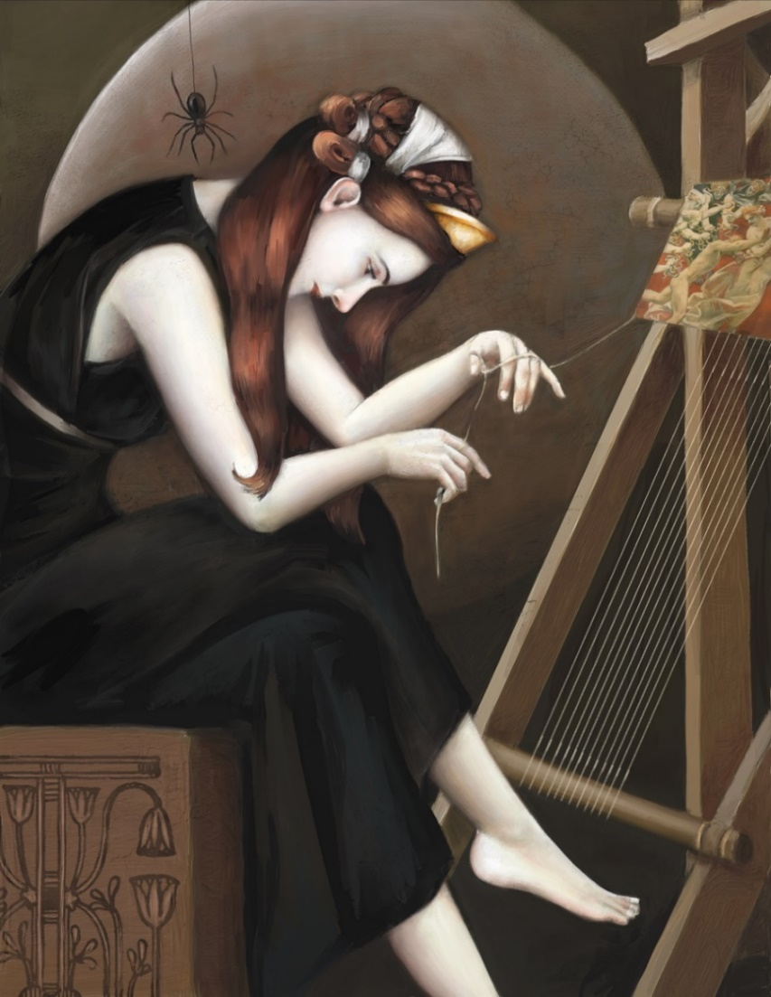
Arachne weaving her final tapestry, by Carlyn Beccia (www.carlynbeccia.com) Reproduced by kind permission of the artist.
Programme

10.00 – coffee/registration
10.25 – Welcome (Emma Bridges)
10.30-12.30 – Session 1 (Chair: Lorna Hardwick)
Atreus, Trujillo and the myth-making of Junot Díaz – Justine McConnell (Oxford)
Border territories: transgressing ancient mythic voices in contemporary poetry. A reading and conversation with Josephine Balmer, Fiona Cox and Elena Theodorakopoulos.
”There is another story”: writing after the Odyssey in Margaret Atwood’s Penelopiad – Emily Hauser (Yale)
Avid for Ovid: using music to enhance danced interpretations of Ovid's mythical world – Malcolm Atkins (Open University)
12.30-1.30 – lunch
1.30-3.30 – Session 2 (Chair: Jessica Hughes)
Twerking for Dionysus in Jan Fabre’s Mount Olympus – Emma Cole (Bristol)
A thoroughly modern maiden: Artemis myth and ritual in twenty-first century Kent – Frances Eley (Open University)
”Stranger still are waters charged”: metamorphosing Salmacis and Hermaphroditus (Ovid, Met. 4.285-388). Artist presentation by Anna Parker (Umeå Academy of Fine Arts)
Regendering Oedipus: from tragic drama to many-mouthed lyric. Poet Amy McCauley in conversation with Gareth Prior
3.30-4.00 – tea
4.00-5.30 – Session 3 (Chair: Henry Stead)
Where on earth did you get a story like that? Readings from a new play, Orpheus and Eurydice, presented by Sharon Jennings (playwright)
Subversive advents: exploring a Bacchic narrative in popular cinema – David Bullen (Royal Holloway)
Apotheon: redesigning myth for a video game – Maciej Paprocki (LMU Munich)
5.45-6.45 – Public event:
Giving life to the Amazons via the modern female gaze. Theatre-makers Laura Martin-Simpson and Rachel Bagshaw (Blazon Theatre) in conversation, with readings from ICONS: a new play by Paula B. Stanic
Abstracts

Malcolm Atkins (Open University)
Avid for Ovid: using music to enhance danced interpretations of Ovid's mythical world
I am engaged in practice-based research into the creation of music for the realisation of dance-based interpretations of Ovid's Metamorphoses, furthering work that I have undertaken with a group that I helped form - Avid for Ovid. We seek to explore how dance and music can be used to create narrative for our time using compositional and choreographic ideas of our time whilst learning from the debates and ideas of the ancient world. Details of our performances and teaching are available on the Avid for Ovid site (http://avidforovid.blogspot.co.uk/).

Josephine Balmer in conversation with Fiona Cox and Elena Theodorakopoulos
Border territories: transgressing ancient mythic voices in contemporary poetry
Poet and translator Josephine Balmer discusses her latest work with Fiona Cox and Elena Theodorakopoulos. In particular, the session will focus on Letting Go, a new sonnet sequence written after her mother’s sudden death, using classical myth and texts to articulate the process of grieving. Among other issues, it will examine the use of cross-gendered male voices as well as the ways in which poetry can employ classical texts in new and sometimes unexpected contexts.

David Bullen (Royal Holloway)
Subversive Advents: Exploring a Bacchic narrative in popular cinema
Euripides' The Bacchae adapted a popular myth on the ancient Athenian stage. Although Euripides' distinctive interpretation is our only extant dramatic version, the basic narrative seems to have been as follows: Dionysus, a subversive figure embodying fluidity between binary oppositions, arrives in a conservative community that resists such fluidity; the guardian of that community comes into conflict with Dionysus as they attempt to expel the god; ultimately, the god proves his divinity by overcoming the guardian, causing them to capitulate to the ideology they initially opposed. This paper begins to consider how and why that same narrative, popular in the war-weary Athens of the fifth century BCE, seems to have made a return in the popular cinema of the last forty years. Not only have comedic and romantic films such as Footloose (1984 & 2011), Chocolat (2000), and School of Rock (2003) adopted this basic narrative, but genre-films such as The Dark Knight (2008) and Skyfall (2012) have used it as well. While these films may not consciously be adapting the myth, the similarities of their plots across a range of decades, countries, and genres invites inquiry as to why this narrative has once more become a compelling means of storytelling. What does the proliferation of this narrative tell us about cultural anxieties and preoccupations, and how does it correlate with the stage history of The Bacchae, a more formal expression of the myth? This paper aims to offer an overview of the issues with a view to opening up discussion and further research.

Emma Cole (Bristol)
Twerking for Dionysus in Jan Fabre’s Mount Olympus
In Tragedy and Dramatic Theatre, Hans-Thies Lehmann posits that the postdramatic might provide a modern-day home for tragic experience. He cites a range of productions that prioritise image, sound, and affect, over character and narrative, including the original works of practitioners such as Sarah Kane. In the past few years, however, British and continental European theatres have demonstrated an increasing interest in staging our surviving tragedies, and in reinventing these plays in postdramatic forms. In this paper I propose that rather than look for tragedy within new dramaturgies, it is in postdramatic reinventions of ancient tragedy that we find the most profound investigations into what constitutes tragic experience.
Jan Fabre’s Mount Olympus is a clear example of a postdramatic performance. The production, which ran continuously for 24 hours, distilled a conglomeration of Greek tragedies down to abstract tableaux, choreographed tests of endurance, and monologues delivered in English, Dutch, German, Spanish, French, and sometimes simply in stutters and screams. In this paper I take the Oresteia sequence within Mount Olympus as a case study for my exploration of the relationship between postdramatic techniques and ancient tragedy. I argue that postdramatic reinventions offer particularly lucid demonstrations of the role of tragedy in modernity, and the pliability of myth on stage in the twenty-first century. Postdramatic reinventions might appear to test the limits of reception; however, my discussion reveals they contain a close interrogation into the idea of tragic experience, and perhaps constitute a new form of classical reception.

Frances Eley (Open University)
A thoroughly modern maiden: Artemis myth and ritual in 21st C Kent
This session will present how a group of women (and children) have acculturated ancient Greek myths and practices into a modern 'neo-pagan' context, synthesising elements with the Celtic Wheel of the Year to create a ritual calendar and practice that satisfies the spiritual needs of modern women. The session briefly explores the art of ritual creation (must it always be described as 'unthinking practice?') and the dynamic processes by which women have received and acculturated Artemisian myth. Three elements that will be presented are: the use of epithets of Artemis in oracling and kinetic meditation, the re-imagining of the Aktaeon myth in Sacred Drama and the placement (and characteristics) of ancient Artemisian festivals on the Celtic Wheel of the Year.

Emily Hauser (Yale)
“There is another story”: writing after the Odyssey in Margaret Atwood’s The Penelopiad
The plot of the Odyssey, as many scholars have noted, is predicated throughout upon its ending with the return of Odysseus (νόστοιο τέλος, Od. 22.323). But what happens when the plot of the Odyssey has ended – after Odysseus arrives home? In this paper I will explore how Margaret Atwood’s The Penelopiad (2005) provides a retrospective vision of an Odyssey that has already happened – and, by so doing, opens up an extended investigation of what it means to receive the texts and stories of the classical past. Atwood’s Penelope begins in the Underworld: “now that I’m dead I know everything,” she says (Atwood 2005: 1). By responding to and reformulating the tale of the Odyssey after the event, Penelope’s storytelling mirrors the process of reception (Zajko 2011: 195) – what James Porter has called a “retrospective” form of reception, where the classical is “identifiable only après coup” (Porter 2006: 53). But I also suggest that there is a second layer to Atwood’s allegorising of classical reception in The Penelopiad: one which, by consciously correcting and altering the narrative of the Odyssey via the subversive counter-story of the maids, showcases a vision of reception as one which also engages with the past and retells/complicates classical texts, by inserting a new (and often subversive) narrative. The Penelopiad thus becomes an exploration of what it means to interpret narratives within the classical tradition – suggesting that we are not only respondents to, but also, like the maids, direct participants in the classical past.
Works cited
Atwood, Margaret. 2005. The Penelopiad. Edinburgh and New York: Canongate Books.
Porter, James. 2006. Classical Pasts: The Classical Traditions of Greece and Rome. Princeton: Princeton University Press.
Zajko, Vanda. 2011. “ ‘What Difference Was Made?’: Feminist Models of Reception.” In A Companion to Classical Receptions, edited by Lorna Hardwick and Christopher Stray, 195–206. Oxford: John Wiley & Sons.

Sharon Jennings
Where on earth did you get a story like that? Readings from a new play, Orpheus and Eurydice
My Orpheus and Eurydice is a new play set in the ancient kingdom of Thrace in an unspecified Classical period. The plot follows the bare bones of the assorted accounts of Orpheus, while exploring various universal questions: the desire to believe in myths, the need to imagine that one can control life and death, the way in which art can give the illusion of being able to bring order to life; and so on. Current issues are also raised, including the plight of refugees (Eurydice is one), and the pitfalls of relativism.

Amy McCauley in conversation with Gareth Prior
Regendering Oedipus: from tragic drama to many-mouthed lyric
This session will focus Amy McCauley's Oedipa poems, examining some of the ways in which their remaking of the original source myths addresses many of the big challenges facing those looking to write fresh poetry today in the modernist tradition. Amy started the project in 2013 and has had individual poems from the series published in leading periodicals. The sequence reworks and re-genders the Oedipus myth in a contemporary context, also tackling significant elements of epistemology and textual transmission. The project has engaged with the academic reception of classical myths from the start, with input from academics in the Faculty of Classics in Oxford.

Justine McConnell (Oxford)
Atreus, Trujillo, and the Myth-making of Junot Díaz
When Junot Díaz opens his Pulitzer Prize-winning novel, The Brief Wondrous Life of Oscar Wao (2007), with the curse of the New World, he plunges us into a world of myth, storytelling, and terror. Brought from Africa to the Caribbean ‘carried in the screams of the enslaved’, the ‘fukú americanus’ is later described as ‘the local version of House Atreus’, signalling the syncretisation of stories from Greece, Africa, and the Antilles which underpins the narrative. This paper will consider Díaz’s myth-making, asking why the ancient Greek myths have a role in this twenty-first-century novel, what it means for the myth of Atreus to be aligned with the damage wrought by European imperialism, and how Díaz’s mythopoeic strategy battles the legacy of the military dictator Rafael Trujillo, who ruled the Dominican Republic from 1930-1961.
The traces of classical myth in Díaz’s work are often fragmentary and palimpsestic, testifying to the complexity of engaging with the Western canon from an anti-colonial standpoint. Yet their presence is persistent and their adaptation wholehearted, encouraging exploration of their role in this new Caribbean classic.

Maciej Paprocki (LMU Munich)
Apotheon: redesigning myth for a video game
Apotheon (http://www.apotheongame.com/) is a 2D platform action/role-playing game done in a black-figure vase art style, set on the rich stage of ancient Greek mythology. Apotheon's narrative combines and develops Hesiod's succession myth and the myth of the five ages of man. At the end of the Iron Age, Zeus decrees the final separation between deities and humanity so that the current generation may die out. The Olympian gods remove their divine faculties from the earth: the civilization collapses as forests and oceans become barren, springs and rivers run dry and crops fail under the sunless sky.
The game story follows Nikandreos, a young Greek warrior from Dion in Macedonia. In the midst of an attack on his hometown, Nikandreos is plucked from the fray by Hera and urged by her to topple Zeus, whose affairs have deeply wounded the Queen of the Gods. Hera directs Nikandreos to wrestle or win six iconic badges of office from Apollo, Artemis, Demeter, Ares, Poseidon, and Athena and thus absorb divine shares of power held within; furthermore, the player may decide to collect the items of four remaining Olympian gods (that is, Aphrodite’s girdle, Dionysus’ kantharos, Hermes’ sandals, and Hephaestus’ hammer). During his journeys, Nikandreos learns that the edict of Zeus has deeply divided the divine society, with many greater and lesser deities (including Helios, Thetis, Persephone, and Daphne) deciding to clandestinely oppose the divine establishment and assist Nikandreos in his quest. At the beginning of the third act, Hera immortalizes Nikandreos and imbues him with her own timē so that he may become powerful enough to challenge Zeus: what ensues is a heated thunderbolt battle, the outcome of which determines who truly deserves the position of the King of the Gods.

Anna Parker (Umeå Academy of Fine Arts)
‘Stranger still are waters charged’: Metamorphosing Salmacis and Hermaphroditus (Ov. Met. 4.285-388)
My multi-layered installation piece ‘Stranger still are waters charged’ transforms Ovid’s Salmacis and Hermaphroditus myth (Ov. Met. 4.285-388) for a contemporary, digital setting. Using multiple mediums (screen prints, fabric prints, neon lights, mirrors), I remake and re-layer Ovid’s evocative tableau, lingering on elements of erotic desire and obsession. In this artist talk, I explore the relevance of this myth to our contemporary milieu, redolent as it is with digital performances of desire and obsession. Artistically, I am interested in the way that multi-layered installations can enliven narratives and produce a dialogue between constituent elements. In this installation, a screen print of Salmacis observing Hermaphroditus through an iPhone engages with a fabric print of a Sleeping Hermaphroditus (after Bernini), which itself engages with a neon light with the words ‘this could be us’ and twin mirrors. The layering of and dialogue between constituent elements force the audience to act as voyeurs witnessing a voyeuristic relationship, implicating them in Salmacis’ desire and obsession for Hermaphroditus. Ultimately, I argue that my metamorphosis of Ovid’s myth mirrors and reflects aspects of contemporary digital culture, namely forces of desire and obsession that ripple through digital platforms.

