DataPlus 2.0 Functional Document
Draft: 1.0
Date: 21/07/11
Index
02 1.0 Introduction
2.0 Data Structure
3.0 Field Types
03 4.0 Creating a DataPlus Database
04 5.0 Managing a DataPlus Database
06 6.0 Templates
08 7.0 Adding a Record
09 8.0 View Records
10 9.0 Viewing a Single Record
10.0 Editing a Record
11.0 Deleting a Record
11 12.0 Commenting
12 13.0 Search
14.0 Export
13 15.0 Import
16.0 Module Settings

1.0 Introduction
DataPlus is a Moodle module allowing course creators to define a simple database into which students and teachers can, as the course creator requires, view, search, add, edit and delete data.
Every instance of DataPlus is highly customisable for course creators through the flexible use of templates and module settings. It creates discreet SQLite3 databases, entirely independent of the core Moodle database, which can be exported and used in a range of situations.
This document describes the full range of DataPlus functionality, however it is worth noting that, as a user, some of the functionality may not be available in a particular DataPlus instance. Course creators have the flexibility to enable and disable features to meet their needs.
This document supersedes all documentation for DataPlus 1.0.

2.0 Data Structure
A DataPlus database contains one table with any number of fields defined by a course creator.

3.0 Field Types
Course creators can select from ten different field types –
- Text (one line) – for storage of short amounts of textual data
- Text (multiple lines) – for storage of large amounts of textual data
- Date – for storing a date
- Date / time – for storing a date and time
- Number – for storing a number
- Image – for storing an image, for display on the view, and supporting alt text
- File – for storing a file for users to download (can be an image)
- URL – a website address with a descriptor
- True/false – a boolean
- Menu
  - (only one selection allowed) – stores the selection from a dropdown
  - Menu (multiple selections allowed) – stores multiple selections from a list menu

4.0 Creating a DataPlus Database
Only Moodle users who can add a module to a course can create or manage a database unless a permissions change has been made.
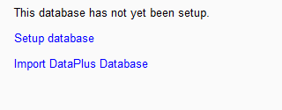
After adding an instance of DataPlus to a course, you have a choice of setting up a database from scratch or importing a DataPlus database created in another instance. The later of these is covered under Import.
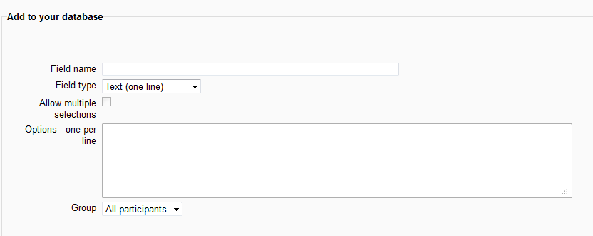
After selecting ‘setup database’, you see a screen that allows you to specify up to four fields for you database of any type. At least one field must be added to get started. If more than four are required, these can be added later, see Manage.
When creating a field you will need to provide a unique name. DataPlus automatically adds a primary key field.

5.0 Managing a DataPlus Database
This section describes functionality that can be accessed under the Manage tab.
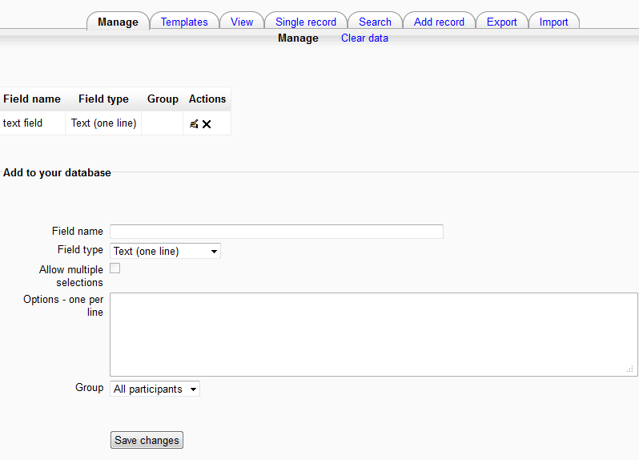
Adding an Extra Field
To add an extra field, complete the ‘add to your database’ form and select save changes. Multiple selections and options are only available for fields of type menu. Fields can be restricted to particular groups if groups are enabled.
Editing a Field
To edit a field, select from the actions column. The editing form contains the same options as the adding form. Once the options are changed, select ‘save changes’.
Deleting a Field
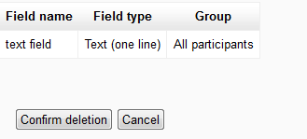
To delete a field, select the icon from the actions column. On the next screen, select ‘confirm deletion’. All data, images and files associated with the field will be deleted.
Clear Data
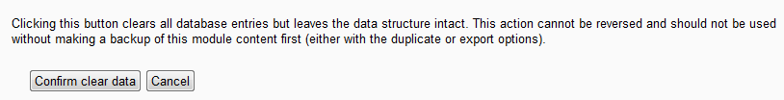
Clear data deletes all of the records in the DataPlus database without deleting the fields created by the course creator. The main purpose of this feature is to overcome an issue with the backup and restore process.
When a Moodle backup of a DataPlus instance is created, it can be set to either include user data (i.e. include the DataPlus SQLite3 database) or exclude it (not include the database). This does not allow the possibility of including the field definitions but not the user generated records when performing a restore. Clear data allows an instance of DataPlus to be restored with all user data, and then for all the user generated records to be deleted.
To use this function, select ‘clear data’ and then ‘confirm clear data’. This action cannot be reversed.

6.0Templates
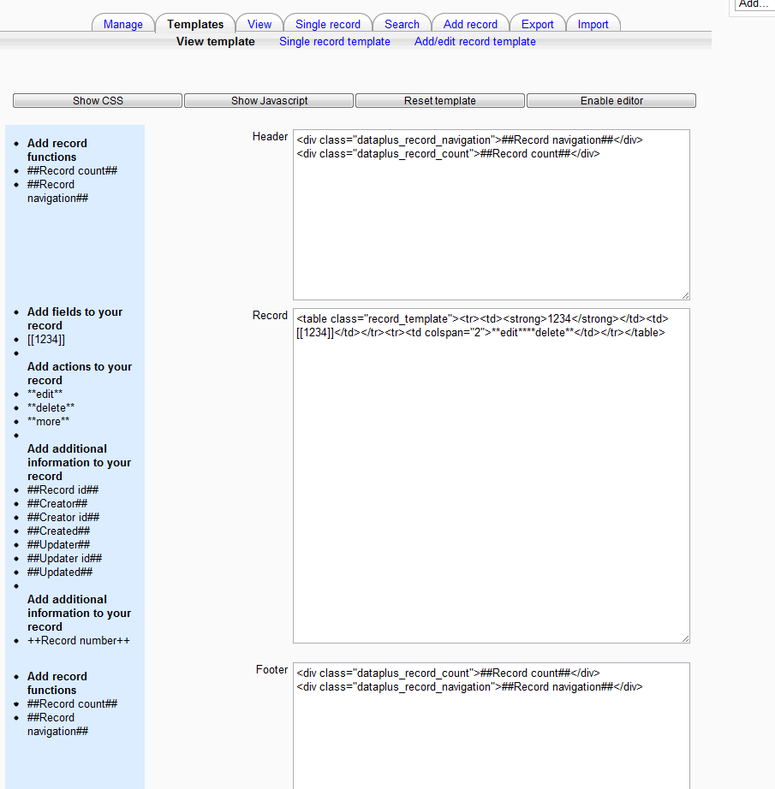
Templates allows course creators to control the appearance of view, single record and add/edit record screens. Course creators are not required to do this, they can opt to use the default templates.
Templates are a mixture of HTML and bespoke identifiers that can be used to add the contents of fields or supporting functions to a template. These identifiers can be added by clicking on the left menu. Templates are edited in plain text, by default, or HTML by selecting the ‘enable editor button’. Templates can be reset to default by selecting ‘reset template’.
View templates are divided into the following sections –
- CSS – allows CSS to be defined to support the template. Output from fields and functions cannot be included.
- JavaScript – allows JavaScript to be defined to support the functions. Function calls can be placed into other sections bar CSS. Output from fields and functions cannot be included.
- Header – top section of the template that is displayed once on the screen. Can include a record count or record navigation to move between screens
- Record – included one or more times according to the number of records being displayed (the number of records displayed on a view screen can be controlled from the module settings). Fields from the database, a unique id for the record and information on the creation and update of the record can be added to the record. Edit and delete record icons can also be added.
- Footer – bottom section of the template that is displayed once on the screen. Can include a record count or record navigation to move between screens
- Sort order – Five levels of sort allowing the order in which records are displayed to be controlled.
Single record templates have the same section as view templates, plus
- Comments – enables the appearance of comments on the single record screen to be controlled. Add and edit icons can also be included.
Add/edit record templates have the following sections –
- CSS – allows CSS to be defined to support the template
- JavaScript – allows JavaScript to be defined to support the functions. Function calls can be placed into other sections bar CSS
- Record – allows form fields to collect user data to be included as well as add and cancel buttons.
7.0 Adding a Record
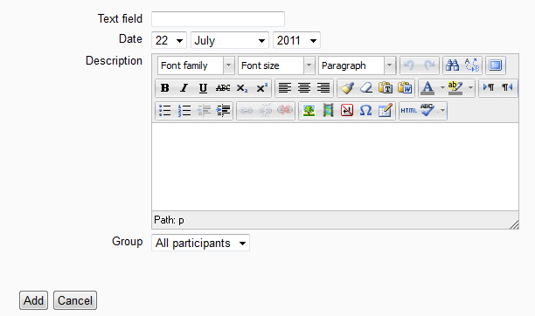
The ‘add record’ tab allows the user to insert data into the DataPlus database. Above is an example of a simple ‘add record’ form. The form will vary according to the fields the course creator has added to the database and any alterations made to the ‘add record’ template.
Course creators can use the group dropdown to control access to records they create if groups are enabled on the DataPlus instance.

8.0 Viewing Records
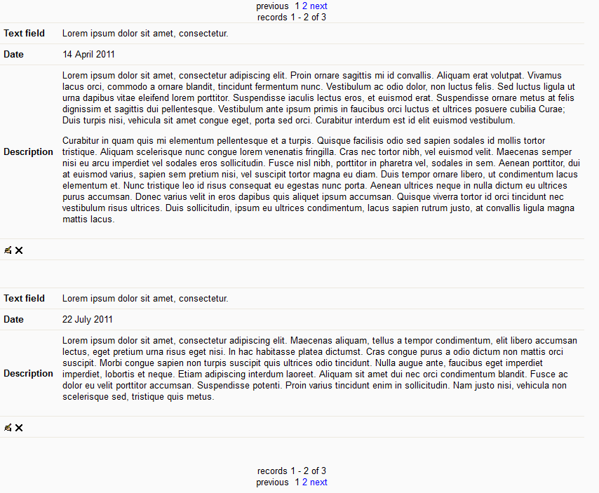User can see lists of records by selecting ‘View’. A simple example is shown above, but this will vary according to the fields added to the database, the ‘view template’. The number of records displayed on the screen is controlled by a module setting.
Users can move from screen to screen using page numbers and next and previous buttons (assuming that there are more records than can be displayed on one screen). The header and footer also contain a count of the total number of records and the range of records being displayed. Record navigation and count can be removed by using the ‘view template’. The ‘view’ tab can be removed or renamed using a module setting.

9.0 Viewing a Single Record
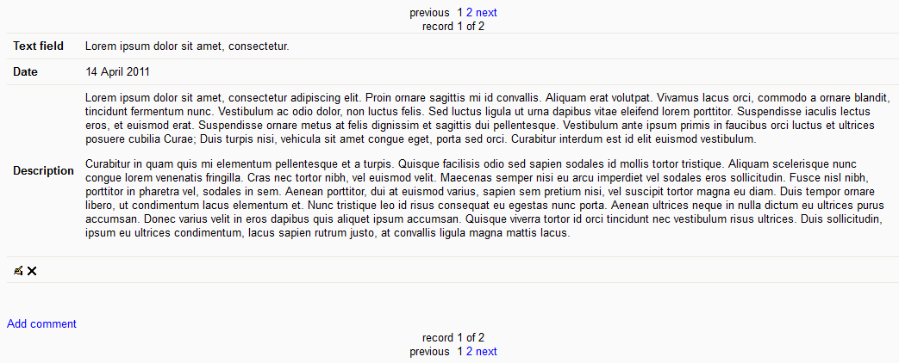
Users can view individual records by selecting ‘single record’ (a simple example is shown above). Record counting and navigation work as per the ‘view’ screen. The ‘single record’ tab can be removed using a module setting.

10.0 Editing a Record
Users can edit a record by clicking on the icon next to the record on the ‘view’ or ‘single record’ screens. The edit record form is the same as the ‘add record’ form. Course creators can use templates or module settings to remove the editing option.

11.0 Deleting a Record
Users can delete a record by clicking on the icon next to a record and clicking on ‘confirm deletion’. Course creators can use templates or module settings to remove the delete option.

12.0 Commenting
Users can add comments to a record via the ‘single record’ tab.
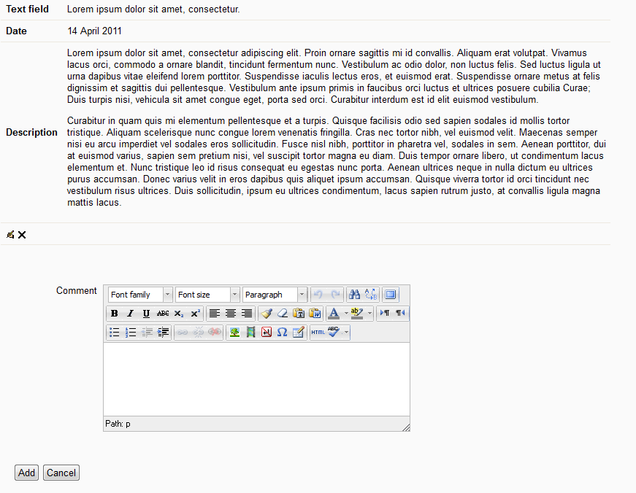
12.1 Add a Comment
Selecting ‘add a comment’ shows the user a text box to provide a comment.
12.2 Editing a Comment
Clicking on enables a user to edit their comment. Only course creators can edit other users comments.
12.3 Delete a Comment
Clicking on enables a user to delete their comment. Only course creators can delete other users comments.

13.0 Search
Users can perform a simple or advanced search from the ‘search’ tab. Course creators can use a module setting to remove or rename the ‘search’ tab.
13.1 Simple Search
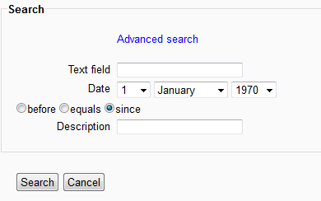
The simple search form allows searches to be performed on any combination of the fields the course creator has defined in the DataPlus database. Text fields are searched on the basis of the field including the string entered, not an exact match. Empty fields are ignored.
13.2 Advanced Search
Advanced search can be accessed by selecting ‘advanced search’ on the ‘simple search’ screen. An advanced search allows the user to specify whether a text field is equal to or contains the string specified and a sort up to three levels.

14.0 Export
DataPlus export options are available under the ‘Export’ tab. A course creator can be used to remove or rename the ‘Export’ tab. When an export is performed by a student or non-editing teacher, group settings are respected and templates, column definitions, comments, supporting information and user information are removed.
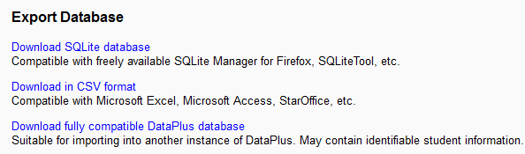
Three export options are available –
- Download SQLite database – allows the download of a zip archive containing an SQLite3 database and any files or images.
- Download in CSV format – allows the download a zip archive containing a CSV conversion of the DataPlus database for use in Excel, Star Office, etc. The archive also includes any images and files.
- Download fully compatible DataPlus Database – a full copy of the DataPlus database and all supporting data. This can be imported back into a DataPlus instance. It can be used for backups or transferring a database from one Moodle installation to another. This option is only available to course creators.
15.0 Import
Course creators can import fully compatible DataPlus databases (see Export on the creation of these). Group and user information may not be respected if they are not available to the instance of DataPlus being used.

16.0 Module Settings
An number of DataPlus specific module settings are available to enable –
- Required entries – enables a DataPlus to be set as complete is a user has added a defined number of entries (does not apply to course creators).
- Entries required before viewing – restricts a user from viewing records until they have entered a defined number of records (does not apply to course creators).
- Maximum entries – the maximum number of entries a database can contain.
- Maximum entries per user – the maximum number of entries a user add to a database.
- Allow student to edit own records – restricts a student from editing a record they’ve created
- Allow students to edit others records – restricts a student from editing other users records.
- Allow teacher to edit own records – restricts a teacher from editing a record they’ve created
- Allow teachers to edit others records – restricts a teachers from editing other users records.
- Allow comments – switches commenting on and off.
- View tab label – changes the text of the ‘view’ tab.
- View tab visible – shows or hides the ‘view’ tab.
- Single record tab label – changes the text of the ‘single record’ tab.
- Single record tab visible – shows or hides the ‘single record’ tab.
- Search tab label – changes the text of the ‘search’ tab.
- Search tab visible – shows or hides the ‘search’ tab.
- Add record tab label – changes the text of the ‘add record’ tab.
- Add record tab visible – shows or hides the ‘add record’ tab.
- Export tab label – changes the text of the ‘export’ tab.
- Export tab visible – shows or hides the ‘export’ tab.
- Save button label – changes the text of the save button on record forms.
- Navigation limit – the maximum number of navigation page links that can appear on a view screen
- Number of entries per page – the maximum number of records that can appear on a view screen.

