DRAFT - Systemic Inquiry Report

‘Governing the Anthropocene. Cybersystemic Possibilities?’
  - Herrenhausen Palace, Hanover 30-31st July 2015.

Ray Ison & Kevin Collins
ASTiP (Applied Systems Thinking in Practice) Group, The Open University, UK
with support from
Konrad Hagedorn¹, Renate Judis¹, Wiebke Hampel¹ & Thomas Aenis²
^{1.} WINS (Berlin Workshop in Institutional Analysis of Social-Ecological Systems) Humboldt University of Berlin
^{2.} Lebenswissenschaftliche Fakultät, Albrecht Daniel Thaer-Institut für Agrar- und Gartenbauwiss, Humboldt University of Berlin
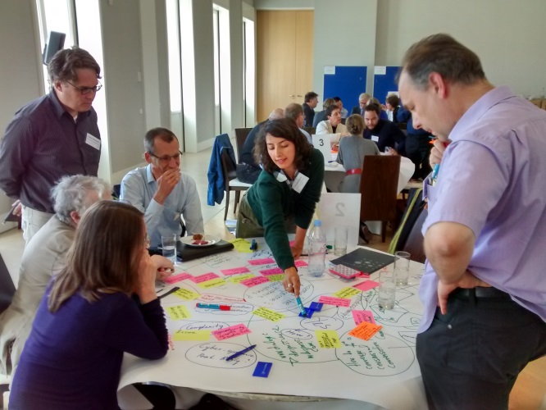 | 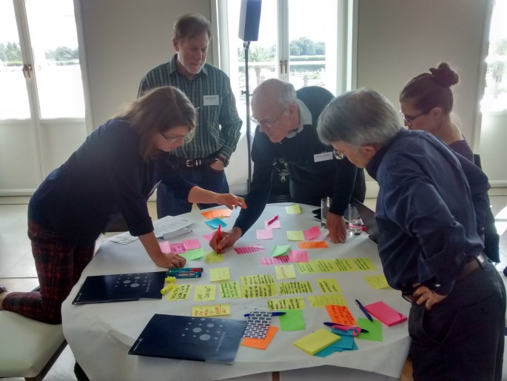
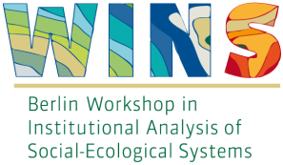

Table of Contents
‘Governing the Anthropocene. Cybersystemic Possibilities?’ 1
ACKNOWLEDGEMENTS 4
SYNOPSIS/EXECUTIVE SUMMARY 5
1 Summary in German 5
2 Summary in English 5
1. INTRODUCTION 7
1.1 Background 7
1.2 Framing the Inquiry 8
1.3 The ‘problematique” for the inquiry 10
1.4 Systemic co-inquiry design 12
1.5 Realising the design intentions 13
2. KEY ISSUES RAISED BY SPEAKERS – AN OVERVIEW 19
2.1 Framing issues – constraints and opportunities 19
2.2. Cybersystemic theory and practice 26
2.3. Institutional constraints and opportunities to realising cybersystemic possibilities 31
2.4 Governance (or governing) innovation 35
2.5 Praxis and policy innovation 37
2.6 Avenues for on-going inquiry 38
2.7 Proposals for transformation through research 39
3. KEY ISSUES EMERGING FROM 16 INQUIRY GROUPS3.1 40
3.1 Introduction 40
3.2 Can cybersystemic lineages and communities generate fresh insights into the problematique? 41
3.3 What can cybersystemics scholarship contribute to governing the Anthropocene? 42
3.4 Can relationships between German scholars and the Anglo-Saxon traditions be strengthened? 44
3.5 A research agenda for innovation in theoretical methodological, institutional and praxis 44
4. INVESTING IN OUR FUTURE 45
5. REFERENCES 47
Appendix 1: PhD Programme Details 50
(i.i) Process Design 50
(i.ii) Final Programme 52
Appendix 2: Letters, templates and database designed for the Inquiry 55
(ii.i) Invitation to nominate participants - example 55
(ii.ii) Invitation to Participants 56
(ii.iii) Invitation to speakers 57
Appendix 3: Feedback from participants and follow-ups 59

ACKNOWLEDGEMENTS

We are very grateful to the Volkswagen Foundation for financial support and for the effective hosting and enabling of the event at Schloss Herrenhausen. We extend particular thanks to Anorthe Kremers, Vera Szöllösi-Brenig, Matthias Nöllenburg and Wilhelm Krull from the VWStiftung.
As Dr Vera Szöllösi-Brenig said in her welcome address:
“The Foundation is not directly affiliated with the car company VW. It owes its existence as well as its name to a contractual agreement between the Federal Government and the State of Lower Saxony which put an end to the controversy concerning the ownership of the Volkswagen Company after the Second World War. Following lengthy discussions, in 1961 it was decided to convert the car company into private ownership by issuing so called “Peoples shares”. And the proceeds resulting from the sales of these shares have been the basis of the capital of the Foundation. Our purpose – as stipulated in our statutes is to support the humanities and social sciences as well as science and technology in higher education and research.”
We find it inspiring that Foundations such as the VWStiftung are prepared to embrace some of society’s most pressing needs by bringing together novel combination of scholars around non-traditional framings. As Dr Szöllösi-Brenig went on to say in her welcome:
“If the Holocene has actually come to an end and if yes, when the Anthropocene started, is being determined by an international working group. The objective of this conference is to identify if there are any possibilities to govern this new era, an era, characterized by the negative and disastrous consequences of men’s impact on planet Earth. More specifically: What contributions would a more coherent field of cybernetics and systems scholarship make to governing the Anthropocene having in mind that the Anthropocene is “die beste aller möglichen Welten”?”
We thank the organising team from WINs, particularly Renate Judis and Wiebke Hampel and also Thomas Aenis from Humboldt University for making the embedded PhD program so effective.
This event was made possible, and the success that it was, through the attentions and activities of those who participated and, for many the organisations that proposed their attendance and, in some case helped financially – we thank all.

SYNOPSIS/EXECUTIVE SUMMARY

1 Summary in German

Vom 30. – 31. Juli 2015 fand in Hannover zum ersten Mal ein Workshop ‘systemic inquiry’ statt, die erste speziell konzipierte Veranstaltung zu 'cybersystemics possibilites for governing the anthropocene' mit einer interdisziplinären Gruppe von Wissenschaftlern, die sich alle mit der Thematik auseinandersetzen. Die 135 Teilnehmer kamen aus 32 Ländern, 27 der Teilnehmer waren Promovierende aus neun verschiedenen Ländern. Die Teilnehmer vertraten außerdem 35 wissenschaftliche und nicht-wissenschaftliche aus dem Bereich systems and cybernetics science. Unserem Wissen nach war dies das erste gemeinsame Treffen von Wissenschaftlern mit cybersystemischen und institutionenökonomischen Hintergründen. Mindestens 26 der letztgenannten Teilnehmer kamen aus Deutschland oder mit deutschem akademischem Hintergrund.
Das spezielle Format des Workshops erlaubte allen Teilnehmer sich kritisch mit ‚cybersystemic‘ auseinanderzusetzen und sich Gedanken über mögliche zukünftige Zusammenarbeiten zu machen. Es gab eine kritische Auseinandersetzung mit dem Begriff Anthropozän und Fragen über die Nützlichkeit dieses Begriffes als Organisations-Metapher. Die Rolle von Institutionen, Wissenschaft und Grenzen der aktuellen linearen Ansätze und Modellierungen in Führungs- und Entscheidungsprozessen stellten außerdem zentrale Anliegen dar. Die Untersuchung ergab auch, dass es keine akademische Disziplin gibt, deren Forschung sich auf Systeme konzentriert. Dies ist die entscheidende Lücke, wenn es darum geht politischen Entscheidungsträgern, Wissenschaftlern und Gemeinden die Komplexität des Anthropozäns zu verdeutlichen. Daher sind Investitionen in institutionelle Abkommen dringend erforderlich, um das Verständnis zu verbessern.
Dennoch waren die Teilnehmer überzeugt von dem potenziellen Beitrag des cybersystemischen Ansatz, insbesondere mögliche Beiträge zur Erforschung von Holismus, Integration, Abhängigkeit und Systeme.
Weitere Ergebnisse waren: (i) Eine ‚systemic inquiry‘-Blog – unterstützt neue und laufende Untersuchungen und dient als Sammlung für Materialien und sonstigen Ressourcen, wie beispielsweise Fotos, Kopien von Präsentationen und Audios aller Gespräche aus dem Workshop - siehe http: // www.open.ac.uk/blogs/govan/; (ii) Ein systemischer Untersuchungsbericht zum Einstellen einer Forschungsagenda und Bereitstellung von Empfehlungen für Folgeaktionen; (iii) Der zusammenfassende Bericht der VolkswagenStiftung, und (iv) Eine Reihe von vorgeschlagenen Folgemaßnahmen (z.B. Strategiepapiere, ein Journal-Sonderausgabe; Follow-up Sitzungen).

2 Summary in English

An innovative approach to collaborative inquiry called ‘systemic inquiry’ was pioneered in Germany at Schloss Herrenhausen, Hannover on July 30-31, 2015. The 135 inquiry participants came from 32 countries d), and 27 of the participants were PhD students studying in nine different countries. Participants represented 35 professional and academic organisations concerned with Systems and Cybernetics scholarship.
To our knowledge this was the first ever joint meeting of scholars from cybersystemic and institutional economics backgrounds. At least 26 of the latter participants came from Germany or from academic backgrounds in Germany. It was also the first purpose-designed event to bring together scholars from such a wide range of organisations concerned with ‘cybersystemics’.
The systemic inquiry design allowed all participants to build ‘evidence’ for investment in, and institutional innovation for, cybersystemic capability building and future scholarship. There was critical engagement with the notion of the Anthropocene, and questions raised about its usefulness as an organizing metaphor. The role of institutions, science and limitations of current linear approaches and modelling in governance and decision-making processes were key concerns. The Inquiry also revealed there is no integrated academic discipline centred on systems. This is a key gap in making sense of anthropogenic complexity for policy-makers, researchers and communities. Investment in institutional arrangements that support capability building to enhance cybersystemic governing praxis in an emerging Anthropocene is urgently needed. Even so, participants were positive about the potential contribution of cybersystemic scholarship to understanding the Anthropocene, in particular the possible contributions to be made exploring notions of holism, integration, interdependence and systems. Running through many opportunities suggested by the participants was a commitment to, and passion for, trust, collaboration and learning as the hallmarks of systemic governance (in) the Anthropocene.
Additional outcomes were: (i) A systemic inquiry Blog – for facilitated, emergent, ongoing inquiries as well as a repository for table-generated materials and other resources such as photos, copies of presentations and audios of all talks – see http://www.open.ac.uk/blogs/govan/; (ii) A systemic inquiry report for setting a research agenda and providing recommendations for follow-up actions; (iii) This summary report to the VolkswagenStiftung, and (iv) A suite of proposed follow-up actions (e.g. policy briefings; a journal special issue; follow-up focused meetings).

1. INTRODUCTION

1.1 Background
A two day systemic inquiry was held at Schloss Herrenhausen, Hannover on July 30-31, 2015. The 135 inquiry participants came from 32 countries (Brasil, Colombia, Germany, Australia, Austria, New Zealand, Mexico, USA, Canada, Sweden, UK, Ireland, Italy, France, Japan, Chile, Ecuador, Switzerland, Spain, Norway, South Africa, Ghana, Belgium, Slovenia, Hungary, Greece, Cyprus, India, China, the Netherlands, Vietnam, Thailand), 27 of the participants were PhD students studying in nine different countries (Germany, Australia, Austria, South Africa, Sweden, Norway, Colombia, USA). Participants represented 35 professional and academic organisations concerned with Systems and Cybernetics scholarship.
To our knowledge this was the first ever joint meeting of scholars from cybersystemic and institutional economics backgrounds. At least 26 of the latter participants came from Germany or from academic backgrounds in Germany. It was also the first purpose-designed event to bring together scholars from such a wide range of organisations concerned with ‘cybersystemics’ (cybernetics + systems sciences).
Contributors built ‘evidence’ for investment in, and institutional innovation for, cybersystemic capability building and future scholarship in table-based group inquiries that also included young PhD researchers, some policy makers as well as individuals from research funding organisations. Other evidence was contributed to the Inquiry by 19 invited speakers (22 presenters in total). Other outcomes were:
- A Systemic Inquiry Blog – for facilitated, emergent, ongoing inquiries as well as a repository for table-generated materials and other resources such as photos, copies of presentations and audios of all talks – see http://www.open.ac.uk/blogs/govan/;
- A Systemic Inquiry report for setting a research agenda and providing recommendations for follow-up actions (e.g. policy briefings; a journal special issue; follow-up focused meetings)
- A shorter report to the VolkswagenStiftung – see http://www.open.ac.uk/blogs/govan/wp-content/uploads/2015/08/Final-report-wokshop-cybersystemic-possibilities.pdf
- A special issue of the journal Systems Research & Behavioral Science (see editorial by Ison and Shelley, 2016) which draws on contributions to the Herrenhausen event as well as ISSS2015;
- A suite of proposed follow-up actions, such as the desire to create a working group on institutional reform within the international cybersystemic community
The Inquiry was a collaborative activity between WINS (Berlin Workshop in Institutional Analysis of Social-Ecological Systems) Humboldt University of Berlin and Prof. Ray Ison (ISSS/Open University & Monash University) largely funded by the Volkswagen Foundation.
The collaboration with WINs developed during Prof. Ison’s sabbatical leave (April-May 2014) at Humboldt University (Program Umwelt Governance led by Prof. Dr. Andreas Thiel). It built on earlier collaboration that has led to a recent Special Issue of Environmental Science & Policy devoted to “Crafting or designing? Science and politics for purposeful institutional change in Social-Ecological Systems.”
The ‘systemic inquiry’ event was co-designed by Ray Ison and Kevin Collins, facilitated by Kevin Collins and built on research/design carried out in Australia as part of the ‘transitioning to water sensitive cities’ events held around Australia in 2009 (research which continues under the aegis of Water for Liveability).
You are invited to read this report in conjunction with the inquiry Blog site where transcripts of talks and copies of almost all presentations can be found. Links to pages with the audio and slide presentations of each speaker are given below in Section 2.

1.2 Framing the Inquiry
The Anthropocene is a term formulated by some earth scientists (Crutzen & Stoemer, 2000) to claim that we have entered a new geological era in which human influences are so great that they are affecting ‘whole Earth dynamics’ through a range of biophysical and social processes. As noted by the Working Group on the 'Anthropocene' these include changes in: “erosion and sediment transport associated with a variety of anthropogenic processes, including colonisation, agriculture, urbanisation and global warming. the chemical composition of the atmosphere, oceans and soils, with significant anthropogenic perturbations of the cycles of elements such as carbon, nitrogen, phosphorus and various metals; environmental conditions generated by these perturbations; these include global warming, ocean acidification and spreading oceanic 'dead zones'; the biosphere both on land and in the sea, as a result of habitat loss, predation, species invasions and the physical and chemical changes noted above” (see http://quaternary.stratigraphy.org/workinggroups/anthropocene/ Accessed 6th June, 2016).
The Working Group further note that “'Anthropocene' is currently being considered by the Working Group as a potential geological epoch, i.e. at the same hierarchical level as the Pleistocene and Holocene epochs, with the implication that it is within the Quaternary Period, but that the Holocene has terminated” and that the “'Anthropocene' is being developed by the 'Anthropocene' Working Group for consideration by the International Commission on Stratigraphy, with a current target date of 2016.”
Acceptance of the entailments of a choice to frame our circumstances as ‘the Anthropocene’, including as it does human-induced climate change also means accepting that we are in a period new in human history. This is the issue of our times, perhaps of all times, and thus the greatest challenge for systems thinking in practice – or all human endeavour for that matter.
In establishing this Inquiry we asked that participants not to accept our ‘framing’ uncritically. Participants were sent articles (see below) and invited to do some background reading before arrival in Hannover and for those who went on to the ISSS [International Society for the Systems Sciences] conference in Berlin during the first week of August.
There is now much written about the Anthropocene – even a new journal, The Anthropocene Review. We suggested to participants that these two papers were worth reading for contrasting perspectives:
- Frank Biermann The Anthropocene: A governance perspective The Anthropocene Review April 2014 1: 57-6.
- Andreas Malm and Alf Hornborg The geology of mankind? A critique of the Anthropocene narrative, The Anthropocene Review April 2014 1: 62-69.
It is not surprising to those who are UK or Australian-based that the discourse about the Anthropocene is more developed in a critically informed way in Germany. There has been a recent exhibition at the Deutsches Museum in Munich – Welcome to the Anthropocene: The Earth in Our Hands (2014/2015) and also a major set of activities at the Haus der Kulturen der Welt in Berlin in 2013 and 2014.
In the latter the claim is that:
“Our notion of nature is now out of date. Humanity forms nature. This is the core premise of the Anthropocene thesis, announcing a paradigm shift in the natural sciences as well as providing new models for culture, politics, and everyday life. In a two-year project, HKW explores the hypothesis’ manifold implications for the sciences and arts.”
Recent German perspectives also include:
- Jürgen Manemann, in Kritik des Anthropozäns. Plädoyer für eine neue Humanökologie
The English description of this work says:
“Welcome to the Anthropocene« – a 2011 title of »The Economist« initiating a new climate policy debate about mankind and the new »Age of Humans«.
“Today, the term is not only found in the gazettes, but also in science, politics, and culture. But what lies behind the term and where does it come from? Jürgen Manemann introduces the debate, points out the dangers of the theory of the Anthropocene, and calls for a human ecology that aims at a transformation of civil society towards a »cultural society« (Adrienne Goehler). It is not time for a new humanization of the world, but a deeper humanization of mankind.”
An English review of this work by Manemann was commissioned after the conclusion of our two day event; the review was kindly written by an inquiry participant, Prof. Sandro Luis Schlindwein, from the Federal University of Santa Caterina, Brazil.
- an engaging Blog by Christian Schwaegerl which features in an article in The New York Times: Varied Views (Dark, Light, in Between) of Earth’s Anthropocene Age, as does material from the Australian ethicist, Clive Hamilton.
There is growing awareness of the term (metaphor) ‘the Anthropocene’. This awareness creates with it the possibility of building new framings for how we think and act or of reenergising older framings that have remained sublimated – such as the field of cybersystemics.
Whether we accept or reject the notion, engaging with the concept and possible consequences of the Anthropocene brings to the forefront the challenge of how we humans govern ourselves i.e., how we respond to, and act in relation to, the biophysical world, other species and amongst ourselves.
Discourses, practices and institutional innovations associated with cybernetic and systems thinking and practice remain sublimated in our governance arrangements (as the Limits to Growth experience testifies), but an historical moment may be upon us to explore and, where relevant, strengthen the ways of thinking, acting and governing that cybersystemics offers? There is significant institutional fragmentation within the cybersystemics field and since the very important Macy Conferences 1941-60 (also partially organised around cybersystemics) there have been few attempts to create new opportunities to revitalise the field. WINS involvement provided an important opportunity to bring into the conversation that branch of economics devoted to institutional analysis and innovation in relation to governing social-ecological systems. This field will be very important if understandings from Limits, the Circular Economy, polycentric governance and other systemic innovations are to contribute to governance reform.
Concurrently with an Anthropocene-framing of our circumstances, global conversations conducive to systemic change are emerging on (i) Sustainable Development Goals – to replace the Millennium Development Goals; (ii) Resilience ; (iii) Planetary Boundaries and (iv) Future Earth. Importantly these discourses are refuting the classic model of sustainable development, of three integrated pillars — economic, social and environmental — that has served nations and the UN for over a decade. Distressingly, understandings of cybersystemics within these initiatives, where they exist, seem weak or inadequate.
Regardless of whether one accepts or likes the framing offered by the neologism ‘Anthropocene’ it is clear that the phenomena to which it refers are ‘real’ to the extent that transformations in our individual and collective understandings and practices are warranted. The extent to which this will include systems and cybernetics (cybersystemic) understandings and practices was the focus of the Inquiry begun at Herrenhausen; it was also a topic of inquiry at ISSS2015 in Berlin.
While being open to critical perspectives, this systemic inquiry was formulated in the desire to start out in an emotion of hope and with some optimism. We sought to go beyond a reiteration of problems to venture a next step: to display the possibilities that cybersystemic theories and practices provide to meet the challenges of the Anthropocene – of contributing to shaping, steering, or governing, viable trajectories of living in the Anthropocene.

1.3 The ‘problematique” for the inquiry
The prevailing paradigm in the governance of the relationship between humans and the biophysical world is characterised by commitments to scientism and linear, causal and dualistic thinking. Currently governance, if understood as enacting cyber-systemic processes that maintain the quality of relationships between humans and the biosphere, can be seen to be failing on many fronts.
The Anthropocene has emerged as a conceptual framing for the breakdown in relationship between humans and the biophysical world (and not merely a naming for a geological epoch), but to date little cyber-systemic understanding and praxis (theory informed practical action) has meaningfully informed the unfolding discourse. There is also contestation over the adequacy, or not, of the Anthropocene framing (e.g. see Latour 2013 - http://www.bruno-latour.fr/node/487, also http://fore.yale.edu/news/item/bruno-latour-thinks-about-the-anthropocene/ ).
For example, over the last 50 years in many countries, the governance of water catchments, or basins, has been guided by commitments to “stationarity” encompassing commitments to linear causality, prediction and extrapolation especially within disciplines such as hydrology and water engineering. Momentum is now growing to address the limitations of this paradigm in the face of a worsening global water crisis that threatens security of supply and food production as well as loss of many vital ecosystems services. Recognition of the significance of this issue is manifest in the funding of the CADWAGO project under the Europe and Global Challenges Program, partly funded by the VolkswagenStiftung. But the issues at the heart of the question: How shall we engage in governing the Anthropocene? are larger than the water domain. Importantly, as we are in a period new in human history, there is a need to critically reappraise our ways of thinking, practicing, institutionalising, investing and governing.
This ‘problematique’ raises two significant inquiry themes for future research and institutional innovation:
- what contributions might a more institutionally coherent field of cybernetics and systems (hereafter cybersystemics) scholarship contribute to governing the Anthropocene? A subsidiary question is: can relationships in this field be strengthened between German scholars and the Anglo-Saxon traditions and made relevant to the issue?
- can ‘representatives from the differing cybersystemic lineages and communities in conversation with each other generate fresh insights into the problematique by identifying a research agenda with potential to realise new theoretical methodological, institutional and praxis innovations able to break with dualistic and linear, causal thinking and acting?
These questions frame the proposal for initiating the systemic inquiry into cybersystemically-informed modes of governing more suited to the contemporary circumstances of humans. The inquiry focus was on the relational dynamics between social and bio-physical systems such that new ways of acting in theory-informed ways (i.e., praxis) can be generated that give rise to systemic and adaptive governance at levels ranging from the international to the program or project. Theoretically this inquiry sought to further develop and build upon some of the revealing and concealing features of Maturana’s account of structural coupling (see Maturana and Verden-Zoller 2008) and the key idea that an evolutionary trajectory is in essence a co-evolutionary dynamic (in this case between humans and the biosphere, including other species).
The inquiry was a first attempt to bridge understandings across several domains of scholarship, the principal domains being systems and cybernetics theory and practice (cybersystemics) and institutional economics. Haggedorn (2015) made the point that “analytical frameworks are a starting idea –real bridging will occur in joint practice of research, teaching and communication”. The two day inquiry was a starting point in terms of engagement in joint practice through the designed inquiry process. Haggedorn (ibid) further notes that “Scholars’ collective action needs to be organized”. From his own traditions of understanding he posed three questions for the Inquiry:
- Systems approach to institutions and governance structures – where are the micro -foundations?
- Governing the Anthropocene – isn’t this infeasible given the insights from institutional analysis, and in view of the ubiquity of institutional failures?
- Solving real actors’ problems in crafting institutions - what have these two approaches contributed to this?
These are relevant questions for on-going inquiry.

1.4 Systemic co-inquiry design
‘Systemic inquiry’ is understood as an institutional form and process designed for engaging with uncertainty and complexity (unlike a project or programme). Inquiry is a form of practice as well as a disposition and it is enhanced by acknowledging uncertainty from the start (Ison 2010).
Systemic inquiry begins by being open to situations and acknowledging uncertainty, thereby enabling participants to begin in a different emotional space to that which accompanies the emotion of certainty associated with programs and projects. As systemic inquiry progresses it involves the enactment of a process of learning amongst those who already have, or through participation build, a stake in an issue or situation of concern (Ison 2002; SLIM 2004).
The design of the co-inquiry was developed by Ray Ison and Kevin Collins. The pictures in Figure 1 shows our thinking and ideas about the design of the co-inquiry process over the two days (1a) as well as a rich-picture designed as a device to aid critical reflection with the PhD cohort after the event. Figure 1a was used as the basis of the final programme.
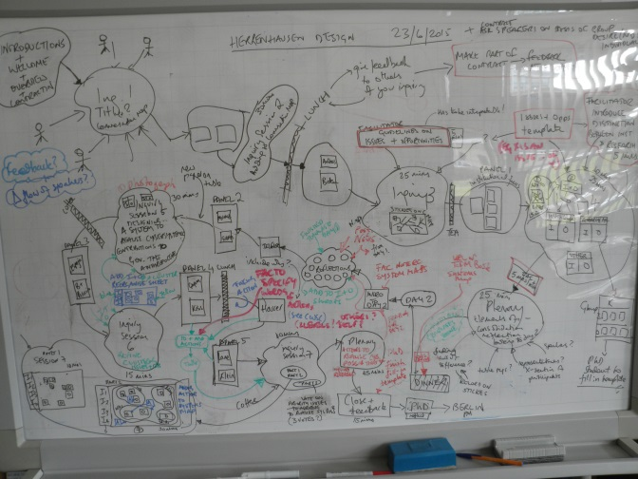 | 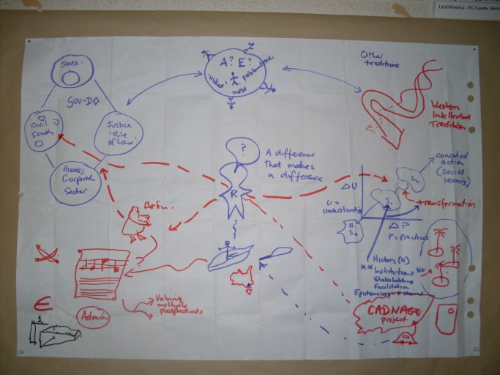
Figure 1. (a) A design for a two day systemic inquiry – from which the final programme was derived; (b) a rich picture prepared by Ison as a device to aid critical reflection on the Herrenhausen event with the PhD student cohort.
Systemic inquiries are flexible and open ended. There is not one ‘right’ way in which to do one and they end only when those involved decide to end them. A systemic inquiry can precede, run in parallel with, or incorporate a programme or project; it can be as short as two days or run until those engaged agree to stop.
Systemic inquiry builds on an intellectual lineage associated with Deweyian inquiry that can be found in systems scholarship (Dewey 1933; Churchman 1971; Checkland 1999; 2002; Blackmore 2009; Ison 2010).
Doing systemic inquiry with others is also a particular means of facilitating movement towards social learning, which we understand as concerted action carried out by multiple stakeholders in situations of complexity and uncertainty. Expressed in everyday language social learning is the sort of action associated with everyone working well together to address an issue of concern, much like a good sporting team, though often the rules of the game and thus what constitutes winning have to be invented in tandem.
Inquiry-based practice has been a concern within different systems practice lineages for many years. Chris Blackmore (Blackmore, 2009, p. 67) traces some of the antecedents in the systems field to current practices associated with ‘inquiries’. She identifies the following lineages:
- what Donald Schön called ‘Deweyan Inquiry’ – thought is intertwined with action and inquiry begins with problem situations rather than problems
- inquiry based on Vickers’ idea of appreciative systems
- Churchman’s inquiring systems, particularly in the sense of recognising that there are many possible worldviews and perspectives in relation to a given situation or issue.
At the Open University, following in the tradition of Checkland (1999), who saw the enactment of soft systems methodology (SSM) as a form of systemic inquiry, we have been further developing and refining systemic inquiry, or systemic co-inquiry as a process as well as an institutional form better able to engage with complex, uncertain situations than projects or programs.

1.5 Realising the design intentions

1.5.1 Invitations and logistics
The initial work undertaken to identify cybersystemic organisations around the world was conducted by Prof. Ray Ison and his research assistant Ben Iaquinto (see Section 2.3). All letters seeking nomination of participants and extending invitations to participate or present were composed by Ray Ison and sent with support by the team at WINs comprising Renate Judis and Wiebke Hampel – a copy of the database of invited organised appears in Ison (2016).
The Excel database of systems and cybernetics organisations developed so as to identify potential participants (Appendix 2) should be seen as an outcome of this work along with Figure 10, in Section 2.3. As many of these organisations are now defunct, or only just functional, including many German organisations it is recommended that this work be expanded into a more operational resource to underpin consolidation of the sector.
Registration management, participant databases and spreadsheets for invitations, accommodation and payments were managed from the WINs team.
The program was designed as a mix of presentations and ongoing table-based conversations – each contributing to the overall inquiry. In all there were 22 presenters from 13 countries – six were from the German-speaking world. The 135 participants were organised into 16 table-based Inquiry Groups with participants selected to maximise diversity and difference at each table.

1.5.2Embedded PhD program/inquiry
The design for the Systemic Inquiry was built around an embedded program for PhD students called: Systems Thinking and Practice in PhD Research: Cybersystemic Possibilities for Governing the Anthropocene. The programme ran from the first day of this Inquiry, 30 July till the 7 August 2015, the final day of the ISSS conference in Berlin. The PhD programme was also framed as a systemic inquiry that comprised:
- Two days of participation in this Systemic Inquiry in Hannover (Herrenhausen) on “Governing the Anthropocene: Cybersystemic Possibilities?
- Two days of dedicated ‘workshops’ introducing different systems approaches, methods and research traditions at Humbolt University in Berlin (1-2nd August)
- Five days of participation in the 2015 ISSS Conference in Berlin, including a group generated presentation on the final day (3rd-7th August)
- an award of 5 ECTS – points for those successfully completing the program awarded by Humbolt University
The objectives were framed in the following way:
“Working strategically to negotiate boundaries for research in a meaningful way in the areas of contemporary concern e.g. sustainability; development; health; farming, food, rural areas and environment/biodiversity, to name but a few, requires particular skills and abilities: It is necessary to be able to make relevant connections and to contextualize research activities without becoming overwhelmed by potential complexity and uncertainty. The context of the increasingly multifaceted complexity of issues of sustainability and climate change in relation to most contemporary issues is particularly challenging for PhD research. It is a context that is however a core part of the ISSS community’s experience.
The purpose of this course was to help the PhD student, develop their skills in contextualizing their research, to make connections among issues using systems, cybernetic and complexity thinking and to so improve their ability to work both strategically and purposefully. The course was also designed to help them build on what other researchers have done.
Through joining this course students were expected to:
• gain an overview of the intellectual traditions of cyber-systemic thinking approaches,
• make links to the history of ISSS and other organized bodies concerned with cybersystemic research and scholarship,
• strengthen their research through developing understanding of cybersystemic theories and methodologies
• have an opportunity to reflect on strengths and weaknesses of different systems approaches and methodologies in relation to their own PhD research
• get added value from their participation in the Herrenhausen Systemic Inquiry and the Berlin ISSS Conference by also becoming part of a parallel critical learning systems community that has a PhD research focus
• critically review potential contributions of their research to help meet global challenges
• develop appreciation of multiple perspectives on contemporary issues
• work across multiple disciplines, build networks and establish new relationships supportive of your research and scholarship
The program was very successful attracting very positive feedback overall; the highlights were:
- 27 PhD students participated and completed (i.e. were awarded 5 ECTS);
- students were diverse in background, nationality, areas of study (from engineering to systemic family therapy) and age;
- The PhD course focused on the use of systems thinking in research practice - all students conducted their own systemic inquiries in sub-groups based on stage of PhD study;
- The course was lively as well as intensive, generated strong group cohesion and enthusiasm for the subject matter and was evaluated very positively by all participants – see Appendix 3 for feedback and evidence of esteem;
- The PhD program design and development built on two previous version conducted at the University of Aarhus, Denmark in 2012 and at Humboldt University in 2014. The initiative has been pioneered and facilitated by Dr Chris Blackmore (OU), Prof, Sri Sriskandarajah (SLU, Sweden), Prof Ray Ison (OU) with assistance from Dr Thomas Aenis (Humboldt University) and the European Branch of the International Farming Systems Research association.
Participation by PhD students was always central to the design of the Herrenhausen event. An attempt was made to ensure two PhD students were allocated to each table-based inquiry group, and these students. Working with a predesigned template, PhD students were central in capturing key themes from each table.
Evaluative feedback was obtained by three means – an end of programme assessment; a review of the Herrenhausen experience as part of the two day intensive (see Figure 1b) and through informal means such as unsolicited cards given as gifts to the organisers. A sample of feedback is given in Box 1.
Box 1. A Sample of Feedback from PhD Students
1. Formal feedback at end of programme
Participants were asked to describe their experience in terms of (i) most significant; (ii) liked most; (iii) did not like and (iv) improve, as in the following example:
1) Most Significant: I had two: At Herrenhausen, I became actively aware of language, how we use it, and its meaning. For so many of the participants, English is not their first language and/or their understanding of the meanings of words were very different than mine. My awareness carried throughout the conference.
The other was the learning from our systemic inquiry and the emergent quality of our learning. It reinforced my belief that we need to feel comfortable with uncertainty and trust the process.
2) Liked most: The instructors, the fellow students, and the process by which we learned. I tend to be someone who likes a road map for where I’m going if I’m teaching or presenting, but experiencing the depth of learning that I did encourages me to try to remain flexible.
3) Did not like: Not much. I wished all the PhD students could have been at the Scandic Hotel (Berlin). The Herrenhausen part needs attention, but we have already been at that.
4) Improve: See above. Next year, have those of us who are at Boulder (ISSS 2016) mentor the new cohort of PhD students.
The following are examples of (i) most significant and (ii) improve:
(i) Most Significant:
* “from an experiential learning point of view, the two days at Humboldt [were] very valuable and I felt that I learned a lot about what it is like to be a part of a critical learning system. It provides a completely different learning and engagement that I am very interested to continue working with, and also a good experience before conducting my own action research project.”
* “Most significant moment for learning was Ray’s rich picture following some of our questions/concerns/experiences at Herrenhausen. I found his authentic presence and revealing of where he was coming from and what he was trying to achieve inspiring and intervential on my own thinking practice.”
*” [the] thing I liked most is how you facilitated our dialog with other researchers and members of the cyber-systemic community, without this, as an individual student, it would have been difficult to engage in dialog with such experienced researchers and persons.”
(ii) Improve:
* “More time with the PhD group in the critical learning system”
* “Areas I think should be improved: + more partner and small group work but around our research or areas of concern. (I found the systemic inquiry to be too general). + Add learning from case studies but in a discussion way. + consider including post docs or early career strand of this program.”

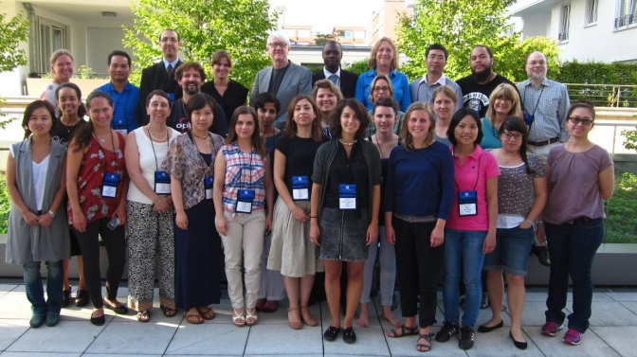 | 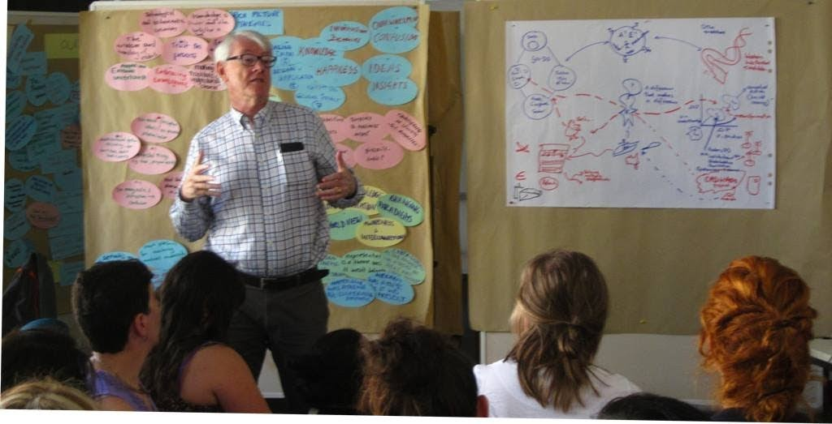
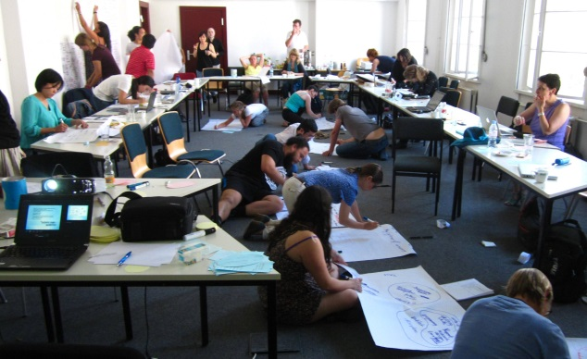 | 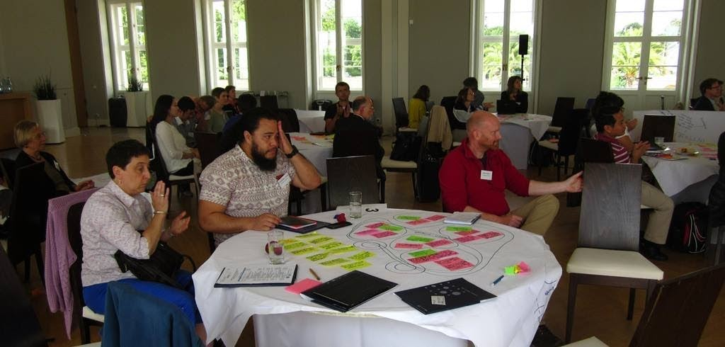
Figure 2. (a) the PhD cohort; (b) Ray Ison responding to student feedback about their experiences at Herrenhausen; (c) students working together at the weekend intensive; (d) two PhD students (from USA and New Zealand) in their table-based inquiry at Herrenhausen.
After participating in the Herrenhausen event the PhD cohort were invited to prepare ‘rich pictures’ of their experience from which emergent themes were identified (Table 1).
Table 1. Structured feedback on Herrenhausen in the two-day intensive: themes from rich picture diagrams prepared in pairs by all PhD students – see Figures 1b and 2b. There are no distinctions to be made between columns.
- Making our traditions of understanding ”clearer“  - Assume and Embrace uncertainty  - Embracing emergence  - The wisdom and humility of elders  - Trust the process  - Emotionally + intellectually disconnected  - Knowledge is power and the North / “West” has it  - Technological and technocentric optimism  - Too much conceptual ideas / less practical solution / action  - Multicultural system thinking, but can´t take due to task + activity  - Unexpected things e. g. task, program activity  - Too many rules + instructions → confusion  - Need Balance of diverse backgrounds in a table  - Defining the bounds and scales within which system are applied  - Start platforms for reaching mutual understudy  - Bring clarity to S.T., Through case analysis  - Need new definitions of community “who is he?”  - Make new footsteps! (Through substantial contributions to scholarship / Praxis)  - Interdisciplinary scholarship needs fun their support  - Different views towards a same big issue  - Human relations cooperation, networks, communication etc. | - Fragmented views 1. Integration 2. Conflicts  - TIME - rushing to solve without time to reflect  - Experiencing being listened to  - Being part of something so good - feelings of humility  - Embraced by beauty  - Genuine care for humanity  - Information exchange  - Over whelming  - Confusion  - Ideas  - Insights  - Teaching & transfer  - Happiness  - Knowledge  - Research & application  - Making impacts  - Recreation of Reality  - Diversity-logic?  - Choreography of utilizing “Gut-Knowledge”  - Tendency to maximize output  - Juxtaposition of interests  - Network communication  - Changing paradigms  - Knowledge & education  - Awareness & interconnection  - World view  - Hierarchy was a theme b/c it was present  - Cyber-systemic as the answer was a theme b/c there are other “answers” too  - Representation is a theme b/c it wasn´t balanced  - Confusion was a theme b/c expectations  - Happy-love was a theme b/c cooperation emphasis

1.5.3 Contracting
In our experience, whenever an inquiry group assembles we have found it important to spend time generating a ‘contract’ about how we will work together. The contract also helps inform the design of the inquiry.
A few weeks before the event, a draft contract was sent to all participants for review. In developing the contract, we invited participants to take a moment to think of all the ways they, or someone else, could make the two days together a bad experience. The process of contracting is designed to avoid, or at least ameliorate these possible bad experiences. Amendments were invited to the Draft Contract
Several suggestions for change were received. These were incorporated into a final draft for agreement on the first day of the inquiry. Although a minor change in the contract was proposed on the first day, after some subsequent discussion with the proposer and others, this was not implemented and the final version of the Contract was used. The final contract can be seen at: http://www.open.ac.uk/blogs/govan/?page_id=302

1.5.4 Design of the two days
Based on previous experience, we recognised that the key to the success of the inquiry would be to enable meaningful conversations and interactions and insights and knowledge to be part of, and emerge, during the two days. Thus the inquiry design was a mix of table-based inquiries, each of about 8 participants, interspersed with speakers and panels which added to focus and content of the inquiries proceeding at the 16 tables.
The table based discussions were facilitated and ‘recorded’ by PhD students (although the process itself enabled all participants to record the work of their group).
Techniques used including how they foster systemic thinking / learning can be seen here: http://www.open.ac.uk/blogs/govan/wp-content/uploads/2015/08/Running-slides-day-1cc.pdf . The Open University in its 40+ year history of teaching systems thinking in practice (STiP) has pioneered the use of a range of systems diagramming techniques for engaging in uncertain, messy situations and for bringing forth key systems concepts like boundary, connectivity, feedback etc (see Open University 2006).
The event was facilitated / coordinated by Collins with close support by Ison to ensure timely running of the workshop and, most importantly, progression of the inquiry. As with any process, some flexibility was needed to accommodate emerging insights and changes during the two days, but for the most part, our design intentions were fulfilled. The ‘running slides’ which introduced and explained each part of the inquiry can be found here: http://www.open.ac.uk/blogs/govan/?page_id=343

2. KEY ISSUES RAISED BY SPEAKERS – AN OVERVIEW

The following is based on the presentations and comments by speakers. All of the presentations by speakers and audio recordings can be found on the event blog at:
http://www.open.ac.uk/blogs/govan/?page_id=88 (day 1)
http://www.open.ac.uk/blogs/govan/?page_id=90 (day 2).

2.1 Framing issues – constraints and opportunities

2.1.1 The Anthropocene
Our event began with the introduction of a critical perspective when during her welcome Vera Szöllösi-Brenig said:
“Or isn’t it hubris – to quote critical voices like the German philosopher Jürgen Manemann: isn’t it hubris to define the Anthropocene as an era? Doesn’t it mean that humans are like God? Or is this effort to govern the Anthropocene by nature invalid as the French sociologist and philosopher Bruno Latour explained in his lecture “Facing Gaia”: Bruno Latour, in combining the thesis of Paul Crutzen of the Anthropocene with his own actor network theory, sees the dawn of politics coming, a new dawn of potentially bellicose geopolitics. Therefore we may ask: are there really possibilities to govern the Anthropocene?”
An important issue resolved by the inquiry was whether our conversation is about ‘governing THE Anthropocene’ or ‘governing IN the Anthropocene’. The latter is most appropriate. But these distinctions also conceal the concern raised above of reifying, in a God-like manner, the Anthropocene as a new era.
The first presenter, Sarah Cornwell posed three initial framing questions:
- Science –how can/do we know what complex systems are doing?
- Governance – (how) can complex systems be steered?
- Policy –what kinds of choices work for complex systems?
In doing so she also introduced another framing choice – to see the earth and all its life as a ‘complex system’. Such a framing, as with all framings, brings with it certain entailments. Sarah also asked: “How do we know what complex systems are doing?” which as posed and addressed revealed two important framing assumptions: (i) that complex systems are knowable (and thus model-able and, possibly controllable) and (ii) it is worth investing in attempts to know what complex systems are doing.
The mainstream approach to making ‘complex systems’ knowable is to simplify, observe, model and extrapolate. Sarah went on to pose the question: What kind of complex system is planet Earth? She concludes that “Living and non‐living parts of the planet interact. They co‐evolve. Some living parts think, and have some foresight.”
The concept and processes of co-evolution was raised by several speakers and is a theme which is developed through this report – see Box 2.
Ison (2015) argued that what we were engaged in was firstly an inquiry about framing and reframing choices. This involved, he claimed, a need to reframe how we think and act, how governance (or governing) is understood and how we frame what is to be governed (e.g. an Anthropocene, or not?). Ison’s (ibid) position posits that “‘Framing’ situations is a choice we have…and one we always make” and that following Lakoff (2010 pp.71-72): “All thinking and talking involves ‘‘framing.’’ And since frames come in systems, a single word typically activates not only its defining frame, but also much of the system its defining frame is in”. This applies equally to ‘the Anthropocene’; governance/governing as well as practice/practicing – doing science, doing systems. Framing choices create initial starting conditions that become conserved as lineages (pathway dependencies) and as institutions (norms, ‘rules of the human game’).
Ison (ibid) argues the need to be open to what ‘the Anthropocene’ as a ‘framing choice’ reveals and conceals; from this perspective the use of the concept Anthropocene is not reduced to a dualistic, either/or choice. A way out of this trap, he suggests is to draw upon metaphor theory and practice that poses the questions:
- what does a framing choice reveal or conceal?
- what are its theoretical entailments?
For example, following Malm and Holmborg (2014) who claim that “We need to question the use of the species category in the Anthropocene narrative …because it is analytically flawed (i.e., only some, not all, humans have contributed) …and it is inimical to action” and that “too often intra-species inequalities are ignored” it could be claimed that concerns about human equity are concealed in the use of the Anthropocene concept. Also concealed is the tendency to conserve non-reflexive commitments to scientism through the use of a categorisation from within the traditions of Earth Systems Science i.e., the naming of a new epoch.
Whilst use of ‘the Anthropocene’ as a framing choice for our contemporary circumstances may have its limitations, there can be little doubt that we are in a period new to human history (Figure 3) and that many of the emergent phenomena are the product of human action (even if not all humans!)
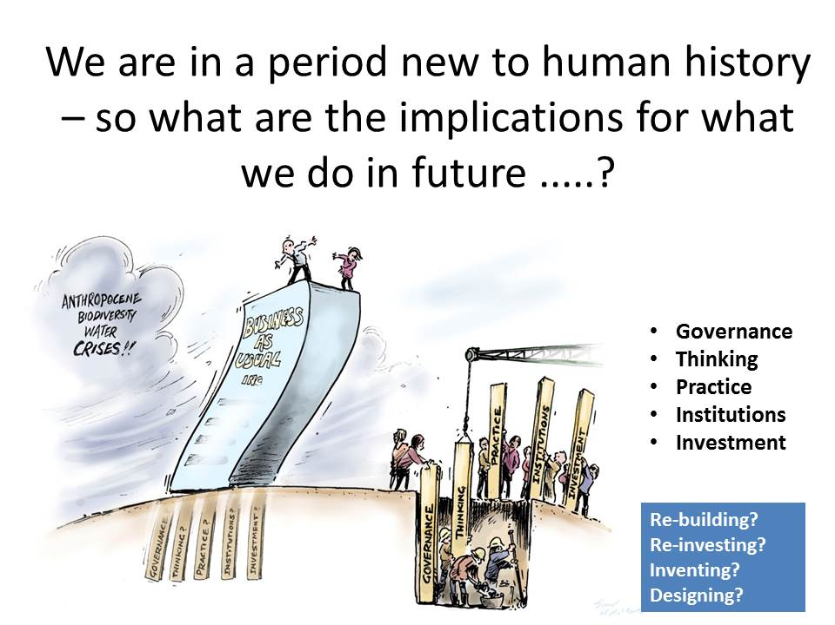
Figure 3. From Ison (2015)
Ison (2015) drew attention to some of the framing choices incorporated in the Encyclical letter, ‘Laudato Si’ of Pope Francis (2015). This encyclical offers several framing choices relevant to this ‘systemic inquiry’. For example:
- When we speak of the “environment”, what we really mean is a relationship existing between nature and the society which lives in it.
- Nature cannot be regarded as something separate from ourselves or as a mere setting in which we live
- We are part of nature, included in it and thus in constant interaction with it. Recognizing the reasons why a given area is polluted requires a study of the workings of society, its economy, its behaviour patterns, and the ways it grasps reality
- Given the scale of change, it is no longer possible to find a specific, discrete answer for each part of the problem. It is essential to seek comprehensive solutions which consider the interactions within natural systems themselves and with social systems.
- We are faced not with two separate crises, one environmental and the other social, but rather with one complex crisis which is both social and environmental
- Nothing in this world is indifferent to us [humans]
The framings incorporated in ‘Laudato Si’ are compatible with those offered in the Systemic Inquiry by Simon Ramirez (2015) based on work undertaken at the ‘Matriztica School of the Southern Hemisphere’, namely that “the interlacing of all the manners of living [of humans and other species] is the Biosphere; humanness as a manner of living is just one domain that belongs to it among many, and that domain we can call the Anthroposphere” It follows from this perspective that sustainability is: “harmonization of the relation between biosphere and anthroposphere [which happens] always in a local space”. This is an alternative way of looking at sustainable development and addressing the question: what is it that we could seek to sustain through governing?

2.1.2 Co-evolution

A key distinction is that between seeking to govern a set of states and a set of processes, or relationships. It can be claimed that most contemporary approaches to governing are concerned with states rather than unfolding, relational dynamics that can be captured in the term co-evolution (Box 2).
Box 2. Co-Evolution
According to Norgaard (1994) “co-evolutionary explanations invoke relationships between entities which effect the evolution of the entities. Entities and relationships are constantly changing yet they constantly reflect each other …everything is interlocked, yet everything is changing in accordance with the interlockedness” (p. 26).
Norgaard (ibid) advances as a major argument for ongoing development failure “the weakness of the systems sciences”. He sees this as a major constraint because “our ability to comprehend as a whole is all that matters in the end“ (p. 8). He rejects thinking that focuses on prediction and control. His conceptual models of a co-evolutionary dynamic compared to the dominant linear paradigm of development are shown in Figures 4a and 4b.
Mishra (2016) argues that “co-evolutionary studies of human culture and cognition propose that the human mind, cognition and perception have co-evolved with the cultural context in which they are embedded (Kallis & Norgaard, 2010; Murray, 2006) and human culture has also been shaped by shifts in cognitive and perceptive capacity. Socio-ecological evolution studies have researched the mutual evolutionary impacts that human culture and genetic make-up have had on each other, such as the co-evolution of lactose-tolerance with dairy farming (Kallis & Norgard, 2010). …Within organisation and management studies, co-evolution has emerged as a popular theoretical framework to study organisational change and development…”
Figure 4(a) Figure 3.1 from Norgaard (1994) which depicts the set of interrelationships that constitute a co-evolutionary dynamic that includes the social and the natural (p. 27); (b) Figure 4.1. from Norgaard (1994) depicting the mainstream, linear, or systematic model of development (p. 33).

2.1.3 Sustainable Development
Cornwell (2015) argued for a return to the 1987 Brundtland framing of our collective ‘problematique’, which, she argues, is more systemic in its concerns than more recent framings, i.e., “the Brundtland report says:
‘Sustainable development aims to promote harmony among human beings and between humanity and nature’. And it specifies a multifaceted integration:
- a political system that secures effective citizen participation in decision making,
- an economic system that is able to generate surpluses and technical knowledge on a self‐reliant and sustained basis,
- a social system that provides for solutions for the tensions arising from disharmonious development,
- a production system that respects the obligation to preserve the ecological base for development,
- a technological system that can search continuously for new solutions,
- an international system that fosters sustainable patterns of trade and finance, and
- an administrative system that is flexible and has the capacity for self ‐ correction’ (WCED 1987).
In contrast Andreas Rechkemmer (2015) questioned assumptions built into the original SD definitions: "Sustainable development is development that meets the needs of the present without compromising the ability of future generations to meet their own needs.” He argues that: “It contains within it two key concepts: - the concept of needs, in particular the essential needs of the world's poor, to which overriding priority should be given; and the idea of limitations imposed by the state of technology and social organization on the environment's ability to meet present and future needs." Historically the three main pillars of sustainable development were: Economic Growth, Environmental Protection and Social Equality.
Rechkemmer (2015) made the case that “Sustainable Development will be achieved more easily if we place the idea and principle of Social-Ecological Justice at its very foundation, conceptually as well as in every action. In the sense of Kant, Social-Ecological Justice should precisely not be motivated by utilitarian or contractarian approaches, but rather be perceived as an a priori, transcendental moral principle informing law, ethics, policy and action alike.”

2.1.4 Governance and governing
Cornwall (2015) makes the case for what she calls creeping ‘complicatification’ in global steering, noting the following pattern:
- 1987: 1 (or 2) goals ‐ harmony between humanity and nature, among human beings
- 1992: 3 issues – climate, ecosystems, human ‐ changed landscapes (UNFCCC, CBD, UNCCD)
- 2000: 8 Millennium Goals, 18 targets (n.b: No. 8 –systemic change – not achieved)
- 2010: 5 Goals, 20 Aichi Targets for biodiversity
- 2012: 8 then >27 sustainability goals proposed (by Colombia, Guatemala and Peru), 19 criteria for goal selection ultimately agreed.
- 2015: 17 goals, 169 targets, hundreds of indicators.
She suggests that “complicating the analysis … suggests (some) people don’t really want to change...”
Ison (2015) was more explicit about his preferred conception of governance (Figure 5) which is essentially a cybersystemic, co-evolutionary conception of governance.
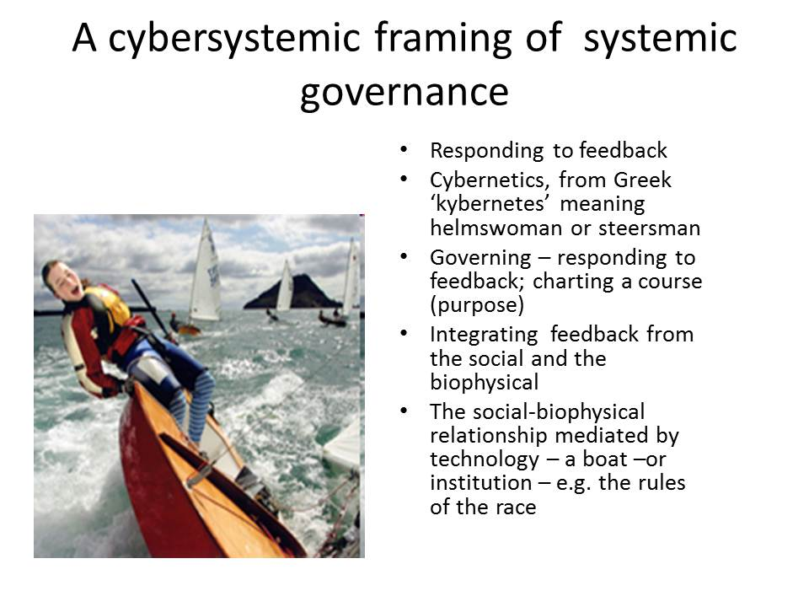
Figure 5. A cybersystemic framing for systemic governance (Source: Ison 2015).
Ison (2015) concluded by addressing the question of “governing for transformation” and asking what constrains the transformations we seek? Drawing on his research experiences he identifies the following as major constraints to transformational action that draws on cybersystemic understandings:
- widespread lack of epistemic awareness in domains of practice and policy development – a crisis of knowing;
- lack of awareness of the implications of living in language – e.g. framing failure;
- inappropriate measures of ‘system performance’ (e.g. GDP);
- lack of awareness of how objects arise …and the implications of reification, the creation of ‘things’ such as the environment, resources, systems etc;
- lack of congruence between what is espoused and what others experience - ‘talking the talk but not walking the walk’;
- failures to institutionalise systems understandings and practices in manners that create demand pull and sustain institutionalisation, and
- a focus on scientism at the expense of design – particularly the praxis associated with the design (crafting?) of learning systems and governance innovations
Ramirez (2015) offered a framing of what it is that we might govern – “that part of the medium in which the observer sees that an organism is continuously encountering itself in spontaneous sensorial, operational and relational harmony so that it lives, its ‘dynamic ecological niche’ (see Maturana, Davila and Ramirez 2015).
Various participants drew extensively on the work of Elinor Ostrom (Ostrom 1990; 2005; 2009; Ostrom and Hess 2006) elaborating on her concerns about governance, particularly polycentric governance (though unfortunately no single presentation was devoted to polycentricity, its enactment, and the place of cybersystemic understandings in future scholarship – see Box 3). Heiner Benking (2015) drew out the following features of Ostrom’s work (Table 3; Box 3):
Table 3. Key features of Ostrom’s work – from Benking 2015.
•multi-perspective  •multi-positional and multi-centric  •mix of scales  •nested  •meta-data analysis research included  •diversity of rules and systems  •coping with dilemmas | •multi-level not chaotic –but complex  •common pool resources and sets  •common analytical tools and language  •common and diverse regimes across scales  •communication and agent-based models  •clarifying concepts, trust and reputation

Box 3. Polycentricity
Polycentricity is a broad notion, a conceptual tool used to consider the organisation of political, economic and social systems (McGinnis 1999). According to Andersson and Ostrom (2008), the first use of the term polycentricity in the academic literature was by Ostrom et al (1961) who investigated the utility of a polycentric political system in providing an adequate form of governance to metropolitan areas. They described “polycentric” as signifying “many centers of decision-making which are formally independent of each other. Whether they actually function independently, or instead constitute an interdependent system of relations, is an empirical question in particular cases” (Ostrom et al 1961: 831).
McGinnis (1999) believes a system is polycentric when areas of responsibility and authority are multiple and overlapping, and also states that polycentricity can occur at all scales – from the community level to the global level. Polycentric governance disperses decision-making authority throughout numerous hubs in a system (Marshall 2009). It grants users partial authority in the creation and enforcement of rules, using the benefits of dispersed authority while taking into account the shortcomings of such an arrangement (Falk et al 2009).
Polycentricity, it can be argued, encompasses the systemic notions of hierarchy or nested, layered structures or systemic levels. But it is not the same framing as say the structural coupling of two systems – social and biophysical. Maja Goepel (2015) presented models of governing that incorporate the social and biophysical that demand cybersystemic sensibilities (Figure 6).
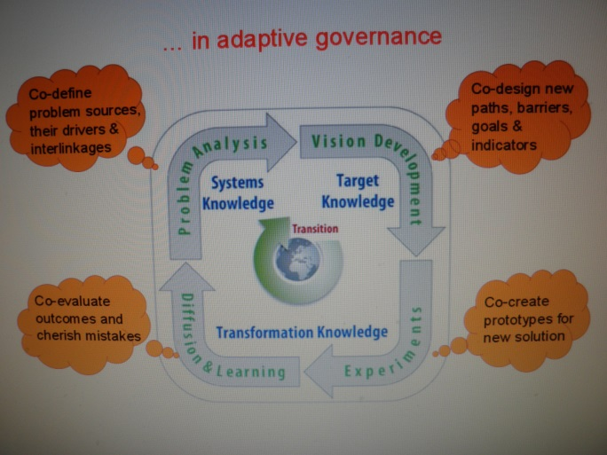 | 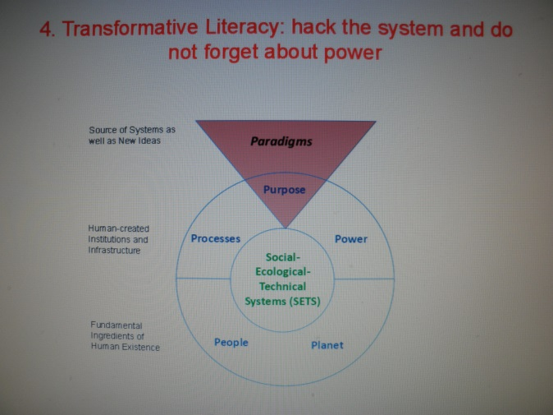
Figure 6. A conceptual model of adaptive (and systemic?) governance which relies on ‘systems knowledge’ (a); and (b) a 6 P model (paradigms, purpose, power, planet, people, processes) that situates paradigms, and paradigm choice as the overarching concern (Source; Goepel 2015).
Goepel raised the important issue of power which has had a vexed and contested history in terms of conceptualisation and scholarly concerns within the cybersystemic fields. Her scholarship leads into questions of praxis: how to ‘hack the system’? Or institutionalising processes of co-defining and or co-creating systems knowledge?

2.2. Cybersystemic theory and practice
Cornwell (2015) offered a number of possible framings based on systems theory; in addition to ‘complex system’ these included:
- Hybrid’ systems: assemblages of inorganic, organic and social systems (de Landa, Deleuze, Bhaskar)
- Adaptive systems: Resilience (and resilience speak); self ‐organizing, responsive, co‐evolving
- Purposive systems?
- Learning systems?
- Zombie systems? (Frankensteinian models?)
  - OR and management heuristics, classic systems methods, Ackoff & Gharajedaghi 1996 – purpose in wholes/parts
As evidenced by the ways in which the term ‘system’ is used in everyday discourse, including in scientific fora such as the Planet Under Pressure Conference in 2012 (see Figure 7a), it is reasonable to conclude from an academic, conceptual point of view the term ‘system’ has ‘become feral’ (Figure 7b). Ison (ibid) argued that in academic and policy circles few have an overview of the different cybernetics and systems lineages that are available to engage with the concerns of this inquiry (Figure 8). There is a general lack of awareness of the two adjectives that derive from the word system, namely systemic (relational and holistic) and systematic (linear causality that acts step-by-step). Within practice systematic thinking dominates but in situations of uncertainty, complexity and interdependency systemic approaches are required, especially when initiating any form of purposeful activity (Figure 9a). Within these lineages two major commitments by practitioners can be discerned – to see systems as things in the world, as ontologies or as epistemological devices for engaging with, and transforming situations of concern (Figure 9b).
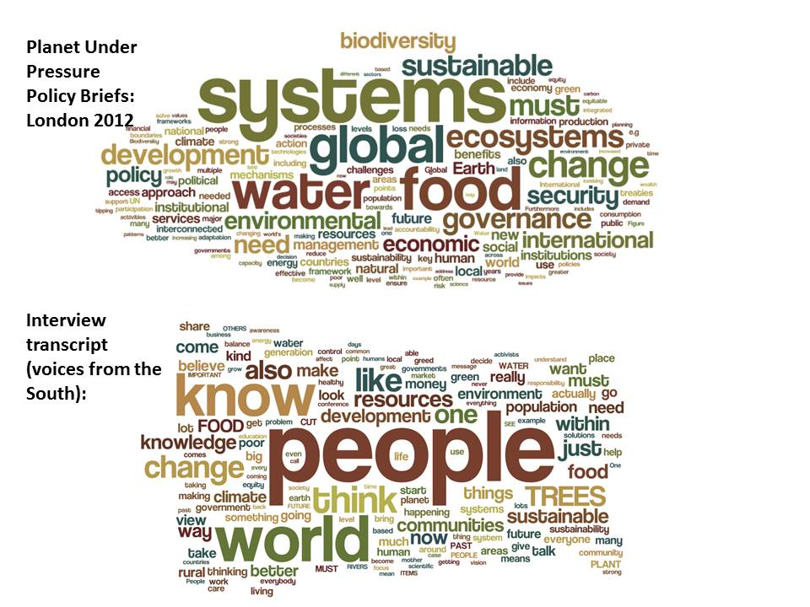 | 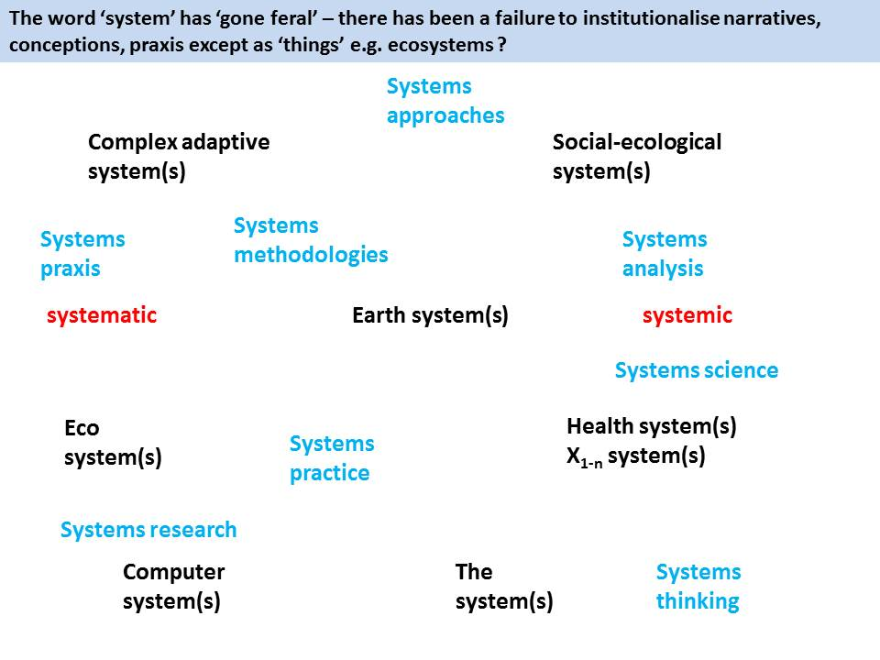
Figure 7. (a) an analysis of terms appearing in the main discourses of scientists (top) and voices from the South (bottom) – in the main the term ‘system’ was used in its everyday sense rather than its academic sense; (b) some of the different ways in which the concept ‘system’ has gone feral in language and practice – note the two main adjectives, systemic and systematic.
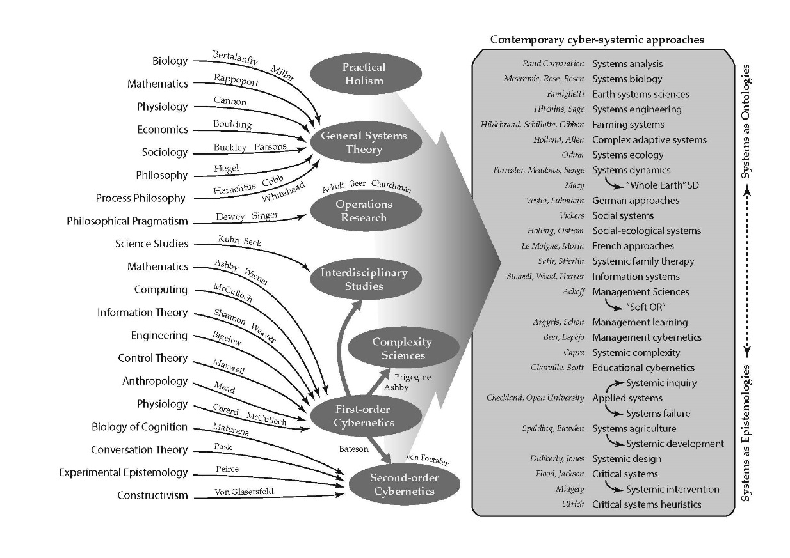
Figure 8. A heuristic model of some of the different influences that have shaped contemporary cyber-systemic approaches and the lineages from which they have emerged. This Figure is best read from right to left in the first instance. Down the right-hand side are a set of contemporary cyber-systemic approaches which are written about, put into practice and sometimes taught. Some names of people (practitioners) are added who are particularly associated with approaches. The approaches are also organised from top to bottom in terms of what can be perceived to be common commitments, or tendencies, of a majority of practitioners within the given approaches to seeing systems as entities (ontologies) or heuristic devices (epistemologies). As noted by Ison (2010), this heuristic is not designed to map all of the possible lineages – but to foster a conversation about what these might be (Source: Ison & Schlindwein, 2015 and adapted from Ison 2010).
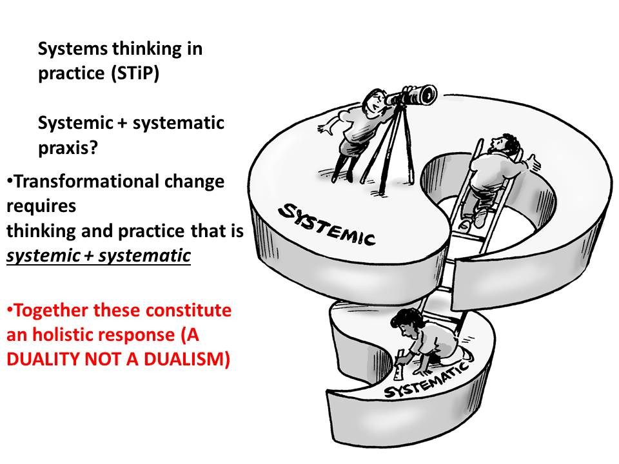 | 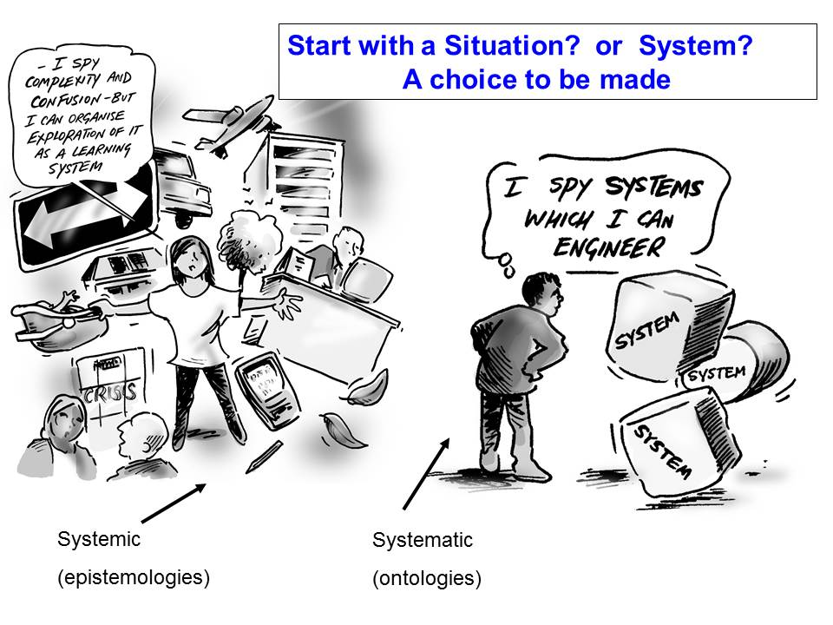
Figure 9. Systemic and systematic approaches understood as a duality, not a dualism (a) and the praxis, and epistemological choice that al systems practitioners must make – to start with a situation and engage with it via systems as epistemological devices, or to see systems as things in the world (ontologies). (Source: Adapted from Ison 2010).
Ison (2015) asks: Do we appreciate our own domain? Where do we draw boundaries? How are cybersystemic understandings and practices institutionalised? What future trajectory exists or can be facilitated?
Alexander Christakis (2015), a participant in, and scholar of, the ‘Limits to Growth’ work in his reflections on the actions of the Club of Rome drew attention to an ongoing set of tensions, sometimes conflict, within science practice generally and systems sciences specifically (i.e., the field described in Figure 4). He introduced the ‘three Phases of science’ and argued that the Club of Rome failed to appreciate the anthropocentric paradigm, preferring instead the technocentric paradigm. As an alternative pathway he outlined the science of dialogic design; provided examples of the application of the science; and showed how to reverse the dominance of technocracy over democracy.
Robert Hoffman (2015) reflected on his ‘learnings’ from living with the Limits to Growth work from 1972. His learnings include:
- that models are essential for understanding and working with complex systems as the human mind cannot grasp the relationships even between a small number of variables and how the relational dynamics differ in time and space.
- the importance of dynamics in contrast to mainstream economics which is exclusively concerned with comparative statics of points of equilibrium – the systems dynamics model at the core of the Limits work opened a ‘new world’ – in dynamics concerns shift to pathways rather than endpoints (i.e. the world in which we live is not a matter of making choices about endpoints but choices about pathways – see Box 1 on co-evolution);
- the World 3 systems dynamics model was the first model that purported to deal with a ‘whole system’ and this brings forth limits or boundaries – which is not a concern of economics concerned with the action of agents – hence the great clash between economists and systems dynamics scholars;
- the triggering of insights into two approaches to modelling (and the functioning of science much as outlined by Christakis); the first is that based on Newtonian science (independence of the observer; search for universal and timeless laws that are extrinsic yet govern the Universe) and is the underpinning epistemology of the World 3 model i.e., comprising time independent parameters that governed this global system; reversibility and independence from history, an approach that he finds ‘deeply flawed’. The alternative is evolutionary systems modelling; the observer or modeller is integral to the model, the relational dynamics between the model and the user is also part of the system and thus the ‘system’ as a whole is capable of learning (i.e., is capable of generating emergent properties) and is thus not independent of history.
He concludes that models need not be technocratic (in the sense introduced by Christakis) if they are open to people’s participation and learning. Modelling can this be seen as a means to facilitate play – if they do not purport to specify an end point, an equilibrium position. From this perspective the feedback that comes from human participation should be left open because the object is to change behaviour not to specify how it was in the past. ‘Models should be hypotheses about how things work and they should be adaptable over time’. Our challenge is to not use models as devices to predict the future, not as devices to prescribe what the future should be, but which extend our capacity to perceive beyond the limitations of our biology so as to appreciate longer term and systemic consequences and to decide how to act.
Mary Catherine Bateson (2015) through the question: ‘what does it mean to live cybersystemically’ illuminates how and why cybersystemic thought and action matter. She draws attention to the inescapability of us always living in a ‘bigger system’. “Can we look at ourselves in relationship, rather than separate” she asks? The case is made to move away from a focus on individual rights to settings where relational phenomena convey rights – e.g. a family, a community, a tribe, as the basis of an ethics of living.
Bateson invoked the Tower of Babel myth as a metaphor for our times suggesting that we operate in multiple languages and have an inability to cooperate, but she observed that new social technologies were emerging, such as the Systemic Inquiry process employed at Herrenhausen, that take us away from our historical focus on the podium (i.e. pulpit) from which knowledge or expertise is promulgated.
Bateson observed that one of the great problems of our time is the emphasis put on independence: ‘Independence is an illusion. There is no such thing as independence….We are not going to be able to deal with the Anthropocene unless we can coordinate, cooperate and act at the unit of survival, an organism in a population of that species, in an environment’. She noted that “the US is a very individualistic society” and offers a poor role model for moving forward.
Bateson noted that Herbert Spencer (the founder of social Darwinism) coined the term ‘the survival of the fittest’ (Spencer was against feeding the poor) and observed that Darwin borrowed the phrase, an act that has generated unintended consequences, particularly Darwin’s concerns for cooperation. Work on cooperation has been subjugated in many different ways and over a long time frame. Bateson used the example of Lynne Margulis’ pioneering work on symbiosis (a form of cooperation) and the fact that her paper was rejected initially by the reviewers. Bateson said:
“If we wish to survive we are going to survive thinking systemically, by looking at ourselves not as separate and competitive, but as parts of larger systems. The concept of interdependence must be the route to surviving, maintaining the diversity of the planet on which we depend.”
Bateson posed the question: “How do you become individualistic?” She argued that it begins at birth, particularly in the (American) Western World: e.g. ‘guidance given to mothers… ..independence training from day 1.’
The alternative question is: ‘How do you become someone who thinks of themselves as part of a larger community which is part of bigger communities that are interdependent?’ Bateson (2015) noted:
“it starts immediately after birth- we carry the experience of a well-functioning system with us in our bodies ..health is the model. How do you learn to experience that? To notice your own needs, and count on them being met. Not in conflict with the environment. Look at the goal of raising human beings who see themselves as part of the biosphere, not ruling, exploiting. …We need to look really critically at local relationships…to practice trust. Give people the gift of the pleasure of helping me….practice in being and helping with each other…….we need corporations that stop competing …and move to cooperating.
The theme of responsibility was one that emerged through many of the presentations. For example, Bateson (2015) said: ’take the concept of interdependence as being our responsibility to be in and maintain caring relationships – care for the atmosphere, for the oceans.’ Taking responsibility includes taking responsibility for yourself and this is a form of reflexivity.
Telfener (2015) concluded with the issue of responsibility as an ethical stance, building her case from consideration of (i) the need to refer to epistemology; (ii) the notion of construction; (iii) second order operations and, (iv) the depth of our fundamental ignorance. It follows from the cybersystemic framing of governance presented by Ison (2015; Figure 5) that systemic family therapy as a field of inquiry and praxis has contributions to make that, as yet, have not been extensively drawn upon for the central concerns of this systemic inquiry. Systemic family therapy is concerned with the loss of quality in the unfolding relational dynamics between different ‘actors’ such as in a family, a group, an organisation or any collective concerned with undertaking and conserving cooperation: “what happens among people in the consultancy room is a fractal of what happens in other contexts among the same people (in the relationship among professionals, between family members, ...).”
“When we reach the point in which our actions are spontaneous, to act is no more a decision about what to do in order to obtain a certain goal. The action becomes the expression not of what we want but rather of who we are: The possibility to feel connected with the other, with the world outside of ourselves and the ability to follow in acting the way of least resistance, as water that flows (Telfener 2015).
Telfner’s work, and that of many within the field of systemic family therapy, diverges from the mainstream understandings (i.e., epistemologies) that underpin contemporary economics, positivistic science and behaviourism. A major source of inspiration is the sub-field of ‘second-order cybernetics’ (see Figure 8) and, in particular research on the biology of cognition (Box 4) and the emerging field of embodied cognition (Beilock 2015).
Box 4: Key concepts from the biology of cognition (Ramirez 2015)
* We are Autopoietic Molecular Systems in a space of structural determinism!
* Nothing that interacts with us can determine us;
* We are observers! That is, a special class of living beings, ‐ human living beings ‐ who make distinctions, that appear in language and conversations;
* So....If we are determinate structural systems, what is language and conversations? ... Language and conversations are human manners of living, and that manner is a history of transformation of coordination of coordination of doings, FEELINGS AND EMOTIONS
Ramirez (2015) concludes that “The biosphere doesn’t care what happens with us or to it, it just happens; it is for us Human Beings in our loving [whenever an other arises as a legitimate other] and ethical nature, who care about EVERYTHING! in the cosmos ...which theory, feelings and emotions we conserve will be the manner in which we will do it. ‐What we want, and how we want it? That is our responsibility as human beings..” He claims in concluding that: “The systemic view which [he presented] is only possible to comprehend if we are capable to release our certainties, truths, exigencies, prejudices, and begin to live in mutual care and respect, in collaboration, co‐operation and co‐inspiration in the space of the biology of love.”
Greyson (2015) argued that ‘the irreducible world is ironically more manageable’ than the ‘divisible world [which] looks and feels more manageable’. The latter is characterised by: ‘Numerous complex global problems; Every small change adds up; Linear, gradual change; Celebrate anything positive; Manage with systematic plans for everything’. In contrast the former is: ‘One problem in one complex system; Smallest relevant unit of change is the paradigm; Binary, diametrical, step change; Restorative goals; Manage with policy levers.
Ramirez and Greyson raise major issues that when encountered require reflections that are beyond the scope of this short report. It is important to note that when someone accepts a new explanation then their world changes; critical conversations of the type led by these presenters invite the acceptance of new explanations for our circumstances.

2.3. Institutional constraints and opportunities to realising cybersystemic possibilities
Vatn (2015) offered an account of how institutions could be best understood (Box 5). The inquiry accepted these as an important starting point.
Box 5: Institutions – after Vatn (2015)
“Institutions are human constructs. They can be seen as common ‘rules’. I more specifically define institutions as the conventions, norms and formally sanctioned rules of a society. They provide expectations, stability and meaning essential to human existence and coordination. Institutions support certain values, and produce and protect specific interests.
Institutions are to a large extent internalized – ‘embodied’ (different to North who sees them only as external constraints). Note the difference between ‘classical’ and ‘new’ institutional economics).”
Institutions influence perception as well as defining a basis for human action and interaction. There are different types of institutions:
– Conventions: Waste is of different categories
– Norms: You must sort waste
– Legal regulations: You must sort waste, or else you will be fined
(Ostrom: The language of institutions (ADICO))
Institutions define what is right or proper action. They are rationality contexts
Plural rationality comprises: – individual rationality: What is best for the individual (I rationality) and social rationality: What is best for the ‘group’ (We rationality).
The institutional context – e.g., the market or the community – influence what rationality is expected/found logical –e.g., competition vs. cooperation.
Institutions, conflict and coordination:
Institutions define or affect: (i) rights to resources; (ii) transaction costs (costs of interaction/coordination); (iii) perceptions; (iv) motivation (rationality). This way they influence: what problems/challenges may appear; how we perceive them and how easy it is to handle them.
This Systemic Inquiry was designed with the ambition of fostering a resurgence in cybersystemic thought and action in the cause of ‘Governing (in) the Anthropocene’. The added aims were to build stakeholding (including political support) within key constituencies and to generate potentially fundable research agendas relevant to the future of Europe. The imperative to do this arises from institutional failure across the ‘cybersystemic’ intellectual field (Figure 8) characterised by institutional and organisational proliferation and limited collaboration (Figure 10).
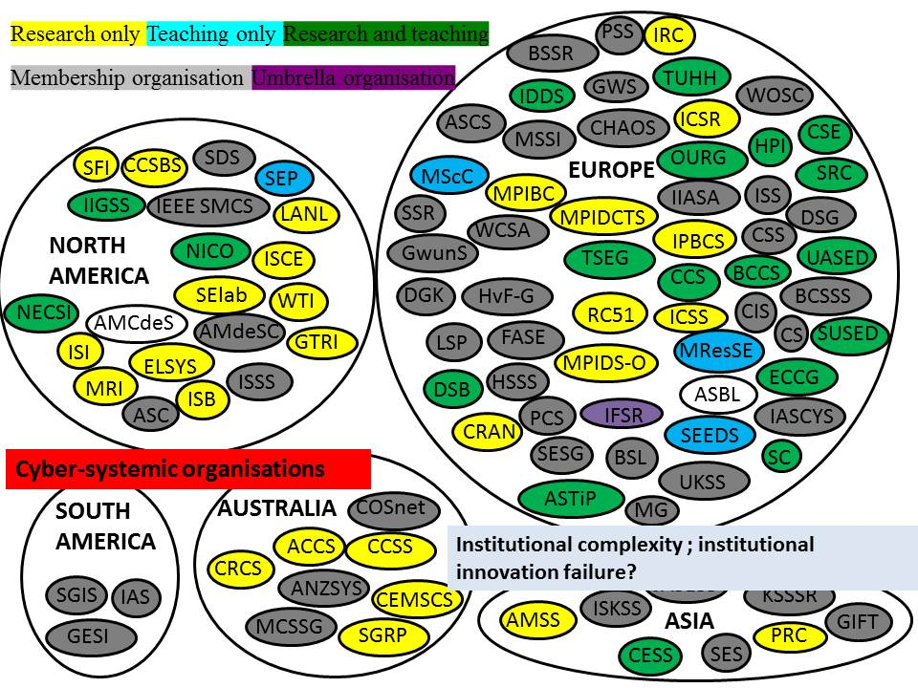
Figure 10. A systems map some of the world’s cybersystemic organisations (See Appendix 2 for details of organisations).
An aim of the inquiry was to initiate a process that fostered and built a new discourse and network of relationships from the fragmented global community of cybersystemic scholars (Figure 10) in an innovative organisational form – a systemic inquiry – that is designed to gain institutionalisation and investment in cybersystemic thinking and practice in diverse forms and contexts.
Ison (2015) argued the need to identify institutions that are missing, such as:
- Institutions that create ‘demand pull’ for cybersystemic understandings and practices?
- Institutions built on circular, systemic, recursive causality rather than linear causality?
- Faculties of cybersystemics…and trained faculty?
- A curriculum that deals with the breadth of material that could contribute?
- Institutions that drive and reward praxis (theory-informed practical action) innovation e.g. 17 SDGs (sustainable development goals)
And to engage in institutional innovation and reform, by addressing questions such as:
- can we design better institutions to realise better conversations/actions?
  - Cybersystemic Peak Body?
  - Cybersystemic educators Community of Practice?
  - Cybersystemic governing/governance ‘rules’?
- can we design cyber-systemic-institutions that can change our co-evolutionary trajectory?
  - e.g. requirements for ‘company boards’ to learn their organisations and account for their structural coupling?
The adequacy of the framings from the Rio Conventions was brought into question i.e., Climate Change; Biodiversity; Desertification & Land Degradation and Forests. Equally several speakers referred to the inadequacy of the triple-bottom line framing that has become so pervasive (i.e., economic, social and environmental). In other words all had become institutions no longer adequate to our circumstances.
Arild Vatn (2015) in his talk focused on the role of institutions in governance of non-linear systems – given the challenges of the Anthropocene. He undertook a discussion of the potential of institutions in influencing human action and offered some ‘evaluations’ of present (environmental) policies from the perspective of understanding (environmental) problems as non-linear and presented a few ideas regarding institutions for a sustainable economy given a non-linear ‘natural’ and ‘social’ world.
He proposed ways to operationalise institutional innovation in situations of non-linearity by proposing institutions for integrated and responsible action regarding both consumption; production; and international trade. The operational goal at the macro level is to reduce the need for growth, the key to which lies in the motivation behind production/ investment which leads in turn to a need for socio-ecological enterprises – new ownership structures and aims; firms that do not need a growing demand or firms that are highly sensitive to their environmental impact. In turn this requires:
- facilitated coordinated action (level 1): firms that accept collectively defined norms regarding their operations
- facilitated coordinated action (level 2): ‘Fine-tuning’ at local and regional levels
Vatn characterises present institutions (the current operating paradigm) in four dimensions:
- Rights: Individual rights to ‘economic resources’ – resources that are/can be commodified – are strongly protected. (Protecting some...)
  - Operating in markets leads to positive feedbacks.
  - Burden of proof by those trying to protect the integrity of environmental systems (strengthen resilience and ensuring ‘safety’)
- Transaction costs: High for coordinating individualized while still interdependent actions
- Perceptions: Myopic; oriented at individual gain
- Motivation: Individual rationality dominates
Within this world of Corporate governance there is a demand for a world without thresholds. Within this paradigm present policies are:
- Ex post, myopic and rather static
- Legal regulations in the form of limits
- Economic regulations in the form of taxes, subsidies and tradable quotas (markets)
- Not hopeless, but limited (ex post; individual rationality which gives rise to systemic conflict between the I and the We).
Vatn proposes to focus on developing institutions for non-linear systems based on:
- Rights: Strengthened and widened responsibility of actions
- Transaction costs: Reduce costs of interaction
- Perceptions: Broadminded and farsighted
- Motivation: Foster social rationality (the attractor of cooperation)
And then creating positive synergies between the four.
The speakers on day one challenged various framing assumptions about our current human predicament and offered alternative framing options. Challenges were also offered to the cybersystemic community to know its scholarship and praxis better, to more effectively institutionalise and to learn, in collaboration with institutional scholars, what crafting new institutions might entail.
As organisers of the systemic inquiry our empirical and experiential evidence suggests there is very limited formalised institutionalised capacity for cybersystemic thinking and practice in Germany today. This is very disappointing and, it could be argued, an intellectual and praxis strategic failing. This is interesting given the contributions made by German scholars in the immediate post-war period and up until the 1970s. For example, as Goepel (2015) noted Erich Jantsch, Club of Rome and University of Hanover articulated a systems approach to university education and innovation (1970): give it “a new purpose which may be recognized as a means of increasing the capability of society for continuous self-renewal”. There are some exceptions of course, such as the new investments at Leuphana, the University of Lüneburg (see http://www.leuphana.de/en/university/faculty/sustainability.html . Cybersystemic thinking and practice capability in a transdisciplinary setting has the potential to combine expertise of practitioners with theoretical expertise for potentially new knowledge (Goepel 2015).

2.4 Governance (or governing) innovation
A series of presentations were included in the inquiry for the purpose of illuminating how cybersystemically informed designs and actions could begin a process of transforming our system of governance’ towards potentially viable models of governance in the context of an unfolding Anthropocene. These presentations included reflections on historical experiences such as “Limits to Growth” and “Cybersim” in Allende’s Chile (Espejo) as well as several contemporary strands of inquiry including social leaning (Ison); the circular economy (James Greyson), the blue economy (Tibor Kiss) and “Systemic design” from which the number “of relations generates a new economic –productive model” (Luigi Bistagnino & Pier Paolo Peruccio, 2015).
Espejo (2015) reflecting on the Chilean experience with Cybersyn argued that “Beyond its technological implementation Cybersyn was a proposal for holistic governance; Beer’s Viable System Model was a visionary anticipation of the shortcomings of our reductionist and fragmented management.” Drawing on cybersystemic theory he makes the case for investment in a new phase of governance innovation that strives to “overcome fragmentation [by] guiding and enabling the self-organisation of the resources necessary for the holistic governance of our eco-systems: ‘Every Good Regulator of a System Must be a Model of that System’ (Conant & Ashby, 1971).”
Espejo (2015) makes the case for investment in the use and institutionalisation of the Viable Systems Model (VSM) because a cyber‐systemic challenge is making citizens and politicians increasingly aware of the need of holistic governance to improve on the prevailing reductionist approaches. Today we are increasingly aware about the costs of this reductionism he argued. Political and cultural constrains, among others, are making very difficult the idea of a holistic governance of the Anthropocene ... However, I suggest the Viable System Model offers a heuristic for good regulation.” He concludes: “In a democracy holistic governance requires the co‐production of values between policy ‐ makers and citizens to make visible political and expert guidance and people’s interests and concerns. Transparency of communications between citizens and policy‐makers is far more than making information available: it is building up effective organisational systems. These are points emerging from the vision of Beer ́s Cybersyn.”
Luigi Bistagnino & Pier Paolo Peruccio, (2015) provided an example from an Italian region of a design activity to create ‘productive processes in order to obtain ecological goods by planning the flows of matter and energy that flow from a system to another one’. They put the case for the contextual redesign of the flows of energy and matter, making the point that in our current paradigm ‘whenever you buy you are giving money to a platform of logistics’…and almost invariably 20-40% of what is consumed, and paid for by the consumer, goes to landfill.’ This is very different to local food. They demonstrate with a case study from Italy the positive benefits both economically and systemically from taking a systemic design approach (Figure 11).
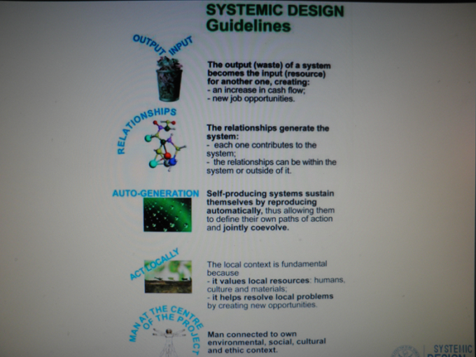 | 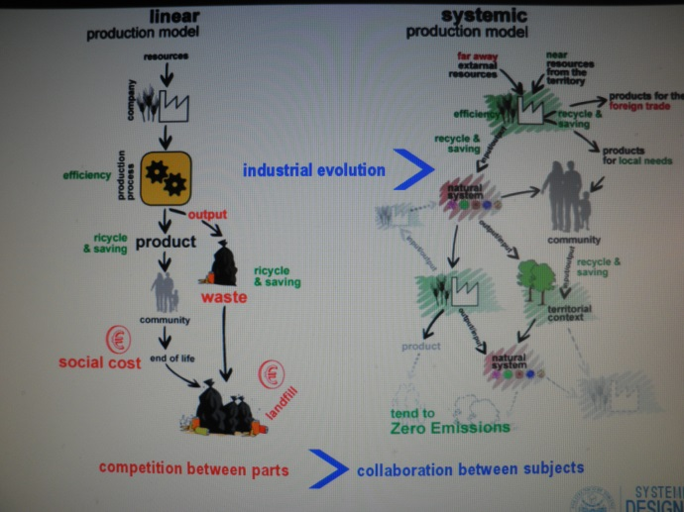
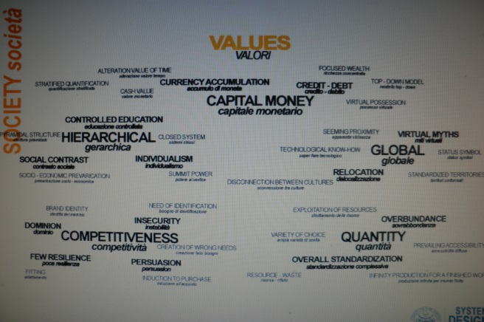 | 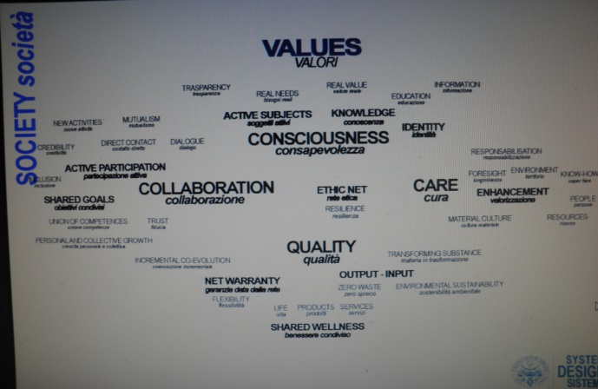
Figure 11. (a) Systemic design guidelines; (b) characteristics of a linear (systematic) design process compared to a systemic approach; (c) traditional design values (d) systemic, transformative design values.
Greyson (2015) reflects that “five decades [have been spent] seeking [the] ‘circular economy’ and other solutions to global problems [but we] focus on reductionist, incremental and technical solutions yet problems still worsen”. He argues that “non ‐ incremental non‐reductionist and systemic solutions remain as blindspots.” He provides an example of traditional ‘waste management’ compared with the circular-economy concept of precycling to characterise the shift that is possible: the former is characterised by (i) managing waste after it happens; (ii) talking about the circular economy; (iii) raising awareness; (iv) calling for action; (v) watching more incinerators being built, whereas precycling entails: (i) stopping waste before it happens; (ii) understanding every product has a waste ‐risk; (iv) producers insure waste ‐ risk; (v) price signals with precycling funds.
In articulating the possibilities of a new ‘blue economy’ Kiss (2015) characterised the governance/conceptual shift as to where ‘Ecosystems connect, creating networks of networks, where each contributes to the best of its ability and endlessly cascades nutrients and energy using the enduring laws of physics’. From this perspective there is ‘no trade-off: we have to develop biodiversity around us in order to have abundance.’ ‘The Blue Economy is a bottom-up approach, where Nature based autopoietic processes could provide a solid substrate/basis for a healthy social and economic development.’ Cybersystemic concepts sit at the heart of this initiative, namely:
- Autopoiesis: "creation, production” refers to a system capable of reproducing and maintaining itself. (Wikipedia)
- Hierarchy: Autopoietic systems can generate (more) complex systems, where there are enough control to achieve coordination towards the larger systems’ good and enough autonomy to keep all subsystems flourishing.
- Structural coupling : these systems develop in a co-evolutionary dynamic process –emergent properties
- Cybernetics: “The science of communication and control in man and machines” (Norbert Wiener)
But Kiss, asks: ‘what type of control can be applied in these processes?’ His answer is: ‘institutional systems … generated at the points, where emergent properties need them.’ In other words institutions that arise, or are designed after emergence rather than ex ante.
Klein (2015) argued strongly that in any conversation about the Anthropocene it was important to remember that ‘the invisible hand is not your friend’. He situated his arguments within the precepts of the Frankfurt School that somewhere ‘the enlightenment went wrong’ cultivating hubris and ceding power to the individual from which the individualised risk of the ‘risk society’ (Ulrich Beck) has emerged. All too often we are confronted by heroic management – the mistaken belief that through superhuman effort the capable manger can control, cause, effect all that is his/her purview. Drawing on the metaphor of ‘The Matrix’ he argued that we had to work to change the matrix – without this there is not a lot of good we can do in the current ‘system’ where both positive and negative sanction fail and where ruling is no longer politics but responses to a globalised economy. The alternative he proposes, recognising that the outer frame in which structure regulates behaviour and produces different (and often incommensurable) mental models and institutions, is to build through investment and praxis innovation a field of systemic social design to learn more about and bring about transformative possibilities.

2.5 Praxis and policy innovation
Presentations by Harrer (2015) and Lane (2015) provided compelling evidence of the effectiveness of cybersystemic approaches in a range of governance settings associated with uncertainty and complexity (e.g. Figure 12). Lane (2015) argued that cybersystemic approaches may be the only real means to break out of the limitations of the current inadequate mental models and pointed to a range of examples from his own work (Lane 1999; 2000; Lane and Husemann 2006). Our current mental models are inadequate he argued because (i) we only look at partial ‘pictures’ of an issue; (ii) our approaches are inadequate for issues that are separated in time and space; (iii) we are all too often immersed in a situation and unable to see it for what it is (iv) with the end result that social and physical dimensions of situations are no longer accessible to lived experience – they are often not conceptualisable. In praxis terms there is a propensity to (i) stop when a simple cause is found; (ii) not expect or manage feedback; (iii) become convinced by a hegemony or ideology; (iv) rely on inadequate mental models.
Lane (2015) proposed a strategy for effective action in the cybersystemic domain which is worthy of further development and investment: (i) know some good case studies of where cybersystemic approaches have been used effectively (i.e., have access to a repository); (ii) know good systems thinkers/practitioners you can recommend; (iii) be a good systems thinker yourself; (iv) know policy makers who understand and are interested in systems thinking; (v) do good work. He makes the point that the stocks in contrast to the flows) become invisible in the praxis dynamic unless they are made visible. He concluded with the observation that ‘we have it in our power to begin the world over again…..a beginning that has a more powerful place for cybersystemic thinking and action’.
Following Lane’s logic it can be concluded that there are too few known examples of cybersystemic praxis concerned specifically with effectively ‘governing’ the social and biophysical in co-evolutionary terms (the work by Ison and colleagues on social learning being a possible exception). There is a strong case for building the evidence base in this domain.
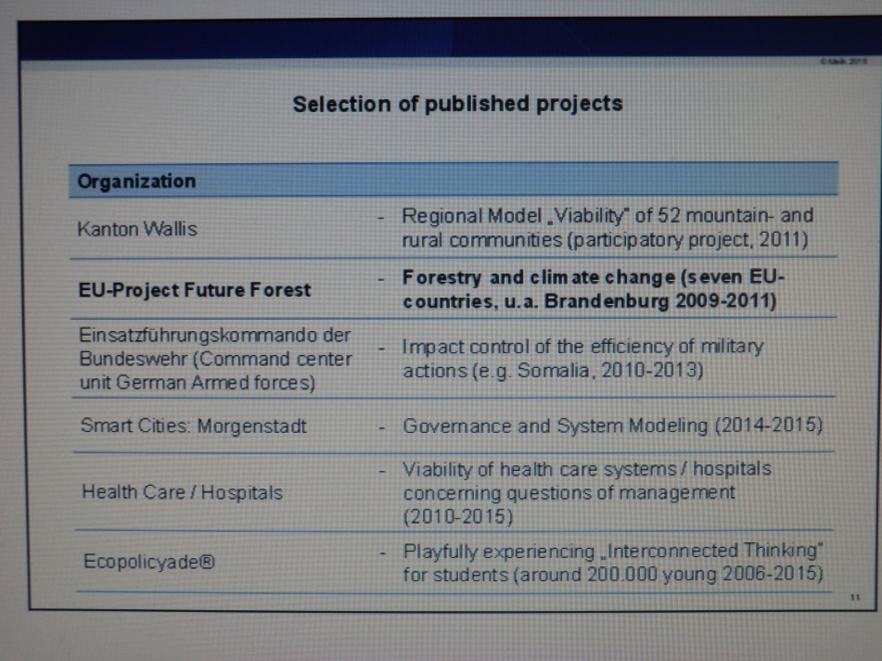
Figure 12. A selection of projects undertaken using cybersystemic approaches by the Malik organisation (Source: Harrer 2015).

2.6 Avenues for on-going inquiry
Rechkemmer (2015) argued the need to move towards a collaborative research, teaching and policy agenda on Social-Ecological Justice for Sustainable Development ...going beyond the old triple-bottom line conception pf Social/ Environmental/ Ecological Justice towards something more systemic. Pier Paolo Petruccio (2015) cited the success that ‘design innovation’ has had over the past six years in terms of policy support and development at the European level. Design is a driver of user-centred innovation…..and there is a desire to have this type of thinking and practice institutionalised by 2020.
It is recommended that meeting between scholars/practitioners and policy makers from (i) systemic design; (ii) cybersystemic praxis; (iii) institutional crafting be designed and funded as a means of aiding the development of institutional arrangements that support capability building across these three interacting domains – all with capability to enhance governing praxis in an emerging Anthropocene’.
Vatn (2015) claimed that “governance in the Anthropocene implies responding to challenges we have caused at levels beyond the ‘local’ – it demands reorganizing. Existing institutional structures are ill-equipped to meet the challenges of us operating in environmental systems that are non-linear and characterized by thresholds. Progress lies especially in understanding the non-linearities observed in the interplay between institutions and human motivation. Progress also lies in deepening and strengthening the ‘attractor of cooperation’ – strengthening institutions that foster cooperative action.” In making these claims he aligns himself with the main arguments of Bateson (2015)
The presentations on praxis that links with policy by Harrer, Lane and the activities of the SystemicExcellence group (Klein) provide responses to two of Haggerdorn’s opening questions, namely: (i) where are the micro -foundations for systems approaches to institutions and governance structures? and (ii) solving real actors’ problems in crafting institutions - what have cybersystemic approaches contributed to this? Lane’s UK Child Protection (Munro Review) case study is clearly an excellent example – but the case possibly remains that we have too few examples, and that there is a need to invest in research and praxis innovation in, say building better ‘we’ institutions (after Vatn) into our governing praxes.

There was a strong and well supported recommendation from the Inquiry audience to invest in producing a set of Policy Briefs for a future World Economic Forum meeting based on the inquiry material and framing of the problematique.
This recommendation built on the observation by Maja Goepel that ”earlier this year in Davos, I was tremendously impressed by the shared appreciation emerging for ecosystem approaches to wicked opportunity; approaches that engage communities and reimagine government, while tapping market forces for scaling up.”

2.7 Proposals for transformation through research
Maja Goepel (2015) made claims for research to realise a set of potentials of a contemporary cybersystemic initiative, viz:
- transdisciplinarity – making rigorous, robust, relevant knowledge;
- what systems? – side-effects of a hype;
- transformation ≠ adaptation ≠ revolution – the “radical” agenda;
- transformative literacy - – paradigms as structural power and empowering lever i.e., hack the existing ‘system’ and do not forget about power.
Possible research questions put forward by Goepel (2015) were:
- which role does power play in cybersystemic governance processes?
- Which structures today inhibit cybersystemic governance?
- Is there a cap on size for cybersystemic governance processes?
- Yes, institutionalize for Deutungshoheit;
- Build/invent a lab for ecosystem-based business ecosystems....
Klein, with support from Lane argues the need for a cybersystemically-informed investment in a ‘big science’ equivalent on the theme of “social design impact evaluation”. His vision is to build a tradition of continuous and transformative research in which society leans more about what we are, and are not doing in the social systems we inhabit (i.e., research that is critically transformative). Supporting this proposal, Lane argues that the default of TINA (there is no alternative) needs to be surpassed by the continual generation of good examples of what could be; he notes however that many in society appear to be afraid of good examples and are not able to deal well with variety.
Laouris (2015) offers on-going collaborative possibilities with his ‘Reinventing Democracy in the Digital Era’ research program; Zoraida Mediwelso-Benek argued for the joining up of cycbersystemic research concerned with community initiated transformation with the wider fields associated with community development and social/ecological justice (Mayo et al 2013).
Future collaborations with WINS, the Wuppertal Institute (Berlin), Ecologic, Leuphania University Sustainability Science Faculty and Prof. A Thiel (University of Kassel) are under discussion.
Inquiry participant Professor Rik Leemans has mentioned the possibility to publish with COSUST (http://www.journals.elsevier.com/current-opinion-in-environmental-sustainability/) based on the Herrenhausen event. Participants interested in exploring this possibility ae invited to consult other participants about possible collaborations and/or contributions. COSUST is a journal that publishes timely short (i.e. 3000 words) review and synthesis papers, but not research papers with new research results or insights. Prof Leemans says: “If you believe that it is possible to submit a series of papers, please, submit an issue proposal and we'll judge if it is appropriate for COSUST. The proposal should contain information on the timeliness of the topic, a motivation to publish in COSUST, and an annotated and structured outline of all intended papers and their authors. More information can be found at http://www.journals.elsevier.com/current-opinion-in-environmental-sustainability/

3. KEY ISSUES EMERGING FROM 16 INQUIRY GROUPS3.1

3.1 Introduction
The 16 inquiry groups generated a lot of data during the two day event – see http://www.open.ac.uk/blogs/govan/?page_id=88 . The key issues emerging from the inquiry groups reported below are based on a meta-analysis of the summaries produced by each table. Inevitably, there is some generalisation.
The purpose of the meta-analysis is to shed light on the framing questions of the inquiry and to draw attention to emerging issues, opportunities and possible actions. Where possible, we have indicated a sense of common insights and consensus between tables, but our meta-analysis is not based on emerging consensus. Sometimes, stark differences or individual discussions on just one table can be revealing. We have used the objectives from the original Inquiry proposal to structure reporting of the meta-analysis, although reordered for the purposes of this report, namely:

- Can representatives from the differing cybersystemic lineages and communities in conversation with each other generate fresh insights into the problematique?
- What contributions might a more institutionally coherent field of cybersystemics scholarship contribute to governing the Anthropocene?
- Can relationships in this field be strengthened between German scholars and the Anglo-Saxon traditions and made relevant to the issue?
- Can the representatives identify a research agenda with potential to realise new theoretical methodological, institutional and praxis innovation able to break with dualistic and linear, causal thinking and acting? What actions are needed to enable this to happen?

3.2 Can cybersystemic lineages and communities generate fresh insights into the problematique?
At the beginning of the inquiry, the tables were asked to explore a key question: ‘Governing the Anthropocene: Cybersystemic possibilities?’ and to identify a range of issues and opportunities associated with the question. The issues identified in the ensuing conversations generated considerable insight into the problematique of governing the Anthropocene. However, there was insufficient time to be able to draw out the different intellectual lineages (primarily cybernetic, systems and institutional economic) within the inquiry and how they might contribute to understanding of the problematique. Nonetheless, the design of the event meant that these lineages were integral to the conversations at each table. The outputs of the tables thus represent the diversity of different cybersystemic communities and their perspectives on governing the Anthropocene. It is clear that the problematique has many different facets.
From the outset, there was questioning of the term Anthropocene itself – its meaning, usefulness and how it could be measured. For some, the term carries a ‘selfish’, egotistical element which assumes that humans are the most important causal part of global change. For others, the Anthropocene is too ‘global’ in scope and is largely meaningless at more local scales where changes in behaviour are needed. Participants drew attention to the boundary choices of the Anthropocene and noted the term is only as useful as the extent to which we engage with it and use it to reflect on socio-ecological relationships at different scales.
Aside from definitions, perhaps unsurprisingly, power and power structures were identified as part of the problematique. Power structures were seen as often lacking transparency, with power, money and resources continuing to be invested in “business as usual” trajectories and thus prohibiting real changes. For some, an inability, or fear, to name economic systems as a major hurdle is part of the problematique. This raised a fundamental question about who governs (in) the Anthropocene? For some, existing institutions cannot govern the Anthropocene because they cannot (or do not) question their own assumptions due to the continuing dominance of dualistic, hierarchical, non-interdependent, linear thinking.
Allied to this, participants noted the continuing bias in governance towards being independent and competitive as a desired state. This led some tables to question whether it was even possible to govern the Anthropocene because governing implies a goal orientation (though this notion of ‘goal-seeking’ as a way of thinking and acting has been denigrated within parts of the cybersystemic community). Current goals of profit and competitiveness have led to the current situation where organisations and companies are regarded as ‘successful’ when they endanger critically important ecosystems such as the Arctic and rainforest. The competency of business models to recognise or accommodate the complexity of the Anthropocene was cause for doubt.
If business models are lacking, participants were equally concerned about the relationship between science and governance and its limitations. Science and governance processes have found it hard to deal with notions of complexity, scale issues and non-linearity. For some participants, even though science is dis-embedded from political processes, it is still being used as an instrument for governance without appropriate understanding of the science and its caveats or how it can be best used.
This led to concerns of a disconnection and lack of integration between research communities using different methodologies, different scales (local, global, territory, geographical, political etc.). Hence, there is no integrated academic discipline centred on systems – a key gap in making sense of Anthropogenic complexity. These facets exacerbate confusion and complexity experienced by decision-makers trying to use scientific findings. Championing the case for investment and institutional innovation is a role that the VolkswagenStiftung could well undertake and/or facilitate.
Modelling is equally problematic both in predictive power and in the assumptions embedded within models which are rarely explored, questioned or understood. ‘Alternative‘ modelling approaches centred on participation and learning are rarely utilised because they are not part of the scientific tradition. This leads to framing and investigating complex situations as single issues: e.g. global warming can be ’solved’ by C0₂ reduction. The resulting tendency of science and governance processes to focus in on one dimension using systematic thinking and discussion limits capacity to deal with complex social phenomenon.
Other facets of the problematique were raised including concerns about differences in language and a lack of a common language to make sense of the Anthropocene; and the limitations of skills and concepts taught in universities, professional fora and existing governance institutions to address systemic complexity and interdependency. The speed and systemic nature of possible changes in the Anthropocene mean that education in more general terms is an issue because of the time taken to change paradigms and practices in society and in governance processes.
Drawing on Bateson’s presentation, the culture of independence was noted at many tables as part of the problematique because it builds walls between people, and in relation to nature/environment and thus avoids understanding a situation. Learning about and working with notions of interdependence as complementary to cybersystemics was, for many tables, a key strategy for governing (in) the Anthropocene. However, it was also recognised that currently concepts associated with cybernetics and systems thinking are often ‘too far away‘ from ordinary thinking to be meaningful and to provide alternatives.

3.3 What can cybersystemics scholarship contribute to governing the Anthropocene?
There was a range of perspectives and suggestions on opportunities and possible contributions from the cybersystemic community. Participants were positive about the potential contribution of cybersystemic scholarship to understanding the Anthropocene, in particular the possible contributions to be made exploring notions of holism, integration, interdependence and systems. Even with concerns about their ‘ease of use‘, cybersystemic scholarship were seen as key to providing conceptual clarity and (a) language and methodologies to help progress praxis for governing (in) the Anthropocene.
A very positive response arose on several tables following the presentation of Mary Catherine Bateson. Her talk on distinctions between independence and interdependency led to insights amongst participants about opportunities for social learning to learn more about interdependence and the role of trust. Celebrating and utilising human creativity and agency could be a way of transforming the more negative and egocentric discourses centred on the “Anthropocene”. For at least one table, the core value of ‘interdependence‘ compared to ‘independence’ is both the challenge posed by and also the key to making sense of and learning how to act in the Anthropocene.
In a similar vein, suggestions to develop ‘Whole System Theory‘ were offered as a way of developing and deepening a core body of knowledge for governing the Anthropocene and developing understanding of interdependence. Systems language and concepts could be a means to help achieve this across different disciplines. A cybersystemic focus on boundary choices and interdependencies could also be helpful in revealing multiple perspectives available for defining the Anthropocene at a local scale and not just the planetary scale as a means to engage local communities and actors.
Engaging with other perspectives to understand the assumptions that underpin differing world views was considered an important first step to systemically co-approach new narratives of envisioning and describing what ought to be, or become, governing in the Anthropocene. However, engaging with and learning about interdependencies at different system levels will require trust, new skills and understanding. In particular, cybersystems concepts, methodologies and practices could be a way to enable actors to acknowledge and work constructively, in collaboration, with the heterarchy of values, plurality of perspectives and diverse ethical frameworks implicit in governing (in) the Anthropocene. Fundamental to this is the shift in thinking required from seeking ‘control’ to ‘navigation’ as a more systems-informed response to managing, rather than solving, the range of complex situations encompassed by notions of the Anthropocene.
As part of the shift to navigation, and in the search for more equitable power relations, cybersystemic approaches were also thought to offer an opportunity to make explicit ethical assumptions and consider responsibilities arising from an appreciation of systemic interdependencies within a context of uncertainty. At least one table suggested efforts could be directed at developing and promoting ‘fundamental values’ for the Anthropocene, by focussing on ‘wellness beyond GDP‘ as a step in making visible viable alternative systemic economic change where wellbeing is understood as part of the means of production.
Cybersystemic approaches also present an opportunity to reveal and renegotiate system boundaries with decision-makers and escape traps inherent linear methods. Developing cybersystemic institutions that, by definition, question their own assumptions would also require a language of communicating about complex systems which is meaningful and useful beyond scientific communities. In regards to science, a challenge of current scientific approaches is whether they allow the opportunity for navigation rather than control. According to participants, science needs to develop holistic and systemic capacity which embraces uncertainty and which generates epistemological awareness by recognizing, critiquing, developing, using, and choosing among multiple perspectives. Experimental, living labs (new agoras) were suggested, but, in recognition of the significance of locality and context, an imperative must be to abandon reproduce-ability as the test of knowledge. Suggestions were also made to embed science into political processes, recognising that incorporation of different types of knowledge could help to repoliticize knowledge science and begin a process of changing perceptions on the nature and role of science.
Running through many opportunities suggested by the participants was a commitment to, and passion for, trust, collaboration and learning as the hallmarks of systemic governance (in) the Anthropocene.

3.4 Can relationships between German scholars and the Anglo-Saxon traditions be strengthened?
Presenters drew on German systems scholars including Vester, Luhman, Jantsch, members of the Frankfurt school, von Foerster, von Bertallanffy and Hegel. Whilst German institutional economics and cybersystemic practitoners and scholars were well represented the inquiry did not receive any input from an active German research and/or teaching programme in cybersystemics (apart perhaps, from participants from several Vienna-based groups). This absence was not from want of trying by the organisers. It remains to be tested via longitudinal evaluation if the Germanic traditions of cybersystemics have expanded due to the event at Herrenhausen. Well received input was made from active German-based praxis groups – Malik and Systemic Excellence.
As organisers of the systemic inquiry, our empirical and experiential evidence suggests there is very limited formalised institutionalised capacity for cybersystemic teaching and research practice in Germany today. This is, it could be argued, a strategic failing, especially given the contributions made by German scholars in the immediate post-war period and up until the 1970s. For example, as Goepel (2015) noted, Erich Jantsch, Club of Rome and University of Hanover articulated a systems approach to university education and innovation (1970) to give it “a new purpose which may be recognized as a means of increasing the capability of society for continuous self-renewal”. There are some exceptions of course, such as the new investments at Leuphana, the University of Lüneburg (see http://www.leuphana.de/en/university/faculty/sustainability.html ).
We suggest that the Inquiry was a major step forward in helping to rekindle interest in and develop new links between German scholars and Anglo-Saxon traditions, but more widely, from many other traditions. Future collaborations between various participants with WINS, the Wuppertal Institute (Berlin), Ecologic, Leuphana University Sustainability Science Faculty and Prof. A. Thiel (University of Kassel) are under discussion.

3.5 A research agenda for innovation in theoretical methodological, institutional and praxis
Given the numbers of participants, their backgrounds and interests and design of the event, as well as the nature of the problematique, the inquiry process did not define and agree a single research agenda or focus on research. However, the design of the event did enable each inquiry table to formulate an actionable system in response to the issues raised during the two day event. Each actionable system incorporates elements of a research agenda. While the details of each system are beyond the scope of this summary report, the following amalgamation of the different table reports represents the main elements and activities. It is not intended to be read as a complete list of actions all at the same ‘level’ since the elements were specific to particular discussions at each table. The intention is to provide a sense of the range and type of activities that could be progressed to develop conceptual, methodological and praxis innovations. The suggestions are:
- Advance the concepts and methodologies of science to include systemic and cybersystemic applications
- Support and explore diverse perspective and normative positions of others
- Develop capacity and use networks to share knowledge of cases, successes and failures
- Make explicit and include ethical framing and assumptions
- Allow co-approaches to develop new narratives of e.g. navigation rather than control
- Review and make explicit (and negotiate) boundaries and scale
- Use models and modelling to promote learning, education and as a tool for citizen participation and democracy
- Acknowledge, explore, enable and learn about interdependency and its diverse forms
- Act on the basis of analysis and awareness of interdependencies and interconnections
- Explore, uncover and challenge/ break-up power structures
- Embrace and value uncertainties in perspectives and decision-making
- Foster action research to apply cybersystemic approaches and philosophy
- Create more reflexive governance systems and institutions which learn from feedback
- Embed cybersystemics in learning and teaching at school – university and in the workplace
- Explore opportunities for circular economy and application of cybersystemics in industry
- Reframe narratives from competitive to collaborative / responsible

The detail of how any one of the above might be enacted will vary according to context and aims. However, collectively, these high level elements point to the need for governance systems which are capable of dealing with uncertainty, able to make plain and incorporate diverse framings, perspectives and feedback and which are able to acknowledge and act with awareness of interdependencies. The need for cybersystemic skills, capacities and learning are evident – a follow-up action could be to facilitate and institutionalise a strong network of systems educators and support an international strategy for building systems literacy supported by the IFSR (see Box 1 in the Annex). On the back of this initiative we envisage linking with participants in the Inquiry to begin the process of expanding and consolidating an international network of cybersystemic educators and educational organisations.
Another key area is modelling as a form of praxis that may, or may not enhance governing. Models need not be technocratic if they are open to people’s participation and learning rather than specifying an end point or an equilibrium position. Our opportunity is to not use models as devices to predict the future, nor as devices to prescribe what the future should be, but as devices which extend our capacity to learn about and appreciate longer term and systemic consequences in governance and to facilitate deciding how to act.
Individual actions and voting patterns for those tables that did vote are available from the Inquiry blogsite.

4. INVESTING IN OUR FUTURE
This report highlights a number of important theoretical and methodological insights gleaned from the inquiry process. As this report remains a ‘draft’ we are inclined to leave this final section open to feedback from you, the participants, as to what would you now recommend for investing in our future? Based on your Herrenhausen experience what have you done that you could attribute, even in part, to the experience? What opportunities can you now see that would be worth sharing with the community that was initiated? Avenues for future investment include future research and development, capacity building, networking, institutional innovation or ongoing inquiry.
Scranton (2015) argues that in respect of the Anthropocene, and especially global warming ‘across the spectrum ..nobody seems to have the tools, clout or conceptual framework we need to fix it, or even to come up with a good plan to protect ourselves from the greatest dangers. There’s no reset button for civilization, and no visible plan for transforming global infrastructure, agriculture and energy networks in the next ten to twenty years’ (p. 67). Whether cybernetics and new governing praxes can make a major contribution remains an open question, but one that holds considerable promise in terms of harnessing and refreshing human systemic sensibility accompanied by building systems literacy and systems thinking in practice capability (Ison and Shelley 2016).
This joint meeting of scholars and practitioners from the fields of cybersystemics and institutional economics was an experiment but one that holds promise of producing further synergies if on-going inquiry is enabled and grounded in, for example, particular research programs. The same possibility exists for cyberystemic scholars with other academic areas that ultimately have concerns with praxis and governance innovation e.g. planning, public policy or public administration, systemic design, systemic evaluation, and perhaps new fields could be created in public policy that draw heavily on systemic family therapy and/or dramaturgy and choreography?
In the final round of action statements that came from each table group at Herrenhausen one proposal that attracted considerable enthusiasm (as measured by applause) was the recommendation to invest in producing a set of Policy Briefs for a future World Economic Forum meeting based on the inquiry material and framing of the problematique. Is there a champion for this initiative available?
Fostering and building institutional capacity and cohesion for cybersystemic in the German-speaking-world, and in turn with the global cybersystemic community would seem a logical next step. The 2017 meeting of the ISSS will be held in Vienna in July – this may provide an opportunity for follow-up actions. Alternatively a follow-up event with input from Future Earth could be explored given the systemic and transformational nature of their mandate.
The publication of Laudao Si, a profoundly cybersystemic document, provides an opportunity to explore whether the encyclical has begun to play any role in policy formation and development i.e., are its arguments enough to trigger changes in praxis?
Since the Herrenhausen meeting IFSR has formulated a ‘Proposal to Articulate the Foundations of Cyber-Systemics’ (Box 6). Other proposals are to be welcomed before this report is put between covers.
Box 6
The meeting, “Governing the Anthropocene: Cyber-Systemic Possibilities,” sponsored by the Volkswagenstiftung in July 2015, was successful in a number of ways. It brought together professionals from systems and cybernetic organizations, along with experts from related fields of study, whose research and interests were similar but not always connected. The meeting allowed a broadening of both the thinking and the relationships amongst the participants.
Just as importantly, this meeting supported Ph.D. students whose interests and research were focused on cyber-systemic topics, and allowed them to participate with the experts as ideas were being debated and developed. Since that time, a number of other events have taken place. Out of those have come specific needs which require attention and resources.
For many years, there have been requests for common introductory materials for students (and professionals) interested in cyber-systemic topics. Despite the fact that complexity is so often identified as a global concern, programs focused on a holistic understanding of complexity and chaos have been eliminated from many universities, in favour of narrow, technological approaches. That deficit has limited the development of cyber-systemic literature, which would normally result from the needs driven by professors and students. While examples of materials exist, most tend to fall within specialized areas of study, or to introduce only narrow and particular theories attached to individual authors and ideas. They do not provide an overview of the most fundamental concepts across the broad fields of study which are affected. (This is necessary if students are to learn how to work across specialized disciplines.)
An important next step would be to hold a meeting involving similar participants to those in Governing the Anthropocene: both experts and students involved in cyber-systemic work. The purpose of this meeting, however, would be much narrower. The aim would be to create first drafts of the Fundamental Concepts of Systems and Cybernetics. Since the theories have been developing for over 60 years (and sometimes closer to 100 years), it will require some time and effort to review and prioritize those which are deemed to be foundational (meaning that all students should have at least a basic understanding of them) as opposed to those that are more advanced or specialized in their applications. These concepts would then be encouraged for use in introductory textbooks, university courses, and online sites relevant to the topics. It is hoped that such a meeting could be held no later than 2017.

5. REFERENCES
Andersson, K. P. and Ostrom, E. (2008). Analyzing decentralized resource regimes from a polycentric perspective. Policy Science 41: 71-93.
Beilock, Sian (2015) How the Body Knows Its Mind: The Surprising Power of the Physical Environment to Influence How You Think and Feel, Atria Books, New York.
Blackmore, C.P., (2009). Learning systems and communities of practice for environmental decision making, Unpublished PhD Thesis, The Open University (UK).
Checkland, P., (1999). Systems Thinking, Systems Practice: includes a 30-year retrospective Chichester: John Wiley and Sons Ltd. 416 p.
Checkland, P., (2002). Thirty years in the systems movement: disappointments I have known, and a way forward. Systemist 24(2), 99-112.
Churchman, C.W., (1971). The Design of Inquiring Systems: basic concepts of systems and organization. New York: Basic Books.
Conant, Roger C. and W. Ross Ashby (1970) Every good regulator of a system must be a model of that system Int. J. Systems Sci., 1 (2), 89-97.
Dewey, J., (1933). How We Think. A Restatement of the Relation of Reflective Thinking to the Educative Process (revised edn), Boston, D.C. Health.
Falk, T., Bock, B. and Kirk, M. (2009). Polycentrism and Poverty: Experiences of Rural Water Supply Reform in Namibia. Water Alternatives 2(1): 115-137.
Ison, R., (2002). Some Reflections on a Knowledge Transfer Strategy: A Systemic Inquiry, In: Farming and Rural Systems Research and Extension, Proceedings of the Fifth IFSA European Symposium, pp. 647-656.
Ison, R.L., (2010). Systems Practice: How to Act in a Climate-change World. Springer, London.
Ison. R.L. (2012) A cybersystemic framework for practical action. In Murray, J., Cawthorne, G., Dey, C., and Andrew, C. eds. Enough for All Forever. A Handbook for Learning about Sustainability, pp. 269-84. Champaign, Illinois: Common Ground Publishing.
Ison, RL (2016) Governing in the Anthropocene: what future systems thinking in practice? Systems Research & Behavioral Science (in press)
Ison, R.L. & Schlindwein, S. (2015) Navigating through an ‘ecological desert and a sociological hell’: a cyber-systemic governance approach for the Anthropocene, Kybernetes, 44 (6/7), 891 - 902.
Ison, R.L. & Shelley, M. (2016) Governing in the Anthropocene: Contributions from Systems Thinking in Practice? Editorial, Systems Research & Behavioral Science (in press)
Kallis, G. & Norgaard, R.B. (2010) Co-evolutionary ecological economics, Ecological Economics 69,690 – 699.
Lakoff, G. (2010) Why it Matters How We Frame the Environment, Environmental Communication, 4, (1), 70-81.
Lane, D. C. 1999. Social Theory and System Dynamics Practice. European Journal of Operational Research 113(3): 501-527.
Lane, D. C. 2000. Should System Dynamics Be Described As A ‘Hard’ Or ‘Deterministic’ Systems Approach? Systems Research and Behavioral Science 17(1): 3-22.
Lane, D. C. and E. Husemann. 2008. Steering without Circe: Attending to reinforcing loops in social systems (2007 Jay Wright Forrester Award address). System Dynamics Review 24(1): 37-61.
Malm, A. & Hornborg, A. (2014) The geology of mankind? A critique of the Anthropocene narrative, The Anthropocene Review
Marshall, G. R. (2009). Polycentricity, reciprocity, and farmer adoption of conservation practices under community-based governance. Ecological Economics 68: 1507-1520.
Maturana, H.R and Verden-Zoller, G. 2008. The Origin of Humanness in the Biology of Love, Imprint Academic Press, Exeter.
Maturana, Humberto, Davila, X. and Ramirez, S. 2015 Cultural Biology: Systemic Consequences of Our evolutionary natural drift as molecular autopoietic systems, Found Sci, Published online 28th September 2015.
Mayo, M., Mediwelso-Bendek, Z. & Packham, C. eds (2013) Community Research for Community Development, Palgrave Macmillan, Basingstoke.
McGinnis, M. D. (1999). Introduction. In Polycentric Governance and Development: readings from the Workshop in Political Theory and Policy Analysis, McGinnis, M. D. (Ed.). Ann Arbor: University of Michigan Press; 1-30.
Mishra, Kirti (2016) Unpublished PhD Thesis, Monash University.
Murray, J. (2006) Toward a Cultural Theory of Gaming: Digital Games and the Co-Evolution of Media, Mind, and Culture, Popular Communication, 4 (3), 185–202.
Norgaard, R.B (1994) Development Betrayed. The End of Progress and a Co-evolutionary Revisioning of the Future, Routledge, London & New York.
Ostrom, Elinor (2009) Economy and Political Sciences, Nobel Prize Lecture, Dec, 8.,
Ostrom, Elinor (1990) Governing the Commons: The Evolution of Institutions for Collective Action, Cambridge University Press.
Ostrom, Elinor (2005) Understanding Institutional Diversity, Princeton, Princeton University Press.
Ostrom, Elinor and Hess, Charlotte, Eds (2006) Understanding Knowledge as a Commons: From Theory to Practice , The MIT Press, Cambridge, Massachusetts.
Ostrom, V., Tiebout, C. M. and Warren, R. (1961). The Organization of Government in Metropolitan Areas: a theoretical inquiry. The American Political Science Review 55(4): 831-842.
Scranton R. 2015. Learning to Die in the Anthropocene. Reflections on the End of Civilization. City Light Books: San Francisco.
SLIM., 2004. SLIM Framework: Social Learning as a Policy Approach for Sustainable Use of Water, (available at http://slim.open.ac.uk). p 41.
WCED (World Commission on Environment and Development) (1987) Our Common Future, A/42/427. Chapter 2 The concept of Sustainable Development. www.un‐documents.net/ocf‐02.htm.

Appendix 1: PhD Programme Details

(i.i) Process Design
The course will be held in connection to the 2015 ISSS Conference in Berlin and the Herrenhausen ”Governing the Anthropocene” systemic inquiry (sponsored by the Volkswagen (VW) Foundation at the Herrenhausen Palace in Hannover – see http://en.wikipedia.org/wiki/Herrenhausen ) and draw on the gathering of specialists and researchers within this field. The design draws on tried and tested ways of experiential learning and the expertise of academics who have been designing learning experiences for mature age learners for many years. The course will be grounded in a project of your own choice, preferably based on your PhD work. In your time in the program, if accepted, you will participate in an inquiry with three main parts - before, during and after the conference. It will also involve some preparation and submission of a final reflection.
- Before the course, you will be asked to complete an assignment in which you describe and reflect on either (i) your understanding and use of systems/cybernetic theories in your project; or (ii) the rationale you have followed, or would follow, in making a choice to include, or not, systems/cybernetic theories in your PhD research; this will require an on-line submission prior to your arrival.
- The course will start with participation in a purposefully designed ‘systemic inquiry’ exploring the question: Governing the Anthropocene: cybersystemic possibilities” taking place on 30 - 31 July at Herrenhausen Hannover hosted by the VW Foundation. You will be engaged in active table-based inquiry with 150 invited participants keynote presenters and panels who will provide ‘evidence’ for your inquiry. As part of your participation you will be expected to help with report preparation from your inquiry group.
- The second part of the course is a weekend workshop held on the campus of Humbolt University Berlin followed by the ISSS conference held at the Scandic Hotel, Berlin. This phase will start by exploring your own research context and needs and beginning a process of self-designing a ‘critical learning system’. You will be supported in the process by facilitators and other specialists who will provide inputs and resources and prepare you for the final phase of the course including mentorship that helps you plan your attendance at the most relevant sessions for you at the ISSS conference. It will also provide an opportunity for joint reflection and feedback as the conference progresses. The endpoint of this phase will be a presentation developed by the whole PhD group for the ISSS conference attendees during the final session.
- After the conference (afternoon of 7 August), you and the other students will gather for half a day to recapitulate and work in groups, and complete the assignment that has been agreed, on possible improvements of your own PhD study design, or future research trajectory, linking it to cybersystemic thinking and practice.
Background and resources
This PhD course will benefit strongly from the fact that many outstanding researchers within the systems, cybernetics and complexity science approaches will be gathered at the ISSS Conference. Contributions specifically to this course will come from experienced researchers who have been a part of the ISSS and related community for many years. They will include lectures and/or workshops that
- introduce systems and cybernetic (hence cybersystemic) theories;
- consider different cybersystemic approaches and methodologies suitable for researching issues of contemporary concern grounded in the participant’s own research interests:
- bridge the different cybersystemic approaches – soft, hard, critical, viable, first-order, second-order etc.
- explore how to deal with handling of complexity and the role that modeling can play
- critically review focuses on action, learning and reflexivity
- explicate social learning and learning systems approaches
- explore the relationship between cybersystemic approaches and transdisciplinary research
Key literature
Blackmore, Chris (Ed.) (2010) Social Learning Systems and Communities of Practice. Springer: London. For online extracts see: http://www.springer.com/computer/information+systems+and+applications/book/978-1-84996-132-5
Ison, Ray (2010) Systems Practice: How to Act in a Climate-Change World. Springer: London. For online extracts see: http://www.springer.com/computer/information+systems+and+applications/book/978-1-84996-124-0
Ramage, Manus and Shipp, Karen (2009) Systems Thinkers. Springer: London.
For online extracts see:
http://www.springer.com/life+sciences/behavioural/book/978-1-84882-524-6
Reynolds, Martin and Holwell, Sue. Systems Approaches to Managing Change. Springer: London. For online extracts see: http://www.springer.com/computer/information+systems+and+applications/book/978-1-84882-808-7
Course Assessment
To obtain the course certificate you will be required to:
- complete the assignments as outlined above
- participate in the lectures and group discussion.
- participate in one of the relevant working groups of the ISSS conference .
- after the conference, discuss improvements to your own PhD study, or future research trajectory design linking it to cybersystemic thinking and practice.
Nomination process
Nominations are open to any current PhD students studying anywhere in the world. A maximum of 30 places exists. When nominating students must:
- provide details of their current PhD enrolment
- explain in no more than a paragraph why they would benefit from the course
- affirm that they have the financial resources to participate and have, or can obtain a relevant visa
To be accepted students must register using the student registration box on the ISSS conference website – see http://isss.org/world/node/608
Nominees will be advised by the end of April 2015.
Fees
The only direct fee is the student registration fee for the ISSS conference (US$399). For those accepted all expenses at Herrenhausen (Hannover), including European travel, will be paid by the organisers. All other travel, accommodation and living expenses will be the responsibility of the student.

(i.ii) Final Programme
Course programme
 | Morning | Afternoon | Evening
Wednesday 29th July, 2015 Mercure Hotel, Hannover |  | Familiarise yourself with the program for the systemic inquiry.  Read your pre-joining instructions once again | 2000: Those present to meet in the Mercure bar for:  - networking  - meeting course facilitators  - reviewing roles and responsibilities in Hannover (Sri & Ray)
Thursday 30th July 2015 | - 0815 Depart Hotel for Herrenhausen Palace  - Register  - Join pre-allocated table groups  - Join other PhD students for lunch | - Make sure that by now you are fully aware of your roles and responsibilities in the Herrenhausen systemic inquiry. | - Group Dinner  - Network  - Hold evaluative conversations
Friday 31st July | 0815: Depart for Herrenhausen and checkout | - Complete your allocated responsibilities for your table-based inquiry.  - 1700: Please meet as a group at end of Herrenhausen for up to 1 hour (Kevin & Ray) | Travel to Berlin after 1800; make own travel arrangements.
Saturday August 1st | 0900: Commence at venue – Humbolt University – see map.  Re-Introductions:  - sharing our research and systems trajectories (Sri)  - working as a critical learning systems (CLS) community (Chris)  - reviewing Herrenhausen experience & taking an overview of the course resources and program  - Emergent issues from Herrenhausen  Sri, Chris, + Ray, | - Systems theoretical lineages and traditions (Ray, Chris and Sri))  - Implications of these traditions for practice  - Research as a practice (Ray)  - Modes of research – action research (Sri)  - Introducing systemic inquiry in context of ISSS(SI session 1)– Ray + Chris+ Sri  Ray , Sri, Chris | ‘Walking our talk’: grounding what has been presented in your own context. Practical exercise over dinner  Chris, Sri
Sunday August 2nd | - Exploring three traditions – systems, cybernetics and complexity  - Exploring contexts & emerging issues  Sri, Debora, Michael, Chris, Ray | - Using systems approaches, methodologies, tools techniques, modelling (Chris + participants)  - Contextualising you and your PhD research’  (SI session 2) Sri  - Continuing a systemic inquiry at ISSS: skills/enthusiasm audit; contracting/protocols; preliminary designs for final presentation.  - Clarifying tasks for the week  - ISSS Reception at 1800  Sri, Chris and Ray
Monday 3rd August | Conference Registration (cont’d)  Conference sessions | Conference Sessions | Networking; inquiry conversations
Tuesday 4th August | Conference sessions | Conference sessions | 5pm to 6pm  CLS community reflections session 1
Wednesday 5th August | Conference Sessions – embedded ASC day | Conference Sessions | ASC - evening performances
Thursday 6th August | Conference sessions | Conference sessions | 5pm to 6pm  CLS community  reflections session 2  Finalising feedback presentation
Friday 7th August | - Conference sessions  - PhD student feedback in plenary | - Final course assignment:  - Group report  - Linking your future research trajectory design to your inquiry outcomes.  - Final reflections & course certificates  - 1600 CLOSE  Sri, Chris, Thomas, Ray

Appendix 2: Letters, templates and database designed for the Inquiry

(ii.i) Invitation to nominate participants - example
16th January 2015
Dear Prof. Dr. Marcos Pereira Estellita Lins
I am contacting you in my capacity as President of the International Society for the Systems Sciences (2014-15) to advise you of a series of important events in Germany in late July and early August 2015.
Our Society’s annual conference will be held in Berlin in the week of 2nd-7th August 2015. Details about this event (Governing the Anthropocene: the greatest challenge for systems thinking in practice?) can be found here. Whilst I would urge you to attend and make it known within your networks this is not my prime concern with this email.
With this email I would like to advise you of another event called “Governing the Anthropocene: Cyber-systemic Possibilities” that is being held at Herrenhausen Palace, Hannover Germany, on the 30th and 31st July 2015, just before the ISSS conference. Attendance at this event is by invitation only; it is designed to bring together enthusiastic discussants from as many of the world’s systems and cybernetics organisations as possible. Funding support for this event has been secured from the Volkswagen Stiftung (Foundation) through collaboration with WINS (Berlin Workshop in Institutional Analysis of Social-Ecological Systems) based at Humbolt University in Berlin.
Before explaining the invitation let me provide a little background. I have been intimately involved in the Systems and Cybernetics (which I will call cyber-systemic) intellectual community for over 30 years and have come to believe that on-going fragmentation of groups, discourses, organisations and activities within our field is failing to serve humanity as well as our contemporary circumstances demand. Doing something about this situation has been my motivation in securing funding for this event with the support of WINS. You will find in the attached document the case that has been made for funding so please consider the purpose of the event when nominating people to attend. We have secured sufficient funding to enable about 150 people to come together in Hannover to explore possible future trajectories and collaborations across the global cyber-systemic communities.
This collaboration opens up new opportunities that include rebuilding, or strengthening, relationships between Anglo-Saxon and German scholars and also building relationships between cyber-systemics and institutional economics through the collaboration with WINs.
I would like to encourage you to put forward nominees from PSIGMA for attendance at this event. Receipt of confirmed invitations is a two stage process, viz: putting forward 2 nominees to our organising committee (via return email to me) and then issuing of formal invitations (i.e., please note that your nomination is not an invitation, please do not tell nominees that you have arranged for their invitation. We will copy you on each formal invite). The reasons for this process concern conditions imposed by our funders. In order to meet the diversity goals our funder has requested of the attendees, please nominate both men and women and where possible younger scholars. Nominees from this call should not include PhD students; we will have a later call for PhD student attendees and hope that 30 out of the 150 attendees will be PhD scholars.
For those whose nominations are accepted we will be able to cover all expenses whilst an attendee is in Hannover (including one or two night’s accommodation); we can make some small contributions to travel within Europe to Hannover but our funding does not extend to international travel.
Of course it would be pleasing if those attending felt able to stay on in Germany taking the time to visit Berlin or other sites before the ISSS conference which begins on the Sunday night (2nd August).
Please do not hesitate to contact me for further background and or clarification. I would really appreciate an early response so that we can progress the design and logistics of the event as early as possible. We will respond to your nominations within a week of receipt.
I do think this is an exciting opportunity and would very much value your support.
Yours faithfully
Ray Ison
PS When replying please provide us with an up to date link to your most recent website so that we can better appreciate your current activities and interests.
PPS. We would appreciate advice of whether you intend to nominate as soon as possible - we will need final nominations by the end of January at the latest.
President ISSS (International Society for Systems Sciences) 2014-15

(ii.ii) Invitation to Participants
Dear Gary,
I am contacting you in my capacity as President of the International Society for the Systems Sciences (2014-15) to extend an invitation to you to attend the following event:
“Governing the Anthropocene: Cyber-systemic Possibilities”
You have been nominated to receive an invitation by the IFSR.
This ‘systemic inquiry workshop’ is being held at Herrenhausen Palace, Hannover Germany, on the 30th and 31st July 2015, just before the next ISSS conference in Berlin (2nd-7th August). Attendance at this event at Herrenhausen is by invitation only; it is designed to bring together enthusiastic discussants nominated from as many of the world’s systems and cybernetics organisations as possible. Funding support for this event has been secured from the Volkswagen Stiftung (Foundation) through collaboration with WINS (Berlin Workshop in Institutional Analysis of Social-Ecological Systems) based at Humbolt University in Berlin.
Before explaining the invitation let me provide a little background. I have been intimately involved in the Systems and Cybernetics (which I will call cyber-systemic) intellectual community for over 30 years and have come to believe that on-going fragmentation of groups, discourses, organisations and activities within our field is failing to serve humanity as well as our contemporary circumstances demand. Doing something about this situation has been my motivation in securing funding for this event with the support of WINS. The purpose of the event is to:
- foster a resurgence in cybersystemic thought and action in the cause of ‘Governing the Anthropocene’ with the aim to build stakeholding (including political support) within key constituencies and to generate a potentially fundable research agenda relevant to the future of Europe
- explore institutional innovations that might makes us, as cyber-systemic researchers and practitioners, stronger and better able to respond to the challenges of our times
You will find in the attached document the case that has been made for funding so please consider the purpose of the event and the interests of your nominating constituency when deciding whether or not to accept your invitation as places are limited. We have secured sufficient funding to enable about 150 people, including 30 younger researchers and some policy makers, to come together in Hannover to explore possible future trajectories and collaborations across the global cyber-systemic communities. A major report will be produced.
This collaboration also opens up new opportunities that include rebuilding, or strengthening, relationships between Anglo-Saxon and German scholars and also building relationships between cyber-systemics and institutional economics through the collaboration with WINs.
We will be able to cover all expenses whilst you are in attendance in Hannover (including one or two night’s accommodation); we can make some small contributions to travel within Europe to Hannover but unfortunately our funding does not extend to international (i.e., beyond Europe) travel. This is not meant to discourage non-Europeans from attending, merely a budget limitation.
Of course it would be pleasing if those attending felt able to stay on for the ISSS conference which begins on the Sunday night (2nd August) – but this is not a requirement.
Please do not hesitate to contact me for further background and or clarification. I would really appreciate an early response (i.e., by the end of January) so that we can progress the design and logistics of the event as early as possible.
I do think this is an exciting opportunity and would very much value your attendance and support.
Yours sincerely
Ray Ison
Professor of Systems
PS We will send registration details once we know if you will be attending or not.
President ISSS (International Society for Systems Sciences) 2014-15

(ii.iii) Invitation to speakers
Dear Professor S,
I am contacting you in my capacity as President of the International Society for the Systems Sciences [ISSS] (2014-15) to extend an invitation to you to attend and speak at the following two events: “Governing the Anthropocene: Cyber-systemic Possibilities” and to present as a Keynote speaker on the opening day of our annual ISSS conference entitled: "Governing the Anthropocene: the greatest challenge for systems thinking in practice?"
The first ‘systemic inquiry workshop’ is being held at Herrenhausen Palace, Hannover Germany, on the 30th and 31st July 2015, just before the next ISSS conference in Berlin (2nd-7th August). If you were able to accept I would ask you to present on the 31st.
Attendance at the Herrenhausen event is by invitation only and all participants are asked to be present for the two full days; it is designed to bring together enthusiastic discussants nominated from as many of the world’s systems and cybernetics organisations as possible. Funding support for this event has been secured from the Volkswagen Stiftung (Foundation) through collaboration with WINS (Berlin Workshop in Institutional Analysis of Social-Ecological Systems) based at Humbolt University in Berlin.
Before explaining the invitation let me provide a little background. I have been intimately involved in the Systems and Cybernetics (which I will call cyber-systemic) intellectual community for over 30 years and have come to believe that on-going fragmentation of groups, discourses, organisations and activities within our field is failing to serve humanity as well as our contemporary circumstances demand. Doing something about this situation has been my motivation in securing funding for this event with the support of WINS. The purpose of the event is to:
- foster a resurgence in cybersystemic thought and action in the cause of ‘Governing the Anthropocene’ with the aim to build stakeholding (including political support) within key constituencies and to generate a potentially fundable research agenda relevant to the future of Europe
- explore institutional innovations that might makes us, as cyber-systemic researchers and practitioners, stronger and better able to respond to the challenges of our times
You will find in the attached document the case that has been made for funding. At Herrenhausen I would invite you to respond to what you have heard as a policy maker and researcher and concerned with how cybersystemic approaches may, or may not be taken up in Future Earth. A draft of the program is attached.
We have secured sufficient funding to enable about 150 people, including 30 younger PhD researchers and some policy makers, to come together in Hannover to explore possible future trajectories and collaborations across the global cyber-systemic communities. A major report will be produced and a research agenda.
This collaboration also opens up new opportunities that include rebuilding, or strengthening, relationships between Anglo-Saxon and German scholars and also building relationships between cyber-systemics and institutional economics through the collaboration with WINs. Should you need it we will be able to cover all your expenses.
Please do not hesitate to contact me for further background and or clarification - if you are agreeable we could then discuss in more detail the possible content of the two presentations. I look forward to hearing from you.
I do think this is an exciting opportunity and would very much value your attendance and support.

Appendix 3: Feedback from participants and follow-ups

- James Greyson james.greyson@blindspot.org.uk 16 Sep 2015:
Dear Wiebke and Ray
Thanks again for bringing me along to this excellent event. The blog is a wonderful record of the experience, which I'll enjoy revisiting. Have added a little comment, as below, that I hope is constructive. Please let me know your advice on how I may be able to contribute to future discussions or research projects. It would be a pleasure and honour to stay in touch.
Thanks also for the reimbursement, which arrived safely today.
Best regards
James
- “This was a super event; much looking forward to the synthesis. I’m curious to see the organisers outlook on whether the anthropocene now looks more governable than before. Will the system science community go for change a bit at a time, or can we also explore the options for global whole system change? If so can the policies to enact this, such as circular economics, finally resolve the false choice between growth-as-usual and anti-growth? Thanks to all!” (James Greyson)

- Harrer, Gabriele Gabriele.Harrer@mzsg.ch 12 Oct 2015
“Hello Ray,
How are you? Thank you again for the invitation to participate at the Herrenhausen Systemic Inquiry in July. The participation was a great pleasure for me. I learned a lot from the other speakers and collegues and appreciated the structure of the program very much. The systemic protocol at the tables was highly inspiring and connecting ideas, knowledge, methods and people. I made some very good working contacts and am looking forward developing new approaches also from my side, will also participate at upcoming conferences next year. Thank you and your team very much again…… Looking forward staying in contact with you and exchanging new ideas. There is still a lot to do in order to establish systems thinking at a broad level.”
Gabriele Harrer-Puchner; Senior Project Manager; Head Malik Competence Center Vester; Visiting Professor Capital University of Economics and Business Beijing Malik Management Zentrum St. Gallen AG.

- Stefan Blachfellner <stefan.blachfellner@bcsss.org>
“Dear Ray, while my vacation I received a password and username for the blog " Governing the Anthropocene Systemic Inquiry". Thank you for all the opportunities you create and your kind invitations for participation. I am so impressed by the work you are doing. If you should find time for a short chat on Skype once, I would be delighted. Unfortunately we never found time for a chat in Berlin, which was such a wonderful meeting.
Regarding the invitation below: Are there any expectations? What would you like me to do?
Best regards
Stefan
- Dear Ray,
Whilst we spoke at the Herrenhausen Palace, I wanted also more formally to express my thanks for the opportunity to attend and speak at the ISSS meeting on “Governing The Anthropocene: Cybersystemic Possibilities?”
I found this an unusual and very stimulating event, in terms and its topic, format and attendees. I greatly appreciate the invitation to attend.
Regards,
David Lane (Professor)
http://www.henley.ac.uk/people/person/professor-david-lane/

- Dr Hillary Sillitto. On 31 Jul 2015, at 18:17, Hillary Sillitto <hillary.sillitto@blueyonder.co.uk> wrote:
Dear Ray
It was a pleasure to meet you at Herrenhausen. I'd like to express my thanks for the opportunity to participate, and my appreciation for your effort and evident enthusiasm in organising and animating the event. It was great to catch up with people from ISSS, INCOSE and elsewhere with whom I have collaborated in the past

- Dear Ray,
I am happy to have met you in Hanover.
Great organization and a significant scientific event!
I hope the Berlin meeting you are organizing will be a success too.
Maybe we will see each other during another meeting.
Very best regards.
Pierre BRICAGE bricagepierre@gmail.com
- A series of Blog posts by Heiner Benking - http://quergeist.info/ also http://www.newciv.org/nl/newslog.php/_v396/__show_article/_a000396-000377.htm

- Professor Umberta Telfener
Dear Ray, I wanted to thank you for your invitation to Hannover. It has been very challenging and fun.
It was nice seeing you and I hope that the Berlin event has been interesting and energetic as the Hannover one.
Remember you have a guest room in Roma waiting for you and you can come any time.
I hope that our dialogue will continue, signal any event you think I should attend and I will try and be there.
Un forte abbraccio, grazie Umberta

- Hi Ray
Thanks so much for having me over for your splendid event. Feeling very honoured and warmly glowing with all the great company and event organisation. (My first experience of a hotel putting out wine and cheese for guests!)
…
Do you think there is any chance that the blindspotting mapping, whole system approach or policy options can be collaboratively explored further in any of the research and teaching initiatives that you see forthcoming? Even the individual policy sub-topics, such as whether it's necessary to fight growth, seem to have potentially huge outcomes for the effectiveness of global governance efforts.

A real pleasure to meet you. Looking forward to staying in touch.
Best regards
James

http://blindspot.org.uk/wpb/wp-content/uploads/2013/07/GreysonHannover2015.pdf
James Greyson
BlindSpot Think Tank
PO Box 140, LEWES, BN7 9DS UK

- Dear RAy,
First let me congratulate you on a diverse and stimulating conference, and also for the many ways you helped to make it accessible for me. The trip home was difficult, the most tiring part of the entire trip………. Many many thanks. I will hope to see you in Denver next year. Catherine
(Professor Mary Catherine Bateson)

- Dear Ray,
First, congratulations on organizing two very successful events, back-to-back. I can imagine what your last year must have been like. It looks like your work may already setting the stage for more progress, though, and that is extremely encouraging.

….. The Saybrook students are great, though, and that is what keeps me committed. I am actually more concerned about how better ways of learning systems might be developed across and/or outside of traditional universities, while still supporting (i.e. paying) those who can teach them. (That touches on your question in Berlin about forming some kind of systems education group, I think.)
Gary
(Professor Gary Metcalf, President International Federation of Systems Research)

- Dear Ray,
… The workshop and conference were super. I'm still processing both specific things and the general sweep. I believe you've set some important things in motion. More reflections later.
Noam
Professor Noam Cook (USA)

- Dear Ray,
…..Congratulations on two very successful events and especially the phD student participation. I think the 'managing in the Anthropocene' theme was brilliant as it found common ground for the ISSS and ASC interests. Well done.

Best regards,

Rob
Robert Hoffman
President
whatIf? Technologies Inc. (Ottawa, Canada)
- Dear Ray and Sri,
How are you, are you some more days in Berlin?
….Nonetheless ISSS PHD Course and the entire Governing the Anthropocene: Cybersystemic Possibilities event will be for my work and my thinking a life changing experience, and after some days of holidays I am looking forward to start writing and making more and more connections to the systemic theories and practices.
I have already seen the movie of the final presentation and I wish I have not missed that- really amazing team-A system team!
I am also honored being given the opportunity to meet you and all the great fellow phd students – I am looking forward to future collaborations and meetings.
Ana Zatezalo Schenk; An der Kieler Bruecke 24; 10115 Berlin –DE
Please let me know about your future meetings and keep in touch
Kind regards
Ana
- Hi Ray,
I hope your travels home go well and you get to rest a little before your next conference.
First of all I would like to thank you once more for the fantastic opportunity to be part of the PhD group. I can definitely say that this experience has opened my eyes to approaches I did not know existed.
Also, attached is the word document of table 6 and a link to download the video with the music and lyrics of the song we performed at the PhD feedback session. I really hope you enjoyed it.
https://www.dropbox.com/s/iu02epy0i5gy4yx/ISSS%20we%20are%20the%20system5.mp4?dl=0
I´m looking forward to seeing you again in Australia.
Best wishes,
Luisa
(Luisa Perez Mujica luisa.pmujica@gmail.com) Charles Sturt University, Albury

- Dear Professors Ray, Sri and Chris,

Thank you very much for everything. It's a great experience for myself, and I do believe all other students have the same feeling!

Would you kindly see attached our report (Table 5) at the 2-day conference in Herrenhausen, please? We had to compress the photos to reduce size, should you need original ones, please let us know, we will email you those separately.

Again, thank you very much and hope to see you again!

Have safe travels!

(P/S. Table 5, students: Michaela, Sue and Tuan)
Kind regards,
Tuan
Tuan M. Ha, PhD candidate, The University of Adelaide Business School
Room 9.11, Level 9, Nexus 10 Building, 10 Pulteney St, Adelaide, SA 5005.
E: tuan.ha@adelaide.edu.au
- Dear Ray
Thank you very much for your e-mail, I hope you enjoyed the last days in
Berlin and have a nice and safe trip back home. I thank you again for the
incredible experience and learning experience. Unfortunately, I couldn´t
incorporate to my work activities because I had to travel to Madrid (
where my father lives) and accompany him to some unespected medical
treatements . I will be here for two weeks and I just realized that I
didn´t bring with me the usb stick where I have my report. Would it be
ok if I send you the report in two weeks when I come back from Madrid? I
really hope it is not too late.
Best wishes
Claudia

- Hi Ray, Chris, and Sri,
Thanks again for such an amazing experience in Hannover and Berlin! I wanted to let you know that on my flight home, I continued reading the Systems Thinkers book, and many things from the conference started to fall into place for me. In fact, I believe I now know what theoretical framework to use for my PhD research. I'm going to focus in on Soft and Critical Systems and read more work by Churchman, Ackoff, Checkland, Ulrich, and Jackson over the next year. If you have other recommendations for reading, I'm all ears!
Marty
Marty Jacobs
360 Cadwell Rd.
East Thetford, VT 05043
- Dear Ray, Dear Chris, Dear Sri,
thank you again for the great event you considerably made possible in the form it happened! As you know I am not dreaming of a general "Theory of Everything", I am dreaming of that essential part of this theory which we can use now in the Anthropocene to mobilize resources of people; resources which help (a sufficiently large number of) diverse individuals to see the benefit produced for themselves when they act systemically and engage in social learning. All the rest of that theory will come (if ever) many years in the future, which we then were allowed to see and -hopefully - to enjoy. I thank you for the great help to raise the probability for this Theory to be found in time a little more. Thank you for bringing together this community of actors who still (casually) dare to dream! Best wishes, Annette
- Hi, Ray and Systemic Dream Weavers,

Thanks for the e-mail and ESPECIALLY for this incredible learning experience that has changed us and that we will never forget. :) It is so wonderful that you, Chris, and Sri gave so much of your time, energy, wisdom, and hearts to us. I feel very grateful! :)

As Sandra said, big hugs to you all, my new friends!

Best,
Karen (McClendon)

- Dearest Ray Ison,
first and foremost, thank you for granting us, the Phd this opportunity which has impacted immensely in our research endeavours, God Bless you and your team.
Please find attached our report on Table one.
Sincerely yours,
Kwamina Banson

- Dear Ray,
Hope you are now enjoying the due rest after organizing two very successful conferences.
I'm writing to ask you about the next year Business Systems Laboratory Symposium 2016 that will be held in Vilnius (Lithuania) on August 24-26 2016.
You can get an idea about what it is about at our Symposium webpage: http://bslab-symposium.net/ (the page of the forthcoming Symposium 2016 is of course still work in progress, but you may have a look at the previous editions)
I'm actually preparing the draft for the first call for abstract and I as I told you in Germany I would like to involve you in the Symposium.
I would be honored to have you to chair the Inquiry topic on "Learning Systems" (you are welcome to propose the sub-topics you want inside this Inquiry topic) and to be keynote speaker (on a topic of your choice) at the plenary.
About the invitation, our rules for guest speakers and chairs are:
Keynote speakers will not have to pay any conference fee. Moreover if your inquiry topic will reach a minimum number of 7 registered (i.e. paying the membership fee) participants there will be a panel on those topics and we will offer to the chair 2 nights' accommodation and a €200 forfeit for traveling.
Looking forward to your feedback.
Kind regards
Gandolfo
Gandolfo Dominici, Ph.D.
Scientific Director:
Business Systems Laboratory
Associate Professor of Marketing
Dep. SEAS, Polytechnic School, University of Palermo, Italy
- 17 November 2015
Dear Ray,
Thanks for a wonderful meeting in June [July]. I bought your book on systems analysis and climate policy, which is already a great resource for me! I will have a look at your blog.
Yes, I indeed mentioned the possibility to publish with COSUST (http://www.journals.elsevier.com/current-opinion-in-environmental-sustainability/)
COSUST is a journal that publishes timely short (i.e. 3000 words) review and synthesis papers, but not research papers with new research results or insights (see attached editorial). ……..If you believe that it is possible to submit a series of papers, please, submit an issue proposal and we'll judge if it is appropriate for COSUST. The proposal should contain information on the timeliness of the topic, a motivation to publish in COSUST, and an annotated and structured outline of all intended papers and their authors. More information can be found at http://www.journals.elsevier.com/current-opinion-in-environmental-sustainability/
If you still have questions, do not hesitate to call me.
With kind regards, Rik
Prof. Dr. R. Leemans
Editor-in-Chief COSUST
- Yiannis Laouris laouris@futureworldscenter.org 20 Aug
Dear Wiebke et al
I hope all is good. I am still thrilled by the lively discussions and brainstorming we had in the Anthropocene workshop and look forward to the summaries and other materials.
Could you please be so kind to send me the instructions on how to prepare my application for partial reimbursement from the the Hannover workshop? My kindest regards

- Arild Vatn [arild.vatn@nmbu.no] Sent: 08 December 2015 20:05
Dear Ray
Thanks! It was a great event!
I wonder if you could help me on one issue. The last day, I talked to a lady that represented an organization that somehow were engaged in investments in ‘alternative businesses’. I got her email, but somehow I have lost it. Do you have an idea about who this may be?
Best wishes for 2016,
Arild

- 19 Aug 2015
Dear Ray,
Thank you very much for your email and the first conclusions of the meeting. I think that everyone enjoyed it very much which the thank you card from the PhD students also mirrors.
Alas, I have bad news for you. The pictures we took during lunch break are unreadable – in fact the whole card seems to be damaged. I took the precaution of checking the camera beforehand and did some snapshots and everything worked well. There might have been some collision with a magnet or some other kind of technical problem. In short: I can’t send you the photos because there is no data left on the SD card. I have tried everything, talked to our IT department – nothing. I am awfully sorry. I think they would have been great. My apologies to everyone – especially to you and Kevin.
All best wishes,
Anorthe
Anorthe Kremers
Vice Head
Conferences & Symposia

- Ray or Delia,
I just received the request below from Eric Reynolds, a Saybrook student who is also working as the editor the Integral Leadership Review, an online publication run by Russ Volckmann, a part-time faculty member at Saybrook. ……
Hello Gary,
It occurs to me suddenly and likely far too late, but is there any chance you’d be interested in writing a short piece about ISSS and its role in helping to govern the Anthropocene for the Notes from the Field section of ILR? Or a feature article for the late September release? I’m looking to lean more on the transdisciplinary and non-wilberian aspects of Integral as the journal moves forward, and would be honored to be able to share your perspective!
Eric
Eric Reynolds, M.A. Transformative Leadership
Managing Editor, Integral Leadership Review
eric@integralleadershipreview.com

The summary is that taken from the final report to the VolkeswagenStiftung.
http://hkw.de/en/programm/projekte/2014/anthropozaen/anthropozaen_2013_2014.php (Accessed 29th November 2015)
http://www.transcript-verlag.de/en/978-3-8376-2773-2/kritik-des-anthropozaens (Accessed 29th November 2015)
See the arguments developed in Ison, RL (2010) Systems Practice: How to Act in a Climate-Change World, Springer, London (see http://www.springer.com/computer/information+systems+and+applications/book/978-1-84996-124-0 ).
Further design and programme details for the programme are given in Appendix 1. To initiate and conduct the PhD program for 27 students, a €8,268.79 investment was required over and above support provided by the VolkswagenStiftung; these funds were provided by Prof. Ray Ison acting in a private capacity. Prof Skandarajah and Dr Blackmore also contributed their time.
For related publications see: http://www.henley.ac.uk/people/person/professor-david-lane/; also further information on the systems modelling work relating to Child Protection may be found at: http://www.theorsociety.com/Pages/Awards/President.aspx
“Deutungshoheit is a German word meaning "having the sovereignty over the definition of thought," sometimes also called "the prerogative of final explanation." The German philosophers Immanuel Kant and Georg Hegel, for example, could easily promote 'The End of All Things' or 'The End of History' simply because they had written the history of all the world's people in German language, thus felt they owned world history. Seeing it this way, European dominance over the history of thought is a language trick.” – see http://thorstenpattberg.blogspot.com.au/2013/05/deutungshoheit.html Accessed 29th November 2015.
http://reinventdemocracy.info/w/index.php?title=Reinventing_Democracy_in_the_Digital_Era (accessed 7th November 2015).
Summary versions of these objectives are used as headings.
IFSR is headquartered in Austria – see http://www.ifsr.org/
Unfortunately no recording of this final round of reporting from each table group appears to have been made – do you remember what your Table reported?

