INTRODUCTION
This template will support you in meeting the requirements of the Public Sector Equality Duty (Great Britain) and Section 75 of the Northern Ireland Act. You should use this template to record evidence that equality analysis has been carried out before policy decisions take place. The template is a written record that demonstrates that you have shown due regard to the need to eliminate unlawful discrimination, harassment and victimisation, promote and advance equality of opportunity, and promote and foster good relations with respect to the characteristics protected in equality law.

This template covers the 6 stages, namely:
STAGE 1: ABOUT THE POLICY/PROJECT
STAGE 2: DECIDE IF THE POLICY/PROJECT IS RELEVANT TO EQUALITY
STAGE 3: EVIDENCE AND CONSULTATION
STAGES 4 & 5: IDENTIFYING ADVERSE IMPACTS & MITIGATION, PROMOTING EQUALITY AND GOOD RELATIONS
STAGE 6: ACTION PLANNING, MONITORING AND SIGN-OFF

Please read the Guidance and any available examples before attempting to complete this template.
Section 4 of the Guidance provides instructions on how to complete this template.
If you require further help, please contact the Equality, Diversity and Information Rights Team.

STAGE 1: ABOUT THE POLICY/PROJECT
The term policy encompasses any proposed, amended or existing strategy, policy statement, project plan, business plan, change, procedure or practice that may have an impact on people, and is not necessarily a written document.
Name of the policy/project | Open edX workstream of the Minerva Programme
Name and job title of the policy/project manager | Chantine Bradstock, Senior Project Manager.
Name and job title of the senior accountable executive/project sponsor | Matthew Moran, Programme Director.
What is the purpose/aim of the policy/project? | The project has been trialling new technologies and ways of working with a sample of Open University (OU) courses. One of the technologies trialled, Open edX, is a Learning Management System (LMS) which has been used to enable direct collaborative authoring by the course authors into the course delivery platform to provide learning on the changes to the course development processes, course design and, student engagement with the different course designs and activity styles available in the Open edX platform.  The Open University is currently developing a direct authoring tool but ahead of the release of this tool there is demand from faculties to expand the pilots ahead of implementation in order to build on enthusiasm for direct collaborative authoring, module design for online-only delivery, rapid and lean module production, and alternative methods of presenting teaching to students. The steering group for the project has identified that Mid-term, there are opportunities to continue (until July 2020) to use Open edX to:  - gain full insights from an alternative and fast developing system  - meet demands of faculties for direct authoring  - gain insight into the learners study experience for predominantly online-only content delivery  - inform development and implementation of OU direct authoring tool and new Agile workflows  - use specific affordances of Open edX for revenue generation and innovation in teaching and learning.  The Open edX LMS is an Open source platform that has a custom theme from the external supplier to make it fully mobile responsive and with a further customised theme for The Open University to meet our branding and accessibility requirements. OU staff and students for the pilot modules will be expected to interact with their module content in the Open edX environment rather than the OUs core Virtual Learning Environment. Students are preregistered in the platform using their the following personal details:  - email address  - full name  - preferred online name  Other details requested by the platform to create an account such as gender, age and location are registered using a standard set of generic details.  From April 2017 the core Open edX meets all WCAG 2.0 Accessibility guidance to AA standard which means that the platform works with a range of assistive technologies. However authors can include inaccessible content in the platform or students may have requirements for alternative formats. To assist authors with identifying inaccessible content or applications the project team has developed some guidance on how to perform some basic accessibility checks on externally sourced content and applications. For students that require alternative formats, such as print, the project has also been developing and trialling a semi-automated process to convert the courses in Open edX from a course export of the content to multiple formats in line with the existing offering that is provided by the OU in its core platform.  In trialling the platform we have identified lessons that will help inform moves towards rapid course production and direct collaborative authoring that have an impact on protected some characteristics. These lessons are being captured and reported to the projects steering group to inform other projects and course productions.
Is it a new or revised policy/project? | Revised – this is an extension of use.
How does the policy/project relate to other University strategic priorities or programmes and/or external organisations? | This project is a precursor to
Does this policy/project involve any public or student services delivered in Wales? If yes, please refer to the OU Welsh Language Scheme to ensure you meet the Welsh Language Act duty. | Yes. The platform provided will enable users to input content. However it will be the responsibility of the module teams to ensure compliance with the Welsh Language standard.
Could the implementation of this policy/project have particular implications in the different nations of England, Northern Ireland, Scotland or Wales? If yes, please give details and say how any issues will be managed. | Yes. The platform provided will enable users to input content. However it will be the responsibility of the module teams to ensure compliance with each UK nation’s standards and legislations.
Does this policy/project have any implications for access to learning or other University services for students in prisons or secure units, or other students who do not generally have internet access? If yes, please give details and say how these implications can be managed or mitigated. | Yes. Decisions about format provision and intended audience are the responsibility of individual module teams. The Open edX platform is predominantly for online course delivery only, however the project team has developed a semi-automated tool and capabilities within the BAU teams to convert content out of Open edX and into accessible Word and PDF format for delivery to students online or in print. The minimum we have provided for any module is a screen reader optimised Word version of blocks of the module, this complies with the organisational minimum requirement, which can be used to provide offline formats or hard copies of course content to those who do not have access to the internet.

STAGE 2: DECIDE IF THE POLICY/PROJECT IS RELEVANT TO EQUALITY
What level of impact is the policy/project likely to have on people, e.g. students, staff, contractors, the general public, etc.?  If the impact is likely to be major, complete all stages of the analysis, including consultation. If the impact is likely to be minor, consultation is not essential but may be beneficial. If the impact is none, no further analysis is required and you can move to stage 6, authorisation and sign-off, ignoring the action plan table if it is not needed. | Major  Minor  None

STAGE 3: EVIDENCE AND CONSULTATION
What existing OU data/information has been used to inform this analysis?  For each data source, state which characteristics there is data for. | There is currently only information on the impact on staff and students gained through voluntary experiential feedback. The platform is an enabling technology and there is no requirement for learners or staff to declare their characteristics protected under equality law to use the platform. Impact to users would be through the use of an assistive technology or for the requirement of an offline format.  The technical capabilities of the platform could have an impact on disability. The Open edX platform has been through internal OU accessibility testing to ensure that, where possible, the platform meets as many requirements as possible but there is on-going work both by the supplier and the core platform developers to continue work on accessibility improvements.  Alternative formats are also provided for students who have registered their disability with the OU, this includes the provision of print formats sent out via the Disabled Students Resources Team.  Module teams will conduct their own Equality analysis in relation to the subject, content of modules and student profiles.
What external sources of data/information have been used?  See Appendix E & F of the Guidance for a list of sources. | The following external information has been used to inform decisions about the accessibility of the technology:  - EdX complies with all WCAG 2.0 double AA standards due to a legal settlement and it was last audited in January 2017. Please see appendix 1.  - Platform developers (edX.org) ‘Website Accessibility Policy’ https://www.edx.org/accessibility. Please see appendix 2.  Further supporting sources:  - Platform developers (edX.org) ‘Enhance Accessibility Documentation’ https://open.edx.org/features/enhance-accessibility-documentation  - Platform developers (edX.org) ‘Developer guidance on accessibility’ http://edx.readthedocs.io/projects/edx-developer-guide/en/latest/conventions/accessibility.html  - Platform developers (edX.org) ‘Guidelines for creating accessible content’ http://edx.readthedocs.io/projects/open-edx-building-and-running-a-course/en/named-release-birch/getting_started/accessibility.html  - Platform developers (edX.org) ‘What is the edX accessibility best practice guidance based on?’ http://edx.readthedocs.io/projects/edx-partner-course-staff/en/latest/accessibility/edX_accessib_guidelines.html  - Platform developers (edX.org) ‘Accessibility Best Practices for Developing Course Content’ http://edx.readthedocs.io/projects/open-edx-building-and-running-a-course/en/latest/accessibility/best_practices_course_content_dev.html
What consultation has/will take place to inform this analysis?  Consultation should always take place when the equality relevance is Major.  If the policy or project has Major equality relevance and it affects people in Northern Ireland, you must consult with the agreed list of organisations in Appendix 5 of the Equality Scheme.  Suggestions for consultation are included in Section 3.2 of the guidance. | The project is currently surveying students after each presentation to evaluate their experience of studying within the platform.

STAGES 4 & 5: IDENTIFYING ADVERSE IMPACTS & MITIGATION, PROMOTING EQUALITY AND GOOD RELATIONS
 | Document below any adverse impacts you have identified  (The duty to eliminate discrimination, harassment and victimisation) | Possible mitigation for any adverse impacts identified in the previous column | Document below any opportunities to address under-representation or disadvantages or meet different needs  (The duty to promote and advance equality of opportunity) | Document below any opportunities to tackle prejudice or promote understanding  (The duty to promote and foster good relations)
General consideration’s applying to all Protected Characteristics | Information regarding some of the protected characteristics can be captured in relation to a specific individual, if they so choose to enter them into the system. | When the OU registers students into the platform a generic year of birth and location is used. Other characteristics are set to ‘Prefer not to say’. | Most protected equality characteristics are not identified as standard in the platform. | Communicate expectations and issues that could affect people’s ability to study. We work closely with Disabled Students Resources Team and promote their facilities within the module teams.
Age | None identified | The systems generates a default year of birth, of the year of creation of the OU. | Students have the option to update and present their personal profile should they choose to do. | We have used a default date of birth.  This will form part of the module equality analysis for each module where possible.
Caring and dependency | None identified | There is no requirement to capture this information. | This will be managed at the module staff level, and it is irrelevant to the Open edX platform. | This will be between the student and their tutor if such a requirement is to be supported.
Disability – Physical or mobility impairments | Accessible resources websites do identify if a user has registered a special need rather than if they are disabled or the type of disability.  The information about specific disability requirements comes from the Disabled Students Resources Team.  The provision of hard copies of materials can be affected by resourcing delays. | Provide assurance regarding confidentiality by restricting access to this information to the MTC/CM and System admin staff.  We update module teams regularly regarding a delay in alternative formats. Module teams and /or the tutor are encouraged to manage student’s expectations and communicate openly about such issues, including granting extensions to assignments.  . | The platform complies with WCAG 2.0 to promote an inclusive learning opportunity and experience using assistive technology or settings.  It’s the responsibility of the module team to manage student’s expectations and, to offer additional support and assessment extensions. | Communicate expectations and issues that could affect people’s ability to study. We work closely with disabled resources team and promote their facilities within the module teams.  We provide hard copies of materials, where required.  We are capturing lessons learned from the impact of rapid production on the production of accessible formats to help inform future productions on rapid timescales.
Disability – Mental health difficulties | Accessible resources websites do identify if a user has registered a special need rather than if they are disabled or the type of disability.  The information about specific disability requirements comes from the Disabled Students Resources Team | As above | As above | As above
Disability – Sensory impairments | Accessible resources websites do identify if a user has registered a special need rather than if they are disabled or the type of disability.  The information about specific disability requirements comes from the Disabled Students Resources Team | As above | As above | As above
Disability – Specific learning difficulties, e.g. dyslexia | Accessible resources websites do identify if a user has registered a special need rather than if they are disabled or the type of disability.  The information about specific disability requirements comes from the Disabled Students Resources Team | As above | As above | As above
Disability – Manual skills restricted | Accessible resources websites do identify if a user has registered a special need rather than if they are disabled or the type of disability.  The information about specific disability requirements comes from the Disabled Students Resources Team | As above | As above | As above
Disability – Other unseen disabilities | Accessible resources websites do identify if a user has registered a special need rather than if they are disabled or the type of disability.  The information about specific disability requirements comes from the Disabled Students Resources Team | As above | As above | As above
Gender Reassignment (Transgender) | None identified | None identified | None identified | None identified
Marital/Civil Partnership status | None identified | None identified | None identified | None identified
Political Opinion  (For policy/projects affecting people in Northern Ireland only) | None identified | None identified | None identified | None identified
Pregnancy and Maternity | None identified | None identified | None identified | None identified
Race/Ethnicity | None identified | None identified | None identified | None identified
Religion or Belief | None identified | None identified | None identified | None identified
Sex (Gender) | The platform does capture gender information on registration. This can be shared by a student or tutor if the share their profile. | When the student is registered by the OU the gender characteristics are set to ‘Prefer not to say’ but this can be overridden by the student in the profile settings, and the profile can be set to visible.  Staff can opt to define their gender or select ‘Prefer not to say’. | This information is recorded in OU systems rather than the platform, and opportunities to identify issues like under-representation, or disadvantages or meet different needs would need to be addressed by the module staff. | None identified
Sexual Orientation | None identified | None identified | None identified | None identified

Is there evidence of the potential for intersectional discrimination, e.g. older women, disabled ethnic minorities, younger men, etc.? | Yes  No
If yes, please give details | This information may be captured by OU systems but it is not captured in the platform unless users volunteer the information.
Possible mitigation for any intersectional discrimination | This should be reviewed and addressed by the module team which support in the module specific equality analysis, as the information is not available from the Open edX platform. Additionally, staff and teams which support students with additional needs have processes in place to support these students with the study of the course materials and interactions in the platform.

STAGE 6: ACTION PLANNING, MONITORING AND SIGN-OFF

ACTION PLANNING
Summary of actions proposed (add additional rows if required) | Responsibility (should be a named post and current post holder) | Date(s)
- Register students with generic details for protected characteristics. | Chantine Bradstock | 05/03/2017
- Provide offline formats for those with an identified additional requirement. | Senior Project Manager for each module | 05/03/2017
- Work with the DSRT to ensure disabled students have access to their content and to limit wider OU staff access to lists of disabled students. | Media Developer in Online Services | 05/03/2017
- Communicate delays and issues to students to help manage their expectations. Communications with ALs and additional support that should be offered will be come from the module team. | Senior Project Manager for each module and module team chair. | 05/03/2017
- Promote their services with module teams using the platform. | Chantine Bradstock | 05/03/2017

MONITORING
Following implementation of this policy, will any equality monitoring be carried out to determine the actual impact of the policy/project on different protected characteristics? See Section 4.2 of the Guidance for further information. | Yes  No
If yes, please give details of which management group or committee will receive the monitoring report
What frequency will this monitoring report be produced?

Additional comments/notes

SIGN-OFF
Name & job title of person completing this analysis | Chantine Bradstock (senior Project Manager)
Date of completion | 07/04/2017
Name & job title of senior responsible executive/owner who has authorised this completed analysis
Date of authorisation
Name of the committee, steering or management group that completion of this equality analysis has been reported to
Date reported to relevant body
Date this completed analysis form sent to Equality, Diversity and Information Rights Team
Review Date

Major relevance describes an impact that is likely to affect many people to some extent or one that is likely to affect a small number of people to a significant extent. Examples include plans to increase student fees, changes to eligibility criteria for financial support, development of a new teaching strategy, or closure of a student advocacy service that is used primarily by students with mental health conditions.
Minor relevance describes an impact that is likely to affect many people to a limited extent or affect a small number of people to some extent. Examples include changes to student assignment submission procedures, relocation of a department to a different building nearby, or closure of a staff service that is currently used by few people.
Policies and projects that have no equality relevance include things such as proposals to change a waste disposal contractor, implementation of a new IT system (providing that accessibility and usability are included in purchasing/design decisions), and minor changes to existing processes or statements of service.
The first part of the duty is the requirement to give due regard to the need to eliminate unlawful discrimination, harassment and victimisation. Examples of eliminating discrimination include implementing a policy to amend the University pension scheme to include civil partners as survivor beneficiaries, or amending the University’s protocols on publicity materials for potential students to include alternative formats accessible to disabled students
The second part of the duty is the requirement to give due regard to the need to promote and advance equality of opportunity between people who share a protected characteristic and those who do not share that characteristic. Examples could include projects that aim to increase participation of female students in Faculties where they have been traditionally under-represented, a marketing campaign that might increase the number of ethnic minority student enquirers, or a policy that aims to increase the number of male staff taking up agile working options.
The third part of the duty is the requirement to give due regard to the need to promote and foster good relations between people who share a protected characteristic and those who do not share that characteristic. Examples could include increasing the integration of people from different backgrounds through engagement and consultation or providing unconscious bias training for staff to explore stereotypes and perceptions.
A person has a disability if he or she has a physical or mental impairment and the impairment has a substantial and long-term adverse effect on his or her ability to carry out normal day-to-day activities. For the purposes of equality analysis ‘Disability’ has been broken down into broad categories to help determine the impact of policies on different impairments. However, it is not possible to provide an exhaustive list of conditions that qualify as impairments.
Under the Equality Act, only those who are married or in civil partnerships are protected, and it is only necessary to demonstrate that due regard has been given with respect to the need to eliminate unlawful discrimination in employment situations. Under Section 75 of the Northern Ireland Act, all marital statuses are protected, discrimination in all circumstances is unlawful and there is a duty to promote equality of opportunity between persons of different marital statuses Appendices Appendix 1 - edX settlement Appendix 2 - Website Accessibility Policy Appendix 1 edX settlement 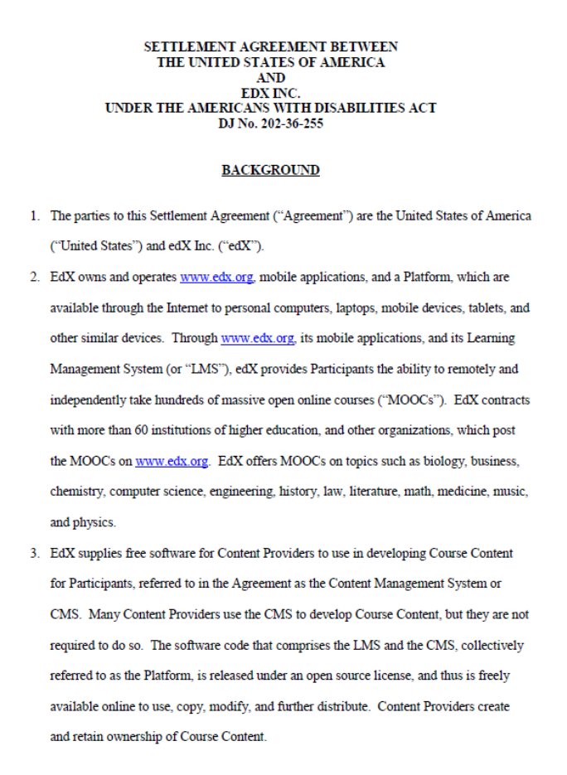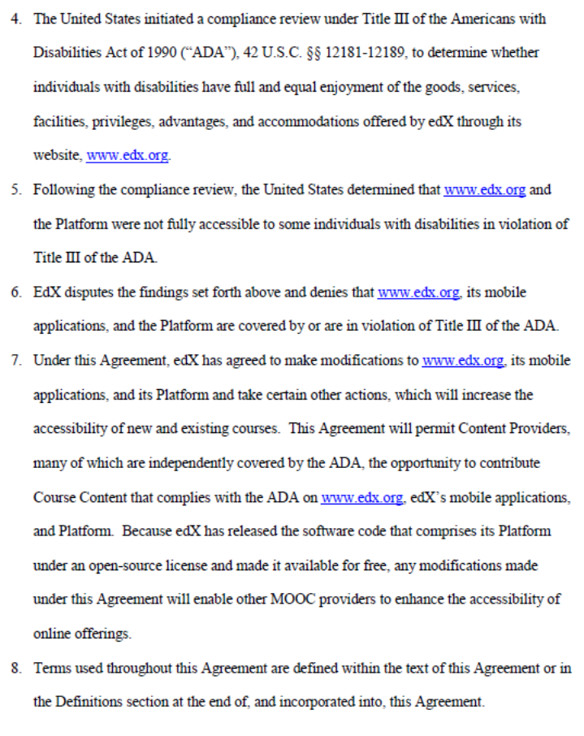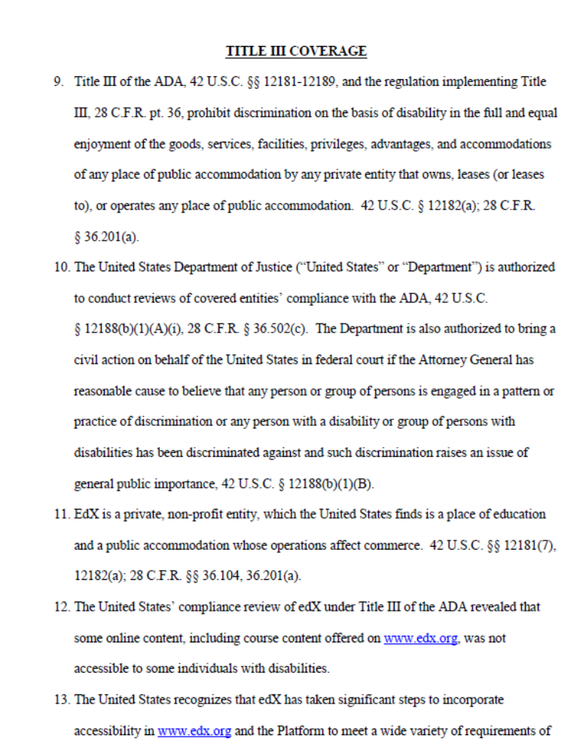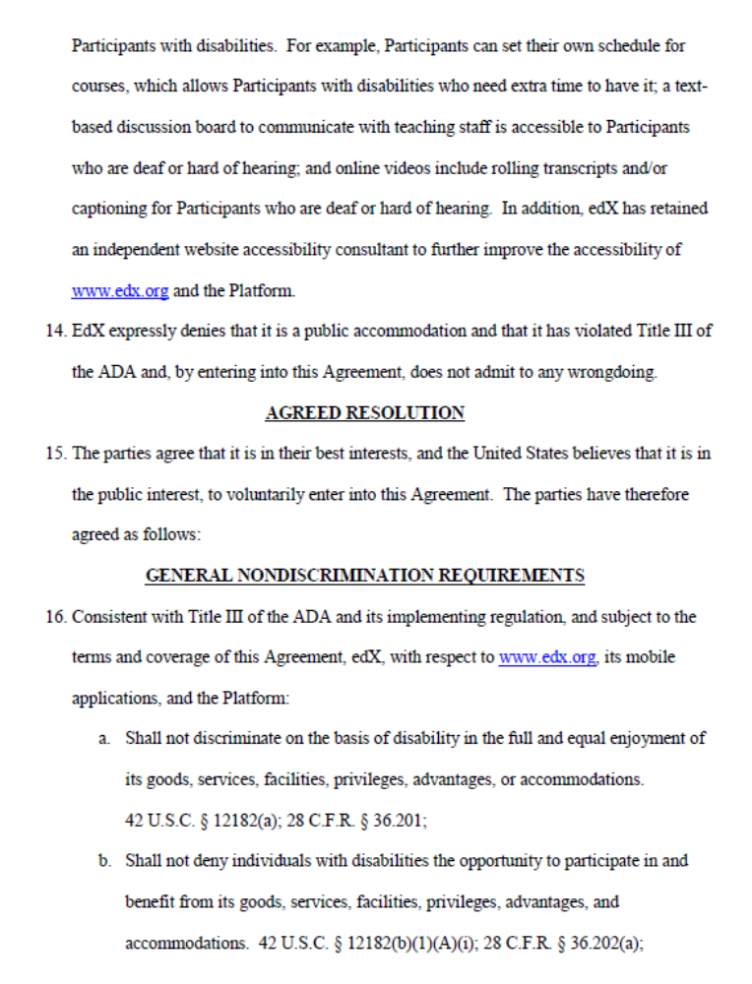 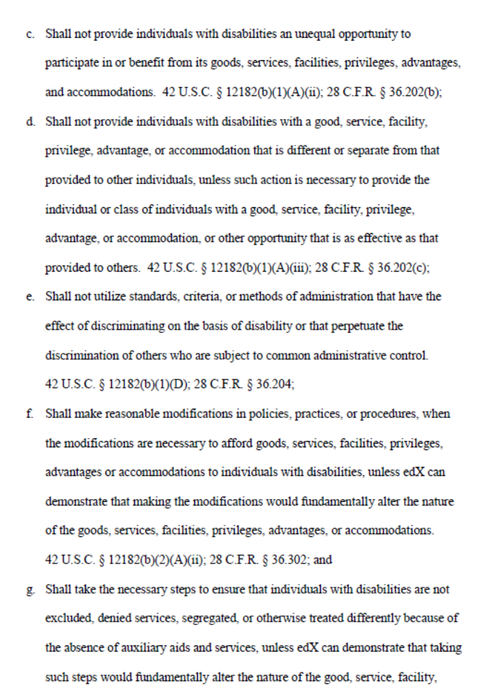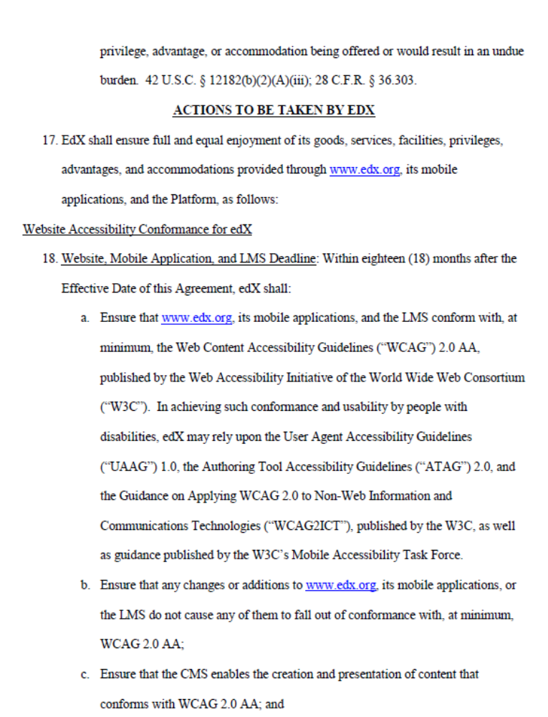 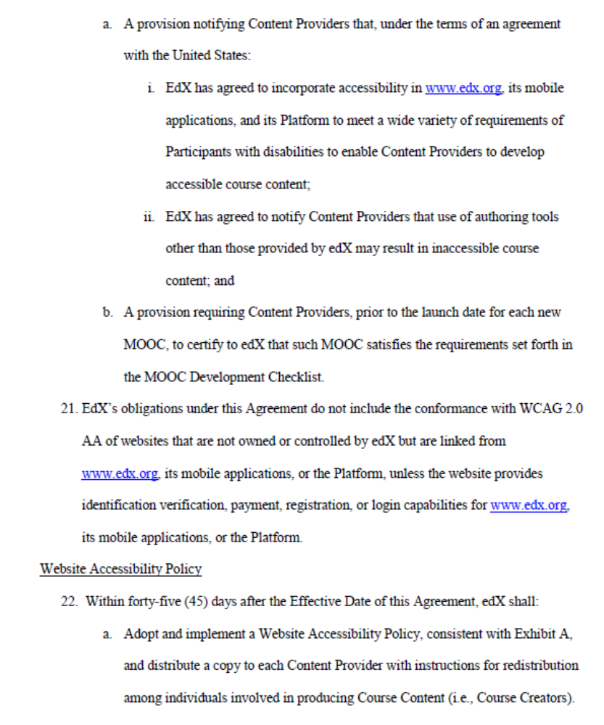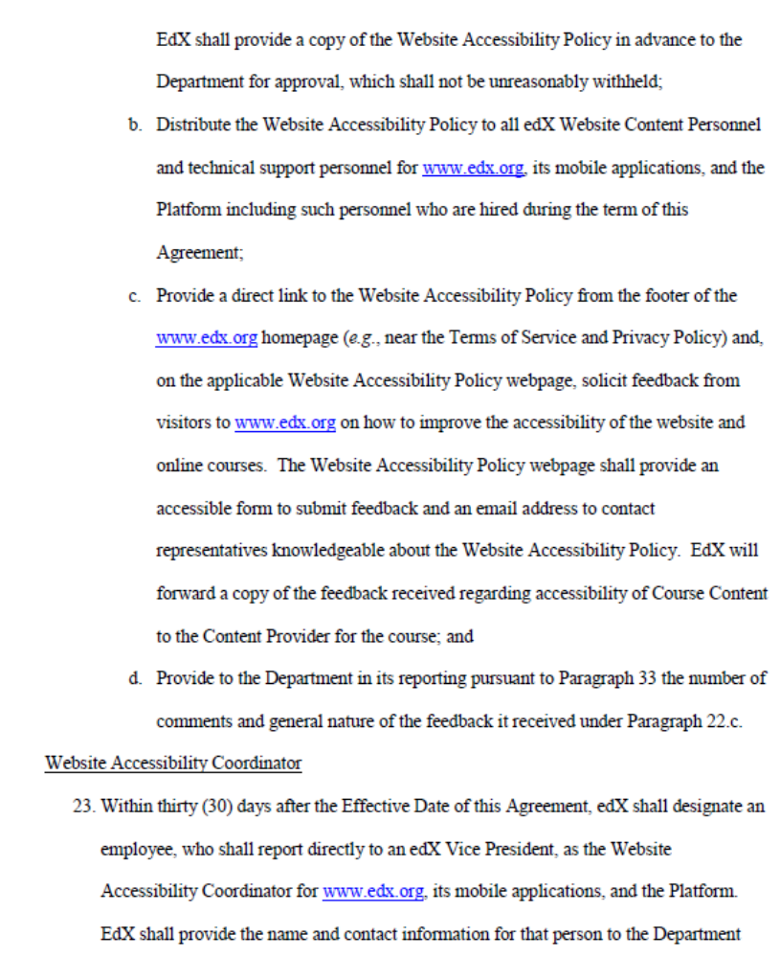 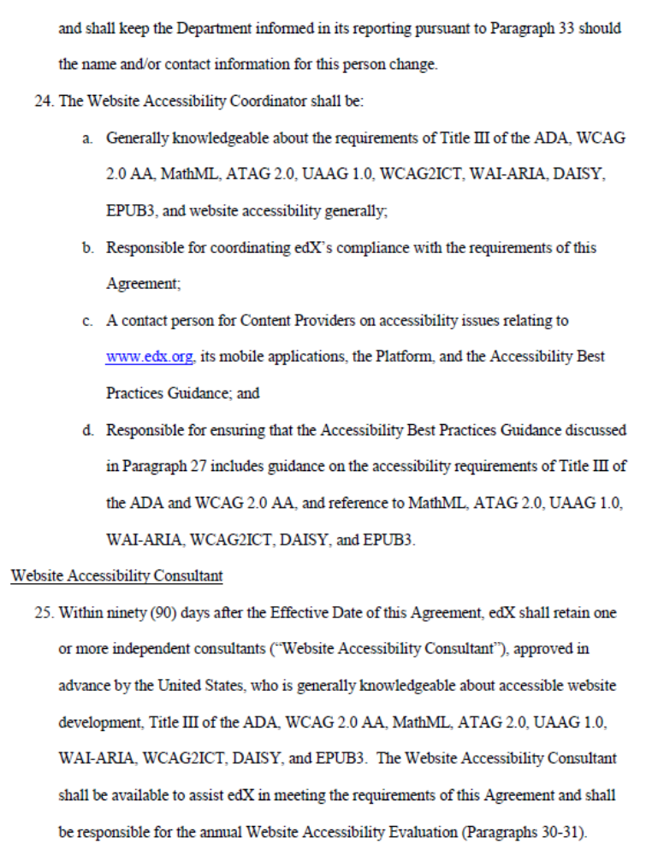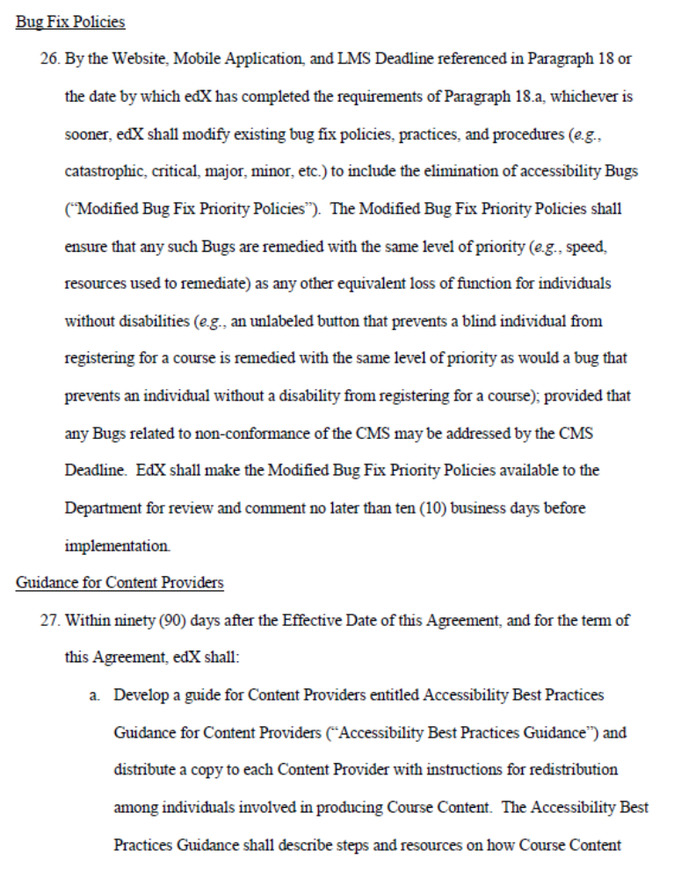 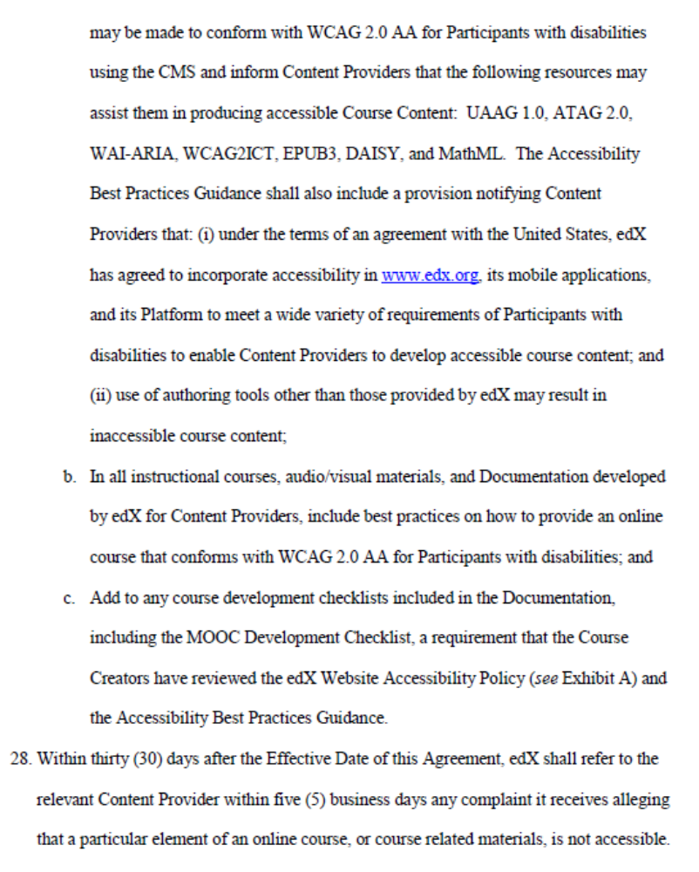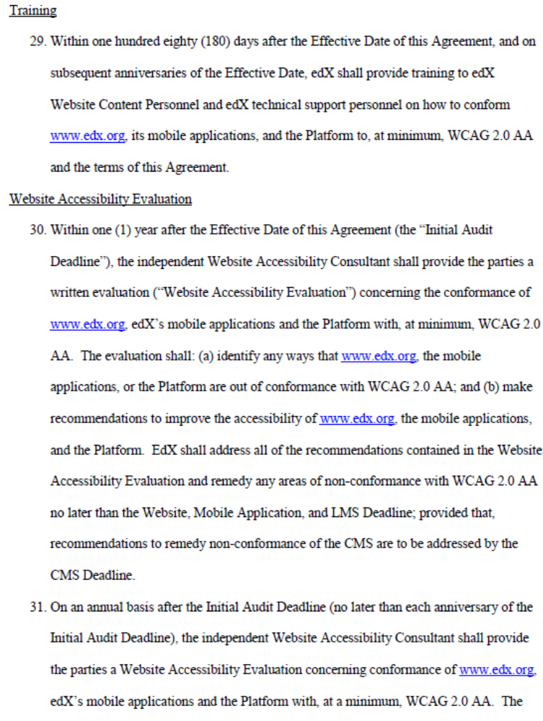 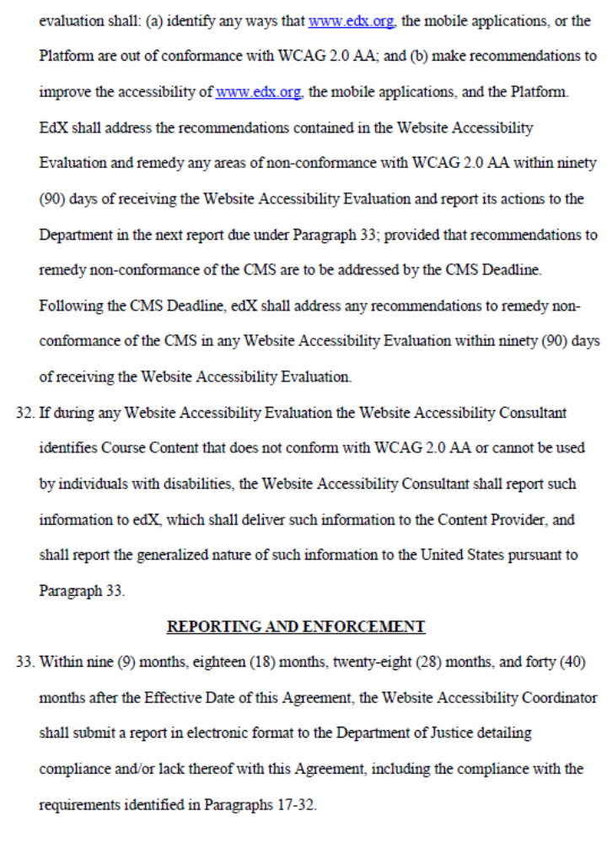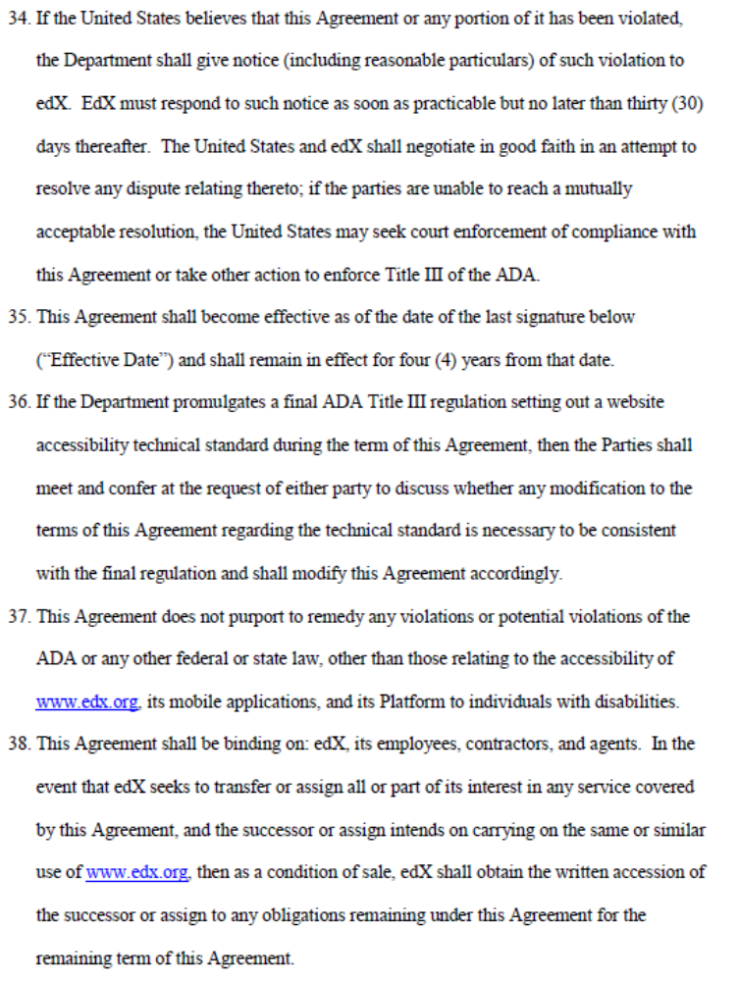 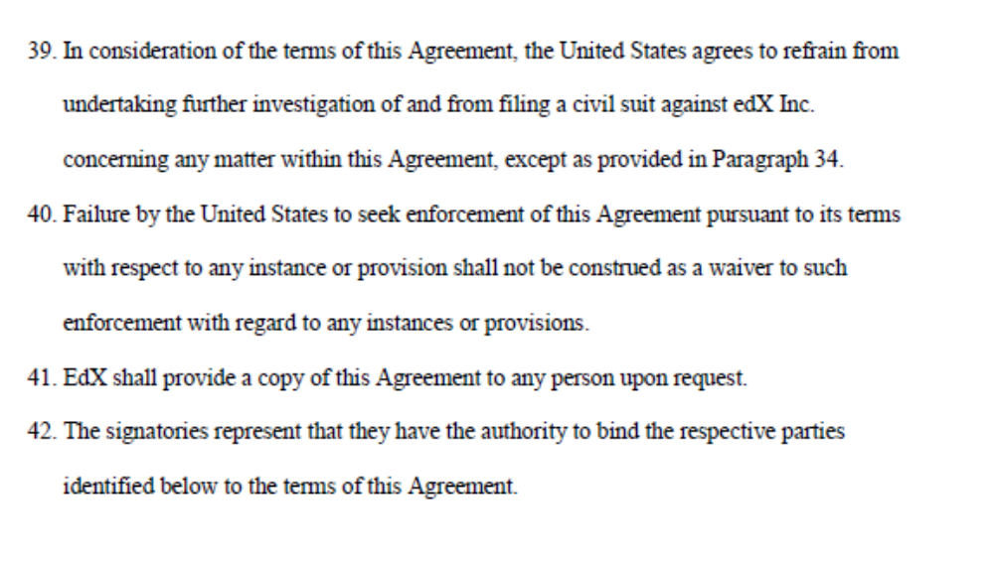 Appendix 2 Website Accessibility Policy April 2, 2015 At edX, we seek to understand and respect the unique needs and perspectives of the edX global community. We value every learner, and are committed to being a leader in expanding access to all, including learners with disabilities. It is thus edX's commitment to ensure that our website, mobile applications, and platform are accessible to individuals with disabilities and that they permit content providers to develop and post accessible content. To meet this goal, edX is implementing several initiatives, including: •Conforming www.edx.org, our mobile applications, and our software platform with the Web Content Accessibility Guidelines ("WCAG") 2.0 AA, published by the World Wide Web Consortium; •Modifying Studio, our course authoring software, to permit content providers to post course content in a format that conforms with WCAG 2.0 AA for web content; •Ensuring that www.edx.org, our mobile applications, and platform do not interfere with the posting of course content in formats that conform to MathML for digital mathematical and scientific notation; the W3C's Guidance on Applying WCAG 2.0 to Non-Web Information and Communications Technologies ("WCAG2ICT") for non-web software and content; and the Digital Accessibility Information System ("DAISY") Standard, published by the DAISY Consortium, or EPUB3, published by the International Digital Publishing Forum, for digital publications and documents; •Distributing this policy to content providers and edX website content and technical support personnel for www.edx.org, our mobile applications, and our platform; •Linking to this policy from the www.edx.org homepage, soliciting and providing a method to submit feedback, and providing a method to contact knowledgeable edX personnel; •Developing and distributing Accessibility Best Practices Guidance for content providers; •Appointing a website accessibility coordinator who is knowledgeable on website accessibility and digital accessibility standards, responsible for coordinating edX's responsibilities with respect to accessibility, and responsible for developing the Accessibility Best Practices Guidance; •Modifying policies to prioritize accessibility bug fixes to ensure they are remedied with the same level of priority as any other equivalent loss of function for individuals without disabilities; •Retaining one or more knowledgeable website accessibility consultants responsible for conducting annual website accessibility evaluations of www.edx.org, our mobile applications, and our platform; and •Providing annual training to edX website content and technical support personnel on ensuring www.edx.org, our mobile applications, and our platform conform with WCAG 2.0 AA. EdX has undertaken these accessibility initiatives to expand access to high quality education for everyone and to assist content providers, many of which have independent obligations under accessibility laws, with providing content in accessible formats. EdX urges content providers to incorporate accessibility in course content posted on www.edx.org to meet a wide variety of requirements of learners with disabilities. We will continue to spend quality time and extensive resources to make significant improvements to www.edx.org and our platform. Please direct any questions or suggestions on how to improve the accessibility of our site and platform to accessibility@edx.org, or use the form below. We welcome your feedback. Glossary Abbreviation/termTerm/DefinitionAgileAgile project management frameworksAssistive technologiesTechnologies that enable a user with an additional need such as a mobility issue to interact with their computer and web services.BAUBusiness as usualCMCurriculum ManagerLMSLearning Management SystemModuleCourseMTCModule Team ChairPDFPortable document formatOpen sourceThe original source code of the software is available to anyone to redistribute and can be modified by anyone. VLEVirtual Learning EnvironmentWCAGWeb Content Accessibility Guidelines .

