Department Application

Department of Life, Health & Chemical Sciences

The Open University

Bronze Award

**Guidance to Athena SWAN Assessment Panels**

**for Open University submissions**

*This is a standard Guidance document that has been agreed by Athena SWAN to accompany all OU submissions. Please note that it is not included in the word count.*

The Open University (OU) is unlike any other Higher Education Institution in the UK. Both the student body and staffing structure are very different from that of a conventional university, which means that some of the information presented in its Athena SWAN submissions may be unfamiliar to Assessment Panels. This guidance aims to give additional background information to assist panels in completing their assessment of Open University submissions.

1. **Students**

The OU is the largest UK University, with over 174,000 undergraduate (UG) and taught postgraduate (PG) students, all of whom study part-time and at a distance. There are also around 1000 full-time and part-time postgraduate research students. Most Open University students are in employment and are mature students (only 5% of students are under 20). They are based in all parts of the UK, and there are also 10,000 non-UK based students. Around 20,000 of our UG and PG students have declared disabilities. The University operates an open access policy, meaning it accepts all applicants who apply to study at undergraduate level, without any academic prerequisites.

*Study mode*

Students are taught via the OU’s unique model of distance learning known as ‘supported open learning’. Course materials are delivered via a number of different media, such as on-line and printed material. Students are allocated to a personal tutor (Associate Lecturer) who provides academic expertise, guidance and feedback individually and as part of a tutor group, via on-line conferencing and face to face at tutorials and residential schools. Full time funded PhD students are based at the Milton Keynes campus while part time students (who are usually self-funded) are required to attend occasionally but are usually supervised remotely.

*Modules and Qualifications*

There has always been considerable flexibility in the patterns and pathways of study, and as they are studying part-time, most students usually take at least 6 years to complete their degree. Historically, OU students have registered on individual modules which they have used to build credits towards a qualification, which for many students has been the interdisciplinary BA (Open).

Since 2012, the OU curriculum has begun to move to being qualification-based, rather than module-based, with students registering for a named qualification from the outset. However, as this is a relatively recent development, there are still a large number of students who began with and are still following the module-based route. Moreover, individual modules may be common to a number of different qualifications, thus individual departments often contribute towards degree attainment outside of the named qualifications reported in the data.

For these two reasons, panels should note that OU departmental submissions will consider and reflect on student data at a module level, as well as qualification outcomes.

1. **Staff**

The majority of academic teaching and research staff are based at the main campus in Milton Keynes and are referred to in OU submissions as Central Academics. These Central Academics develop teaching materials as part of multi-disciplinary module teams and manage the delivery and assessment of modules. They also form the OU’s research base, together with Research Associates and Fellows.

*Regional Academics*

In addition to academic and research staff based in Milton Keynes, there are almost 200 ‘Regional Academics’ (also known as Staff Tutors) who are based in 12 OU regional and national centres across the UK, whose roles include teaching, administration and research. Regional Academics are employed on the same salary scale as Central Academics; however they have different terms and conditions in their contracts. In particular they are allowed less research time than central academics, and have a higher administrative load, because part of their role is to appoint and manage Associate Lecturers. These different responsibilities are allowed for within promotions criteria.

*Associate Lecturers*

Approximately 6000 Associate Lecturers (ALs) are employed on short term contracts to carry out tutoring roles and support student learning and assessment for specified modules. Many of them have substantive posts with other employers. Their contracts with the OU do not include production of course materials or research. They are appointed and managed by the Regional Academics at Faculty level, and are members of curriculum based Student Support Teams (i.e. not departments) along with student advisors, administrators and other non-academic staff. Since their contracts and career development remain beyond the responsibility of departments, there is limited scope for including this staff group within departmental Athena SWAN submissions. However, as ALs are the main point of contact with the university for students, departmental submissions will provide basic data including a gender analysis of ALs who are employed to work on relevant modules.

1. **Flexible working**

The nature of the OU’s teaching and learning model provides the flexibility for students to study where and when they choose, to fit in with jobs, families and other commitments. This also means that academics and researchers have always had a high level of flexibility about their working arrangements and this approach continues to be a unique part of the working culture and of how the OU operates. Therefore panels should be aware that this is the reason there been very few formal applications for flexible working among academic and research staff. For colleagues working in regional/national centres across the UK, remote participation at meetings is also facilitated and encouraged and there are excellent audio and video conference facilities, so it is often not necessary to be physically at the Milton Keynes campus. Meetings are rarely held before 10am or after 4pm, to enable colleagues from regions to travel if necessary. Regional academic colleagues make particularly extensive use of flexible working because much of their work with the ALs necessarily takes place outside conventional office hours.

|  |  |  |
| --- | --- | --- |
| Name of institution | The Open University |  |
| Department | Life, Health and Chemical Sciences | |
| Focus of department | STEMM |  |
| Date of application | April 2016 |  |
| Award Level | Bronze |  |
| Institution Athena SWAN award | Date: April 2013 | Level: Bronze |
| Contact for application  Must be based in the department | Daniel Berwick |  |
| Email | daniel.berwick@open.ac.uk |  |
| Telephone | 01908 332512 |  |
| Departmental website | http://www.open.ac.uk/science/main/about-the-faculty/departments/life-health-and-chemical-sciences | |

## Letter of endorsement from the head of department

It is with great pleasure that I write in support of Life, Health and Chemical Sciences’ submission for an Athena SWAN Bronze Award.

It is my conviction that gender equality must be fully embraced in Life, Health and Chemical Sciences, and as Head of Department I am privileged to be in the position to change our working practice for the better. I believe the arguments for promoting gender equality are both moral and pragmatic. It is of course right that all members of the Department enjoy appropriate opportunities for career advancement; no one should be disadvantaged by their gender. (Or, for that matter, their ethnicity, sexuality or faith.) Promoting gender equality is therefore the right thing to do and I can say with considerable pride that two female Professors have been appointed whilst I have been Head of Department (the second too recently to be included in the submission). But more than this a fair, diverse and inclusive workplace creates a better working environment for all, which improves the quality of the work we do.

I see our assessment of Departmental practices presented in our submission as essential to achieving this. Our submission results from a detailed analysis of all areas of our Department’s activity and an appraisal of where our procedures and activities impact on gender equality. I am personally keen to evaluate any differences between work load plans and how they change as they are implemented, and am encouraged by plans to introduce Unconscious Bias training. I’ve no doubt that action in these areas, as well as implementation of other parts of the Action Plan, will go a long way to enhancing the working environment of our Department.

I would like to end by stating that am proud of the Department I lead. It is a friendly place with flexible working practices taken for granted. We have more women than men at all grades other than Professor, and the OU’s open admissions policy mean our undergraduate cohort is more inclusive than those of any other university. But we can still build on this and in this submission we describe some realistic and achievable ways to do so. I have no doubts that this combination of an established, female-friendly working culture and sound plans for improvement will enable the Department to develop. I have no hesitation in saying that I consider our Department more than deserving of an Athena SWAN bronze award.



Dr Robert Saunders,

Head of Department

Words used in this Section: 409

## Description of the department

Life, Health and Chemical Sciences (LHCS) was formed in 2011 from a merger between the Department of Life Sciences and the Department of Chemistry and Analytical Sciences. LHCS prides itself on being friendly and collegiate, and the OU has always created an excellent environment for women. For example, family-friendly practices like flexible working and scheduling meetings to fit with the school run have long been taken for granted. Furthermore, The OU’s founding principle – widening access to education (there are no entry requirements for OU degrees) – with its implicit message of inclusivity resonates amongst staff today.

LHCS is engaged in teaching and research, with the majority of staff and PhD students based on site in Milton Keynes. Academic staff fall into two categories: Central Academics, who are the equivalent of academics in other universities, and Regional Academics, who are unique, reflecting the OU’s status as a distance learning provider. The majority of Regional Academics are based outside Milton Keynes, and ~60% of the Regional Academics’ role is administrative. This includes management of Associate Lecturers, who act as course tutors. LHCS Regional Academics manage 302 Associate Lecturers, of whom 69% are female. The roles of Central and Regional Academics are outlined in Figure 1 and explained in detail in the attached ECU-approved Guidance document.

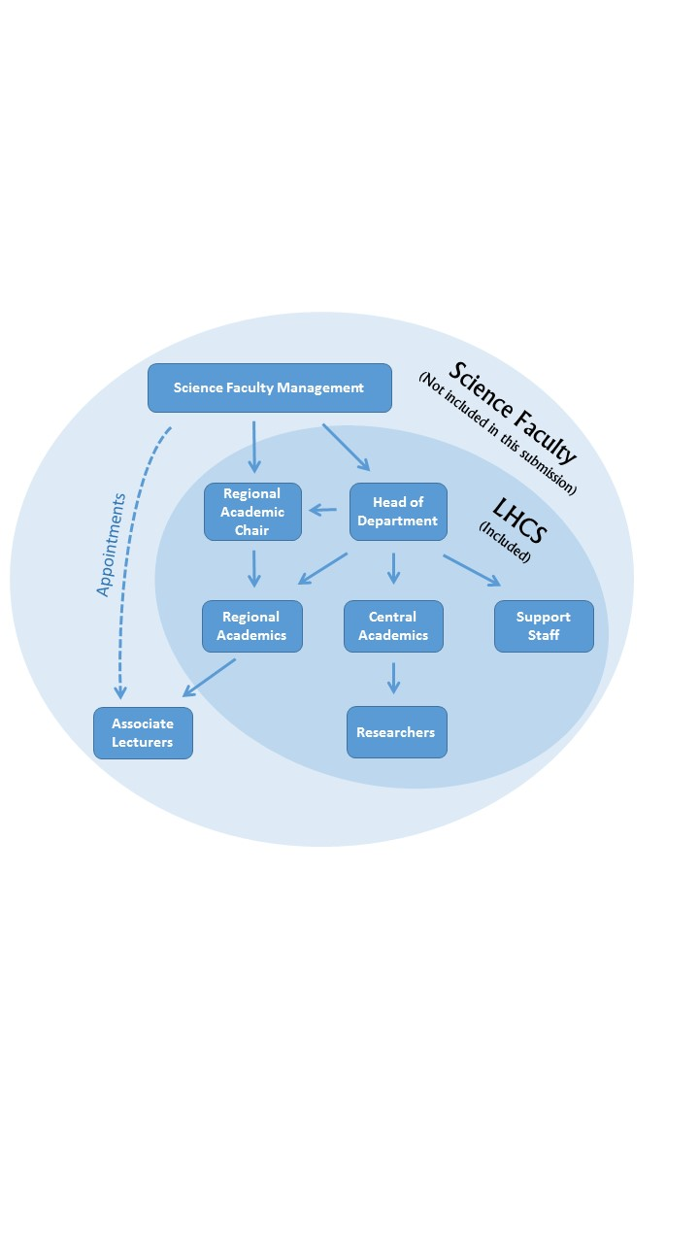

Figure 1 - Organogram showing relationship between staff categories. (Note that Associate Lecturers are managed by LHCS Regional Academics but are employed by Faculty, and thus, as agreed by the ECU, are not covered in this submission.)

As of March 2015 there were just under seventy staff in total. By discipline, the majority of academics are Biologists (just over 60%) or Chemists (just under 30%), with the remainder Psychologists and a Medical Physicist. Figure 2 shows the percentages by gender of all categories of staff and students, and reveals equivalent or higher levels of women at all levels other than Professor and Reader (discussed further in Section 4).



Figure 2 - LHCS Staff and Students 2015

In the course of the self-assessment process we have identified a number of Action Points that are being adopted to make our Department even more inclusive, fairer, and more gender-neutral. Many of the flexible work practices that we take for granted have never been formally codified: we are making sure this is changed so they are protected. We are also paying attention to the expanded Athena SWAN charter and looking towards reducing bias and prejudice in all its guises. Throughout the rest of this document we hope to convince you of what we already know; our friendly, flexible workplace and plans for the future make LHCS an excellent environment for women working in STEM, and worthy of the Athena SWAN Bronze Award.

Words used in this Section: 405

## The self-assessment process

#### a description of the self-assessment team

Members of the LHCS Self-Assessment Team (SAT) are volunteers but represent all levels of staff and provide a mixture of work and life experiences, career types and genders. The disciplines of Biology and Chemistry are represented, as are teaching and research. Importantly, non-academic staff feature on the SAT.

**Robert Saunders** (Reader, Molecular Genetics, Head of Department) joined the OU following a Senior Fellowship at Dundee University. Prior to taking the role of Head of Department, he was responsible for delivering Roberts-funded research career development across all University disciplines, and for all career stages from research student to Professorial.

**Daniel Berwick** (Lecturer, Health Sciences, **SAT co-chair**) is a newly appointed Lecturer and SAT co-chair. He is also a member of the OU STEM Gender Equalities Group and Institutional Athena SWAN SAT. Dan is passionate about fairness in the workplace and promoting a balance between work and family life. He shares parenting responsibilities for his one-year old son.

**Elaine Moore** (Reader, Theoretical Chemistry, **SAT co-chair**) joined the university in 1975. She has two children and has worked full time throughout her career. Flexible working arrangements were invaluable when Elaine’s children were at school. Elaine has a long term interest in diversity, having contributed to the recording of OU texts for dyslexic and visually impaired students.

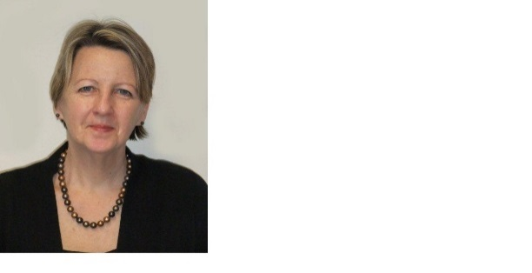**Julia Barkans** (Laboratory Manager) joined the OU in 2007. She has two children, aged 21 and 15.  Julia took a one year maternity break for her second child who was unwell. She has found the flexible working arrangements at the OU invaluable as her second child continues to require her support. Julia represents LHCS technical staff on the SAT.

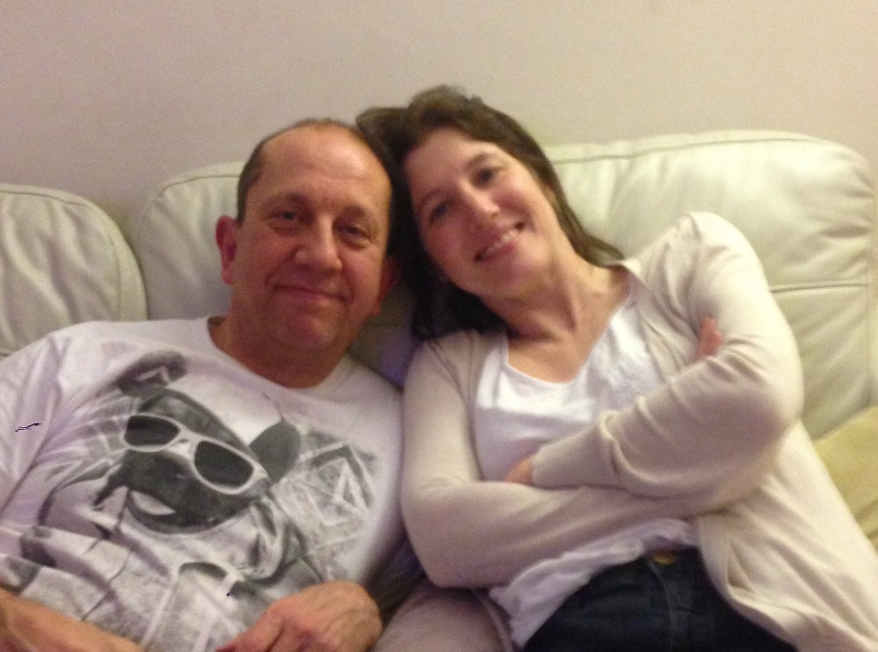**Alex Beazleigh** (Departmental Administrator) joined LHCS in 2000 and is now the senior administrator in the department. He is the father of four children, and values the OU’s capacity to accommodate the individual requirements of its staff. Alex has taken advantage of the university’s onsite nursery, and worked flexibly when his wife was suffering severe postnatal depression. Alex ensures administrative staff are represented on the SAT.

**Martin Bootman** (Reader, Life Sciences, Director of Research) was recruited to LHCS as Research Lead in 2013, following a successful research career at the Babraham Institute. As a single father to two teenage daughters, he appreciates the flexible working environment offered by the OU, and has a strong personal interest in gender equality. By serving on the SAT, Martin ensures LHCS research strategy is diverse and gender-neutral.

**Tala Chehab** (Research Student, Biology) joined the university in 2013 to pursue a PhD following a career in industry. She has one son and has always combined full-time working with childcare. As a part-time personal tutor, she values the working flexibility that the university offers, for childcare support and career progression. Tala represents LHCS PhD students on the SAT.

[](http://www.google.co.uk/url?sa=i&rct=j&q=&esrc=s&source=images&cd=&cad=rja&uact=8&ved=0ahUKEwi3oZqW6v7LAhWD8RQKHYuECSIQjRwIBw&url=http://www.rsc.org/eic/editorial-board&psig=AFQjCNEPAS7YCfKMaWMi4FrdgjjpNLLgnw&ust=1460197607046834)**Eleanor Crabb** (Senior Lecturer, Chemistry, Deputy Associate Dean Teaching) joined the OU in 1993. She has three children and worked on temporary contracts and part-time before her full-time appointment in 2006, possible due to the OU’s flexible working arrangements. She has interests in accessible curriculum design and is a school governor. Eleanor ensures teaching strategy and undergraduate issues are represented on the SAT.

**Janet Haresnape** (Senior Lecturer, Life Sciences, Regional Academic) worked as an OU Associate Lecturer (AL) for 15 years while raising three daughters, before becoming a Regional Academic in 2005.  Her husband worked overseas during much of this time, so she appreciated the flexible working hours.  More recently flexible working allowed Janet to care for her mother at the end of her life. Janet is the SAT Regional Academic representative.

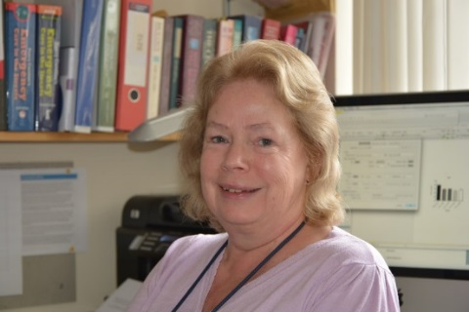**Hilary MacQueen** (Professor, Health Sciences) joined the university in 1982. From 1986 to 1996 she worked part-time while raising a family, returning to full-time work as a Lecturer in Health Sciences. Whilst part-time the OU’s flexibility and willingness to consider different ways of working allowed her to keep in touch with her subject, and this has paid off in helping her reach Chair. Hilary represents the Professoriate on the SAT.

**Katja Rietdorf** (Research Investment Fellow, Biology) joined the OU in 2013 to establish her own laboratory. She is the only Fellow in LHCS and is not involved in teaching, putting her in a unique position and allowing a different perspective on the development of the OU research environment. She is the OU’s representative for The Physiological Society, UK. Katja also represents the views of the postdoctoral researchers in LHCS.

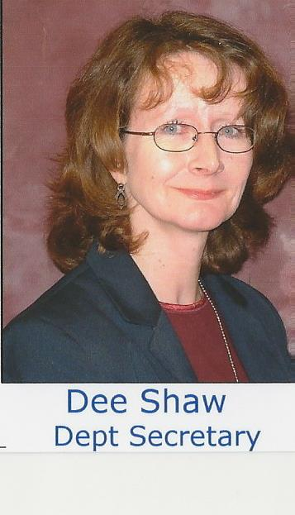**Dee Shaw** (Departmental Secretary) joined LHCS in 2001 and is currently in her third administrative role. Dee initially worked part-time while her two children were at school, but in 2011, with her children older, moved to a full-time contract. Dee’s official role on the SAT is providing secretarial support, but her detailed knowledge of HR practice make hers a valued voice on the team.

#### an account of the self-assessment process

The SAT was formally constituted, with Terms of Reference, in April 2014; monthly meetings were held until our initial unsuccessful submission in November 2014. Following submission, meetings were held every two months and from July 2015 were aimed at resubmission, focussing on the panel’s feedback. Most notably, this has led to greater efforts to explain the OU’s unique structure and degree system that reviewers found confusing, including the production on the ECU-approved Guidance document. SAT meetings and their outcomes/actions are formally recorded. The SAT receives clerical support from the department. Membership of the SAT is formally recognised with time allocated in members’ workloads.

Throughout preparation of this submission there has been regular consultation with Faculty senior management, the university’s STEM Gender Equality group (SGEG), and all members of the department. Athena SWAN business has been discussed at every Departmental meeting since February 2014, and regular updates are emailed to all staff members through the Departmental ‘Message for the Day’. The co-chairs are members of the university Athena SWAN SAT and SGEG, and have attended meetings of the Athena SWAN London and Eastern Regional Network, Athena SWAN workshops organised by the Royal Society of Chemistry and an Equality and Diversity meeting of the Royal Society of Biology.

Throughout this submission a cut-off date of March 2015 is used for staff data. Data is either presented as a snapshot of numbers as of March 2015 or for years up to March 2013, 2014, and 2015. Student data is available up to 2014/15.

Benchmarking numbers are taken from the 2013/14 HESA data provided on the ECU website.

#### plans for the future of the self-assessment team

Bi-monthly SAT meetings will continue to ensure the Action Plan included in this submission and subsequent submissions is implanted, monitored and progressed. Athena Swan activity will continue to be an Agenda item at each Departmental meeting, be discussed at Departmental away days and feature in the Message for the Day when appropriate. Future meetings will consider broader aspects of diversity such as the number and success of BAME staff and students.

Words used: 1134

## A picture of the department

## Student data

As stated in the accompanying Guidance document, this section will cover both qualifications and modules. LHCS is currently responsible for the following undergraduate degrees – B.Sc. Natural Sciences (Biology), B.Sc. Natural Sciences (Chemistry), B.Sc. Natural Sciences (Broad Pathway), B.Sc. Health Sciences. Please note that Natural Sciences data broken down into the three degree pathways is not always available and combined data, referred to as “B.Sc. Natural Sciences (all pathways)”, is presented instead.

Students who started their degree before 2012 can continue studying towards the previous B.Sc. Life Sciences and B.Sc. Molecular Science qualifications but must claim these degrees before October 2017 or transfer to a newer degree. Students registering after 2012 but before the introduction of the current degrees will have registered for B.Sc. Natural Sciences or B.Sc. Health Sciences.

#### Numbers of men and women on access or foundation courses

Access Courses

The OU’s Centre for Inclusion and Collaborative Partnerships (CICP) runs an access course which is presented twice annually starting in October and February. The course covers generic skills for all STEM subjects. Credit on this module does not count towards a degree.

Table 1 shows the gender split for students who registered and passed this module. Fewer women take this module, but their success rate is higher.

|  |  |  |  |  |  |
| --- | --- | --- | --- | --- | --- |
| **CICP STEM Access Course** | | | | | |
| **Academic Year** | **Presentation** | **Registered** | | **Passed** | |
| **Female** | **Male** | **Female** | **Male** |
| **2013/14** | **October** | 185 (32.6%) | 383  (67.4%) | 122 (65.9%) | 260 (67.9%) |
| **February** | 136 (27.0%) | 367 (73.0%) | 96 (70.6%) | 229 (62.4%) |
| **2014/15** | **October** | 181 (39.2%) | 281 (60.8%) | 125 (69.1%) | 176 (62.6%) |
| **February** | 159 (36.8%) | 273 (63.2%) | 95 (59.7%) | 162 (59.3%) |

Table 1 - Numbers and percentages of students by gender on the STEM access module.

Foundation courses

Note that all foundation modules are being replaced and the Action Points reflect this.

SDK125 *Introducing health sciences: a case study approach* is the foundation course for B.Sc. Health Sciences. It is run twice a year (Table 2).

|  |  |  |  |  |  |
| --- | --- | --- | --- | --- | --- |
| **SDK125 *Introducing health science: a case study approach*** | | | | | |
| **Academic Year** | **Presentation** | **Registered** | | **Passing** | |
| **Female** | **Male** | **Female** | **Male** |
| **2012/13** | **October** | 988 (74%) | 352 (26%) | 486 (49%) | 186 (53%) |
| **February** | 698 (77%) | 204 (23%) | 292 (42%) | 83 (41%) |
| **2013/14** | **October** | 858 (75%) | 280 (25%) | 492 (57%) | 170 (61%) |
| **February** | 526 (76%) | 170 (24%) | 242 (46%) | 85 (50%) |
| **2014/15** | **October** | 872 (78%) | 244 (22%) | 377 (43%) | 127 (52%) |
| **February** | 551 (77%) | 168 (23%) | 238 (43%) | 85 (51%) |

Table 2 Number and percentage of students by gender on the Health Sciences foundation module.

The percentage of registered students passing is slightly lower for women than for men on most presentations. Looking at the age distribution, we note that the age category with the largest number of students is 30 - 39 years. It is possible that more women students have high demands on their time due to both employment and family commitments and that this limits the time they have available for study.

**Action Point 2.1. Write to chairs of replacement foundation modules to ensure female-friendly features are included.**

**Action Point 2.2. Monitor performance on the replacement Health Sciences foundation module and, if there is a problem, ask the module team to propose adjustments.**

*S104 Exploring science* and S141 *Investigative and mathematical skills in science* are interdisciplinary foundation modules for all Natural Sciences degrees and for B.Sc. Life Sciences and B.Sc. Molecular Science. Data on these modules are given in Tables 3 and 4. S104 has two presentations per year, S141 has one.

|  |  |  |  |  |  |
| --- | --- | --- | --- | --- | --- |
| **S104 *Exploring science*** | | | | | |
| **Academic Year** | **Presentation** | **Registered** | | **Passing** | |
| **Female** | **Male** | **Female** | **Male** |
| **2012/13** | **October** | 962 (42%) | 1314 (58%) | 511 (53%) | 726 (55%) |
| **February** | 548 (40%) | 837 (60%) | 248 (45%) | 366 (44%) |
| **2013/14** | **October** | 819 (41%) | 1174 (59%) | 396 (48%) | 588 (50%) |
| **February** | 487 (39%) | 773 (61%) | 219 (45%) | 355 (46%) |
| **2014/15** | **October** | 716 (40%) | 1096 (60%) | 356 (50%) | 599 (55%) |
| **February** | 390 (38%) | 636 (62%) | 170 (44%) | 311 (49%) |

Table 3 - Numbers and percentages of students by gender on the Natural Sciences foundation module

|  |  |  |  |  |
| --- | --- | --- | --- | --- |
| **S141 *Investigative and mathematical skills in science*** | | | | |
| **Academic Year** | **Registered** | | **Passing** | |
| **Female** | **Male** | **Female** | **Male** |
| **2012/13** | 163 (39%) | 251 (61%) | 79 (49%) | 127 (51%) |
| **2013/14** | 417 (41%) | 595 (59%) | 268 (64%) | 352 (59%) |
| **2014/15** | 427 (43%) | 562 (57%) | 289 (68%) | 350 (62%) |

Table 4 - Numbers and percentages of students by gender on the investigative and mathematical skills foundation module.

We note that on the Natural Sciences foundation modules, there is a roughly 40:60 split women: men registered. The percentage female will be biased by the inclusion of a substantial fraction of students on degrees such as B.Sc. Mathematics and Physics (20% female).

#### Numbers of undergraduate students by gender

Qualification data

Due to the OU’s open access policy (see Guidance document) data on offers and acceptance rates are not applicable.

Table 5 shows the number of students at all levels who have declared their aim to achieve one of the qualifications relevant to LHCS. Students are free to change their aim at any time. As the B.Sc. Natural Sciences degrees with Biology, Chemistry and Broad Pathway have only recently been approved, previous degrees B.Sc. Molecular Science and B.Sc. Life Sciences are covered instead. Data for B.Sc. Natural Sciences (all pathways) are given for reference.

|  |  |  |  |  |
| --- | --- | --- | --- | --- |
| **Total Number of Students linked to each Qualification** | | | | |
| **Qualification** | **Academic Year** | **Female** | **Male** | **% Female** |
| ***B.Sc. Life Sciences*** | 2012/13 | 230 | 143 | **62** |
| 2013/14 | 202 | 110 | **65** |
| 2014/15 | 37 | 15 | **71** |
| ***B.Sc. Molecular Science*** | 2012/13 | 132 | 137 | **49** |
| 2013/14 | 45 | 76 | **37** |
| 2014/15 | 8 | 14 | **35** |
| ***B.Sc. Natural Sciences  (all pathways)*** | 2012/13 | 2575 | 3253 | **44** |
| 2013/14 | 587 | 906 | **39** |
| 2014/15 | 428 | 569 | **43** |
| ***B.Sc. Health Sciences*** | 2012/13 | 785 | 237 | **77** |
| 2013/14 | 585 | 151 | **79** |
| 2014/15 | 498 | 130 | **79** |

*Table 5 - Numbers of students (at all levels) linked to qualifications by gender.*

While the proportion of women on B.Sc. Life Sciences has increased, the percentage on B.Sc. Molecular Science has decreased. It would be useful to know if the change in fee structure has affected women studying Chemistry more than men studying Chemistry or women studying Biology. Were women studying Chemistry more likely to have had higher education experience and thus now be ineligible for loans?

**Action Point 3.1. Investigate differences in prior qualification between Biology and Chemistry students by gender.**

Data on degree attainment is presented for B.Sc. Life Sciences (Table 6, Figure 3) and B.Sc. Molecular Science (Table 7, Figure 4). Natural Sciences and Health Sciences data are not shown since a breakdown of B.Sc. Natural Sciences by individual pathways is not available, and only 5 students have so far claimed B.Sc. Health Sciences (one man was awarded a 1st, two women and one man 2.1., and one man a 2.2). Classifications are calculated from the grades of pass obtained from 120 credits of level 3 study (which are doubly weighted) and from grades of pass in up to a further 120 credits of study at levels 2 or 3 (i.e. up to 240 credits in total).

**Action Point 1.5: Obtain qualification classification data on B.Sc. Natural Sciences (Biology) and B.Sc. Natural Sciences (Chemistry) analysed by gender.**

The percentages gaining first class degrees for both male and female students is comparable to the benchmark for all years for all degrees. Compared to the sector average, however, for B.Sc. Life Sciences in particular there is a lower percentage 2.1 and a higher percentage 2.2 and 3rd, particularly for women. However the numbers are small and more insight can be gained by looking at the module performance.

|  |  |  |  |  |  |  |  |  |  |
| --- | --- | --- | --- | --- | --- | --- | --- | --- | --- |
| **Degree Attainment – B.Sc. Life Sciences** | | | | | | | | | |
| **Class** | **1** | | **2.1** | | **2.2** | | **3** | |
| **Gender** | **Female** | **Male** | **Female** | **Male** | **Female** | **Male** | **Female** | **Male** |
| **2012/13** | 10 (18%) | 6  (30%) | 19 (35%) | 8  (40%) | 16 (29%) | 5  (25%) | 10  (18%) | 1  (5%) |
| **2013/14** | 10 (16%) | 2  (14%) | 24 (38%) | 5  (36%) | 20 (32%) | 5  (36%) | 9  (14%) | 2  (14%) |
| **2014/15** | 3  (12%) | 2  (17%) | 7  (27%) | 4  (33%) | 13 (50%) | 5  (42%) | 3  (12%) | 1  (8%) |

Table 6 - Degree attainment by gender for B.Sc. Life Sciences

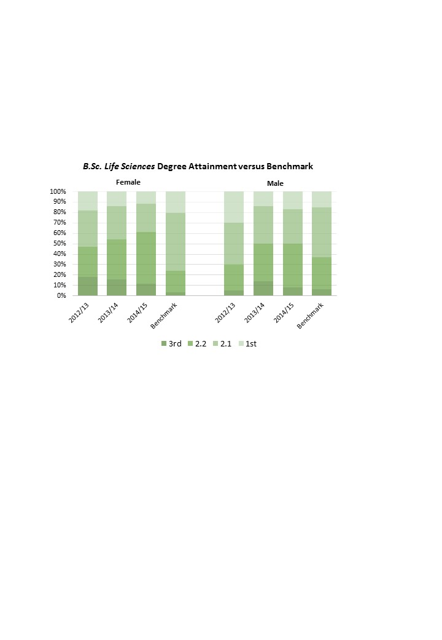

Figure 3 - Distribution of classes for female and male students in B.Sc. Life Sciences compared to HESA 2013/14 benchmark data for Biological Sciences.

|  |  |  |  |  |  |  |  |  |
| --- | --- | --- | --- | --- | --- | --- | --- | --- |
| **Degree Attainment – B.Sc. Molecular Science** | | | | | | | | |
| **Class** | **1** | | **2.1** | | **2.2** | | **3** | |
| **Gender** | **Female** | **Male** | **Female** | **Male** | **Female** | **Male** | **Female** | **Male** |
| **2012/13** | 10 (40%) | 5 (18%) | 8  (32%) | 16  (57%) | 3  (12%) | 7  (25%) | 4  (16%) | 0  (0%) |
| **2013/14** | 5  (17%) | 7 (32%) | 14 (48%) | 10  (46%) | 7  (24%) | 4  (18%) | 3  (10%) | 1  (5%) |
| **2014/15** | 5 (31`%) | 6 (29%) | 6  (38%) | 9  (43%) | 1  (6%) | 4  (9%) | 4  (25%) | 2  (10%) |

Table 7 - Degree attainment by gender for B.Sc. Molecular Science.

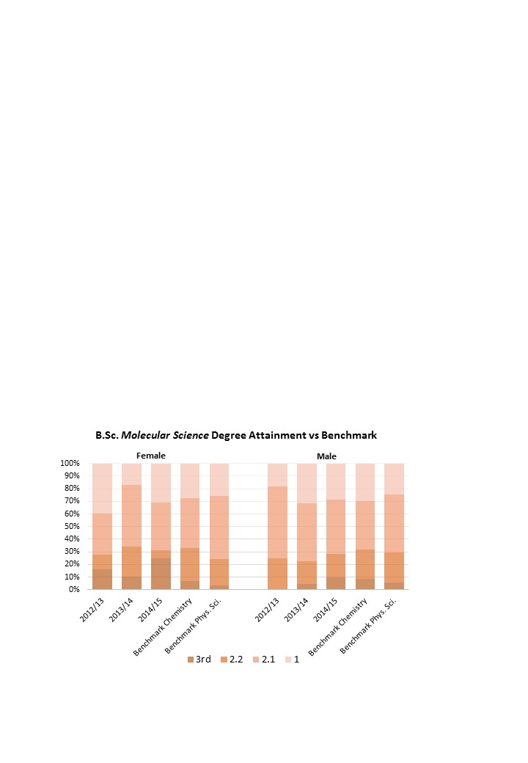

Figure 4 - Distribution of classes for female Chemistry students in B.Sc. Molecular Science compared to HESA 2011/12 benchmark for Chemistry and 2013/14 benchmark for Physical sciences.

Post-foundation module data

B.Sc. Health Sciences

Figure 5 shows the requirements for B.Sc. Health Sciences.

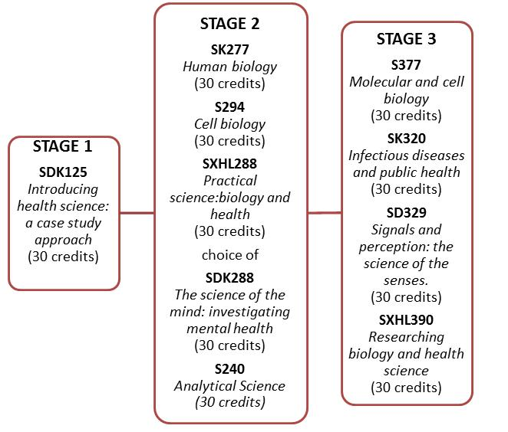

Figure 5. Requirements for B.Sc. Health Sciences at each level of study. S indicates a module for which the Science Faculty has responsibility. D and K indicate input from the Social Science (D) and/or Health and Social Care (K) Faculties. Additional Psychology modules are taken to make up the number of credits at level 1.

Data on SDK125 was given under Foundation courses. Data for levels 2 and 3 are given in Tables 8 and 9. S294, SDK288, SK277 and SXHL288 are also taken by students studying for B.Sc. Life Sciences. S240 is interdisciplinary covering Biology, Chemistry, Earth science and Astronomy.

|  |  |  |  |  |  |  |  |  |  |  |  |
| --- | --- | --- | --- | --- | --- | --- | --- | --- | --- | --- | --- |
| Level 2 Health Sciences Modules | | | | | | | | | | | |
| **Academic Year** | **Gender** | **SK277  *Human Biology*** | | **SDK228  *The Science of the mind: investigating mental health*** | | **SXHL288  *Practical science: biology and health*** | | **S240  *Analytical Science; health, heritage and environment*** | | **S294  *Cell Biology*** | |
| **Registered** | **Passing** | **Registered** | **Passing** | **Registered** | **Passing** | **Registered** | **Passing** | **Registered** | **Passing** |
| **2012/13** | **Female** | 984  (77%) | 583  (59%) | 785  (81%) | 523  (67%) | 174  (70%) | 106  (61%) | 135  (65%) | 89  (66%) | 339 (69%) | 144 (43%) |
| **Male** | 298  (23%) | 191  (64%) | 184  (19%) | 130  (71%) | 76  (30%) | 42  (55%) | 73  (35%) | 50  (69%) | 151 (31%) | 71 (47%) |
| **2013/14** | **Female** | 811  (74%) | 481  (59%) | 697  (79%) | 410  (59%) | 254  (76%) | 155  (61%) | 133  (73%) | 81  (61%) | 378 (70%) | 206 (55%) |
| **Male** | 288  (26%) | 195  (68%) | 184  (21%) | 124  (67%) | 81  (24%) | 48  (59%) | 50  (27%) | 36  (72%) | 158 (30%) | 84 (46%) |
| **2014/15** | **Female** | 892  (71%) | 466  (58%) | 880  (79%) | 563  (64%) | 187  (70%) | 108  (58%) | 114  (73%) | 45(39%) | 388 (68%) | 200 (52%) |
| **Male** | 336  (29%) | 224  (67%) | 230  (21%) | 156  (68%) | 80  (30%) | 43  (54%) | 42  (27%) | 23  (55%) | 185 (32%) | 85 (46%) |

Table 8 - Number and percentage of students by gender on level 2 compulsory modules for B.Sc. Health Sciences.

|  |  |  |  |  |  |  |  |  |  |
| --- | --- | --- | --- | --- | --- | --- | --- | --- | --- |
| Level 3 Health Sciences Modules | | | | | | | | | |
| Academic Year | **Gender** | **SD329  *Signals and perception: the science of the senses*** | | **SK320  *Infectious diseases and public health*** | | **S377 *Molecular and cell biology*** | | **SXHL390 *Researching biology and health sciences*** | |
| **Registered** | **Passing** | **Registered** | **Passing** | **Registered** | **Passing** | **Registered** | **Passing** |
| 2012/13 | **Female** | Not Presented | | 212 (73%) | 104 (49%) | 233 (62%) | 100 (43%) | 101 (71%) | 76 (75%) |
| **Male** | 79 (27%) | 41 (52%) | 142 (38%) | 68 (48%) | 41 (29%) | 25 (61%) |
| 2013/14 | **Female** | 230 (63%) | 121 (53%) | 206 (68%) | 97 (47%) | 220 (64%) | 88 (40%) | 99 (68%) | 73 (74%) |
| **Male** | 133 (37%) | 80 (45%) | 96 (32%) | 48 (50%) | 122 (36%) | 39 (32%) | 46 (32%) | 33 (72%) |
| 2014/15 | **Female** | 249 (67%) | 130 (52%) | 204 (79%) | 131 (64%) | 275 (63%) | 107 (39%) | 113 (67%) | 83 (74%) |
| **Male** | 122 (33%) | 71 (58%) | 53 (21%) | 32 (60%) | 164 (37%) | 64 (39%) | 56 (33%) | 32 (57%) |

Table 9 Number and percentage of students by gender on level Health Sciences modules. SD329 was not presented in the academic year 2012/13 due to a change from a February to October start date.

Both level 2 and level 3 modules have a lower percentage of female students registered than the benchmark. However the benchmark for Subjects Allied To Medicine is very high (FT 80% F, PT 84% F) so our numbers represent a more balanced intake. This is partly because these modules are also studied by Biology students. However we also note an increasing number of male students, which we welcome for modules in this subject area.

At level 2, the pass rate for women on the practical module is higher than for men but lower on SK277 and SDK288. On S294 the performance of women shows an improvement over the years considered. SDK228 is also an optional module in B.Sc. Psychology and in 2014/15 only 10% of students on this module had B.Sc. Health Sciences as their aim compared to 29% B.Sc. Psychology and the performance of students on different degrees is not recorded. Figure 6 shows the qualification aim for students on SK277 *Human Biology* where the male/female disparity is particularly high*.* Nearly a third of students are studying this as a single module. It is possible more women than men are opting for just the module, perhaps as part of continuing professional development or to demonstrate ability to study for applications to degrees in Nursing or Paramedic science elsewhere.



Figure 6 - Qualification aim of students on the key level 2 module SK277 Human Biology.

**Action Point 3.2a. Interrogate the data to see if more women than men in earlier years had HE qualifications and hence would now not be eligible for loans.**

**Action Point 3.2b. Investigate the gender ratio and prior study of those studying SK277 *Human Biology* as a single module.**

The pass rate on S240, particularly for female students, has markedly decreased recently in line with an increase in students on B.Sc. Health Sciences taking this module. This module will not be presented in future and this may increase the performance of female students on B.Sc. Health Science.

At level 3 the female pass rate varies from year to year with no clear trend.

B.Sc. Life Sciences

Figure 7 shows the compulsory modules for B.Sc. Life Sciences. The total number of credits required is made up by other Science modules at the appropriate level.

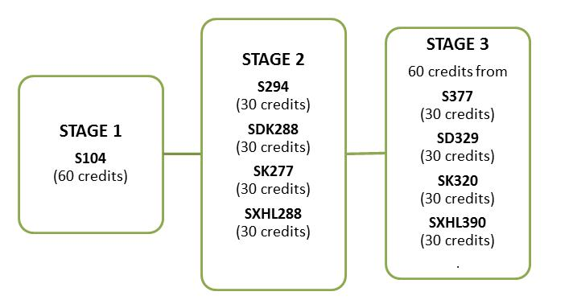

Figure 7 - Requirements for B.Sc. Life Sciences. Students choose an extra 60 credits of level 1 Science. At level 3, students can choose up to 60 credits from other Science modules.

Data all of these modules have been given in Tables 8 (level 2) and 9 (level 3) since these modules are also studied by Health Scientists. At level 2, the percentage of women students is above the HESA benchmark (Biological Sciences 2013/14 59% female FT, 67% female PT)as a result of the contribution from B.Sc. Health Sciences students*.*

B.Sc. Natural Sciences (Chemistry)

Figure 8 shows the modules required for B.Sc. Molecular Science.

Figure 8 - Requirements for B.Sc. Molecular Science. Students are required to choose 60 credits level 1 science and 60 credits level 2 science in addition. At level 3, they are required to study another 30 credits of level 3 science unless they have obtained 30 credits from practical modules

Data on the levels 2 and 3 Chemistry modules are presented in Tables 10 and 11.

|  |  |  |  |  |  |
| --- | --- | --- | --- | --- | --- |
| **Level 2 Chemistry Modules** | | | | | |
| **Academic Year** | **Gender** | **S205 *The Molecular World*** | | **S215 *Chemistry: essential concepts*** | |
| **Registered** | **Passed** | **Registered** | **Passed** |
| **2012/13** | **Female** | 186  (52%) | 101  (54%) | Not Presented | |
| **Male** | 174  (48%) | 92  (53%) |
| **2013/14** | **Female** | 159  (56%) | 92  (58%) | Not Presented | |
| **Male** | 126  (44%) | 81  (64%) |
| **2014/15** | **Female** | Not Presented | | 129  (51%) | 71  (55%) |
| **Male** | 125  (49%) | 64  (51%) |

*Table 10 - Number and percentage of students by gender on the compulsory level 2 modules, S205 The Molecular World and its replacement, S215 Chemistry: essential concepts.*

|  |  |  |  |  |  |  |  |  |  |
| --- | --- | --- | --- | --- | --- | --- | --- | --- | --- |
| **Level 3 Chemistry 20 Credit Modules** | | | | | | | | | |
| **Academic Year** | **Gender** | **S345 *Chemical changes and environmental applications*** | | **S346 *Drug design and synthesis*** | | **S347 *Metals and life*** | | **SXM390 Science Project Course: *Frontiers in Chemistry*** | |
| **Registered** | **Passed** | **Registered** | **Passed** | **Registered** | **Passed** | **Registered** | **Passed** |
| **2012/13** | **Female** | 66  (54%) | 40  (61%) | 86  (56%) | 48  (56%) | 79  (55%) | 44 (56%) | 50 (49%) | 36 (72%) |
| **Male** | 57  (46%) | 32  (56%) | 67  (44%) | 36  (54%) | 66  (45%) | 45 (68%) | 53 (51%) | 37 (70%) |
| **2013/14** | **Female** | 84  (60%) | 53 (63%) | 106  (58%) | 58  (56%) | 86  (62%) | 54 (63%) | 49 (50%) | 31 (63%) |
| **Male** | 56  (40%) | 37 (66%) | 76  (42%) | 55  (72%) | 52  (38%) | 29 (56%) | 50 (50%) | 31 (62%) |
| **2014/15** | **Female** | 66  (52%) | 40 (60%) | 117  (63%) | 85 (73%) | 112 (57%) | 74 (66%) | 52 (55%) | 33 (63%) |
| **Male** | 60  (48%) | 36 (60%) | 70  (37%) | 50 (71%) | 86  (43%) | 60 (70%) | 42 (45%) | 25 (60%) |

Table 11 - Number and percentage of students by gender on Chemistry level 3 modules.

The Chemistry modules attract a greater percentage of women than the benchmark figures for Chemistry 2011/12 (part time 37% women and full time 43% women) and Physical Science 2013/14 (part time 41% women, full time 39% women) with women in the majority. The percentage of registered students passing the module is greater for women at level 2 but varies for level 3. Student surveys show a high level of satisfaction with the support provided by the ALs and module team, and forum postings suggest that this is particularly appreciated by women. S205 was replaced in 2014 by a new online module S215, which will be compulsory for B.Sc. Natural Sciences (Chemistry). The percentage of female students has dropped in going to the new module and could be due to the new fee structure or the method of delivery. However the percentage of female students passing has increased. Action Point 3.2a would provide some insight here.

**Action Point 3.2a. Interrogate the data to see if more women than men in earlier years had HE qualifications and hence would now not be eligible for loans.**

B.Sc. Natural Sciences (Broad Pathway)

There are no compulsory modules for this pathway at level 2. However, we consider the recommended module S250 *Science in context* (Table 12). This module attracts more female students than male. The performance of females is lower, but in the latest year is almost equal. This module is being rewritten with attention paid to continuing this improvement.

|  |  |  |  |
| --- | --- | --- | --- |
| **Level 2 Natural Sciences module S250 *Science in context*** | | | |
| **Academic Year** | **Gender** | **Registered** | **Passing** |
| **2012/13** | **Female** | 234 (56%) | 153 (65%) |
| **Male** | 181 (44%) | 132 (69%) |
| **2013/14** | **Female** | 224 (60%) | 157 (67%) |
| **Male** | 147 (40%) | 113 (73%) |
| **2014/15** | **Female** | 168 (55%) | 114 (68%) |
| **Male** | 136 (45%) | 94 (69%) |

Table 12 - Number and percentage by gender of students registered on level 2 recommended module for B.Sc. Natural Sciences (Broad Pathway)

#### Numbers of men and women on postgraduate taught degrees

LHCS presents one complete taught Masters degree, M.Sc. Medicinal Chemistry. This is a part time degree delivered via distance teaching. Meaningful analysis of this course is not possible, as it has not been running long enough for sufficient students to have completed. In addition, as for undergraduate degrees, application, offers and acceptance rates are not applicable.

Nonetheless, initial figures are promising. Over the three-year data collection period, 62% of the students linked to this qualification have been women, and of the handful passing, 65% were female. We note that the benchmark for Physical Sciences taught masters 2013/14 is 47% FT and 44% PT. Evidence from forum postings and requests for references suggest that women are using this degree to help them back into employment after a career break.

#### Numbers of men and women on postgraduate research degrees

Table 13 shows applications, shortlisting and appointment for FT postgraduate students by gender. The number of appointments is small, but we note that the proportion of females shortlisted is higher than the proportion applying.

|  |  |  |  |  |  |  |
| --- | --- | --- | --- | --- | --- | --- |
| **Men and Women on Full-Time Postgraduate Research Degrees** | | | | | | |
| **Academic Year** | **Applied** | | **Shortlisted** | | **Appointed** | |
| **Female** | **Male** | **Female** | **Male** | **Female** | **Male** |
| **2012/13** | 28 | 34 | 8 | 8 | 1 | 2 |
| **2013/14** | 44 | 69 | 14 | 16 | 2 | 5 |
| **2014/15** | 47 | 33 | 17 | 11 | 3 | 1 |

Table 13 - Applications, Shortlisting and Appointments to Research Studentships in LHCS

Data available on PT postgraduate students is limited. All current PT students are female. Two are full time researchers on European grants who are registered for a PT degree (these appointments are covered under researchers). We also have 3 external PT students. These generally have applied to a particular academic and are either self-funding or sponsored by the firm they work for.

**Action Point 1.1. Department to keep records on applications from PT postgraduate students.**

#### Progression pipeline between undergraduate and postgraduate student levels

Numbers on postgraduate degrees are too small to give a meaningful comparison between percentages at UG and PG level.

## Academic and research staff data

#### Academic staff by grade, contract function and gender: research-only, teaching and research or teaching-only

Grade and Gender.

|  |  |
| --- | --- |
| **Category** | **Female** |
| **LHCS All Academic Staff** | **64%** |
| **Central Academics** | **56%** |
| Biosciences | 54% |
| Chemistry | 58% |
| Psychology | 67% |
| **Regional Academics** | **85%** |
| Biosciences | 100% |
| Chemistry | 33% |
| ***HESA Biosciences*** | ***44%*** |
| ***HESA Chemistry*** | ***28%*** |
| ***HESA Psychology & Behaviour*** | ***60%*** |

The employment of women in academic/research positions in LHCS compares well to HESA benchmarks across all subject areas (Table 14; the one Medical Physicist is not included).

Table 14 - Percentage Female Academics, March 2015

When broken down by grade, women are either represented equivalently or are over-represented at all grades other than Reader and Professor (Fig. 2). These proportions have remained similar throughout the self-assessment period (Fig. 9), with some evidence that the number of females is increasing. Importantly, these observations hold true if we restrict our comparison to Central Academics, the staff group comparable to academics at other institutions (Table 14; Figs. 2 & 9).

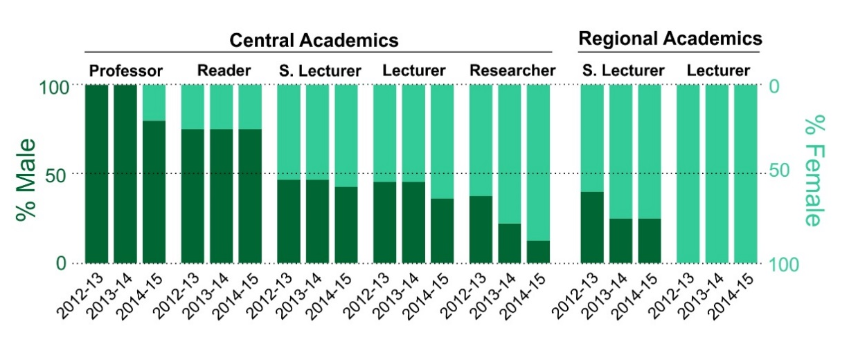

Figure 9 - Proportion of Men and Women in Academic Positions, 2012-2015

Nonetheless, there is some gender imbalance, which we discuss in the Recruitment and Promotions sections (5.1i and 5.1iii).

Contract type (Research-only, Teaching-only and Research and Teaching) and Gender.

All LHCS Academics are on combined Research and Teaching contracts. Thus, to identify gender-specific differences in Research and Teaching contributions, we have used the “actual” number of days on different tasks, as reported by staff. Regional Academics are not included due to the low number of men in these positions. The OU academic year runs from August to July, so we have used the four years spanning the assessment period.

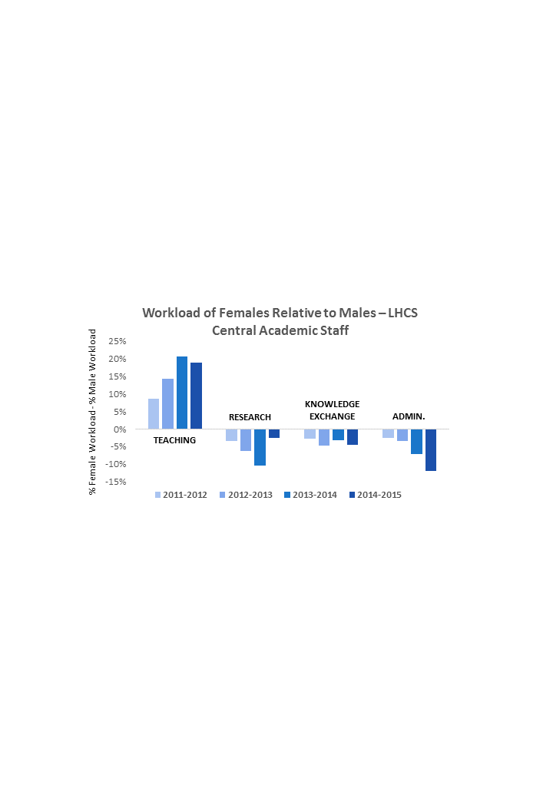

Figure 10 - The Relative Workloads of Female and Male Central Academics

In common with much of the STEM sector, female LHCS Academics devote a greater proportion of their time to teaching and less time to research than men do (Fig. 10). We are currently unable to break these data down by grade, making the impact of research and teaching on career progression hard to determine.

**Action Point 5.1. Introduce a Departmental staff survey question asking each person to quantify how they see their research and teaching contributions and how they perceive it to impact upon their career progression**

#### Academic and research staff by grade on fixed-term, open-ended/permanent and zero-hour contracts by gender

The only meaningful comparison possible is the number of male and female Central Lecturers on permanent and fixed-term contracts, where there is no evidence of gender bias (Fig. 11). All other staff are on the same contract type (Senior Lecturers and above are permanent, Researchers are fixed-term) or are the same gender (Regional Lecturers).

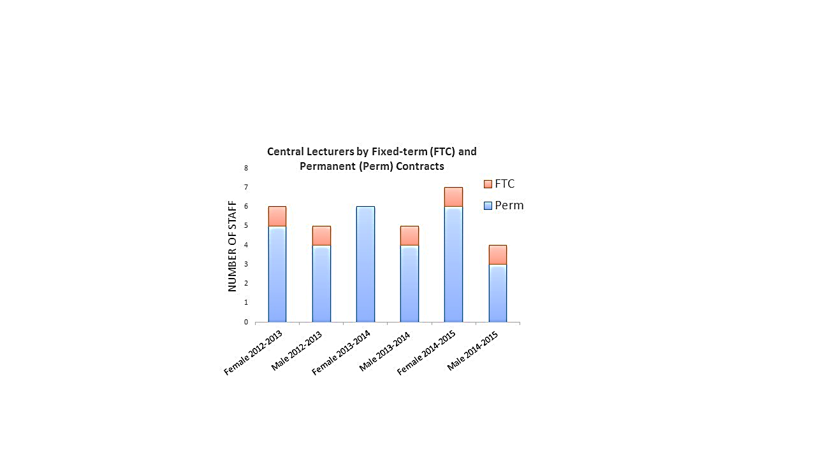

Figure 11 - Central Lecturers on Fixed-term and Permanent Contracts 2012-2015

Regarding continuity of employment, all fixed-term Lecturers whose contracts expired during the self-assessment period were made permanent. In the case of Researchers, our redeployment record is poor. For post-docs and technicians, continuity of employment is dependent on grant success, and the fact that LHCS is a relatively small Department makes redeployment to other research groups unlikely. In common with the rest of the STEM sector this is a problem we struggle to deal with, although efforts have been made (see Section 5.3).

#### Academic leavers by grade and gender and full/part-time status

Within the data collection period 17 staff left and all were full-time. Their grades, genders and reasons for leaving are covered in Table 15.

|  |  |  |
| --- | --- | --- |
| **Reasons for Leaving LHCS** | | |
| **Category** | **Number** | **Reason** |
| Reader | 1M | Normal Retirement |
| Central Senior Lecturer | 2M | Normal Retirement; Ill Health Retirement |
| Regional Senior Lecturer | 2M | Normal Retirement (both) |
| Central Lecturer | 1F, 3M | Returned to home country for family reasons (1M); Moved to a position at a more research intensive university (1F, 2M) |
| Researcher | 5F, 3M | End of Contract (all) |

Table 15 - LHCS Academic Leavers April 2012 - March 2015

These data are too small for insightful analysis. The move of three lecturers to posts in more research-intensive universities was seen as a positive step for their careers and they were supported in their applications. There are no grounds to suspect an effect of gender or full versus part-time status.

However, compiling this table led us to detect a failure in our current policy: reasons for leaving are not consistently recorded. The table could only be completed because the numbers are low and the SAT could account for each individual. We are looking to remedy this as part of Action Point 5.3.

**Action Point 5.3. 1) Promote Exit Interviews for all staff (including Regional Academics) and emphasise that they needn’t be performed by the Line Manager; 2) Lobby for all Exit Interviews to be carried out by HR, with reasons for leaving systematically recorded.**

Words used in this Section: 2204

## Supporting and advancing women’s careers

## Key career transition points: academic staff

#### Recruitment

Diversity is embedded in the university’s recruitment and selection guidelines. The OU provides guidance on the wording of job descriptions, person specifications and advertisements. All advertisements include the University’s current equality and diversity statement.

The Faculty does not keep systematic records of who sits on interview panels, but single-gender panels are avoided. For academic positions, the panel must include a representative from another department.

An online recruitment and selection module is recommended for all staff undertaking recruitment. This is a requirement for interview panel chairs to ensure fair selection is achieved.

Current records show that within the academic staff in LHCS, only nine members have completed the training (6 females; 3 males). It is of note that the majority of female staff are in junior positions, whilst the majority of males are in senior positions. However we are concerned that this data is inaccurate as it does not include academics who attended face-to-face training prior to the introduction of the online module. Tellingly, a show of hands at a recent Departmental meeting revealed that the vast majority of LHCS academics believe they have completed recruitment training.

**Action Point 4.4. Liaise with Faculty to establish how long recruitment training is valid for and produce a comprehensive list of all staff trained under current *and* previous systems.**

Candidates for academic posts, in addition to the formal interview, are given a guided tour of the Department. They are required to give a short talk on their research which all members of the Department can attend. Candidates are also asked to provide a sample of teaching material and discuss teaching with the qualification lead. Members of staff attending all the presentations grade candidates on relevant parts of the person specification. This feedback is passed to the panel.

All unsuccessful candidates are given reasons for their lack of success.

In the three years of the assessment, positions were available at three grades – Central and Regional Lecturer and Researcher. Since recruitment can vary greatly by year we have compiled the three years’ data for analysis. Note that we do not have data for offers, as this is not routinely recorded.

**Action Point 1.4. Arrange with HR for gender split of offers to be recorded**.

The data presented in Figs 12-14 show the following trends regarding the success rates of males and females.

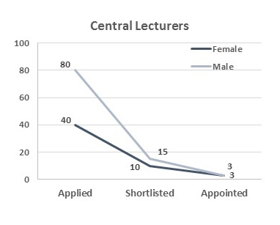At the Central Lecturer grade (Fig. 12) twice as many men apply, but women are more successful at shortlisting. The numbers are too small to determine if gender influences interview success.

These observations suggest that we may be undervaluing male applications or failing to advertise effectively to women (or both). These explanations are being addressed in three ways. Firstly, the University has recently launched a new Equality and Diversity Scheme which includes targets for Unconscious Bias training. We will ensure LHCS is committed to meeting these criteria. Secondly, the OU recently commissioned an external consultancy to advice on increasing the impact of our STEM job advertisements amongst women. We will ensure their recommendations are implemented by Human Resources. And thirdly, we will ensure all vacancies are advertised directly to as many potential candidates as possible, by asking LHCS members to circulate the position amongst their contacts at other institutions. It has been found that women are more likely to apply for positions that have been brought to their attention personally.

Figure 12 - Recruitment of Central Lecturers by Gender, April 2012-March 2015

**Action Point 4.3. Ensure LHCS meets OU targets for Unconscious Bias training.**

**Action Point 4.6. Ensure recommendations of consultancy for female-friendly job advertisements are implemented**.

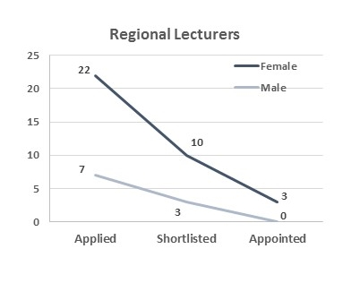**Action Point 4.2. Direct advertising of vacancies to increase numbers of female applicants.**

At the Regional Lecturer grade (Fig. 13) three times more women apply. This ratio is proportional throughout the selection process, suggesting no evidence of bias at shortlisting or appointment stages.

Unsurprisingly, this abundance of female applicants mirrors the over-representation of females in Regional Academic posts. In the year to March 31st 2015, all Regional Lecturers and 75% of Regional Senior Lecturers were women (Figure 2). These numbers cannot be externally benchmarked, but across the entire OU 73% of Regional Academics are female. Given the small sample size, our numbers are consistent with this.

Figure 13 - Recruitment of Central Lecturers by Gender, April 2012-March 2015

These observations lead one to conclude that the Regional Lecturer job profile is somehow unappealing to males, but we don’t think this is the case. Rather, it reflects the normal entry route into Regional Academic positions, from previous work for the OU as an Associate Lecturer. The majority of Associate Lecturers in all disciplines are women, as the part-time home-working nature of these positions (see Guidance document) make them convenient for people with caring responsibilities. Indeed, Associate Lecturer work is an acknowledged mechanism for retaining women in STEM careers[1]. We therefore believe that recruitment to Regional Lecturer positions is not biased towards women. Nonetheless, the lack of any male Regional Lecturers is a cause for concern**.**

**Action Point 4.1. Ensure Regional Lecturer positions are widely advertised, especially to male Associate Lecturers.**

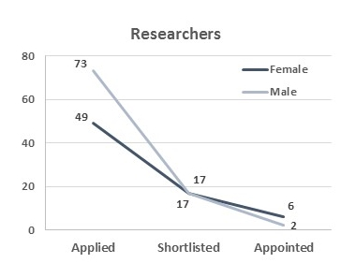

About 50% more males apply for Researcher positions (Fig. 14), but they are less successful in shortlisting and at interview. The numbers are low, but since this has led to the percentage of female Researchers rising from 63% to 88% over the course of the self-assessment period (Figs. 2 and 9), this is concerning. We will address this issue with the following Action Points:

Figure 14 - Recruitment of Researchers by Gender,   
April 2012-March 2015

**Action Point 4.7. Make LHCS Academics aware of current under-representation of males in Researcher positions.**

**Action Point 4.5. Ensure staff involved in interviewing are trained AND undergo further unconscious bias training.**

#### Induction

The OU has a university-wide policy for academic staff induction that is composed of three parts: 1) an extensive introduction at the Institutional level via an intranet course called *Open Insights*; 2) a Department-level induction in the form of pre-arranged meetings with key staff; and 3) on-the-job training via extensive interaction with a Mentor over the first few weeks. This last level of induction blends into on-going academic Mentoring. New staff are also required to undertake equality and diversity training via the Diversity Compliance eLearning module, provided by the university’s Equality and Diversity Team. We will discuss each level of induction in turn.

Figure 15 - Ensuring a warm welcome to LHCS

*The Open Insights OU-wide Induction Module.*This module is intranet based, which has allowed uptake over the 3 year data period to be accurately logged. Within LHCS one new starter took the course in this time. Since the module is available to employees of all grades, this equates to a 5% uptake. Across the Science Faculty uptake is 2.5%. Given these tiny numbers it’s fair to conclude that this part of induction is an utter failure.

**Action Point 5.5. Issue of poor uptake and lack of monitoring raised with i) Institutional Athena SWAN team and ii) a committee developing a new induction course specifically targeted at new academics.**

*Departmental Induction.*LHCS Departmental induction is co-ordinated between the Faculty Staffing Team and the Departmental Secretary, Dee Shaw. A member of the Staffing Team will meet the new starter on arrival to ensure all important bureaucracies are dealt with immediately. The individual is then passed on to Mrs Shaw who provides an introduction to the Department and shows the new starter to their office. Mrs Shaw arranges a series of meetings with members of staff (e.g. HoD, Research Lead, Laboratory Manager, key administrators etc) within the first couple of weeks. The HoD aims to meet new staff on their first day and only on rare occasions is this not achieved. The new starter is always announced to the Department by email, and existing staff encouraged to say hello. We believe this process works well (two of our SAT have recent first-hand experience), but we have no quantitative data to back this up.

**Action Point 5.6. Introduce question into the survey asking people who joined in the last year whether they felt welcomed into LHCS.**

*Mentoring.*Mentoring is one aspect of the induction process in which LHCS has been doing poorly. Over the last ten years or so a considerable number of staff have retired leading to a shortage of experienced staff. This has led to Mentors having to double-up and many new staff not being assigned a Mentor until well after their start date.

**Action Point 5.7. Ensure Heads of Department within the Science Faculty work together to maximise mentoring opportunities.**

#### Promotion

In the three years covered by the self-assessment process there have been very few applications for promotion (Table 16), making an assessment of gender bias impossible. Since no part-time staff have applied, we also cannot comment on the impact of full versus part-time status.

|  |  |  |  |  |  |  |  |  |  |
| --- | --- | --- | --- | --- | --- | --- | --- | --- | --- |
| **All Promotion Cases, April 2012 – March 2015** | | | | | | | | | |
| **Promotion** | **2012 – 2013** | | | **2013 – 2014** | | | **2014 – 2015** | | |
| **Applied** | **Shortlisted** | **Promoted** | **Applied** | **Shortlisted** | **Promoted** | **Applied** | **Shortlisted** | **Promoted** |
| **To Professor** | **1F** | **1F** |  |  |  |  | **2F** | **1F** | **1F** |
| **To Senior Lecturer** | **3F 2M** | **3F 2M** | **3F 2M** | **2F** | **1F** |  | **2F** |  |  |

Table 16 - LHCS Promotion Cases March 2012-April 2015 (Central and Regional Academics Combined).

Nonetheless we note that all applications for promotion to Professor came from women, including a successful application (Table 16; a second female has since been promoted to Professor, meaning the gender balance at this grade continues to improve). Women applying for Chair is undoubtedly a positive thing. As we have observed, men are over-represented at this grade.

With this in mind it is important to highlight a shift in the OU’s promotions criteria that may be at play here, aimed at increasing the value given to teaching. This has culminated in the recent withdrawal of promotion to the research-focussed Reader position (as such, the shortage of female Readers in LHCS cannot be remedied). Across the STEM sector, a well-acknowledged reason for lack of female Professors is the historic bias towards research over teaching, coupled with the tendency for women to take on greater teaching loads. It is too early to say whether increased recognition for teaching is fuelling Professorship applications from women, but it is tempting to speculate that this is involved.

An Overview of the LHCS Promotion Procedure

All staff with a minimum of two years’ service are invited by e-mail to make a case for promotion to be assessed by the Departmental Promotions Committee. Appraisers will urge staff identified as promotable to put forward their case and if necessary will help with the drafting and/or direct the person to someone with experience of the University Promotions Committee. The Departmental Committee consists of the Professoriate, Research Lead, HoD and Deputy HoD. As well as looking at the cases submitted, the Committee also considers every member of staff individually. If it is felt they fulfil the published criteria, these members of staff are contacted directly and asked to apply. The Departmental Promotions Committee submits identified cases to the Faculty Management Team for consideration. Each application is written by the candidate with significant input from HoD and other senior members of the Department in an iterative process. If deemed appropriate at the Faculty level the case is subsequently submitted to the university-level Academic Staff Promotions Committee (after revision if deemed necessary, again in an iterative process with input from senior members of the department).

Staff can also put forward personal submissions for promotion (i.e. not going through the Departmental and Faculty route) to the Academic Staff Promotions Committee.

The composition of the Departmental Promotions Committee is described in 5.6.iii.

For promotion to Professor, The OU’s Chair & Readership sub-committee considers cases on a rolling basis three times a year. Any cases submitted to the Dean are sent to a professoriate panel (consisting of the Associate Dean Research, HoD, plus two other professorial staff) for comment. Candidates are then invited to a 1:1 with the Dean for feedback before submission to the sub-committee. Cases can also be submitted directly and the sub-committee then seeks comments from the Dean. Typically, the promotion case is built over a lengthy period of time, with several rounds of feedback from existing professorial staff and the Dean prior to submission.

#### Department submissions to the Research Excellence Framework (REF)

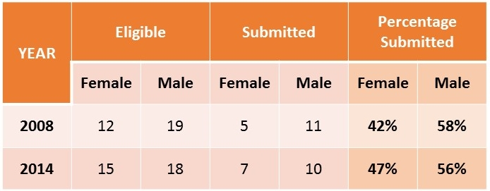LHCS submitted 47% of eligible women and 56% of eligible men to REF2014 (Table 17). We have defined eligible as Central Academics and Research Fellows whose contracts extended beyond the REF assessment period. Comparison with RAE2008 suggests this gender gap may be narrowing, but this observation should be taken with extreme caution given the small sample sizes.

Table 17 - LHCS Submission to RAE2008 and REF2014 by Gender

Since men devote a greater proportion of their time to research, the fact they are more likely to be submitted for REF is most likely the consequence of this already identified problem, rather than a new one. Nonetheless, the possibility that unconscious biases are held by the Departmental Research Committee cannot be excluded.

**Action Point 5.4. Make the Departmental Research Committee aware that female academics are less likely to be included in REF and make efforts to include eligible women in REF2020.**

|  |
| --- |
| SILVER APPLICATIONS ONLY Key career transition points: professional and support staff (i) Induction  Describe the induction and support provided to all new professional and support staff, at all levels. Comment on the uptake of this and how its effectiveness is reviewed.  (ii) Promotion  Provide data on staff applying for promotion, and comment on applications and success rates by gender, grade and full- and part-time status. Comment on how staff are encouraged and supported through the process. |

## Career development: academic staff

#### Training

LHCS does not offer its own training or career development activities, except for ad hoc training on laboratory equipment. However, all academic staff have five days in their workload for training and are encouraged to use them, with extra days permissible.

A wealth of courses are offered by several university units (e.g. HR, Library, Research Career Development Support Team, Equality and Diversity Unit). Regrettably, this means formal training records are not held in one place. We have tried to infer training records from Workload planning data, but this data has proven patchy and unreliable, such that differences between gender groups cannot be identified.

**Action Point 1.2. Raise the issue of staff training data at the institutional level. Ensure that HR builds in appropriate monitoring reports in the University’s soon-to-be developed Staff Development database, to make the monitoring process more robust.**

#### Appraisal/development review

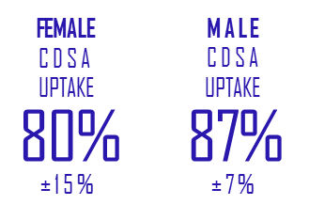The OU has a robust career development and staff appraisal (CDSA) process, which is compulsory for all academic and research staff, and has been adopted by all departments.

CDSAs occur on an annual basis, usually during May-July when workloads are under consideration for the coming academic year. The majority of CDSA appraisers are Professors in the most relevant discipline to the appraisee. For individuals in senior roles CDSA is usually performed by the HoD. Staff are allocated an appraiser and informed of their proposed appraiser prior to CDSA preparation. Importantly, staff are able to request a change of appraiser. Prior to the appraisal meeting, staff are asked to complete a form with their achievements over the year and encouraged to seek feedback from colleagues to inform the appraisal process. Following CDSA, electronic copies of appraisal documents are signed by both parties, and sent to the Dean, who is required to report to the university annually about the percentage of staff completions. For the period of the self-assessment period, CDSA completion in LHCS was high (Fig 16).

Figure 16 - LHCS Yearly CDSA Completion, April 2012-March 2015

#### Support given to academic staff for career progression

All staff discuss their career plans at appraisal. A Departmental policy has been introduced that requires appraisers to ask about promotion and career plans and to identify any training needs. Identified needs are then fed into the individual’s workload plan. Appraisers meet their appraisees between appraisals to discuss how career plans are progressing.

#### Support given to students (at any level) for academic career progression

The majority of our UG students are already in employment and study to further their career and for personal development. Few are looking for a career in academia, although there are some who have gone on to successful academic careers including at least one woman Professor.  A dedicated Careers Advisory Service webpage is provided.  It contains a range of resources to help with career plans including social media sites and the opportunity to book a session with an advisor. There is also a free online course on planning your career <http://www.open.edu/openlearn/education/succeed-the-workplace/content-section-overview>. This encourages students to consider their skills, both those from study and those from life, and interests.

. . 

Figure 17 - Illustration of roles OU students may play in life from the OpenLearn course

Opportunities for work experience such as the NHS Scientist Training programme and Analytical Chemistry studentships are advertised on the careers advisory site and in module and student association forums. Central Academic staff will act as referees for students wishing to join learned societies and Associate Lecturers will provide job references. A recent initiative on the taught Master’s degree M.Sc. Medicinal Chemistry arranges for the students producing the best reviews as part of this course to submit them to an international journal for peer review and possible publication.

**Action Point 2.3. To interest students in progressing to a research career by providing podcasts/videos on the qualification forums of academic staff, researchers and PG students talking about their research.**

Postgraduate research students have their own dedicated website, the Virtual Research Environment, which includes details of training available and careers advice.



Figure 18 - An image from the Virtual Research Environment

Postgraduate students are required to keep a record of their skills development and include their progress in their six monthly reports.  A range of continuing professional development workshops are available including ones on using media and impact. Face-to-face workshops are held regularly and repeated to maximise participation. Some are targeted at specific groups such as women seeking an academic career.   Postgraduate students are required to present their work in Departmental seminars and expected to present posters at international conferences.

#### Support offered to those applying for research grant applications

The OU Science Faculty offers considerable support to staff writing grant applications to make submissions as competitive as possible, with all grants being internally reviewed prior to submission. This is achieved by entering a complete draft into the *Awards Management System* (AMS) programme on the university intranet. The proposal is checked by admin and legal staff, and the scientific part sent to review. All LHCS grants are read personally by the Research Lead (Martin Bootman) and by a second member of staff nominated by Dr Bootman. Both reviewers provide constructive feedback and are required to approve that the grant is competitive on AMS before the actual submission is possible.

AMS is also used to help the Department and individual grant applicants learn from successful and unsuccessful proposals. In particular, a project on AMS cannot be considered closed until the result is entered along with some reflective feedback on reasons why the grant was rejected.

|  |
| --- |
| SILVER APPLICATIONS ONLY Career development: professional and support staff (i) Training  Describe the training available to staff at all levels in the department. Provide details of uptake by gender and how existing staff are kept up to date with training. How is its effectiveness monitored and developed in response to levels of uptake and evaluation?  (vi) Appraisal/development review  Describe current appraisal/development review schemes for professional and support staff at all levels and provide data on uptake by gender. Provide details of any appraisal/review training offered and the uptake of this, as well as staff feedback about the process.  (ii) Support given to professional and support staff for career progression  Comment and reflect on support given to professional and support staff to assist in their career progression. |

## Flexible working and managing career breaks

#### Cover and support for maternity and adoption leave: before leave

Line managers make staff aware of their rights, both statutory and any additional offered by the university. Information is given about the onsite crèche and how to apply for a place.

The workload of the member of staff is discussed and prioritised, so that she/he can concentrate on more important tasks in case the leave date has to be brought forward. A conversation with the HoD or line manager about which tasks will have to be allocated to other people is also held.

#### Cover and support for maternity and adoption leave: during leave

The reallocation of teaching and research duties varies from case to case depending on the staff member’s role. Duties are either reassigned to other staff members, a backfill appointment is made (a new appointment or by increasing the hours of part time staff), or their contract is paused (for PDRAs where funding rules allow).

At present it is unclear how the duties are reassigned to other staff members, and whether this increased workload is reassigned proportionally between male and female staff members.

**Action Point 6.2. Monitor how work is reallocated for maternity, paternity, adoption and long term sick leave and whether the reallocation is proportional for male and female staff members.**

Staff retain their access to e-mail and university websites and so continue to receive information on upcoming grants and seminars and the Message of the day. Staff can also make use of ten paid Keeping In Touch (KIT) days.

Three women in LHCS have taken maternity leave since 2011, one Central Academic, one PDRA and one research student. The teaching and admin duties of the Central Academic was shared to other members of staff, but this was not possible with her research, which largely built up to deal with after return. For the PDRA, it was not possible to pause the contract as the maximum extension (6 months) allowed by the funder had already been used prior to the individual taking up the post. The PDRA’s contract expired during her maternity leave (the time on leave was not covered by someone else); a new contract was offered to her upon her return, paid by a new grant. As the PDRA’s contract expired during her leave she did not take any KIT days. The research student’s grant was paused over her leave. During her maternity leave, she was in contact with her supervisors and was visited at home at her request due to the distance between her home and the OU.

#### Cover and support for maternity and adoption leave: returning to work

The Central Academic who returned from maternity leave raised the importance of allowing academics the chance to deal with the backlog in research, to ensure they can continue their research career. One way of achieving this is to allow for a reduced teaching or admin load. The university-wide Athena SWAN action plan includes an action to ‘develop specific support for re-starting research activity following maternity leave including e.g. reducing teaching allocation’.

**Action Point 6.3. LHCS to develop a clear guideline, following action set in university-wide action plan, to support research-active women returning from a career break to re-start their research activity. Recent evidence of good practice should help in formalising this guideline**

The Science Faculty advises mentoring for women returning from maternity /adoption leave, however LHCS does not have a clear structure for this, and the mentoring system was not implemented for the women who recently returned from maternity leave.

**Action Point 6.1. Put in place a Departmental Maternity Leave Mentoring system and encourage staff to use/support it.**

#### Maternity return rate

The OU has had a generous maternity leave policy for over 30 years. All the women who took maternity leave since 2011 returned to work full-time. The Central Academic returned to her permanent post on the same contract, the PDRA returned on a new contract funded by a new grant. The Ph.D. student continued on her grant.

The women were generally positive in terms of support provided by the Department during their pregnancy and return back to work.

#### Paternity, shared parental, adoption, and parental leave uptake

Since 2011 one male Central Academic member of staff (Lecturer) had a child. He voluntarily chose to take only part of his paternity leave (5.5 days of the 10 days available). There have been no formal requests for adoption or other parental leave in LHCS since 2011.

#### Flexible working

The university has long had a Flexible Working Policy and has recently extended this under the name ‘Agile working’. Agile working cases are logged in the Faculty and submitted to Central HR. The Faculty Management team review the log of Agile working requests at least annually. All incidents are handled in accordance with the relevant University policies.

To date, only one (successful) formal application for Agile working has been made by LHCS staff. The lack of take-up is not unexpected as staff are not required be present at fixed times. So long as teaching materials and other work requirements are delivered on time, academic staff are free to work on these when and where they choose. This flexibility has been found useful by both men and women since the founding of the university and is accepted as normal.

Staff are asked via a weekly message where they will be working each week, but this is for information only. In the case of emergencies, for example illness of a family member, staff can simply ring in and say they are at home that day.

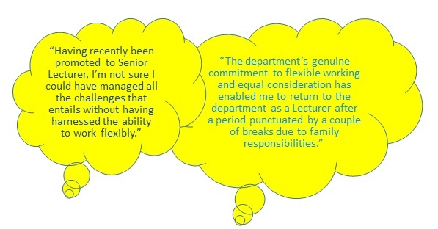

Figure 19 - Quotes from LHCS Staff on the Value of Flexible Working

#### Transition from part-time back to full-time work after career breaks

The OU has no formal policy for part-time staff transitioning to full-time, although many individuals – including several members of the SAT – have done so. We have corresponded with our Faculty staffing team about this issue and they have explained that where an individual has a part-time contract, working hours can only be extended in response to increased Departmental workloads. This requires a valid business case to be presented to Faculty. Since any transition to full-time work will always be dependent on the availability of funds, it is difficult to introduce meaningful policy in this area. However, the Faculty staffing team are only aware of one formal request for increased hours in the last 15 years. Staff on full time contracts who return from maternity leave or extended sick leave have been able to work part time on their return and move to full time when ready.

## Organisation and culture

#### Culture

Overall job satisfaction was shown to be high for female staff (average grading 3.92/5) in a recent university survey. The preparation of teaching materials is a team effort. Although the chair of each module has overall responsibility, they rely on all team members producing their own teaching material and contributing to discussions on other material and module planning. This engenders an atmosphere of cooperation, which has been shown to create an attractive working environment for both males and females[2].

The Department has a coffee room equipped with a hot drinks machine and microwave. This is widely used by all members of the Department and was a key factor in integrating the two former Departments. It provides a space for informal socialising and networking that is more inclusive than the traditional drinks after work. The Head of Department regularly joins other members of staff for lunch here and at other times (unless at a meeting) is available to talk to any member of staff.

This room and the adjacent meeting room is also the venue for Departmental celebrations of success including successful Ph.D. vivas, submission of the previous Athena SWAN bid and the award of an MBE to a female academic.

#### HR policies

All staff are informed of updates to HR policies via university notices and through the Departmental Message for the Day.

Monitoring of HR policy application is done at Faculty level.

Bullying & Harassment cases are reported on the appropriate form and sent to the Equality & Diversity office. There have been no cases during the period covered by this submission.

#### Representation of men and women on committees

LHCS has four internal committees that run continuously. These are the Management committee, the Research committee, the Promotions committee, and the Athena SWAN SAT. The most influential are the Management and Promotions committees. Because of the relatively high percentage of women staff, there are no issues of ‘committee overload’.

*The Management Committee.* Membership of the Management Committee is automatic based on academic role (see Fig. 20). As such, gender balance is not a consideration, although this team is currently gender-balanced. There is also a broad representation of staff grades.

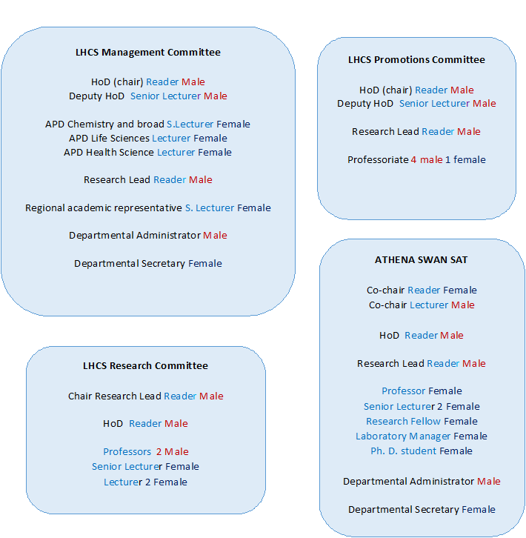

Figure 20 - The Gender and Grade Composition of LHCS Committees, March 2015

*The Promotions Committee*. This team is also automatically appointed based on academic role, but is seven-eighths male, and with a lack of representation from lower grades. LHCS promotions procedures are currently under review.

**Action Point 5.8. Assess the new promotions procedures for gender balance as soon as they are announced.**

*The Research Committee.* The Research Committee is chaired by the Research Lead and the HoD, who invite other academics to fill the remaining positions. Care is taken to ensure a balance of academic grades and genders. This Committee currently has 3 females out of 7 members.

*The Athena SWAN SAT*. The make-up of this team is covered by Section 3.1i. The team obligatorily contains the HoD, but all other positions are invited. We make sure a range of grades are included, and not just academic: this is the only Committee to include support staff and students. There is currently a small under-representation of men on the team.

#### Participation on influential external committees

LHCS has no explicit policy regarding participation on external committees, but it is generally welcomed. Both the current and previous HoDs have been supportive, as external committee membership is boosts the visibility of the Department while helping the individual’s career. With this in mind we are introducing the following Action Points.

**Action Point 5.9. The HoD to emphasise his support for membership of external committees.**

**Action Point 5.10. An exercise at the next LHCS away day for the benefit of junior staff, asking everyone to list membership of external committees and to detail how they came to stand on them.**

#### Workload model

An online workload management system is used by all Academic/Research staff across the university, visible to that individual, the HoD and Faculty administrators. In LHCS staff are allocated their duties for the forthcoming academic year by the HoD and qualification leads, taking into account individual requirements and institutional strategy, and subject to approval by the Dean. Workload plans are updated as activities change. Every task carries a tariff, which is set at Faculty or University level. Within their 217 working days each member of Central Academic staff is expected to undertake approximately 100 days (46%) of teaching (unless they have research funding that allows them to be bought out of some or all teaching) and 79 days (36%) research or scholarship. These do not apply to Staff Tutors who undertake regional duties (that can include teaching) that constitute up to 60% of their allocated time. The remaining 40% is for central work, which can include teaching, research/scholarship and other tasks. Non-standard tasks, (including work on Athena SWAN, Aurora mentoring, service to external bodies and outreach) are also built into the system and are allocated a tariff. For PT staff, the allocation to each category is reduced proportionately.

As a result of engagement with the Athena SWAN process, particular attention was paid to gender differences in the proportion of time allocated to research, teaching, knowledge exchange and administration. This resulted in a more equal allocation of tasks. Allocations for 2014/15 and 2015/16 are given in Table 18.

|  |  |  |  |  |  |
| --- | --- | --- | --- | --- | --- |
| **LHCS Workload Allocations** | | | | | |
| **Academic year** | **Gender** | **Teaching  %** | **Research  %** | **Knowledge Exchange  %** | **Admin  %** |
| **2014/15** | **Female** | 59 | 30 | 4 | 8 |
| **Male** | 43 | 29 | 10 | 19 |
| **2015/16** | **Female** | 50 | 38 | 3 | 9 |
| **Male** | 45 | 36 | 2 | 17 |

*Table 18 - Allocation of tasks to academic staff by gender.*

Encouragingly, among Central Academics, men and women have similar research allocations. Women continue with higher planned teaching loads than men, but the gap is decreasing, while men tend to take on more KE and Admin tasks.

At the end of each academic year staff are asked to complete their actual workload allocations for the previous year. As seen in section 4.2, these returns indicate that in practice women continue to do more teaching and less research.

**Action Point 5.2. Survey women central academics to discover why they are not taking advantage of their research time.**

#### Timing of departmental meetings and social gatherings

The OU has long had a culture where meetings are usually scheduled to allow flexible working (see Guidance document), but this has never been codified formally. Because of this we have generated an Action Point to introduce a Core Hours policy. Other than in exceptional circumstances, all Departmental meetings and any other scheduled meetings must take place between 10am and 4pm. Note that in common with OU culture, all meetings are covered by Skype or Lync systems, to allow external participation.

Almost all social gatherings are held at times that allow staff with childcare and other commitments to attend. The exceptions are some events organised primarily for PhD students, and the annual Departmental Away day, which is residential and held over two days. This residential arrangement provides a unique opportunity for all academic staff – including Regional Academics based far from Milton Keynes – to socialise together.

**Action Point 5.11. Introduction of a Departmental Core Hours policy**.

#### Visibility of role models

Visibility of female role models is not something LHCS has considered to any great extent and we are thankful to Athena SWAN for bringing this to our attention. We have a number of Action Points planned. We aim to develop this aspect of our growth by looking to increase visibility of individuals from ethnic minorities and other under-represented groups.

Examination of speakers at our Departmental seminar series (since January 2013 when the current organiser took over) has revealed that almost 70% of speakers were men (Fig. 21). We have no access to earlier data, but have no reason to believe the gender balance would have been different. It is possible this gender balance reflects the pool of available speakers, however we will still make efforts to address the under-representation of females.

Figure 21 - External Speakers at Departmental Seminars, Jan 2013 - Mar 2015

**Action Point 7.1. Staff to be made aware of the need to invite female speakers, and subsequent gender balance to be monitored with the aim of getting it closer to 50:50.**

**Action Point 7.2. The identification of a benchmark for BAME speakers in future.**

Departmental seminars are chaired by the host academic. Excluding seminars where the speaker is internal and there is no formal invitation, the majority of seminars have been chaired by men (~65%). We are less concerned with this as the majority of speaker invitations are made by a very small group of staff. Like many Departments we struggle to fill all our sessions and we do not want to dissuade those willing to take the time to invite external speakers from doing so in future.

The LHCS website has become largely outdated due to changes in the structure of the OU and staff turnover. Much of the information is out-of-date and it has become poorly navigable. We are therefore in the process of replacing the website in its entirity and analysis of the existing website would be irrelevant. The new website is being designed with considerable consultation from the rest of the Department. Nonetheless, to help ensure a healthy profile of LHCS we will enact the following Action Points:

**Action Point 7.3. Write to website designer to make sure she is aware of the need for gender balance and representation of ethnic minority faces in the design of the website.**

**Action Point 7.4. Ensure that an LHCS Athena SWAN page is included in the new website and is visible from the main homepage.**

#### Outreach activities

Outreach activities are not confined to the area around the main campus and may also take place from our 12 offices throughout the UK. Our outreach also happens through a variety of media including BBC TV programmes co-sponsored by the OU (e.g. ‘Bang goes the Theory’, ‘The Hunt’, ‘Inside Science’), iTunesU; YouTube; and OpenLearn all of which have national, and global, reach. Staff are encouraged to become involved in these media outputs and female staff have also been encouraged to attend external women-only BBC-led courses. The OU also runs its own in-house training; to date 58 women and 67 men have participated.

Science students from local schools are invited to campus to attend annual Christmas lectures. In addition several members of staff give talks and demonstrations in local schools.

Outreach activity is recognised in workload planning and in promotion.

We have attempted to use Departmental Higher Education-Business and Community Interaction Survey (HEBCIS) data to assess the totality of engagement activities. However, we have found the information to be insufficient to make any meaningful comparisons by gender or by grade. This is a great shame as outreach activities are highly valued in LHCS, not least for their capacity to stimulate interest in STEM subjects, in particular amongst school girls.

**Action Point 1.3. Ensure the need for accurate outreach data in Athena SWAN applications is publicised.**

Words used in this Section: 4898

|  |
| --- |
| SILVER APPLICATIONS ONLY CASE STUDIES: IMPACT ON INDIVIDUALS **Recommended word count: Silver 1000 words**  Two individuals working in the department should describe how the department’s activities have benefitted them.  The subject of one of these case studies should be a member of the self-assessment team.  The second case study should be related to someone else in the department. More information on case studies is available in the awards handbook. |

1. Donovan, C. *et al.* 2005. Women in Higher Education: issues and challenges for part-time scientists. *Women’s Studies International Forum*, **28**(2-3):247-258.
2. Chemistry World April 2016, Family friendly science p.38 and refs therein