Annual Remuneration Report for 2019/2020

Introduction

- The Remuneration Committee operates under delegated powers of the Council. In terms of the annual senior staff pay review its remit is to consider and approve merit awards and discretionary increases for all staff earning over £100k in the OU group, including the Vice-Chancellor (VC) and the Vice-Chancellor’s Executive (VCE).
- The Higher Education Senior Staff Remuneration Code requires a Remuneration Annual Report to be presented to the institution’s governing body.
Terms of reference

- This year the Remuneration Committee has reviewed the terms of reference as published on the University’s external website and made small adjustments to terminology for greater clarity.
Institutional performance & strategic objectives

- The context for determining senior pay includes reference to Institutional performance that includes five key strategic objectives;
- Student Success
- Excellent teaching and research
- Growth and sustainability
- Technology that enable success
- Dynamic and inclusive culture

These objectives have a further twelve headline measures aligned to them (see the strategic Performance Report for full details). This year, the Committee has recognised the progress the University has made, especially in light of COVID-19, and how future reward schemes need to reflect the performance against the key institutional objectives.
Approach to remuneration
Recruitment
- When considering proposals for senior appointments with a total pay (excluding pension) above £100k, the Committee considers external market data, internal comparators and a business case before approval is given. This process has been effective throughout the year during which only one candidate for a senior post withdrew after they were offered the role.
Recognition & retention
- We reward, recognise and encourage high performance focused on enabling our students to achieve their goals, and achieving high quality research. When reviewing proposals for salary increases and performance-related merit awards, the Committee considers the following factors:
- Budget: pay increases or one-off awards can only be made if the spend is within the maximum expenditure permitted.

- Contribution:
    - Demonstrable exceptional performance that has a significant contribution to the University’s strategic objectives. This is rewarded through movement to a higher point on the salary scale.
    - Pay increases agreed for Band 3 professors and Band 5 academic-related staff may typically be equivalent to the incremental spinal points on lower bands of the appropriate scale. In exceptional circumstances, increases may be awarded above these points, where justified by an appropriate business case (e.g. market competitiveness).
    - One-off awards (currently paused – refer to para 8a) are proportional to the time spent and the value or impact of the work.
- Internal equity: the average remuneration of other relevant roles is considered when reviewing proposals.

- External market compensation data: a balanced approach of using both University and Colleges Employers Association (UCEA) data and Willis Towers Watson (WTW) is used. The Committee discussed the appropriateness of WTW as a benchmark as there is a concern that the use of private sector data, may risk inflating pay assumptions. It was agreed that UCEA data should be the primary benchmark and WTW should only be used for specialist Professional Services’ roles and then only as context. Members requested sight of the total package (including pension contribution), not just base salary, when reviewing compensation comparisons against the market.

- VCE approved a number of changes to the current reward policies for staff due, in part, to the impact of COVID-19. The changes were approved by the Remuneration Committee, and included;
- Merit/Special award – this is a one-off award for individuals demonstrating excellent contribution and is acknowledged that the scheme is not robust. Against the backdrop of COVID-19, it was felt it would be difficult to recognise the achievements of individuals, and the decision was made to pause the scheme whilst further work on a new scheme progresses.

- Discretionary and additional increments– Additional increments to base pay for senior staff were only considered for structural pay reasons in the following scenarios:
- Where an individual’s pay was agreed earlier in the year with implementation of an increase deferred to the annual pay review period.
- Where an individual’s role changed during the year and pay adjustments were deferred to the annual pay review period.
- Where an individual’s pay required a review to address inequity.

- Going the extra mile award scheme – this scheme remains unaffected. However, as the merit award remains suspended, it is operating with additional scrutiny from an equality perspective.

- Cost of living award – this is nationally agreed for all roles across the sector and for 2020/2021 a zero cost of living award has been proposed in recognition of the sector’s financial difficulties.

- One-off recognition payment – in the absence of the cost of living award, the University has proposed a one-off, non-consolidated payment to all staff in recognition of their contribution and the circumstances colleagues have been working in during the pandemic. After careful consideration, the Committee has approved this payment for all senior staff, with the exception of the Vice-Chancellor and VCE. The scheme details are being finalised and payment is likely to be made in February 2021.

- A substantial piece of reward work is underway to review the future reward framework. This will be a key focus for the Committee at its next meeting.
Vice-Chancellor pay

- This year has been unique when reviewing the Vice-Chancellor’s pay because of the impact of COVID-19 and recognition that across the sector, other universities are struggling financially. In order to carry out a robust process, the Committee gave consideration to the following factors;
- Pro-Chancellor’s report – summary of performance against agreed objectives. The Pro Chancellor seeks feedback from Council members against delivery of the VC’s objectives.
- Institutional performance report - based on KPIs and metrics agreed by the Council (as per para 4).
- Comparative market data – data based on the sector and includes pay multiples
- External market conditions – includes broader factors that may have affected the performance e.g. COVID-19

- Summary positioning of the VC’s pay details and comparison to external benchmarking data is shown below.
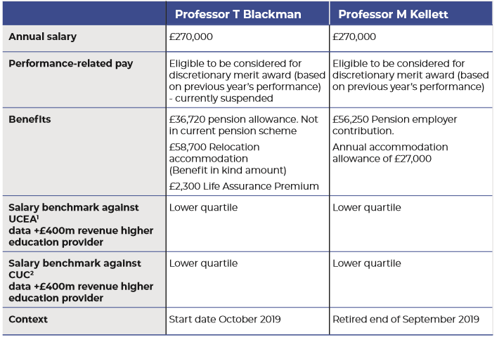
- The pay multiple calculation is based on the UCEA methodology agreed by the Committee of University Chairs.
Pay Multiple based on median pay in the OU  (Based on UCEA methodology) | 31 July 2020 multiple  £40,322 – 6.7x

- The Vice-Chancellor’s remuneration is published in the Financial Statements. Also published is the number of other staff falling into bands of £5,000 above the £100k per annum threshold, as required by the Office for Students (OfS).
- The Committee of University Chairs guidance requires disclosure of any income received by the Vice-Chancellor for externally paid appointments. The Vice-Chancellor received £0 in the financial year 2019/2020.
Senior staff pay review

- The Senior Pay Review was conducted in line with the approach to remuneration for 2020 noted in para 7.
- As part of the Senior Pay Review, the Chair requested a report on changes to and newly created senior staff roles over the last three years. The data indicated that there were no material increases in the overall headcount or the salary costs of the senior staff population. This gave the Committee assurance that the University had controls in place. The exercise will be repeated annually.
Lifetime allowance review

- The University has in place a lifetime allowance policy for individuals who have reached the HMRC pensions tax threshold and wish to leave the USS pension scheme. In response to the Committee’s request, an independent review was completed, and the committee was satisfied with the recommendation that the current policy should continue with a review every two years.
Expenses

- In line with the University’s Travel and Subsistence policy, the Committee received the bi-annual report on the travel and subsistence expenditure of members of the Executive.
- The half-year report was presented in May 2020 and a full year report in October 2020. No concerns or remedial actions were recommended. A summary, by role title, will be published on the University’s Freedom of Information website.

