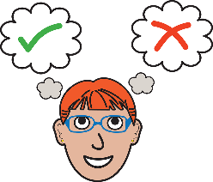Consent form

Letting us use your story, photograph or video

We are The Open University (OU). We teach students; many are studying to become nurses. We are preparing to teach students to support people with a learning disability and their families.
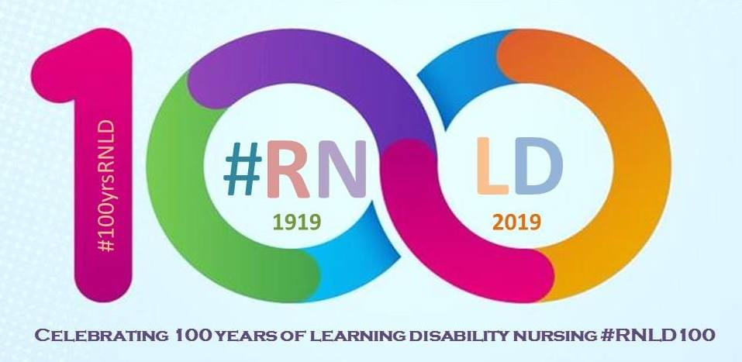
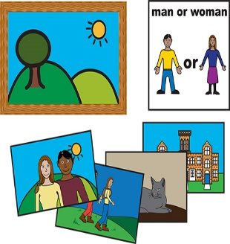In 2019 we are celebrating 100 years of learning disability nursing with a display called:

‘100 Pictures and Memories of Learning Disability Nursing’.

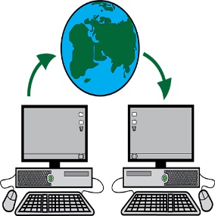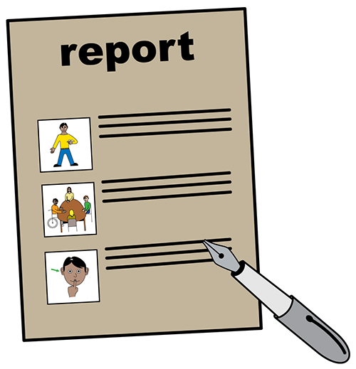We might use your story, photograph or video in different ways to help the OU. For example:
- Websites
- Leaflets and posters
- Reports
- Virtual Learning Environment (a private and secure place on the internet where the students’ study)
- Social media (places like twitter and Facebook)
You can tell us at the end of this form if there are places you don’t want us to use it.

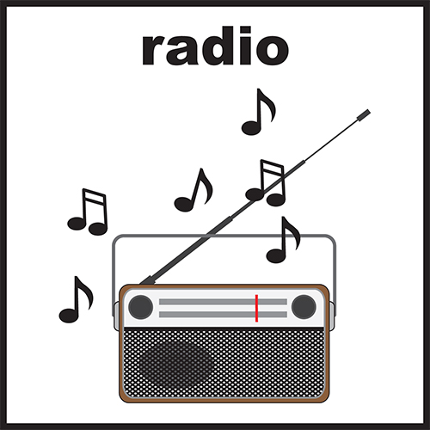We will check with you first before we use anything in the national media. Places like:
- Newspapers and magazines
- Radio and TV

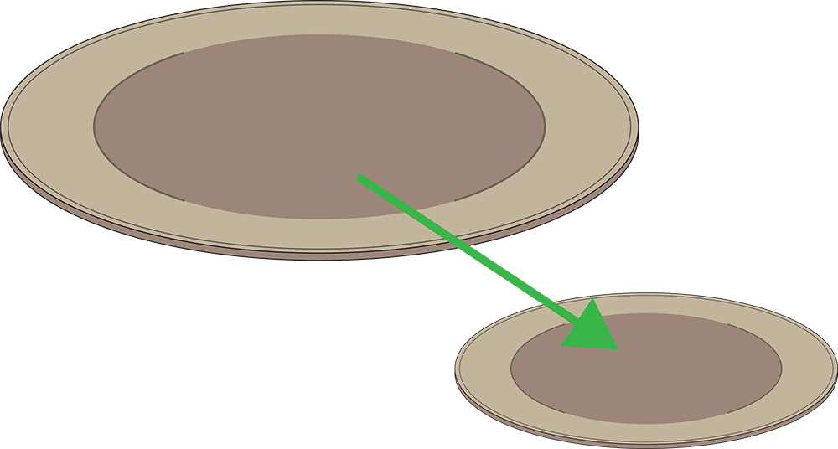We may need to change your story, photo or video when we use it. For example, we may need to make it shorter or smaller.

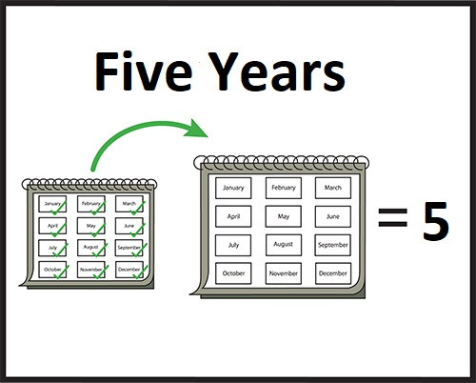We will keep your story, photograph or video in a safe place on our computers for 5 years after this time it will then be deleted.

If you want us to stop using your information, please write to this address or ask your supporter to help you:

To: Jillian Pawlyn, Lecturer in Nursing, Learning Disabilities.
The Open University, Walton Hall, Milton Keynes, MK7 6AA
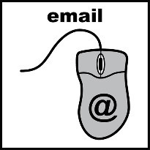
or email Jillian.Pawlyn@open.ac.uk

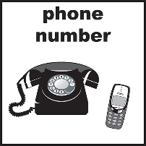You can also call Jillian on +44 (0) 1908 653464 (please leave a message on the voice mail)

You can get in touch at any time.

This form is about letting The Open University (OU) use
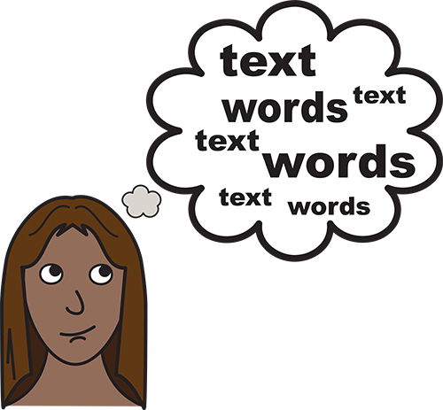(You can select/ tick more than one)

My story

My photograph/ picture
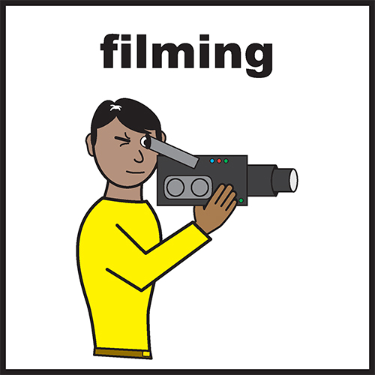
My video

About you (the person the story, photograph or video is about)
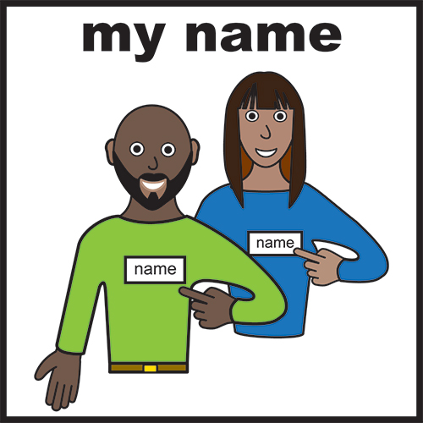
My name
Address

Postcode

Email

Telephone number

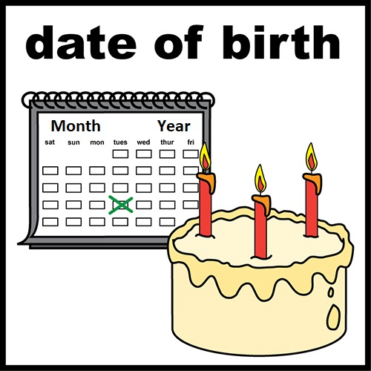
Date of Birth

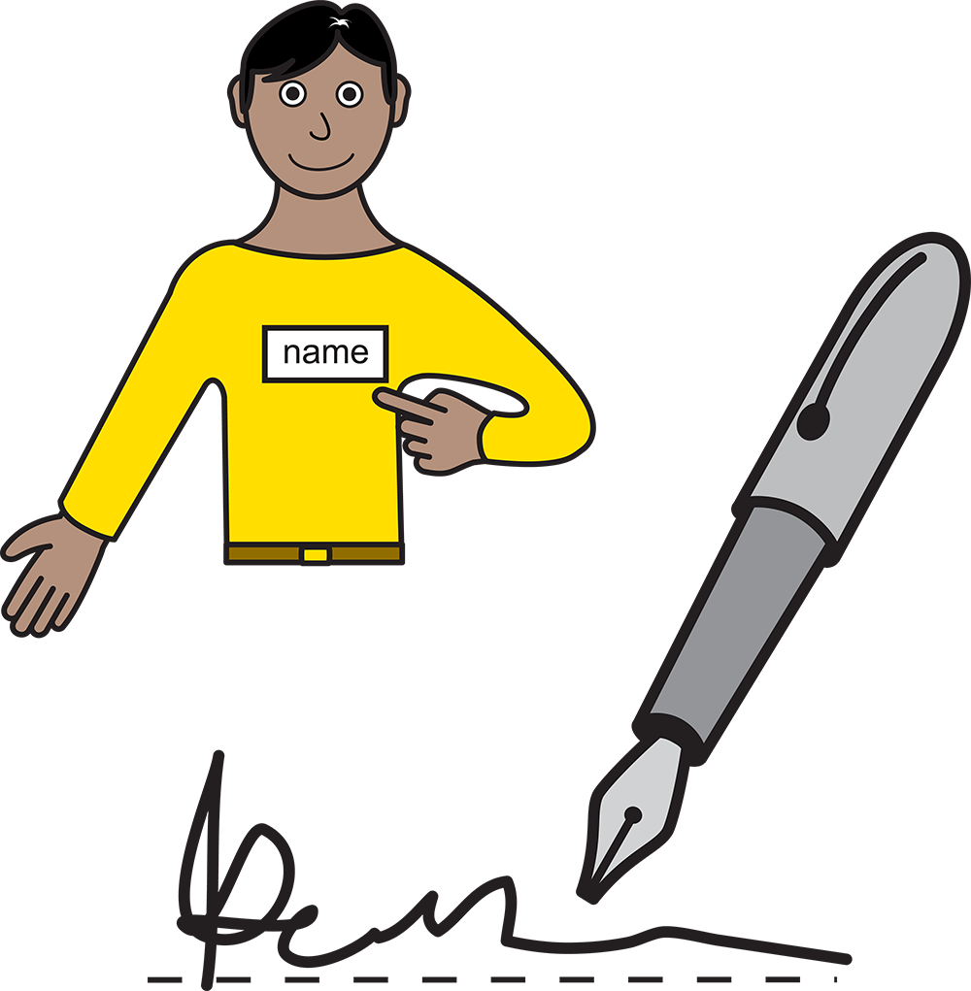
Sign here

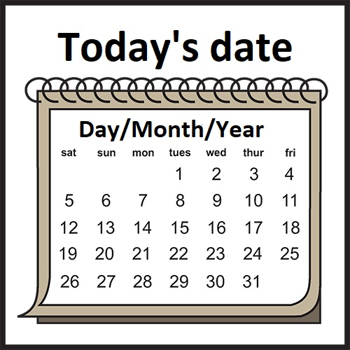

Date signed

If you are under 18, or cannot sign yourself, then your parents/ guardian or the person that cares for you, must sign the form for you on the last page.
How would you like your name to appear when we use your story, photograph or video?
e.g. Susan Smith may want to be presented as Mrs or Ms S Smith…
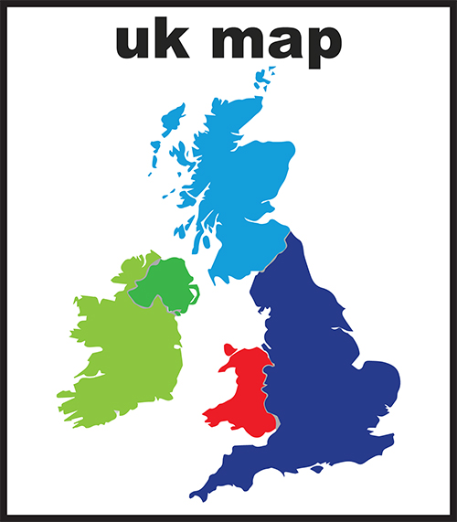

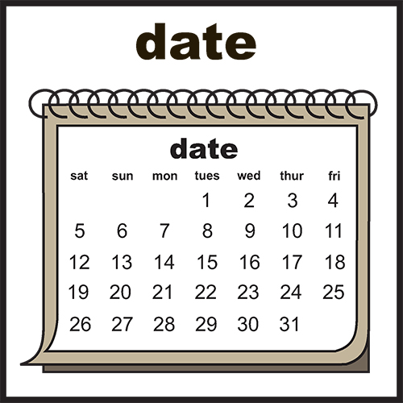Please tell us where and when the photographs or video was taken.

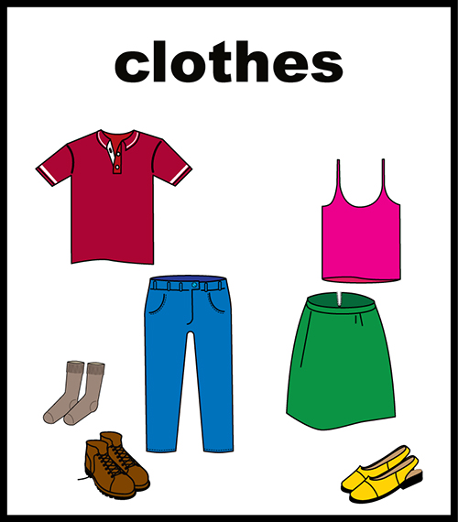
To help us identify you, please tell us what you are wearing in the photograph or video.

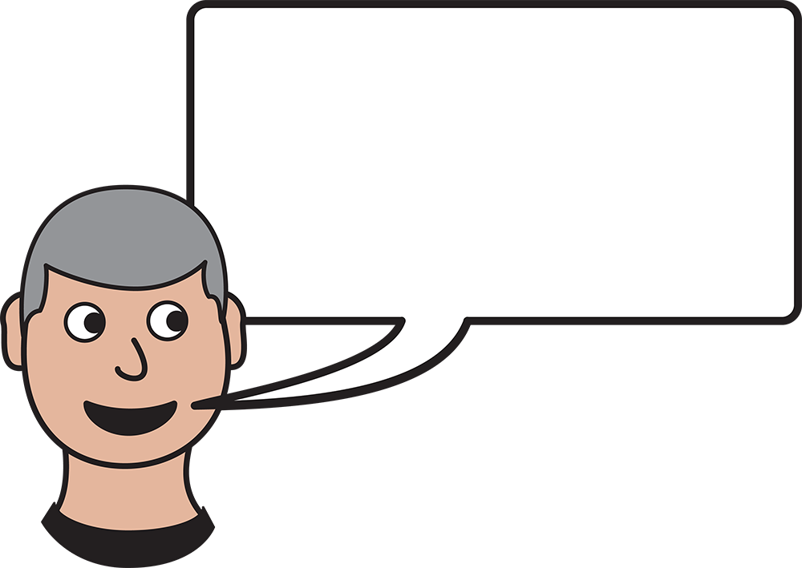Is there anything else you want to tell us about your story, photograph or video?

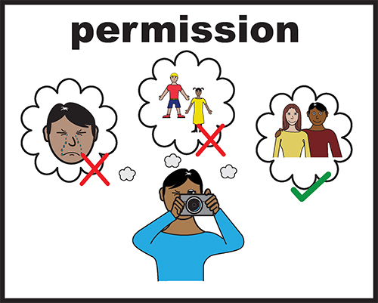Please send us photographs or video which belong to you.
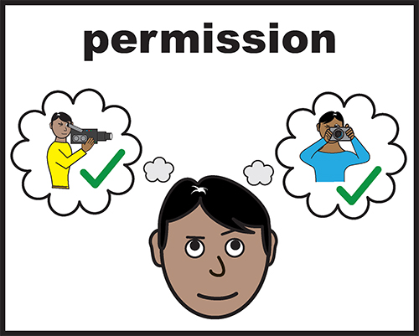If the photographs or video do not belong to you, do you have permission from the person who took it to share it with the OU.?
If your photograph or video includes images of other people, it is nice to check with them first if they are happy to share it with us. But if that is not possible, you can still send in your photograph or video to us. But if anyone subsequently complains, we will review its inclusion.

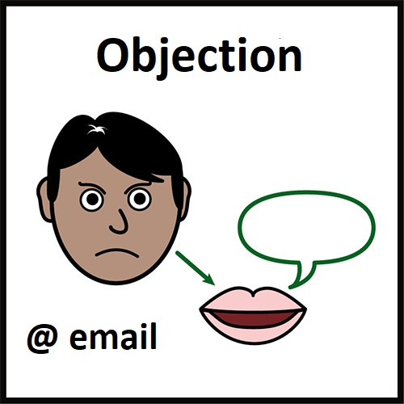If we get any objection to the material which has been shared, we will remove it while we explore what to do. The objection may be because the material:
- Breaches copyright
- Contains sensitive personal information
- Contains content which is disrespectful
We will let you know if we need to take down materials you have shared.

Please only send us copies of your photographs, videos or stories. You can send them to us by email or by post.
We are unable to return your photographs, videos or stories to you.

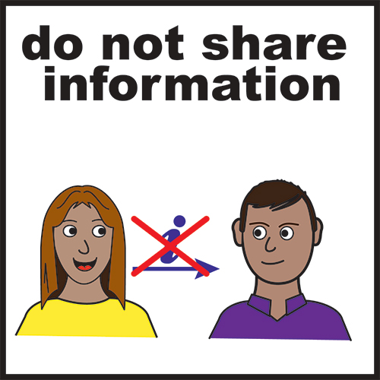We will not share your address or contact information with anyone outside the Open University.

Thank you

Further information about sharing:
For further information about sharing videos and photographs is available on this website https://wiki.rixwiki.org/livingarchive/home/inclusive-archive/sharing-things-to-think-about
It is a different project, but the information may help you with your decision about what to share.

Further guidance on consent:
For helpful guidance and information on giving consent for the use of photos of people with Profound and Multiple Learning Disabilities (PMLD), please refer to the Mencap publication ‘Consent for videos and photos of people with PMLD’ http://www.pmldlink.org.uk/wp-content/uploads/2015/07/mencap.pdf

Thanks to openclipart.org for the use of their image bank.

Support with the story, photo or video:

If you are signing this form for someone else, please tell us:

Your name

Address

Postcode
Email

Telephone number

Date of Birth

Sign here
Date signed

