Top tips for making your abstract (or summary) and presentation more accessible

 | The Social History of Learning Disability conferences are inclusive events.
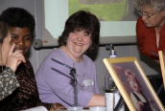  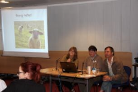  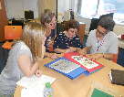 | The audience includes:  - People with learning disabilities  - People who work or study at universities  - People who work in services or people who are paid to support people with learning disabilities  - Family members, friends and advocates
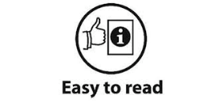 | Abstracts and presentations need to be accessible!
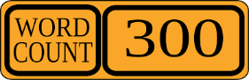 | Your abstract or summary should have no more than 300 words.
 | Use a type font and size that will be easier to read (for example, Arial, point 12 or above).
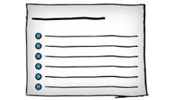 | Avoid sentences that are very long.  You can use bullet points in your abstract if this helps.
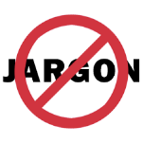     | Avoid jargon in abstracts and presentations!  Keep the language clear and simple.  If you need to use a ‘technical’ or ‘academic’ term, please explain it.
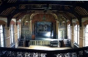  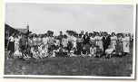   | Photos and images can be helpful in abstracts.
     | Photos, video and sound recordings can also be good in presentations, if you have them.
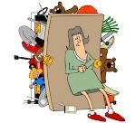     | Don’t rush your presentation.  Make sure you haven’t included too much stuff in it!
Here are some useful links:

https://www.mencap.org.uk/learning-disability-explained/communicating-people-learning-disability
http://www.bild.org.uk/easy-read/about-bild-easy-read/
www.bristol.ac.uk/norahfry/easy-information
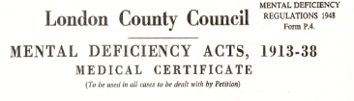  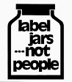 | Language and Labels  If you need to include labels from the past that could be offensive, please do this sensitively.  It’s ok to include them, but you need to explain why.

