**The Kallikak Family, Eugenic false science with tragic consequences.**

The American psychologist Henry H. Goddard (1866-1957) is best known for his work on the area of the inheritability of intelligence. He was influenced by Mendelian genetics, and believed that "feeble-mindedness" was the result of a single recessive gene. Mendel had worked with peas and found breeding a recessive dwarf pea with another always led to dwarf peas. Goddard believed feeble mindedness could be passed on in the same way. He is considered by many to be one of the pioneers of the American eugenicist movement. Early in his career, Goddard believed that feeble-mindedness was dangerous to society. He affirmed that feeble-minded people were

"multiplying at twice the rate of the general population," (1912, p. 71) thus producing

"more feeble-minded children with which to clog the wheels of human progress" (1912, p. 78).

The scientific method emphasizes generating hypotheses and then rigorously testing them in pursuit of truth; eugenics, by contrast, settled upon its fundamental “truth” of genetic inequality and sought methods by which this claim could be substantiated.

Goddard and English Eugenicists such as Galton, Tredgold and Burt saw the ‘feeble minded’ as a greater threat to the population than people with more significant learning difficulties so called ‘idiots’ and ‘imbeciles’. This was because they believed they could pass as normal, but contaminate the population with their defective gene so weakening the stock of the nation.

Goddard met Deborah Kallikak when she was a resident of the Vineland Training School. The genetic cause of her feeble-mindedness is the foundation of Goddard's theories of mental deficiency. Goddard begins Chapter One with "The Story of Deborah":

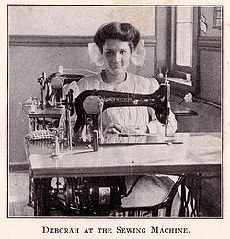“Here is a child who has been most carefully guarded. She has been persistently trained since she was eight years old, and yet nothing has been accomplished in the direction of higher intelligence or general education. To-day if this young woman were to leave the Institution, she would at once become a prey to the designs of evil men or evil women and would lead a life that would be vicious, immoral, and criminal, though because of her mentality she herself would not be responsible. There is nothing that she might not be led into, because she has no power of control, and all her instincts and appetites are in the direction that would lead to vice”. Using Binet’s Intelligence Quotient Deborah was shown to be below the normal range, but the questions she did badly on relied on understanding writing, language and maths.

On enquiring as to Deborah’s ancestors Goddard found out that her great grandfather had been Martin Kallikak. The name "Kallikak" is actually made up by Goddard from the Greek words Kallos (beauty) and Kakos (bad). According to Goddard, the Kallikak family was divided into two strains-one "good" and one "bad"-both of which originated from a common progenitor, Martin Kallikak, Sr. The ‘Normal N’ and ‘Feeble Minded F’ were deduced by what these ancestors achieved in their lives. When Martin Kallikak, Sr. was a young soldier, he had a liaison with an "unnamed, feeble-minded tavern girl." This tryst resulted in the birth of an illegitimate son, Martin Kallikak, Jr. The Kakos (bad) strain of the Kallikak family descended from this line. Later in his life, Martin Kallikak, Sr., married a Quaker woman from a good family. The Kallos (beauty) line descended from this marriage.

Goddard's genealogical research revealed that the union with the feeble-minded tavern girl resulted in generations of "mental defectives" who were plagued by illegitimacy, prostitution, alcoholism, epilepsy, and lechery. His investigation of the other Kallikak branch revealed precisely the opposite: The marriage of Martin Kallikak, Sr., to the respectable Quaker woman yielded generations of society's finest citizens. Goddard believed that the striking schism separating the two branches of the family was due entirely to the different genetic input from the women (1912, pp. 105-106).

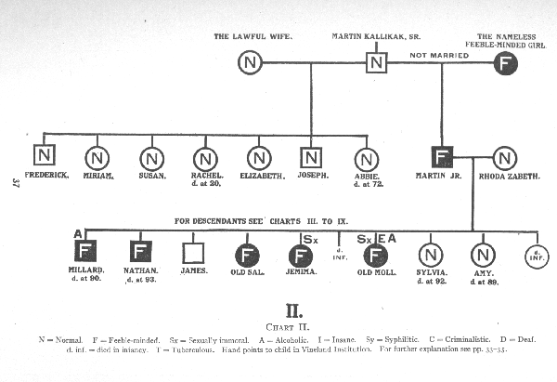

Goddard made assumptions that all sorts of environmental factors that could have led to disease such as poor diet, poverty and deprivation of poor people was the result of the so called feeble minded gene. The Middle class families on the ‘good’ side would have hidden things like sexual affairs, illegitimate babies, illness and alcoholism. So they could not be mapped.

The impact of Goddard’s false science work taken up by the media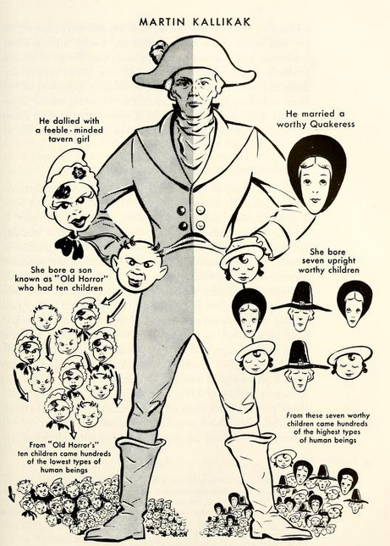 and many prominent people as ‘the need to counter the threat within’, helped to deny American citizens of their freedom and lock them away in institutions with many being sterilised and denied relationships with the opposite sex. The Nazi’s in Germany reprinted his book in German and relied on it for their mass sterilisation and eventual killing of disabled people.

Goddard relied on assistants to visit the shacks of the poor white ‘Hillbillies’ and assess them on the appalling poverty they lived in. From this it was easy to impute mental deficiency even though few tests were administered. To back this up it has now been discovered that the photos taken to emphasis the degeneracy of these subjects had been retouched with black lines to the eyes and mouth. As the director of photographic services at the Smithsonian Institute has confirmed “ There can be no doubt that these photographs of the Kallikak family members have been retouched”.

By the late 1920s, Goddard had reversed many of his early opinions, declaring in multiple public forums that he had been gravely mistaken in many of his most famous conclusions. He had begun to question the validity of the tests that were used to detect morons (feebleminded), and he stated emphatically that his former belief that morons could not be educated satisfactorily was wrong. In addition, he frequently voiced his new opinion that feeble-minded people should be allowed to have children, if they choose to do so. He asserted in a 1927 article for *Scientific Monthly* that the concept of segregation colonies had been a bad idea.

http://www.intelltheory.com/kallikak.shtml

Goddard, H. H. (1912). [*The Kallikak Family: A study in the heredity of feeble-mindedness*](http://psychclassics.yorku.ca/Goddard). New York: Macmillan.

Smith, J.D. (1985). *Minds made feeble: The myth and legacy of the Kallikaks*. Rockville, MD: Aspen.

**Questions**

1. **What fundamental scientific error did Goddard make?**
2. **How did the use of IQ testing misdiagnose Deborah’s difficulties?**
3. **What major mistakes in data gathering about the Kallikak family did Goddard make?**
4. **Why can simple genetics of say characteristics of peas not be applied to human beings?**
5. **Why do you think Goddard retouched his photographs of those with the supposed bad gene?**
6. **Why were Goddard’s later regrets about his findings too late?**
7. **What hypothesis and tests should those such as Goddard have carried out to be scientific?**