The Geography of Eugenics: Long-Stay Mental Deficiency Hospitals in England, Scotland and Wales

After First World War Local Councils were required to build long stay colonies for people with learning disabilities, usually away from where most people lived. Boys and girls, men and women were usually separated from one another and many then stayed for the whole of their lives. This was a result of the Mental Deficiency Act 1913.

The big cities were quicker to build these than smaller towns and country areas.

The effect was that by 1938, 34,290 people were in certified institutions, 9,445 in workhouses, 4,841 under guardianship. A larger number were ascertained but living under voluntary supervision many in long stay establishments. After the 2nd World War with the setting up of the National Health Service all these establishments were called Hospitals. Numbers continued to grow reaching a peak in the 1970’s when over 200,000 were ascertained with 66,000 were incarcerated in long stay hospitals and institutions.

A Series of revelations about mistreatment and new psychological insights that people classed as mentally deficient could learn new skills led to the gradual moving of inmates into the community and the closure of long stay hospital, though this took 50 years to complete.

Find the map in your search engine on a computer

http://ukdhm.org/long-stay-mental-deficiency-hospitals-in-england-scotland-and-wales/

- Each red mark represents the map represents a mental deficiency institution. How would you describe the pattern? Are the dots clustered or spread evenly on the map?
- What do you think this distribution is related to?
- Look at map below of UK population density (1961) and compare it to the distribution of red dots being each ‘mental deficiency’ long stay colony/hospital
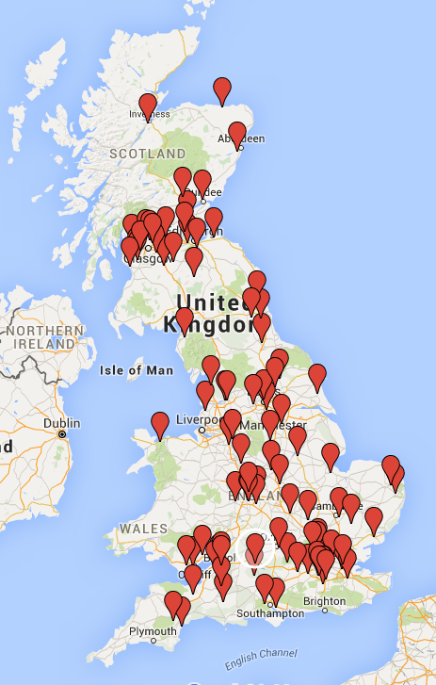
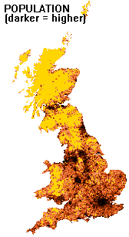

Go onto the Google map onlinehttp://ukdhm.org/long-stay-mental-deficiency-hospitals-in-england-scotland-and-wales/

Focus on London and blow up the map until you can identify the North and South Circular Road. This largely marked the extent of the built up area in London at the end of the C19th -1900. Then examine the distribution of institutions marked by red markers. a) How would you describe the distribution of institutions? b) Can you give reasons for this distribution?

If families had to visit relatives in these Institutions it was not easy. Travel took much longer. In 1951 87% of households had no regular use of a car. This would have meant poor and working class families taking a bus, a train, and then another bus to get to the institution. This would be costly and so what do you think would be the impact on frequency of family visits? Give reasons.

Identify a place you live near or know on the map. Click on the red button and write or discuss what you found out about how many people were inmates/patients. What was it like there? When did it close?

As a follow up you could do an internet search (some websites are on the red button information on the map). Try and find out where the records of people who lived there are held. What can you find out about them?

You could visit the site on line or in reality and find out what the spaces are used for now.

