
Welfare Reform and work bill
November 2015

    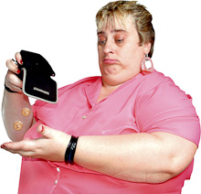      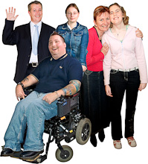       | What is the Bill?  The Government have introduce a bill called the Welfare Reform and Work Bill.  The Government want more people in jobs and they want to spend less money on benefits.  Mencap and other organisations are worried about disabled people not getting fair chances to work and also losing out on benefits if there are cuts.  Parts of the Bill Mencap are worried about  Employment Support Allowance Work Related Activity Group (ESA WRAG)  The Bill says that the amount of money for new people claiming ESA WRAG should be cut from £101 to £73 a week.  This is almost £30 less a week.  Mencap are worried that people with a learning disability need this £30 to pay for bills and other things but also to help them get the right support to get a job.  We are worried people will find this much harder with less money.  Benefits freezes  A benefits freeze means the amount of money people get will stay the same. It will not go up and will not go down.  The Bill says that there should be a benefits freeze for the next 4 years.  The Disability living Allowance (DLA) and Personal Independence Payment (PIP) would not be a part of the 4 year freeze.  These are the main benefits people with a disability get.  But there are many more benefits that disabled people get like  - Job Seekers Allowance (JSA),  - Housing Benefit  - Universal Credit  Which would be included in the benefits freeze  Mencap think that this does not meet the part of the Conservative Party Manifesto which said that disabled people’s benefits would not be changed.  Checking on how things are going for disabled people getting jobs.    The Conservative party manifesto made a commitment to get more disabled people into work.  The Bill says that the Government will check on how things are going to make sure everyone who can work is in work.  They will also be checking on how many people get an apprenticeship, which is a type of job with training.    Mencap thinks the Government need to check on how many disabled people have a job not just the general public.  Mencap thinks that more needs to be done to make sure disabled people are included in apprenticeships.

