Characterisation of the NOMAD detector on the ExoMars TGO mission
using machine learning

Supervision team: Manish Patel, Matthew Soman, Stephen Lewis

External supervisor: N/A

Lead contact: manish.patel@open.ac.uk

Project description: This project provides the opportunity to analyse data from the ESA ExoMars Trace Gas Orbiter mission to Mars.
The project will involve working on:
- Understanding the behaviour of the NOMAD CCD detector during its journey to Mars.
- Characterisation of CCD read-out and signal performance throughout the mission lifetime.
- Design of techniques for optimising signal-to-noise performance of the instrument.
- Machine learning techniques for the analysis of large datasets returned from the ExoMars mission.
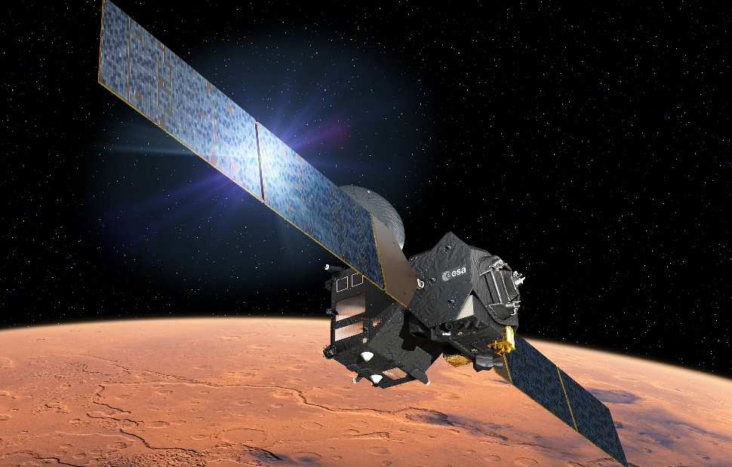

The ExoMars TGO mission is aimed at searching for signs of life on Mars, by furthering our understanding of the composition and dynamics of the martian atmosphere. Having launched in March 2016, it is currently in orbit around Mars. ExoMars TGO will achieve its science objectives through the measurement of trace gases such as ozone and methane in the martian atmosphere from orbit. The project relates to the UVIS channel of the NOMAD instrument, an optical spectrometer led by the Open University to measure solar radiation travelling through the martian atmosphere at UV and visible wavelengths. In this way, we will detect and map the presence of ozone, dust and ice clouds in the atmosphere of Mars in unprecedented detail.
The focus of this studentship is the e2V CCD detector which lies at the heart of the optical spectrometer. To date a vast quantity of calibration and in-flight checkout data have been acquired, and this project is to analyse (using a variety of techniques, including machine learning) this vast data set in order to optimise the data read out from the CCD and subsequent CCD data processing in order to minimise the noise levels within the processed data. Over the duration of the studentship, as massive amount of data will be recorded by the NOMAD instrument through observations of Mars, and these observational datasets will also be exploited using machine learning techniques in order to maximise the scientific return of the instrument.
The student will work within a highly specialist spaceflight team and interact with European collaborators and the European Space Agency. The data analysis studies undertaken may also be conducted in partnership with collaborators based in Belgium and the USA, presenting the opportunity for data exploitation from existing ESA and NASA Mars missions currently in operation. This studentship will form a key part of the international European Space Agency effort currently being undertaken for the ExoMars Trace Gas Orbiter mission, and will play a major role in the success of the NOMAD instrument.
Qualifications required: A first class or upper second class degree in Physics or related discipline

