Preferred: Poster/Oral presentation
Title of the abstract.
First Author¹, Second Author², Third Author³

¹Afiliation of the first author, including name of the university, institution, town and postcode
²Random university name, Random town name, XX00 00XX, Random country name
³Third author affiliation.

The main body of the abstract goes here. It is expected that the authors give a short background about the topic being investigated and then explain the most relevant techniques used and the main results achieved. Main body should not exceed 300 words. References should be indicated by a superindex¹ and it is recommended to used Nature formatting to keep the same format through all the abstracts. Equations and figures (see Fig. 1 as an example) can be included in the abstract, but there is a limit of one page per abstract. Please indicate if you wish to contribute with a talk or a poster.
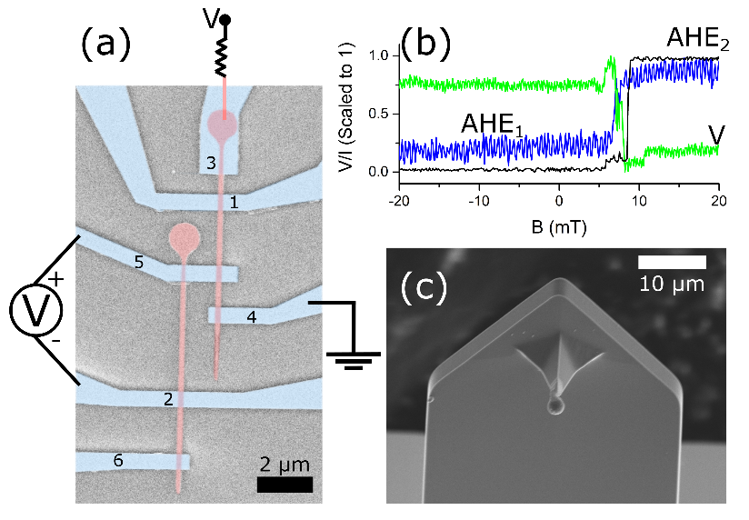
Fig. 1. (a) SEM image of CoFeB/Ta (red/blue) LSV. (b) Voltage V measured in LSV configuration, and AHE measured in 1 and 2, when magnetic field is ramped up. (c) AFM probe with a MB.

1. Corte-León, H. et al. Detection of a magnetic bead by hybrid nanodevices using scanning gate microscopy. AIP Adv. 6, 056502 (2016).

