‘MOOCs are a shining beacon’: FLAN in Dublin
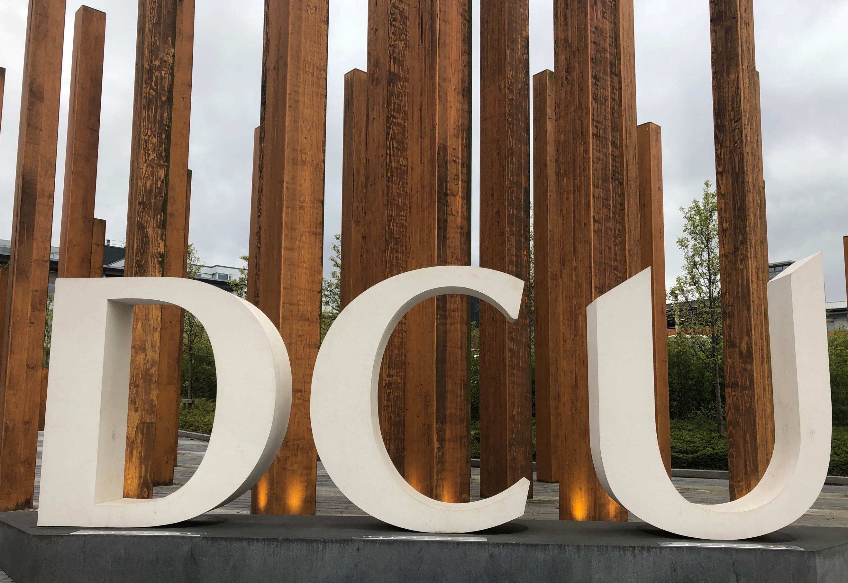The FutureLearn Academic Network (FLAN) met in Dublin City University on 5 April 2019, with participants travelling from as far afield as India in order to attend. In addition to presentations about recent MOOC research, the event included discussion of some of the big questions about MOOC participation, design, and equality – framed as a debate between DCU professors Mark Brown and Gráinne Conole.

Q: Are we afraid of participation rates in short courses / MOOC or are we just dodging the bullet?
On the one hand…
MOOCs are a subset of online learning and, for various reasons, completion rates for online learning are often lower than those in F2F settings (or appear lower – it depends who you count, and at what point). Retention rates are important, and learners should have access to this information. We need to be able to evidence both the public and the private benefit of MOOCs, and good retention levels would be one way of doing this.
On the other hand…
People join MOOCs many reasons and with many aims. Finishing the entire course may not be one of them. We need to be aware that although the enrolment threshold is low, completion requires learners to be self-initiated, self-positioned, motivated and able to deal with a lot of material. People complete MOOCs in different ways and over different periods of time. Some use the material in other contexts, transfer credit, or study parts of a course as a group. Perhaps learning journeys are more interesting than participation rates.

Q: Do platforms overly influence learning design decisions, misshaping rather than enhancing the learning experience, or do they ensure consistency and comparability?
On the one hand…
Platforms are not neutral – they constrain the art of the possible and have a definite impact on student experience. They push us towards standardised approaches even though there is, as yet, no agreement on which learning theory equates to reality.
On the other hand…
Learning design can be used to develop interventions before they are constrained by a platform. The way you get flair and creativity is to encourage experimentation. Different types of MOOC can be run on the same platform and, conversely, some MOOC providers use different platforms for different purposes.

Q: Are we treating our learners equitably, or are we taking advantage of them?
On the one hand…
Although MOOCs have been promoted as inclusive and opening up access, the majority of learners are already highly educated, and the majority of teaching is presented from a western perspective. Universities have been incredibly successful at perpetuating privilege, and they continue to do this in the online space.
On the other hand…
There are ways forward. MOOCs are just part of a larger project that involves opening up teaching and learning as well as building digital skills. MOOCs are a shining beacon of what people who worked to make the Internet wanted to happen. They stand as a contrast to Facebook, with its toxic corporate culture. You can access amazing resources without signing up or by sharing minimal data. We are doing what the Internet was made to do.

What’s next?
If you’d like to hear about the latest MOOC research, or join the discussion about the big issues, the next FLAN event will be a dual-centre live-streamed meet-up, taking place in Melbourne and London on 6 June. For more details, to register for the event or to sign up for the FLAN mailing list, email FLAN@FutureLearn.com

