FutureLearn research worldwide
Rebecca Ferguson
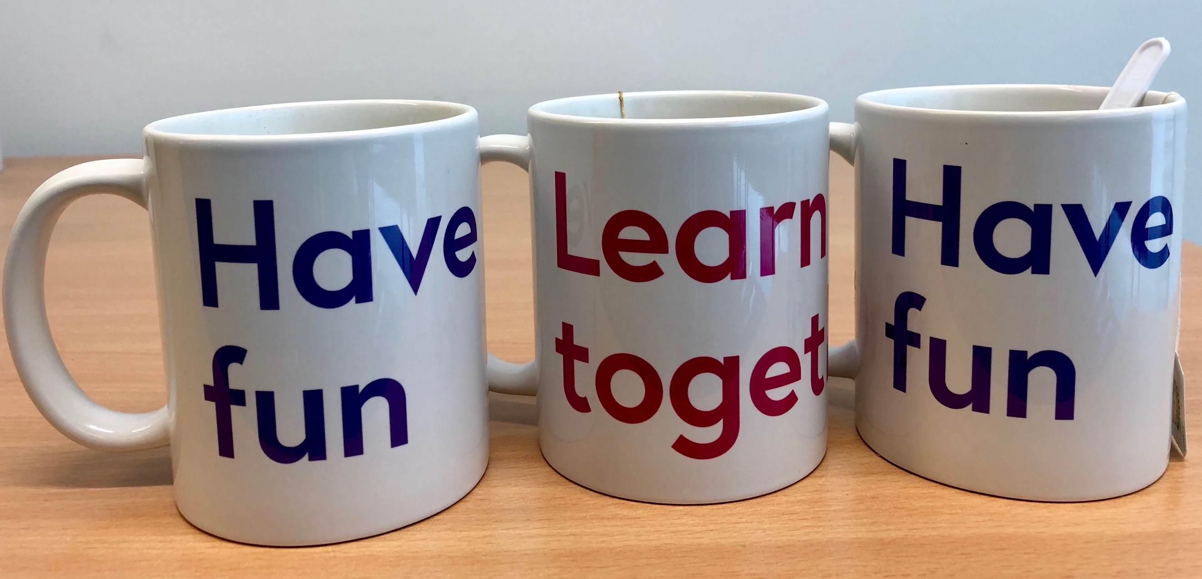
The FutureLearn Academic Network held its first global event on 6 June. The Pacific/Asia chapter took the lead with their inaugural meeting in Melbourne, joined in person by speakers from Japan, and remotely by speakers in Perth. A keynote in London provided a link to the second stage of the event, where participants in the FutureLearn offices were joined by presenters in the USA, Spain, and across the UK.
In his keynote that linked the two parts of the event, emeritus professor Mike Sharples talked about the past, present and future of pedagogy at scale. Mike was academic lead on FutureLearn until his retirement and spearheaded its conversational learning approach. He described the choice and implementation of conversational learning and went on to identify elements to implement in the future, including conversational peer review, adaptive support for reflection, collaborative annotation, peer mentoring, and supported small-group tutoring.
Mike also identified the need for FutureLearn to go on to develop a pedagogy of professional development at scale, which could extend the platform and help it to fulfil its mission to extend access. This could include social learning to share workplace knowledge, coached team learning to develop and practise skills, case-based learning for problem solving and decision making, experiential learning to share and reflect on situated experience, as well as competency-based learning to achieve and demonstrate mastery.
In Melbourne the focus of the talks and discussion was on current practice and how it can be used and built on to enrich future offerings. With three universities in Australia already offering degrees on FutureLearn, the talks dealt not only with MOOCs, also with the possibilities opening up for digital learning on online platforms.
Emeritus professor Beverley Oliver opened the event with a keynote on the future of accreditation, covering micro-certification, employer qualifications, calls for standardisation, third-party extensions, credit pathways, and micro-credentials that surround traditional degrees, evidence of lifelong learning.
Other presentations in Melbourne included Goki Miyakita on generous interfaces that offer rich, browsable views and can be used to encourage open-ended exploration of resources. Goki drew attention to the importance of taking into account different forms of motivation and learning, helping learners to feel connected and stay engaged. Shun Arima introduced the Japanese idea of shi tei kankei, the deep relationship between educator and learner, and discussed different ways of enhancing educators’ social presence, including daily educator videos. Darci Taylor talked about another form of interaction and engagement that takes into account the emotional aspects of learning – digital stories of lived experience that weave together images, music, story, and voice.
In London, the summer FLAN event always highlights work by postgraduate students. This year, it demonstrated how work in this area is maturing. Paco Iniesto presented the findings of his recently completed PhD on understanding stakeholder perspectives in order to design accessible MOOCs. He was followed by Manuel León Urrutia presenting work from his recently finished PhD on MOOCs and competencies for the transformation of higher education. Postgraduate work currently in progress included Shi Min Chua’s study of MOOC discourse, Barbara Conde on the use of MOOCs to facilitate self-regulated learning, and Layla Croll on successful learning design.
FutureLearn’s internal research work on partner archetypes has proved useful for both researchers and practitioners. Reka Budai introduced a related programme of work that identifies five drivers for institutions and organisations partnering with FutureLearn:
- transformation – embarking on a journey
- innovation – pushing the boundaries
- revenue – fulfilling a strategy
- reach a key demographic – reaching specific audiences
- reputation – raising profile and brand awareness.
This provoked lively debate as participants considered which were the main drivers for their institution, their colleagues, and themselves, and the extent to which these drivers change over time.
Recordings of both events are available in the FLAN section of this blog. If you’d like to join the FLAN mailing list, contact FLAN@futurelearn.com. The next meeting of the network will be at the University of Leeds on 11 September contact the email address if you would like to attend either virtually or in person.

