Paper title should fit on one line [X Paper Title]
First Author’s First Name(s) LAST NAME
University’s Name for the Author
author e-mail: drslxd19@metu.edu.tr
Second Author’s First Name(s) LAST NAME
University’s Name for the Author
author e-mail: drslxd19@metu.edu.tr
Abstract: In this section will take place the abstract of your paper. Please prepare an abstract of at most 240 words. Please avoid citing references in your abstract. The deadline to submit the full paper is 10 December 2019. [X Abstract]
Keywords: maximum 5 keywords; abstract; instructions; full paper template; conference website [X Keywords]

1 Introduction [X Heading 1]
This template provides instructions for formatting the full paper for the DRS Learn X Design 2019 Fifth International Conference for Design Education Researchers that will take place between 9-12 July 2019 at METU, Ankara. You may write directly into the template, or copy your finished text into it choosing “match destination formatting” as the paste option. Please do not change the predefined formatting settings in this document (such as paper size, orientation, margins, typeface, size, indents, spacing, headings, etc.).
Please use the predefined formatting styles instead of applying your individual settings. These styles are preceded with “X”, such as [X Paper Title], [X Abstract] or [X Paragraph]. We aim to produce the electronic conference proceedings, abstract book and conference programme using a consistent style.
All submissions for the conference will be double blind peer reviewed by members of the international scientific review panel. Please submit your paper electronically in Word format using this template. The full papers should be between 3000–5000 words in length plus references. To ensure a blind review process, please ensure that all author names and affiliations are removed from the text. If you are using a reference which you have authored, you may indicate as (Author, Year) in parentheses.

1.1 Formatting Styles [X Heading 2]
The template uses A4 size paper in portrait orientation, with the margins being 2,5 cm. from the top, and 2 cm. for the left, right and bottom of the page; the header and footer are set at 1,5 cm. All formatting styles for the full paper are provided in the “styles” menu above. Single line spacing is used throughout the document, with 12 pt spacing between paragraphs.
References should be placed in parentheses (Oxman, 2010) within the main text.
The papers will be published in the conference electronic proceedings and made freely accessible from the drslxd19 conference website as well as the Design Research Society and METU Department of Industrial Design websites.
1.1.1 Paragraphs [X Heading 3]
The formatting style for the main text of the full paper is [X Paragraph], using Calibri as the main font type, with 10 as font size, and in single line spacing, with 12 pt spacing between paragraphs. Please do not use ‘these marks’ in the text and instead prefer using italics to emphasize.
1.1.2 Bullet Lists [X Heading 3]
- For your lists with bullet points, please use the style [X Bullet list].
- And so on.
- Et cetera.
1.1.3 Numbered lists [X Heading 3]
- For your lists with numbers please use the style [X Numbered list].
- And go on with your list.
- For as long as necessary.

1.2 Figures and Tables [X Heading 2]
Figures and tables in your full paper must also be formatted appropriately.
1.2.1 Figures and Figure Captions [X Heading 3]
After you insert a figure into the document, select it and use style named [X Figure]. Figures are followed by a caption placed below. Please do not forget to refer to your figure in the text (Figure 1). The figures should be numbered as Figure 1, Figure 2, and so on (Figure 2). Since the proceedings are going to be distributed electronically you may use colour pictures. However, please make sure that their resolution is good enough to be legible when printed. We recommend a resolution of 300 dpi, with the shortest side of the figure being 6 cm.
Please be selective and to the point in the usage of figures. The figure caption is placed below the relevant figure, and uses the style [X Figure caption]. If the figure is from a source, please do not forget to give reference in the figure caption.
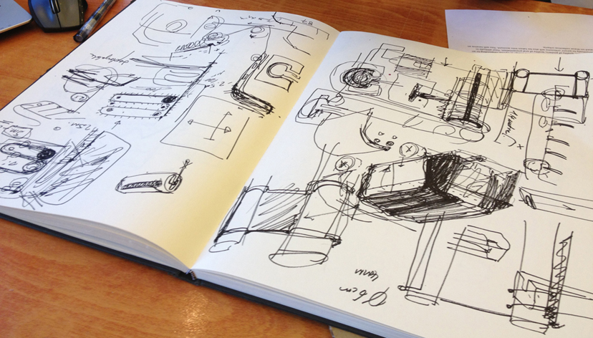
Figure 1. The most critical pages of the sketchbook of a student that really had to be shown in this full paper (Surname, 2006, p. xx). [X Figure caption]
1.2.2 Tables and Table Captions [X Heading 3]
Please use Word generated tables in your paper. The formatting style for tables is [X Table]. The title should be place directly above a table [X Table title]. Please do not forget to refer to a table in the text (Table 1).
Table 1. The distribution of items into subtitle categories. [X Table title]
 | Subtitle 1 | Subtitle 2 | Subtitle 3
Item 1 | 4 | 5 | 6
Item 2 | 5 | 6 | 4
Item 3 | 6 | 4 | 5
Total | 15 | 15 | 15

2 Referencing [X Heading 1]
Please follow the APA style author-date documentation system for referencing in your text. You may reach detailed information on APA at http://www.apastyle.org/

2.1 Quotations [X Heading 2]
If there is direct quotation in the text, please indicate page number (Author, Year, p. xx). Short quotations should take place in the text body (paragraph) and be indicated with “quotation marks” (Author, Year, p. xx).
For long quotations (those that are more than one sentence), please use a separate paragraph. The formatting style for long quotations is [X Long quotation]. Do not use quotation marks for this paragraph.

2.2 Paraphrasing (Indirect Quotations) [X Heading 2]
Please give reference to a source as (Author, Year). Do not use quotation marks for paraphrasing (indirect quotation). Page numbers are optional when paraphrasing, although it is useful to include them. For example, Gigerenzer (1999; cited in Stempfle & Badke-Schaub, 2002, p. 488), claims that many examples of heuristics that humans apply have the common purpose of reducing complexity, and saving time and cognitive effort in the face of incomplete information.
In the text reference format for a source with three to five authors, for the first time, list all the authors such as Williams, Wikström, Otterbing, Löfgren and Gustafsson (2012), and then list only the first author followed by et al. as such as: Williams et al. (2012).
If English is not your first language, or you are not fluent in references, we suggest that you send your paper to Scribendi at http://www.scribendi.com or a similar proof-reader before submission.
Acknowledgements: This section is optional. You can use this section to acknowledge help from you colleagues, students’ participation, internal or external partners’ contribution or funding which supported the research outlined in this paper [X Acknowledgment].

References [X Heading 1]

Referencing Books [X Heading 2]
Book [X Heading 3]
Ulrich, K.T., & Eppinger, S.D. (2004). Product Design and Development (3rd ed.). New York, NY: McGraw-Hill/Irwin.
Edited book
Menges, A., & Ahlquist, S. (Eds.) (2011). Computational Design Thinking. Chichester, UK: John Wiley & Sons.
Translated book
Rancière, J. (1991). The Ignorant Schoolmaster: Five Lessons in Intellectual Emancipation (K. Ross, Trans.). Stanford, California, USA: Stanford University Press.

Chapter in a book
Adams, R., Mann, L., Jordan, S., & Daly, S. (2009). Exploring the Boudaries: Language Roles and Structures in Cross-Disciplinatry Design teams. In J. McDonnell & P. Lloyd (Eds.), About Designing: Analysing Design Meetings (pp. 339–358). Boca Raton, FL: Taylor & Francis.
Alexander, C. (2011). Systems generating systems. In A. Mengers & S. Ahlquist (Eds.), Computational Design Thinking (pp. 58–67). Chichester, UK: John Wiley & Sons.

Referencing Articles
Journal Article
DiSalvo, C. (2014). Critical making as materializing the politics of design. The Information Society: An International Journal, 30(2), 96-105. DOI: 10.1080/01972243.2014.875770
Stempfle, J., & Badke-Schaub, P. (2002). Thinking in Design Teams - An Analysis of Team Communication. Design Studies 23(5), 473-496. DOI: 10.1016/S0142-694X(02)00004-2
Williams, H., Wikström, F., Otterbing, T., Löfgren, M., & Gustafsson, A. (2012). Reasons for household food waste with special attention to packaging. Journal of Cleaner Production, 24(March), 141-148. DOI: 10.1016/j.jclepro.2011.11.044
Article in the Special Issue of a Journal
Menges, A. (Ed.). (2012). Material Computation: Higher Integration in Morphogenetic Design [Special Issue]. Architectural Design, 82(2), 1-144.

Referencing Conference Papers
Börekçi, Naz A.G.Z. & Korkut, F. (2017). Collaborating with external partners in industrial design education: A review of success factors. In G. Pritchard & N. Lambert (Eds.), Proceedings of LearnX Design London 2017 Conference (pp. 183-191). Ravensbourne, 27-30 June 2017. London: Ravensbourne Publications.
Morelli, N. & DeGötzen, A. (2017). A multilevel approach for social transformations and its implications on service design education. In L. Di Lucchio, L. Imbesi & P. Atkinson (Eds.), Design for Next: Proceedings of the 12th European Academy of Design Conference (pp. 803-813). Sapienza University of Rome, 12-14 April 2017.
Peter, A., Lotz, N., McDonnell, J. & Lloyd, P. (2013). The effect of prototyping material on verbal and non-verbal behaviours in collaborative design tasks. In Proceedings of 5th International Congress of International Association of Societies of Design Research (IASDR) (pp. 2382-2393). 26-30 August 2013, Tokyo, Japan.

Referencing Theses and Dissertations
Oxman, N. (2010). Material-based design computation (Unpublished PhD. dissertation). Retrieved from: https://dspace.mit.edu/handle/1721.1/59192#files-area
Töre, G. (2006). User workshops: Procedure for eliciting user needs and user defined problems (Unpulished MS thesis). Middle East Technical University, Ankara, Turkey.

Referencing Online Sources
Kolawole, E. (2016). Where inclusion meets human-centered design – Stanford d.school – Medium. Retrieved June 11, 2018, from https://medium.com/stanford-d-school/where-inclusion-meets-human-centered-design-518a4c1c93a1
Romanik, R. (2013). 12 best practices for retail-ready packaging. Packaging World: Packaging News, Trends and Innovation (online magazine). Retrieved October 24, 2013, from http://www.packworld.com/package-design/retail-ready/12-best-practices-retail-ready-packaging.
The Warwick Commission (2015). Enriching Britain: Culture, Creativity and Growth. The 2015 Report by The Warwick Commission on the Future of Cultural Value. Coventry: The University of Warwick. Retrieved from http://www2.warwick.ac.uk/research/warwickcommission/futureculture/finalreport/enriching_britain_-_culture_creativity_and_growth.pdf
About the Authors [X About title]
Please add in this section, a short biography for each author, in order [X Author Bio]. The short biography should be maximum 60 words for one author.

