On Friday 10th November 2017, the International Centre for the History of Crime, Policing and Justice at the Open University will be hosting the next in its regular seminar series. Four papers will be presented; details are given on the enclosed programme.
Faculty of Arts & Social Sciences
History
The Open University
Walton Hall
Milton Keynes
United Kingdom
MK7 6AA
Tel +44 (0) 1908 653 179
www.open.ac.uk

International Centre for the History of Crime, Policing and Justice
‘Crime, Policing and Technology in the 20th Century’
Friday 10th November 2017
The event will be held in The Library (Seminar Rooms 1 & 2) at Walton Hall, Milton Keynes, and the first paper will begin at 11:00. Tea and coffee will be served on arrival from 10:30 and lunch is included in the booking fee. Papers will last around 45 minutes followed by questions for c.15 minutes. It is expected that the event will finish by 16:00.
To reserve a place, please complete the booking form below and return by 3 November 2017, together with payment of £15 (or £5 for doctoral students).
Travel directions can be found at http://www.open.ac.uk/about/main/faculties-centres/milton-keynes-campus. For further information please contact Marie-Claire Le Roux (Email: FASS-HRSSC-History@open.ac.uk Tel: 01908 653179).
Yours sincerely

Paul Lawrence

To book a place please complete and return this slip (together with cheque for £15 – reduced to £5 for doctoral students - made payable to ‘The Open University’) to Marie-Claire Le Roux, Faculty of Arts & Social Sciences, The Open University, Walton Hall, Milton Keynes MK7 6AA by 3 November 2017 at the latest.
Name (please print):……………………………………………………………………………. …………
Address for confirmation:……………………………………………………………………… …………
…………………………………………………………………………………… ……………… …………
Email / Telephone:…………………………………………………………………… ……….. …………
Car registration no. (for those driving to OU, parking is free).…………………………………….. …
□ Please tick here if you require a vegetarian lunch, or give details if you have any other dietary requirements
□ Please tick here, and give details, if you have any other special requirements

Crime, Policing & Technology
International Centre for the History of Crime, Policing and Justice
10th November, The Library (Rooms 1 & 2), The Open University

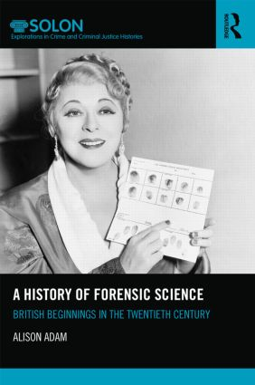 | 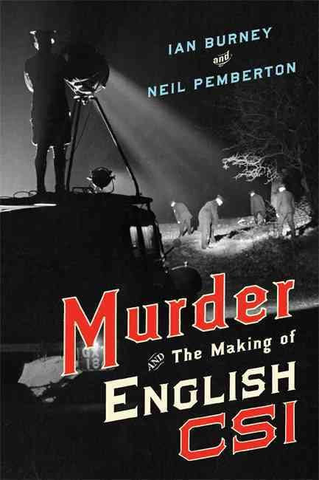 | 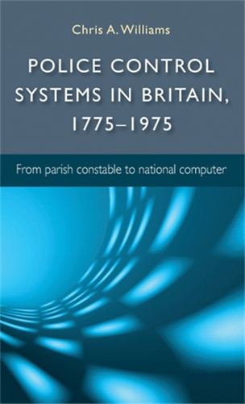 | 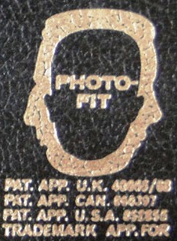

Programme (abstracts overleaf):

10.30 – 11.00 Arrival, Tea/Coffee/Biscuits

11.00 – 12.00 Alison Adam (Sheffield Hallam University) ‘Science in the service of detection: the British ‘scientific aids’ movement of the 1930s’
12.00 – 13.00 Ian Burney (University of Manchester) ‘Spatters and Lies: Technologies of Truth in the Sam Sheppard Case, 1954-1966’
13.00 – 13.45 Lunch
13.45 – 14.35 Chris Williams (Open University) ‘The Home Office, Information and Communications, 1950-1975’
14.35 – 15.25 Paul Lawrence (Open University) ‘Identification, Technology and the British Police: The Curious Case of the Adoption of Photo-FIT’
15:25 – 15:40 Graham Pike (Open University) ‘Response to Papers’
15.40 – 16.00 Discussion

Alison Adam (Sheffield Hallam University)
Science in the service of detection: the British ‘scientific aids’ movement of the 1930s
In 1946, Sir John Maxwell CBE, former chief constable of Manchester wrote that ‘great progress has been made in the application of science as an aid to police work’, citing ‘the gradual development of police laboratories to help in crime investigation’ as a key example of this trend (alongside broader ‘technoscientific’ developments such as the car and radio). This paper investigates the development of ‘scientific aids’ (a term which was often used in the 1930s and 1940s without definition) and considers the formative years of scientific policing and the development of the nascent forensic science laboratory network set up by the Home Office in England and Wales. This paper argues that the ‘scientific aids’ movement of the 1930s was a British response to criminalistics, arriving on British shores from Continental Europe via English translations of Hans Gross's Criminal Investigation Handbook undertaken in Colonial India.
Ian Burney (University of Manchester)
Spatters and Lies: Technologies of Truth in the Sam Sheppard Case, 1954-1966
This paper focuses on the contrasting forensic regimes involved in the celebrated 1955 trial and 1965 re-trial of Dr Sam Sheppard for the brutal murder of his wife Marilyn. The acquittal of Sheppard at his 1965 retrial could be seen as an instance of modern forensic technique as a catalyst for justice – with analytical and objective methods overcoming judgements based on mere common sense and local interest. However, this simple story obscures the more interesting – and surprising – route taken by those seeking to establish Sheppard’s innocence in the decade following his incarceration. In this latter campaign it was the polygraph rather than spatter analysis, and the detective writer Erle Stanley Gardner and the flamboyant defence attorney F Lee Bailey that took center stage. This twist allows us to reflect on the inherently complex relationship between forensic knowledge and the broader context within which it is produced and deployed.

Chris Williams (Open University)
The Home Office, Information and Communications, 1950-1975
Throughout the twentieth century, British police attempted to use technology to cope with the changing social, geographical, and infrastructural demands of policing. They also saw it as potentially a way to increase efficiency and effectiveness, separately or in combination. It is no surprise therefore that the post-war technologies of computing and radio communication were seized upon eagerly, and by 1975 were melded into a new national information system built around UHF radios and the Police National Computer. This paper investigates the process via which these system took shape, a process which required the negotiation of a great deal of investment but which, eventually, bore significant fruit.

Paul Lawrence (Open University)
The Curious Case of the Adoption of Photo-FIT
The process of pre-custody identification of suspects is intrinsic to policing, and has changed relatively little since the inception of the British police in its modern form. Witnesses produce descriptions of suspects for issue to investigating officers and for public dissemination. However, the techniques via which such pre-custody identification is attempted changed considerably over the course of the twentieth century, as written descriptions gave way to an increasingly visual approach. This paper will consider how the police and the Home Office came to adopt a particular technology of identification – Photo-FIT – and will analyse what this adoption tells us about the interface between technology, the police, the Home Office and the world of commerce.

