

Responsible AI Learning Design
From The Learning Design team at The Open University
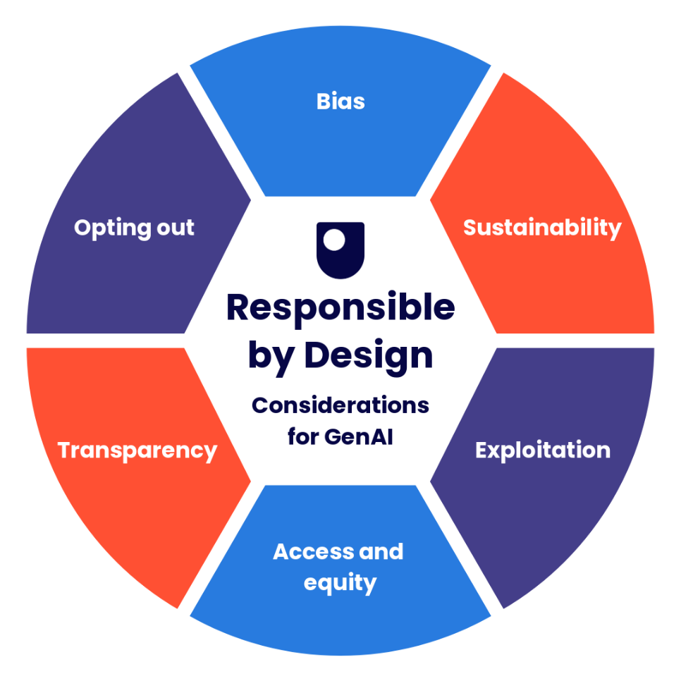

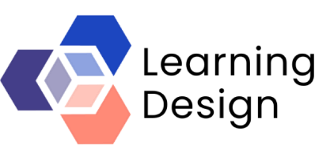

Responsible AI Learning Design
Generative AI is reshaping learning, teaching and assessment across higher education. Institutions face difficult decisions about assessment integrity, responsible use, staff confidence, student guidance and AI literacy. The Open University can help your organisation develop a coherent, evidence-informed and practical response.
We can support your team through a joined-up three-part offer that helps you align responsible AI principles, assessment design and student activity design.
Using our Responsible by Design framework, we will guide you through key considerations. From there, we can support you to review and enhance assessment approaches to make them more robust in the context of GenAI, before exploring practical approaches to designing purposeful GenAI activities for learners.
Sessions can be tailored and typically include:
- Awareness raising
- Facilitated design conversations
- Assessment review
- Hands-on activity design
Sample outputs you will leave with:
Responsible by Design: establishing an ethical foundation for GenAI use
- A shared framework for discussing responsible AI use
- Applying the framework during design
- Practical approaches for developing resources
Assessment in the Age of AI: strengthening assessment approaches
- A review of existing assessment approaches
- Redesigned discipline-specific assessment examples
- Assessment design principles and guidance
GenAI Activity Design: designing purposeful student activities using GenAI
- Prototype activities tailored to your context
- Prompting and evaluation frameworks
- Approaches to developing critical AI literacy
Why work with The Open University?
- Internationally recognised leader in distance and online learning
- Extensive institutional experience responding to GenAI
- Developers of the award-winning Responsible by Design framework
- Creators of practical AI assessment and learning design resources
- Expertise in curriculum design, assessment and learning analytics
- Experienced team of workshop facilitators

Our offer helps institutions move beyond reactive responses to AI and towards sustainable, strategically aligned approaches to learning, teaching and assessment.
The three strands can be delivered as an integrated programme, or selected individually according to your needs.
Our approach starts with the OU’s Responsible by Design framework, which acts as the foundation for design conversations. Through facilitated workshops, structured design conversations, review activities and tailored consultancy, we help teams move from uncertainty or experimentation towards a coherent and responsible approach.

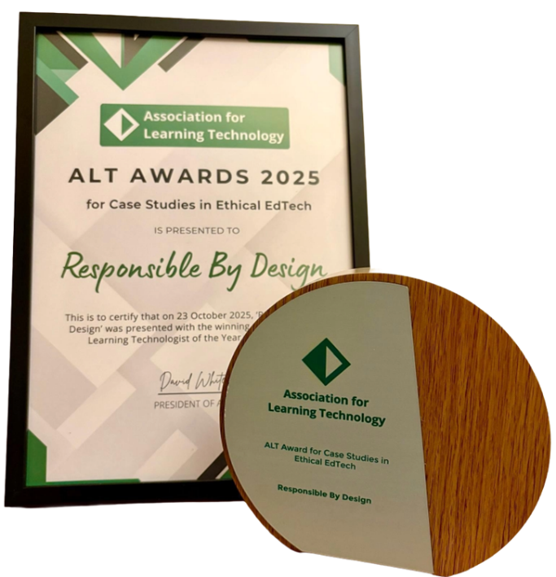
Award: The Learning Design team won the ALT Ethical EdTech Award 2025 for the Responsible by Design framework.

Strand 1: Responsible by Design
The OU’s Responsible by Design framework supports teams to consider the ethical implications of GenAI use in learning and teaching. The framework currently focuses on six core pillars: bias, sustainability, exploitation, access and equity, transparency, and opting out.
The framework won the ALT Ethical EdTech Award 2025, reflecting its value as a practical and accessible approach to embedding ethical considerations into educational design.
We can support your team to:
- Understand the Responsible by Design framework and how to apply it
- Explore the ethical implications of GenAI in your own context
- Identify opportunities to strengthen responsible AI use
- Develop organisational adaptations of the framework
- Create practical guidance or design principles for your own staff and learners
A Responsible by Design workshop may include:
- An introduction to the framework and its six-pillar structure
- Facilitated discussion of ethical tensions and opportunities
- Review of an existing learning activity, assessment or course design
- Mapping of risks, assumptions and learner support needs
- Identification of immediate design changes and longer-term development priorities
This strand is particularly useful for organisations that want to establish shared principles before developing GenAI policies, activities, assessments or staff development resources.

Strand 2: Assessment in the Age of AI
GenAI can produce fluent, plausible responses to many common assessment tasks. This creates challenges for assessment design, particularly where tasks rely heavily on generic explanation, predictable structures, or polished final products. Our approach is not to AI-proof assessment. Instead, we support teams to design assessment that remains meaningful in a world where learners may have access to powerful GenAI tools.
Our assessment offer draws on the OU’s Generative AI and Assessment toolkit, which focuses on practical strategies for creating or adapting assessment. The toolkit encourages a shift from prevention and detection towards task design that prioritises reasoning, judgement, process and critical AI literacy.
We can support your team to:
- Review existing assessment tasks in light of GenAI
- Identify where AI could produce a plausible response
- Strengthen tasks so they better reveal learner reasoning, judgement and process
- Design assessment tasks that incorporate transparent and critical GenAI use
- Develop assessment guidance for staff, students or learners
An assessment workshop may include:
- Exploration of how GenAI affects different assessment types
- Identification of vulnerable assessment features
- Redesign of an existing assessment task
- Application of practical strategies from the OU assessment toolkit
- Development of tailored assessment principles or checklists
This strand is particularly useful for HEIs, professional education teams and organisations that need to review assessment, certification, training tasks or learner evidence in the context of GenAI.

Strand 3: GenAI Activity Design
GenAI can be used in learning activities in many different ways: as a study buddy, brainstorming tool, drafting assistant, critical friend, Socratic opponent, collaboration coach or source of alternative perspectives. However, effective GenAI activity design requires more than simply asking learners to "use AI". Activities need to be purposeful, scaffolded, critically framed and aligned with responsible use.
Our activity design offer supports teams to explore when, why and how GenAI might be used within learning. This includes considering what learners need to know before using GenAI, how they will evaluate outputs, how they will document or explain their use, and how the activity can build critical AI literacy. We draw on structured prompting and evaluation approaches, including the PREPARE and EDIT framework, which supports learners to prompt effectively and then evaluate, verify, identify bias and transform AI outputs.
We can support your team to:
- Explore different pedagogic roles for GenAI in learning
- Design and scaffold purposeful GenAI activities
- Incorporate critical evaluation of AI outputs
- Adapt prompting and editing frameworks for your subject or professional context
- Design activities that support critical AI literacy
A GenAI activity design workshop may include:
- Exploration of different approaches to student or learner use of GenAI
- Review of sample activities and discussion of risks and benefits
- Application of Responsible by Design prompts to proposed activities
- Use of structured prompting and evaluation frameworks
- Design or adaptation of a GenAI learning activity for a specific context
This strand is particularly useful for teams who want to move from general discussion of GenAI towards practical, responsible and discipline-specific activity design.

How we work with you
Our support is collaborative and tailored. We do not offer a one-size-fits-all model. Instead, we work with you to understand your learners, staff, subject area, organisational context and priorities.
Depending on your needs, our support can include:
- Facilitated workshops for academic teams, trainers, curriculum teams or professional services staff
- Design conversations to help teams reach shared decisions
- Subject-specific research and adaptation of AI resources, examples and prompts
- Resource development such as checklists, cards, templates or workshop materials
- Train-the-trainer support to help your staff facilitate similar conversations
- Follow-up consultancy to support implementation and refinement
All workshops can be adapted for different sectors, including higher education, public-sector organisations, professional education, healthcare, defence, charities and private companies.
Contact Us
Use this URL: https://business.open.ac.uk/contact
Complete the form and make sure to include that you are seeking support from the Learning Design team and we will be back in touch.
Further information
- Bluesky: @ou-ld-social.bsky.social
- LinkedIn: Learning Design Team at the Open University
- Blog: Learning Design
Navigate to our GenAI resources — all available under a CC licence; please acknowledge use.

