Appropriating social media
Public engagement with science and technology online
In this workshop we’ll explore these questions:
- What are the challenges of using digital technologies to support engaged research with varied communities?
- What are the roles the digital researcher must fill?
- What motives underlie a commitment to digital engagement?
Your starter for ten - https://goo.gl/iMkTli

Discussion scenarios

1. Getting involved in a national debate (Ken)
A major public engagement outlet (e.g. media or festival) is programming an item that deals with an issue where the scientific evidence base is overwhelmingly convergent on one view. Debates are quickly reinvigorated on twitter, aided by various hashtags, including the official # for the organiser of the programme. As a science communicator, wishing to encourage rational opinion as quickly as possible, what would you do? How do you best influence the discussion and make your comments stand out? Are there lessons to be learned from past experiences?
When thinking about how to get involved in a twitter conversation, which of the following tactics might work best?
- Respond to specific tweets you disagree with.
- Retweet tweets you agree with.
- Make a series of standalone Tweets on the issue that reflect the scientific evidence base.

2. Engaging with Complex Research (Rick)
A Higgs-like particle has been discovered. Along with a scientific seminar, CERN is hosting a press conference and issuing a press release. As a science communicator working within the organisation, how would you relay the significance of the discovery in a digital landscape while being scientifically accurate? What tools could you use and what challenges might you face?
What digital tools could you use to engage with your audiences?
- Twitter: # to ask questions.
- Facebook.
- Google Hangouts involving researchers.
- Live blogging from a scientific seminar.

3. Responding to unanticipated media attention (Ann)
You are one of the organisers of a national conference with about a hundred participants, including researchers, industry stakeholders, university management and journalists. In the spirit of openness and transparency, you have encouraged participants to engage through social media, setting up a Twitter hashtag, a live blog, Periscope live streaming and an Instagram account.
On the second day of the conference a news story breaks that is directly related to one of the presentations. The presenter gets a bit over-excited and makes an unfortunate off-the-cuff remark in response to a question, which is recorded in the live blog. One of the journalists reports the comment in a news article, with a link to the blog. Because of the current news item, the story appears on an online edition of a national newspaper.
How would you handle the situation?
- Do nothing (and hope it blows over).
- Issue a press release explaining the remark.

4. Engaging communities to support projects (Heather)
You are one of a group of science communicators with an idea for an exciting new engagement mechanism that unfortunately, has failed in several funding bids. Your idea is for an engagement activity with some new scientific equipment that has been installed in your local area. As the equipment and facility is new you do not have any existing mailing lists or contacts of your own. You want the public to know about this exciting, unique equipment. Your fundraising target is £20,000 and you decide to engage with communities to raise funds.
When thinking about opportunities to raise funds you and your team come up with a number of different options. Which one of the below would you choose?
- An online crowdfunding platform like Kickstarter or Experiment.com.
- An online donations site like JustGiving.

Notes

Example cases

Case Study 1.1 - Decisions based on science vs politics
A major media outlet broadcasts a television programme about a government that has decided to ban GM crops on the basis they may adversely affect the nation’s food and drink policy. A live debate is taking place via the programme’s hashtag. As a science communicator, what action would you take? How do you tread a path between those who are still influenced by “Frankenstein food” headlines and those who distrust political decisions?
Soil Association: “Scotland is joining a growing movement of countries and regions all over the world rejecting GM crops because they threaten the environment, human health and farmers' livelihoods. Scotland's determination to keep out GM crops is good news for the UK as a whole, because it sets a high standard that England, Wales and Northern Ireland must now live up to.”
Group of universities and research organisations: “Genetic modification of plants has become a well established method and has a 20-year track record of safe use worldwide, as evidenced by the European Academies Science Advisory Council report, Planting the Future.”

Case Study 1.2 - Reinvigoration of a discredited theory
A film festival has programmed an event with a medical doctor, now disbarred, who was at the centre of a now discredited study into links between vaccination and autism – a study which at the time led to considerable media coverage and influenced thousands of parents, arguably putting their children’s health at risk, by not vaccinating against severe childhood conditions. How do you contribute to the online discussion seeking to have the event removed from the programme? How do you defend against the constraining ‘freedom of speech’ counterargument that is trending?
“Having learned lessons the hard way in the past, this time the scientific community was ready for the fight. “Four or five years ago we weren’t as well organised and people didn’t realize the importance of responding quickly and strongly,” said Alison Singer, the president of the Autism Science Foundation and a member of the IAC listserv.
“Today, we know that we have to respond to every incident however large or small, because if you leave any of these discredited theories unchallenged, it allows people to think that there’s something still to be discussed …”

Case study 2.1 - Discovery of a Higgs-like Boson
During the July 4th Higgs Update, CERN’s communications group were able to use a number of digital technologies to communicate and engage with their audiences. A video feed of the scientific seminar was provided, along with a live blog that allowed external audiences to engage to some degree. An experimentalist was on hand to deal with any scientific question. Social media was also used during the press conference, with questions from Twitter being relayed to the speakers. One of the tweets, quoting the director general exclaiming ‘We’ve got it’ went viral and was picked up by the media.

Case study 3.1. – Women in science
In July 2015, in a keynote speech at a conference of science writers a Nobel Prize-winning scientist, gave it as his opinion that women in the lab were sexy and distracting, prone to weeping and best segregated into their own laboratories. The remarks were relayed into the Twittersphere and the scientist was globally, and personally, attacked on a range of social media. Within a few days, the scientist had resigned from his honorary post at a UK university. The university authorities reviewed the affaire a few weeks later but decided not to re-instate him; they said it was impossible for them to remain associated with someone who had so deeply undermined the university’s reputation for supporting female scientists. There was a certain, and inevitable backlash; the scientist’s supporters claimed the remarks were a feeble attempt at a joke that had been badly misunderstood.

Case study 3.2. – Understanding fracking
In October 2015, an emeritus professor of science engagement at a UK university and recently appointed chair of an industry group, was interviewed by a journalist from The Times newspaper. In her interview, she discussed why she believed more women than men are opposed to fracking – that they may well have dropped science at 16, so have less science education, so don’t know the facts and don’t understand the issues. Women, she felt were less likely to be persuaded by facts than men and more likely to go with their gut instinct on what they might see as threats to their family. In other newspapers and on social media, this led to headlines such as ‘leading scientist claims women “don’t understand” fracking’. The reaction from other female scientists and female government ministers was rapid; generally describing the comments as ‘unhelpful’. The professor was invited to respond by an online edition of a national newspaper.

Case study 4.1 - Crowdfunding archaeology
A researcher in archaeology from the University of Aberdeen, who had existing groups that were regularly engaging with their projects, has established a Just Giving page through the university’s donations system to help fund their research.
Within their descriptor they list what different amounts of money donated will fund. They keep in regular contact with supporters through an active Facebook group and through local talks and discussions. They link clearly to webpages with further information and have worked with the central university communications team to spread their message as wide as possible.
The project is very locally focused but has generated interest from further afield by those that are interested in that particular area of archaeology. They set a target of £5,000 and so far have raised over £2,000 which has helped them move forward with their project.

Case study 4.2 - Crowdfunding migration ecology
A researcher in Boston used the experiment.com website to crowdfund part of her research, which was linked to fish migration in the local bay.
Experiment.com helped her create a video, descriptor and incentives for her project; none of which involved any extra funding (e.g. weekly updates from her trip, exclusive photos from her research boat and the top incentive was a trip on a local lobster boat). Research groups often have links to experiences that members of the public are unable to access and she used this to raise her profile. Her university and the local press publicised her scheme and she was invited to deliver talks to community groups.
Through this, she established a close relationship with local fishermen who, in turn, fed back into her project with research data on what fish they were catching and observations about conditions, such as water height. Her project was fully funded and she then launched a second fundraising campaign to support an additional part of the project (a large survey of local fishermen). This second part of the project would not have been created without the relationships she developed through the crowdfunding activities.

Notes

Issues and practical strategies
Be prepared
- Develop and maintain a project or research team communication plan.
- Create a menu of available media options supported by your employer (e.g. websites, blogs, email) or made available to you through a third party (e.g. Twitter, YouTube).
- Identify and communicate clear roles and responsibilities for engagement.
Be strategic
- Who do you want to engage with and why?
- Where do they hangout online?
- What benefits can you bring to them?
- When will be the right time to engage each group (e.g. pre, during and post project)?
Be reflective
- What research values (e.g. authority, accuracy, openness) do you communicate?
- What capacity do you have for engagement individually, and how can you extend your reach through colleagues and collaborators?
- Periodically review your practice, collecting independent evidence to critique your approach.
Be holistic
- How could you combine the use of different online and face-to-face forms of engagement to improve your communication and research?
Be ethical
- How transparent is your practice?
- Professional and social integrity reflects acceptable levels of conduct for attributing credit to others and recognising the value of collaboration. However, engagement activities are typically interdisciplinary and can be problematic when professional or social expectations are not explicitly shared.
- Recognising the contribution of others can strengthen the social ties that enable collaboration and partnership.

Tools

Coaching: GROW model
The GROW model encourages you to consider:
- Goal - Something that you want to achieve.
- Reality - Identify what the current reality is.
- Options - Consider the possible actions to take.
- Way forward - Pick an option and make a plan.
You may want to consider your professional practice with respect to social media, and apply the GROW model to set a personal goal and develop a plan to achieve it.
Goal

Reality

Options

Way forward

2. Social media use: Visitors and residents mapping
The visitors and residents mapping technique (see http://daveowhite.com/vandr) helps you reflect on how you make use of social media in your professional and personal life. The terms visitor and resident refer to your level of engagement in a specific form of media, as a visitor or resident.
To make a mapping, the visitor-resident continuum is drawn on a horizontal axis, which is intersected by a vertical axis representing your personal-institutional continuum. As you consider each form of social media (e.g. Twitter, FaceBook, LinkedIn, email, etc.) reflect on the use you make of it in your personal and institutional life, in order to map out your usage as rectangular regions.
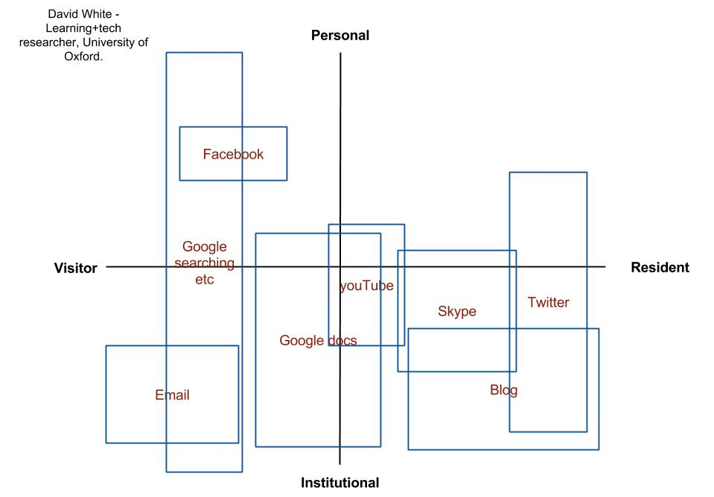
Figure 1. An example visitor resident map (example from http://daveowhite.com/vandr).
When considering new opportunities to engage through social media, extending or adapting your existing practices may be easier and more sustainable than a complete change of practice.

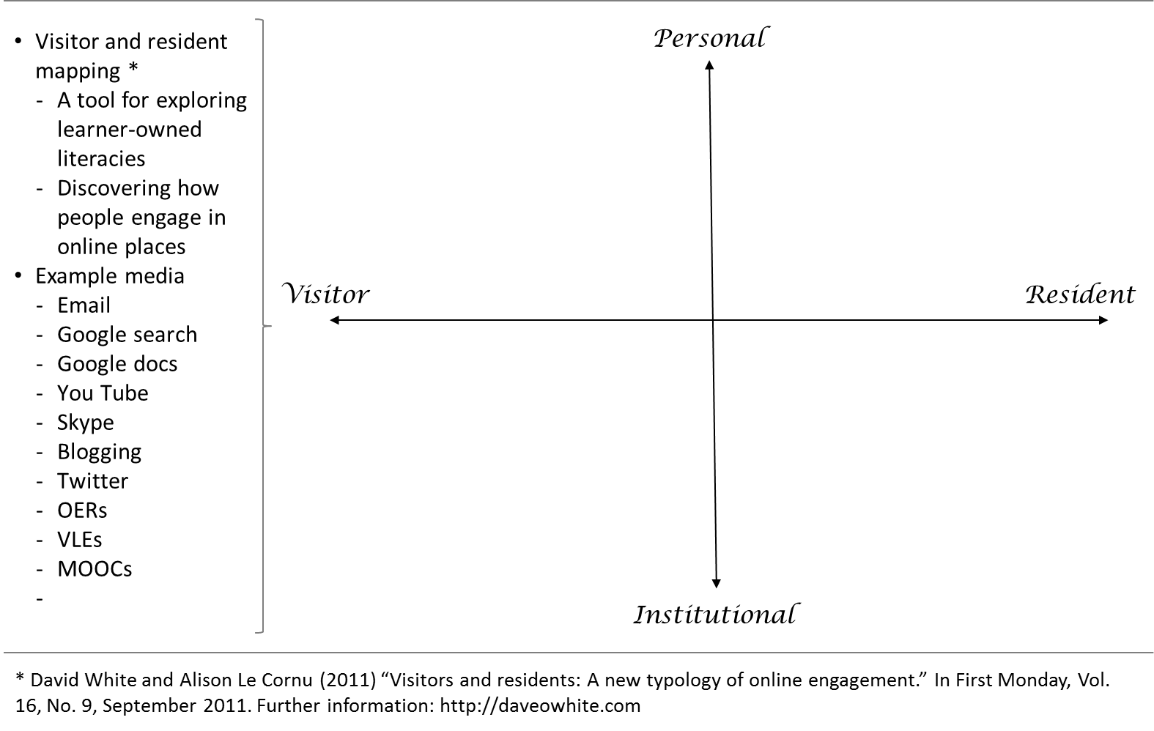

Quiz data: Facts and figures
Q1. Which are the fastest growing social media networks globally (select all that apply)?
- Facebook
- Snapchat
- Pinterest
- Tumblr
- Instagram
- LinkedIn
Answer: According to a globalwebindex.net report in 2015 Pinterest, Tumblr, Instagram and LinkedIn had the biggest growth in active users through 2014.
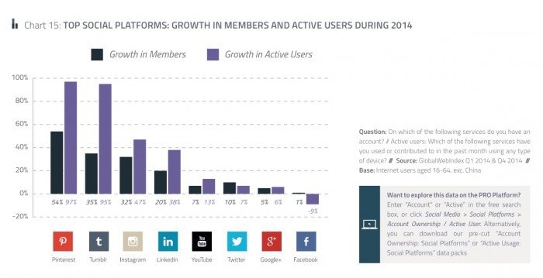

For further information and stats: http://www.globalwebindex.net/blog

Q2. What percentage of the world uses social media (select one)?
- 10%
- 20%
- 30%
- 50%
Answer: Each year, We Are Social update their massive global compendium of statistics, which gives some great insights into the world of social media. They recently reported that 31% of the world population have active user accounts on social media.
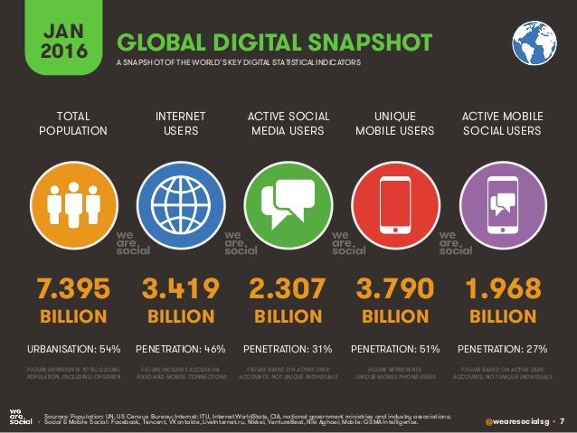

Q3. Which of the following social media networks are NOT in the top five most active online communities in the world (select one)?
- Instagram
- Twitter
- Snapchat
- All of the above
Answer: According to Wikipedia, the top five most active online communities are: Facebook (1.59B active accounts), YouTube (1B), WhatsApp (1B), Facebook Messenger (900M), Tencent QQ (853M).
Rank | Name | Registered users | Active user accounts | Date launched | Country of origin | Date of user stat.
1 | Facebook | 2+ billion | 1.59 billion | February 2004 | United States | December 2015
2 | Youtube | 1+ billion | 1 billion | February 2005 | United States | February 2015}
3 | WhatsApp | 1+ billion | 1 billion | June 2011 | United States | February 2016
- | Facebook Messenger | 2+ billion | 900 million | August 2011 | United States | April 2016
3 | Tencent QQ | 1+ billion | 853 million | February 1999 | China | December 2015
https://en.wikipedia.org/wiki/List_of_virtual_communities_with_more_than_100_million_active_users (24/04/16)

Q4. Which region of the world has the highest number of social media users (select one)?
- USA
- Europe
- East Asia
- South Asia
Answer: We Are Social’s 'Digital in 2016' report, noted the number of active social media users per region as: East Asia 769M, South Asia 234M, North America 213M, South America 211M, Western Europe 201M, Eastern Europe 191M, South Asia 186M, Africa 129M, Middle East 63M.
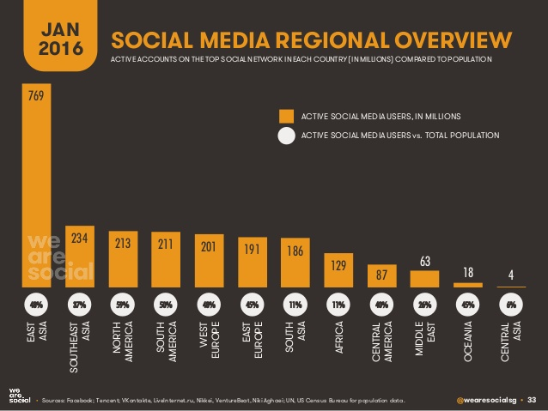

Q5. Which country spends the longest amount of time (on average, per person) on social media (select one)?
- Brazil
- USA
- Philippines
- Italy
Answer: According to the ‘Digital in 2016’ report, the average number of hours social media users spend using social media each day: Philippines 3.7, Brasil 3.3, Mexico 3.2, Argentina 3.2, U&E 3.0, Saudi Arabia 2.9, ...
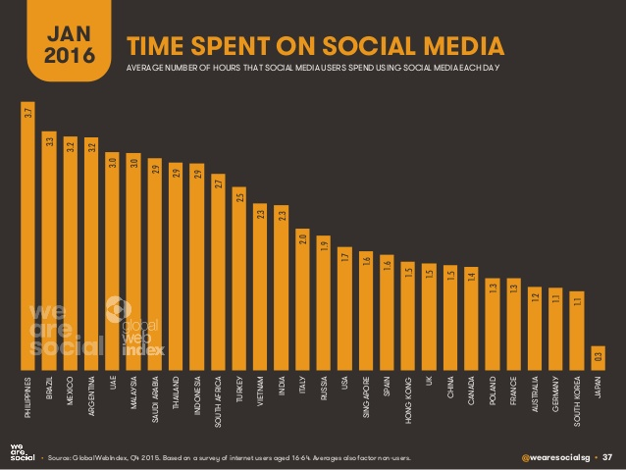
For further information and stats: http://wearesocial.com/uk/special-reports/digital-in-2016

