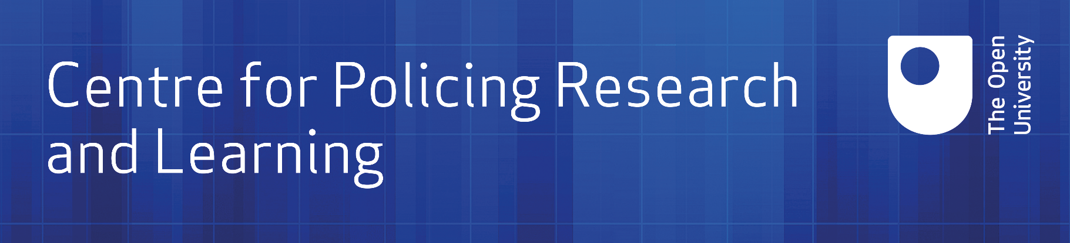

Research support request
CPRL Research Steering Group

This paper comprises two templates:
1. A template for early stage research ideas (Page 1 of this paper) to be brought forward to the CPRL Steering Group for discussion and input leading to the development of a proposal
2. The second template (from Page 2 of this paper) provides the outline template for a research proposal ready for full CPRL Membership Group approval

Research idea proposal to the
CPRL Research Steering Group

Project Title:
Date:
Proposer(s):

Please provide a general summary of the proposed research (in no more than two pages) covering questions such as:

- What is the background and context of this proposed research?

- What is the problem you wish to address?

- What would be the benefits of undertaking this research project?

Research support request
OU Centre for Policing Research and Learning

Title:
Date:
Proposer(s): [Name, Department and organisation]
Other researchers: [Name, Department and organisation]
Policing partner(s): (where already agreed)
Proposed funder and funding status:
CPRL research theme (please select one) Investigation, community and resilience
Digitally enabled policing
Leadership, management and organisation
Health, wellbeing and resilience

1 Background and context
Provide the background to the study by outlining the general field within which the research falls, referring to the current state of knowledge and any recent debates on the topic. Note the significance of the research, how the research fits with CPRL’s strategic priorities and meets partner objectives.

2 Key aims and research question(s)
What is the problem you wish to examine or the central questions you wish to address and how this addresses operational policing issues of important to our partners?

3 Research and methodology
Note the general approach (methodology) that will be taken to answer the research questions. Please provide detail on what assistance is required from policing partners.

4 Plan for completion and timetable
Provide an overview of the plan for completion including a summary of the core elements of this project (e.g. literature review, data collection and analysis, any modelling undertaken and reporting planned). Include your plan for obtaining approval by the OU Human Research Ethics Committee and dates for reporting to the CPRL Membership Group Meeting.

Provide an indicative timetable for conducting the core research. Include project start (month, year) and date due for completion (month, year).

Month | Activity

5 Arrangements for management of the research
Note what support will be required of the partner organisation(s) and whether this research benefits from close working relationships or co-research. If known, summarise the roles of the PI and other researchers.

6 Resource and budget
What resources might be needed for this project?

Resources required | Estimated cost
Total

7 Outputs and impact
Provide a list of intended outputs from this research. Please state clearly the benefits and practical applications for police. Where possible, summarise how the outputs of this research will be disseminated and how the impact of this study will be tracked and measured.

Please note that in submitting this application you are committing to producing a final report and non-technical executive summary for this project. Projects lasting longer than 6 months will also require an interim report. Please tick to confirm you understand this ___________

Additional notes to help with this section:

Arrangements for Intellectual Property Rights (IPR) are covered in the Consortium contract. However, please note any implications for IPR (e.g. should another funding body or organisation be involved). Please contact the Centre for advice or any questions at oupc@open.ac.uk

Advise the expected level of confidentiality of outputs from this research (or note any implications), where the Consortium define categories as:
- Non-public, interim material – material that cannot be made public, unless reclassified, but, by agreement from the CPRL Steering Group, such material can be used by forces/agencies for particular specified purposes. Such purposes may include the exercise of crime reduction and criminal intelligence functions.
- Non-public, forces/agencies in confidence – material only for discussion among forces/agencies and their officers and staff who have a directly relevant interest in the material.
- Public – may be shared more widely than just forces/agencies and made available on the public CPRL website.

