RASSO Learning and Development Guidance
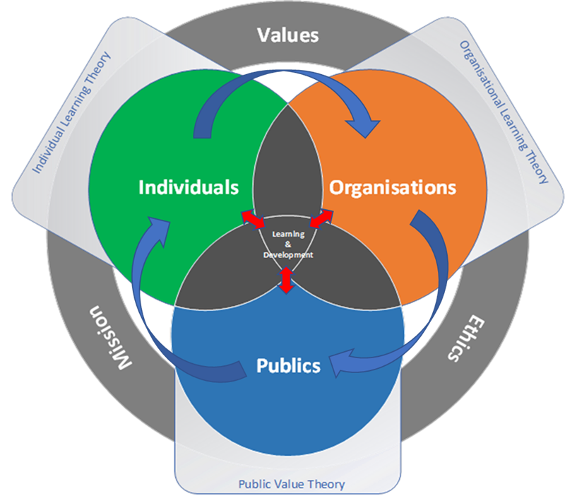

Dr Emma Williams, Richard Harding, Dr Nicky Miller, Dr Rachel Ward, Jennifer Norman March 2021 (adapted from Harding R, Hartley J, Khalil L, et al., 2019)
Licencing & copyright: The content of this document (including models and graphics) and the work from which it is derived are released under the terms of the Creative Commons licence. This allows you to use the content throughout the world without payment but for noncommercial purposes only. Please read the Creative Commons Licence (http://creativecommons.org/licenses/by-nc-sa/4.0/deed.en_GB ) in full before downloading or otherwise making use of the Materials.
Introduction
This document draws on learning and outputs from research conducted by the Centre for Police Research and Learning (CPRL) at The Open University in collaboration with MOPAC and 45 UK policing organizations. One of the focuses of this research was how to create the capability to deliver learning and development outcomes in policing organizations operating in complex and uncertain environments.
The Destination Map (DM, see figure 1 below) was co-developed by academics from the CPRL and policing colleagues (Harding R, Hartley J, Khalil L, et al. (2019)). It and the evidence produced from the earlier research is highly relevant to the RASSO context and this guidance document has been developed to apply this prior learning within this specific field of policing based on the findings from Project Bluestone.
The DM places learning and development activities at the forefront of policing change and improvement. It does so by linking individual and organizational learning and development activity with individual and organizational capacity and capability which supports the delivery of policing missions and values to the publics they serve. Furthermore, it places all activity within a framework of ethical and fair service which is critical to the RASSO context. This approach seeks to ensure that the publics served by policing receive the best service from them. To achieve this there is a need to consider learning from both an organisational and individual perspective, and in particular how individual and organizational activity is experienced by those who are in receipt of the results of that learning and the effects it creates. The DM expressly links activity in each of these three ‘domains’ and encourages feedback and learning from each to inform future activity and learning in the others in a continuous and ongoing process.
The concepts of learning and development are placed at the centre of the DM as the practices of formal and informal learning and development, through for example formal training, reflective practice, debriefing, self-directed and peer to peer learning, locally held data, listening to the views and experiences of victims and survivors etc, when applied to and across all three domains become a potential engine of change and development within policing practice and delivery.
The three domains of the model are defined in the plural (Individuals, Organizations and Publics) to highlight the importance of recognising that each is made up of diverse groups and individuals. As such recognising and engaging this diversity is critical to effectively delivering both individual and group outcomes and effect.
It is perhaps important to recognise that this guide does not seek to set out what learning and development activities are required, given the complex, changing and diverse settings and requirements this would be unlikely to work. It is however intended to provide a model and understanding of the type of iterative learning and development environment that might support the development of improved RASSO investigative ability.
Figure 1 - The Destination Map
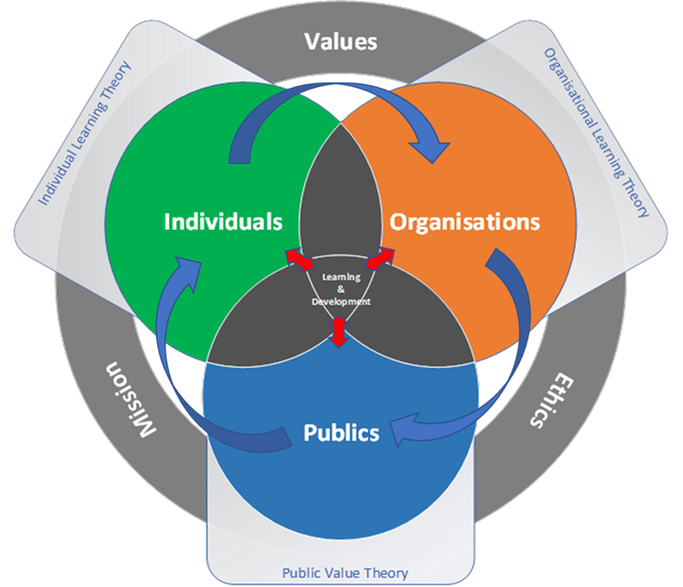

In order to create an environment where the DM can operate successfully 17 essential criteria were identified by the academics and practitioners who developed it. These are listed below along with an outline of how they might apply in the specific context of RASSO investigation.
For more information on the original research and the outputs it created, and in particular the Destination Map, please visit Implementing Transformation of Police L&D | Centre for Policing Research and Learning (open.ac.uk)

Essential Criteria |  | What does this mean for RASSO Investigations?
1 | Systems and processes for understanding the skills and knowledge capital (skills and knowledge held by personnel irrespective of source) within the organisation | Understanding and mapping the knowledge and skills of officers and staff within an organisation is essential. In a specialist environment involving many complex issues in relation to the suspects and victims involved in cases of rape (Rumney et al, 2020) officers and staff should be provided with relevant RASSO training and regular CPD events. The implementation of the Chronicle database will support this and provide further detail of the skills and capabilities currently present in Avon and Somerset and where the gaps are.  Understanding who has completed training and other learning activities and the subsequent portfolio is critical to the delivery of public value outcomes. Working in a specialist area for RASSO would contextualise the formal and informal learning for officers and allow them to complete the portfolio in a meaningful manner. In addition, knowledge of relevant research projects that officers and staff have been or are involved in allows for the opportunity of developing evidence based organisational learning and practice and the potential for sharing and embedding in practice. To do this successfully systems and processes need to be designed and embedded in organisations to capture and make effective use of relevant data.
2 | Understanding of internal and external demand for police service and on police services to support short, medium and long-term L&D planning and delivery | Police services / agencies can be reactive to their immediate demand environments which may make it difficult to think about longer term or more strategic learning and development requirements. This can result in quick decisions that can have long term implications for good or ill. There are opportunities to develop and utilise the force RASSO problem profile more proactively to understanding demand, problems and the potential learning needs of officers and staff. A formalised reflective practice process, as part of the case reviews, will capture CPD needs and any new RASSO demand contexts. This will inform a more evidence informed and strategic approach to learning needs and development based on a sound understanding of internal and external demand.
3 | Systems and processes for understanding L&D requirements at organisational, function and individual level via skills audits and training needs analysis | The recommendation for a formalised learning, reflective review process and wider peer to peer networks are excellent examples of approaches that create systems and processes to understand this criteria which will allow for opportunities to capture the professionally relevant knowledge and skills within the organisation, and importantly any gaps that exist to inform current or future learning or developmental requirements – currently this opportunity is being missed. This would also provide the opportunity to formally capture and share promising practice through the Investigation Professional Development Unit (IPDU).  The targeting of learning needs can also be identified to those most in need – please consider the link to wellbeing (Jackman et al, 2020). The training needs of portfolio assessors are an example of such a priority area identified in the current research.  To achieve these outcomes, it is necessary to create, maintain and use systems and processes to capture this understanding.
4 | Systems and processes to identify patterns across L&D activity to inform decisions | Collecting, measuring and analysing data on learners and learning activity are essential tools for understanding the progress and engagement of learners. It enables understanding of what is working, what is being engaged, what is not, and creates the possibility of understanding how individuals are formally and informally contributing to their own CPD, identifying areas that require support or are not working as intended, and thus supporting the delivery of organisational goals and service delivery to victims and survivors of RASSO. It is therefore important to think about what data systems and processes need to be captured and created to gather data on what and how learners are engaging their learning. Equally, it is important that individual learners can access this data to inform their own learning and development journeys.
5 | Systems and processes for accurately assessing the cost and value of L&D activity | The opportunity cost of an officer or member of staff undertaking a course of learning is relatively easy to calculate. However, understanding the value of the learning outcomes that this activity creates at an external, organisational and individual level is more challenging. Formal and informal L&D activity is often seen as a cost to organisations, but in the context of RASSO investigation its value in terms of increasing individual investigators confidence, capacity and capability to deal effectively with the complex and emotive work they undertake combined with the ability to deliver better outcomes for victims and survivors should, along with other possible value outcomes, be considered against the pure ‘cost’ of training or learning activity. Thinking about the value of learning and development activity provides executive teams and L&D leads with measures that help support more informed and effective L&D strategy and delivery.
6 | Executive, middle and front line buy in of the value of L&D activities | In order for L&D to be successful, leaders at every level of the organisation need to ‘appreciate’ the need for, the benefits of and the value of formal and informal L&D activities at both an organisational and individual level. This was recognised at Avon and Somerset. Learning must not be considered as an abstraction, but rather an investment and one which has the ability to directly impact the link between officers feeling competent within their role and their own wellbeing, as well as more effective investigatory and victim/survivor outcomes. There are vital links here to organisation health and productivity, as well as legitimacy and victim/survivor satisfaction in the RASSO context.
7 | Learning content informed by learning design | Learning content should be derived from and aligned to the requirements it was intended to fulfil. Understanding those requirements and aligning the inputs to outcomes and outputs requires a deliberative and critical design process which is supported and underpinned by incorporating reflective practice. This process should be iterative and informed by the learning needs identified by, changing RASSO typologies locally, new research in this area the shifting national landscape in this field including legislation and other options for disrupting suspects. There are opportunities to use immersive learning, through for example Hydra and greater use of body worn camera footage as real examples and analytical products to further understand the outcomes of learning in a practical context.
8 | Multi-modal (inc digital) design and delivery of and access to L&D offerings to support anyplace anytime learning access | L&D offerings should be available in a variety of formats and accessible on a variety of platforms to suit the learners’ diverse circumstances, requirements, and learning styles. Access should be available anyplace and anytime to facilitate different learning habits and requirements, as well as learning, both mandated and self-directed, inside and outside of the work environment.
9 | Clear signposting to development and learning resources to empower users to take ownership of L&D | Ensuring that learners within organisations can find, access and use learning resources is a key first step to creating a culture of personal responsibility for lifelong learning. This is a mark of organisations who prioritise and encourage learning and development opportunities.
10 | Three-fold Quality Assurance: a) of design b) of delivery c) of impact | All stages of L&D activity should be subject to independent QA, so that the quality, effect and efficacy of the design delivery and impacts are understood.  This could involve outside experts with an understanding in rape research content and/or methods of blended and immersive learning supporting internal learning delivery.  As Stanko and Hohl (2018) argue, there needs to be an understanding of the insight from both police experience and academic perspectives, to value both craft and science. The co-production of the content and approach to RASSO training will allow for the necessary challenge and reflections required in this learning space.  Equally importantly it is necessary to understand what was intended to be taught (design), whether it was effectively delivered to its intended audience (delivery) and how this learning impacts the performance of practitioners and the experience of victims and survivors (impact).
11 | Risk aligned levels of QA scrutiny and complexity | In an environment of finite resources ensuring that the greatest depth, breadth, and detail of scrutiny is aligned to the highest risk areas ensures that QA activity is appropriately focussed on business and risk priority areas. RASSO training and learning approaches should be one of these priority areas and thus commensurate effort should be expended in quality assuring learning approaches in this area.
12 | Embedded and effective feedback culture | Creating a safe organisational environment where challenges, mistakes and errors (both human and systemic) can be openly aired and discussed, good practice recognised and assessed for replication, and personal and organisational learning can take place in a safe environment is a critical component of creating a situation where cycles of reflective practice and ongoing learning can take place. It also supports the development of policing as a learning organisation. This is strongly recommended through the development of the case review process and the reflective practice points it sets out for the investigative teams.  There are additional opportunities to invite others, including colleagues and partners, to support feedback and reflective practice activity such as the Police Constable Degree Apprenticeship (PCDA) cohorts. This would allow them to contextualise and consider their learning on vulnerability and victim care from in practice learning and therefore support the further embedding of their learning.
13 | L&D personnel selected for aptitude and potential and provided with training and skills via appropriate learning pathways | L&D skills can be taught. However, the aptitude and attitude to be an effective L&D professional is more difficult to instil. It is suggested that 1) there should be learning pathways designed and available for L&D strategic and tactical professionals to access throughout their careers to facilitate their personal and professional development, and 2) when recruiting staff recognise that aptitude may be more important than apparent qualification level, especially if element 1 is in place to provide access to the necessary technical knowledge and skills required. Individuals understanding of the iterative process of learning, blended learning, and the application of learning to assess outcomes should be prioritised.
14 | L&D strategic activity informed by, and delivery undertaken by, individuals with appropriate L&D experience and qualifications | Strategic level L&D activity and planning should be informed by suitably qualified and experienced L&D professionals. This might involve the input experts in a training capacity to discuss methods of case reviews in the learning process and other ‘real life’ case information to think through decision making, the type of knowledge being applied, where things might be done differently, and how to best translate that information into appropriate learning approaches. These methods encourage learning in practice and support moving from training by face to face upfront delivery to more blended and embedded learning. Decisions around the delivery of L&D activities should always be made by or supported by suitably experienced and qualified individuals, potentially fulfilling the role of learning tactical advisors to senior decision makers where necessary.
15 | Key partners and authorising authorities are engaged and supportive (College of Policing, NPCC, Home Office, PCCs, Local Govt partners, etc) | Where relevant engage other agencies such as the College of Policing, CPS, ISVAs, subject experts (including academics), partners, and victims and survivors of RASSO where appropriate. Consider jointly developing and delivering training in relevant sections of the learning process to enable more thoughtful, informed and evidence-based understanding of vulnerability, offending behaviour, the impact of investigative approaches (on perpetrators and victims and survivors) and patterns of RASSO cases. External partners are a vital resource within the investigation of RASSO. They have potentially much to contribute to the development of greater understanding, and thus the creation of opportunities for learning and improved outcomes for victims and survivors.
16 | Organisational and personal reflective practice embedded | Reflective practice is a core requirement for personal and organisational learning and is identified as a central tenant of creating more professional organisations and practice. This requires going beyond ‘feedback' and features as a central tenant of the case review process for rape investigations recommended by this research.
17 | External and internal Value creation | Often systems and processes within policing are internally focused and sometimes do not effectively or adequately consider external users and recipients of services (the publics, or in this case victims and survivors of RASSO). The DM is explicitly designed to link L&D activity, individual capacity and capability, the wider policing organizations and the external spaces where the publics experience the effect and affect of policing activity. In designing, delivering, or undertaking learning activity the aim should always be to contribute to the creation of value outcomes both internally and externally. Here the requirement is not only to think about what do we or I need to know, learn, practice and become confident and competent in to create value by the internal measures my organization requires but also what do we or I need to know, learn, practice and become confident and competent in to create value for victims and survivors of RASSO.

References
Harding R, Hartley J, Khalil L, et al. (2019) Police Learning and Development 2025: Destination Map. Centre for Policing Research and Learning, Milton Keynes: The Open University. POLICE LEARNING & DEVELOPMENT 2025: DESTINATION MAP (open.ac.uk)
Jackman, P., Henderson, H., Clay, G. et al (2020) The relationship between psychological wellbeing, social support, and personality in an English police force. International Journal of Police Science and Management, Vol 22 (2):183-193. ISSN 1461-3557
Rumney, P. et al. (2020) ‘A police specialist rape investigation unit: a comparative analysis of performance and victim care’, Policing & society, 30(5): 548–568
Stanko B and Hohl K. (2018) Why training is not improving the police response to sexual violence against women: A glimpse into the ‘black box’ of police training. In: Milne E, Brennan K, South N, et al. (eds) Women and the Criminal Justice System Failing Victims and Offenders? Cham: Palgrave Macmillan, 167-186.

