Create an accessible e-thesis

Table of Contents
What is accessibility? 1
Accessibility checklist 1
Thesis accessibility guidelines 2
Converting your thesis to a PDF file 3
PDF accessibility evaluation 4

What is accessibility?
The Open University Student Accessibility Policy confirms The Open University's approach to promoting accessibility and ensuring all our students are effectively supported in achieving success in Higher Education.
In order to be accessible, The Open University adheres to the following set of principles:
- Promote an inclusive environment
- Ensure proactive and responsive processes and procedures
- Enable effective communication
Accessibility also means the consideration of human diversity in digital services and therefore, accessibility must be taken into consideration when creating your e-thesis. Accessible theses are created in a specific way so they can be used by everyone, regardless of background, circumstances or disabilities.

Accessibility checklist
In the accessibility checklist you will find the main principles to follow in order to create an accessible thesis. To ensure your final PDF document is accessible you must first ensure your original Microsoft Word document is accessible, once you have done this you can then covert it into PDF format using the appropriate procedure detailed at the end of this document.
- Plan a clear structure for your document. Use built-in Word styles to mark structures (headings, paragraphs) and create formatting. Headings are for structure not appearance so they should be used in the correct order (e.g. a document should only have one heading 1 etc). Any names or phrases not in the language of the main document need to be marked up, please follow the steps as detailed in this document - PDF19: Specifying the language for a passage or phrase with the Lang entry in PDF documents | Techniques for WCAG 2.0 (w3.org).
- Provide an alternative text for any images used. Not including caption text. To add alternative text to a picture, shape, chart, or SmartArt graphic, right-click on the object and choose Format Picture. In the Format Picture panel, choose the Layout and Properties icon. Then choose Alt Text. Add a title for your object, then a description. Images should never be described as ‘image of’ and must always describe the image. Context is important when determining appropriate alternative text, the alternative text for one image may be extremely different based upon the context and surroundings of the image itself. WebAIM provides some excellent guidance on how to write alt text - WebAIM: Alternative Text.
- Use tables to present information. Create tables using the Insert Table command within Microsoft Word. Guidance for creating accessible tables can be found below.
- Check the document language is set in document settings. Click Review, Language, and Language Preferences.
- Provide a title for the document in file properties. To do this display the File tab and then click Info. The option to add a title is under the Properties title.
- Provide a descriptive name for the file. Include similar information when writing the title of the document, and apply appropriate punctuation, e.g., no underscores. A document’s page title is the first thing assistive technology will recognise and read after opening the document. For example, this document is titled Thesis Accessibility Guidance.
- Use the Microsoft Word Check Accessibility functionality to inspect the accessibility of your document (more details below).
- Convert the Microsoft Word file into PDF format (detailed steps below).

How to create an accessible table
1. In the Ribbon, select Insert tab, then select Table.
2. Select the number of rows and columns by highlighting the boxes on the grid.
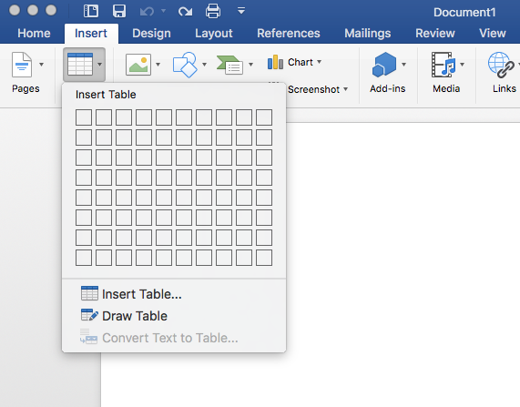
3. Type in the table data.
4. Title your table using the caption tool.
In the Ribbon, select References tab, then select Insert Caption.
In the popup window, type the title of the table in the Caption textbox.
In the Label textbox, select Table. Then select OK.
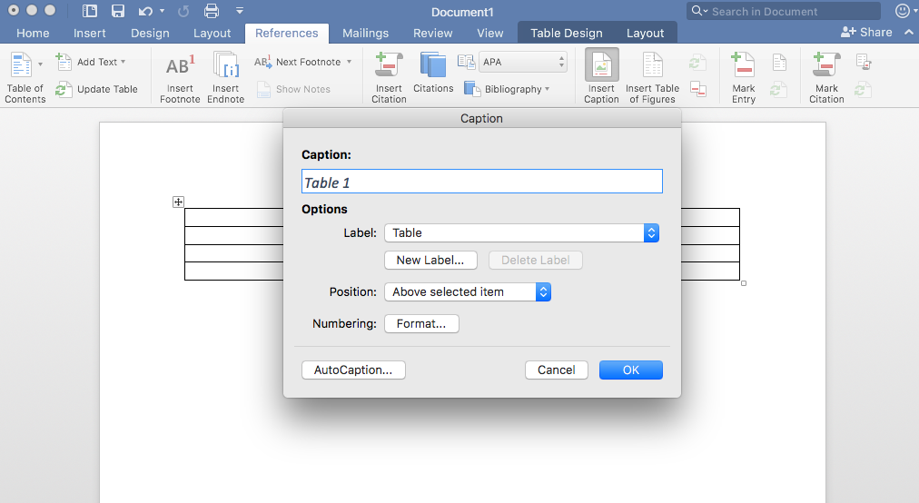
5. Identify the Header Row
Select the top row of the table and right click.
Choose Table Properties.
In the popup window, select the Row Tab and check “Repeat as header row at the top of each page.” Then select OK.
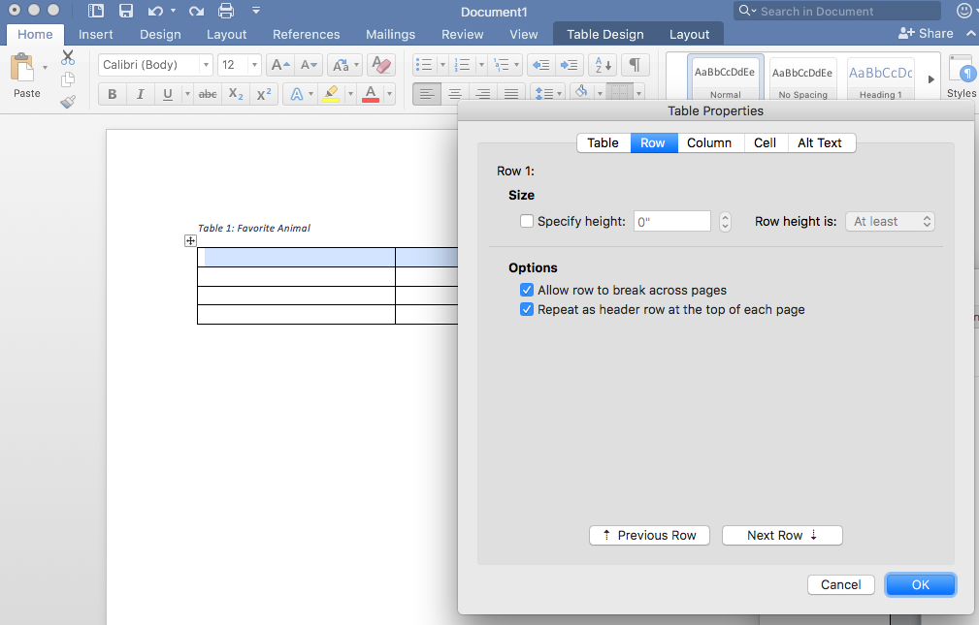
6. Restrict the table to your page width.
Select the entire table and right click.
Choose Table Properties.
In the popup window, select the Row tab and uncheck “Allow rows to break across pages.”
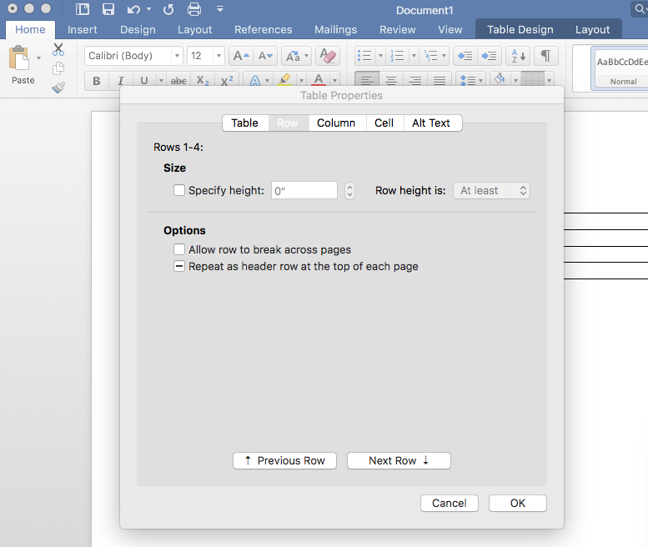
7. Add Bookmark
Place cursor inside the first cell (A1).
In the ribbon, select the Insert tab, then select Bookmark.
In the Bookmark name textbox, type “Title” then the name of your table. Use underscores instead of spaces.
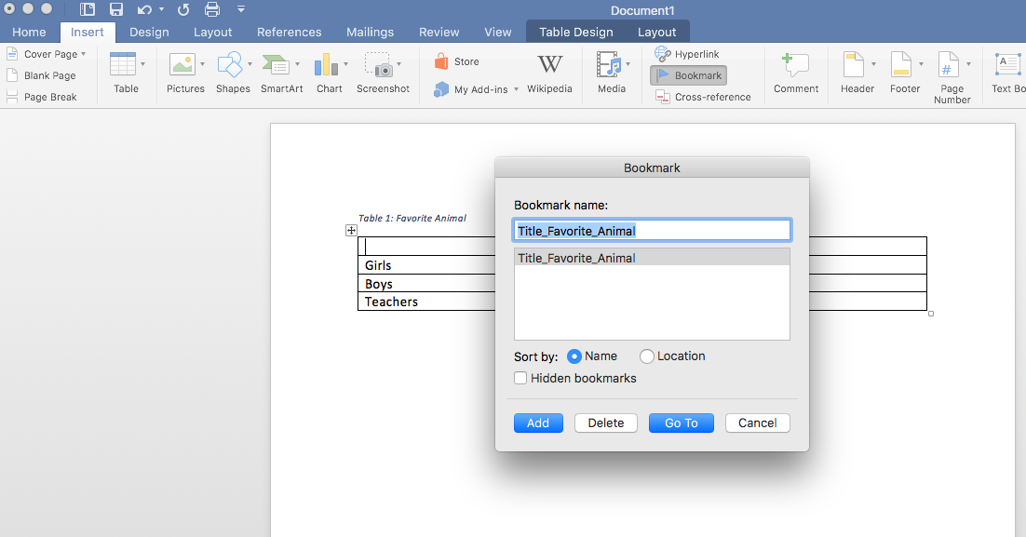
8. Add Alt Tag description to Table
Right click on the Table and select Table Properties.
In the popup window, select Alt Text.
Type in a description of your table
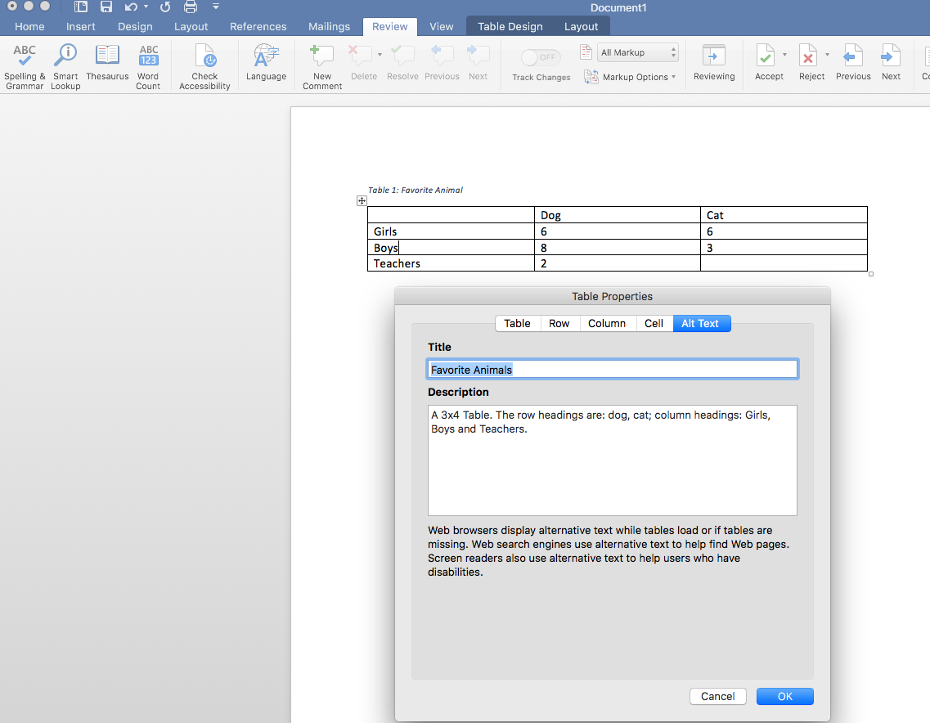
9. Use the Word Accessibility Checker to check for accessibility.
In the Ribbon, select the Review Tab, then select Check Accessibility.
The Accessibility Checker will appear on the right side of the screen with the inspection results. If there are accessibility issues, the errors will be listed.
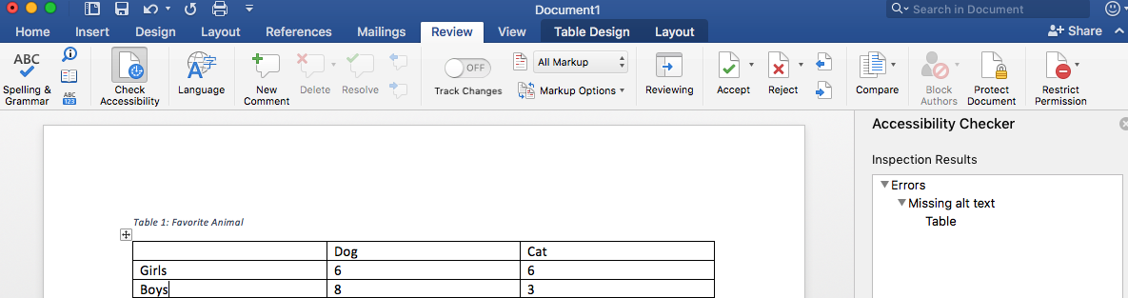
10. Things you should NOT do:
Do not create your table using the Draw Table Tool.
Do not create page layouts with tables.
Do not merge or split cells.
Do not control spacing in your table with blank rows or columns. Adjust line spacing instead.

Thesis accessibility guidelines
When you have finished working on your Word document, you should double check its accessibility functionality. Use the built-in automatic checking function in Word and check certain things yourself such as whether you’ve used tables wisely. Please note that you can only inspect documents saved in the docx format. If your document is in an older doc format, convert the document into a docx file.
Word software provides a function that allows you to check the accessibility of your document. This function is called Check Accessibility and it can discover many accessibility errors and problems, however, not all of them. The function is found in the File tab, or in the latest Word versions, in the Review tab.
- Open the File/Review tab.
- Open the Check for issues menu.
- Select Check Accessibility.
- This opens the Accessibility window on the right side of the Word document. The inspection results show possible errors and warnings.
- Go through all errors and correct them where possible. Please note that Word also provides additional information about the errors and instructions on how to fix them.

Converting your thesis to a PDF file
Once you have produced a Word document in accordance with the accessibility instructions above and have checked its accessibility, you can convert your document into an accessible PDF file. You will need Adobe Acrobat Standard or Pro installed in order to maintain accessibility information when converting from Word.
Convert a Word document into PDF/A as follows:
- Select the File tab.
- Select Export.
- Then select Create PDF or XPS Document.
- Click on Create PDF/XPS.
- In the window that opens, determine the folder in which the file is saved. Give a file name that describes the content of the document.
- Before clicking Publish, open Options.
- Select both Document structure tags for accessibility and Document properties. By selecting these boxes, the heading identifiers (i.e. tags) and the title given to the file are transferred to the PDF file.
- You should also select Create bookmarks using Headings. This facilitates moving within the PDF file.
- Select PDF/A compliant
In older versions of Word you can create a PDF file with the Save as function, however, you must not use File > Save As > PDF, File > Save As Adobe PDF or File > Print > Adobe PDF, as this will not retain accessibility information when converting from Word. Make sure that you have selected both Document structure tags for accessibility and Document properties.
Note! Do not use the ‘Print to PDF’ function to create PDF files. If you do so, the document will have no structure. Instead, it will resemble a scanned image.
If you are using Adobe Acrobat Pro and your Word version contains the Acrobat PDFMaker function, make sure that you have selected the Convert document information and Enable Accessibility and Reflow with tagged Adobe PDF boxes in the Acrobat tab Preferences.

PDF accessibility evaluation
For a free way to further check the accessibility of your finished PDF file:
- Free downloadable PDF Accessibility checker - https://pave-pdf.org/index.html?lang=en

