Visual false information

Introduction
The activity False information explained defines what different types of false information are, and what impact they can have on society.
False information comes in many different forms, and this activity is going to look specifically at images and how they can be used to spread false information quickly.
This activity will help you to identify common types of false and misleading images.

xxx
Images can be a powerful way to disseminate false information, and they are used extensively over all digital environments.
Images can convey meaning and impact much quicker than words on a (digital) page can.

The UK weathermap
Below is an image which was circulated widely in 2022, when Europe was experiencing a heatwave. The image shows two weather maps of the UK. Similar images were shared in other European countries (EDMO, 2022).
- What’s going on in this picture? What do you see that makes you say that?
- What more can we find?
Once you've thought about these questions, continue reading to see what we thought.
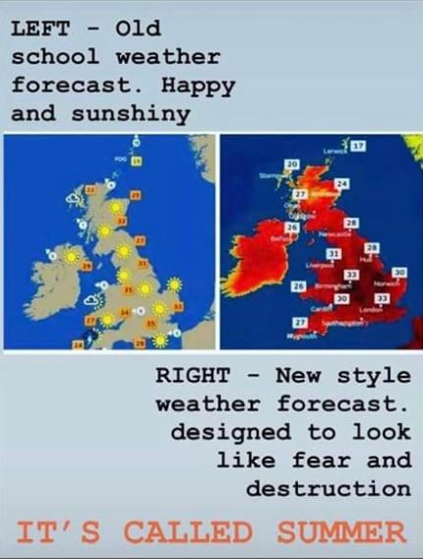
(Image source: @aidanweather on X)

Is it fake news?
The image implies:
- The design of weather maps has changed.
- The purpose of the redesigned map is to convey “fear and destruction”.
- The high temperatures shown on the map are not unusual summer temperatures.
The image is an example of fake news.

The BBC did redesign its weather maps in 2017 to improve their accessibility. A spokesperson for the BBC reported "The colours used now range from blue for the coldest temperatures through to red for the hottest temperatures as these colours are easier to see if you live with colour blindness" (AFP Fact Check, 2022).
The temperatures experienced in the UK in 2022 were not usual summer temperatures. In fact, they repeatedly exceeded previously recorded temperatures. On July 19 2022, The Met Office reported that 46 weather stations in the UK recorded temperatures higher than anything they had ever measured before (AFP Fact Check, 2022).
The image is designed to discredit traditional information sources like the BBC, by implying that their reporting about climate change cannot be trusted.
It also casts doubt on climate science as it implies that the extreme heatwaves experienced across Europe in 2022 were not caused by climate change.
There are several manipulation techniques used by this image:
- Emotional manipulation – the example uses emotional language (“fear and destruction”, note the capital letters and exclamation mark “IT’S CALLED SUMMER!”) to deliberately spark an emotional response.
- Conspiracy thinking – the example pushes the conspiracy theory that traditional news sources cannot be trusted.
These techniques manipulate us into sharing the misleading content – increasing its reach and generating revenue for its creators.

Real but fake
Another example of images being used as false information is when real images are being used to illustrate a completely different, and often completely unrelated, event. This can be an easy, low effort way for false information to spread quickly.
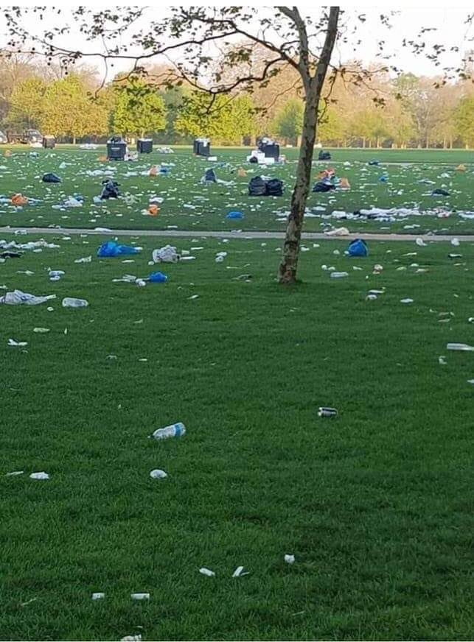
An example of this occurred in 2019, when an image supposedly showing piles of rubbish left in Hyde Park by the climate activist group Extinction Rebellion was shared thousands of times on social media in an effort to discredit the environmental movement.
(Image source: @theroyalparks on X)
The viral image is not fake, it does indeed show what it purports to – piles of rubbish left behind in Hyde Park. But the image was actually taken of the aftermath of an unofficial marijuana-based festival that was taking place in Hyde Park while Extinction Rebellion were protesting in Marble Arch (a nearby but different part of London) (Zhou, 2019).

How to spot repurposed photos
The easiest way to spot repurposed photos is by using a search engine like Google image search to do a reverse image search. Uploading this image into the search engine brings back a lot of results talking about how this image was used in an online hoax.

Manipulated images
Images that are taken out of context are not the only way that images are used to spread false information – images can be manipulated to present a false reality. This isn’t a modern phenomenon – photographs have been manipulated for both good and bad reasons almost since the medium was invented. You can see some examples from history in the article ‘It never happened – but the picture says it did’: 28 fake images that fooled the world.

How to spot manipulated images
Over time, the techniques used have become more sophisticated and harder to spot. Some top tips for things to look out for are:
- Check the reflections and shadows, as these are harder to ‘line up’ with a light source once the image has been manipulated.
- Check the image for marks left by the editing tool, like cloned areas.
- Check the metadata for the image – it may indicate if any editing software has been used.
The BBC article How to spot a manipulated image goes over these tips in more detail.

AI generated images
Advances in AI technology have made it very easy for anyone to generate fake images that look real, and are getting harder to spot.

Not all of these images have been created with nefarious intent, but even images that are created to simply illustrate an article can harm the cause they are trying to help by perpetuating cliches and stereotypes rather than reflecting reality (Johnstone-Hack, 2024), and can also draw criticism towards the cause they want to promote, even if the message itself is important and accurate.

How to spot AI generated images
Spotting AI generated images can be tricky, but it can be done! Three top tips are:

- Look carefully at the details, like fingers or text.
- Does the image look ‘perfect’? Maybe it’s too good to be true.
- Can you find the original source of the image with a reverse image search?
(BBC Bitesize, 2025)
The BBC Bitesize article How to spot AI images on social media goes over these tips in more detail.

Summary
This activity has introduced you to some of the different ways that images are used to spread false information.

If you are not sure whether an image that is being used to illustrate a story or promote an idea is ‘real’ or not, there are steps that you can take to try establishing its authenticity. These steps include:
- Using Reverse image search to locate the original source of the image or to see if there are any stories about it being used for misinformation.
- Carefully check the fine details of the image – if something seems off then it’s possible the image may have been manipulated or created using and AI image generator.
- Check the context in which the image is being used. It is being used to emotionally manipulate you, or to push a conspiracy theory?
If you want to learn more about other types of false information and how stop its spread, have a look at the other activities in the Spotting and stopping false information pathway.

References
AFP Fact Check (2022) BBC weather maps coloured red as visual aid, not to ‘lie about climate change’. Available at: https://factcheck.afp.com/doc.afp.com.32FG7L3 (Accessed 20 January 2025).
Alpuim, M. and Ehrenberg, K. (2023) ‘Why images are so powerful — and what matters when choosing them’, Bonn Institute, 3 August. Available at: https://www.bonn-institute.org/en/news/psychology-in-journalism-5 (Accessed: 27 January 2026).
BBC Bitesize (2025) How to spot AI images on social media. Available at: https://www.bbc.co.uk/bitesize/articles/z6s4239 (Accessed: 5 February 2026).
EDMO (2022) Disinformation about climate change – main narratives in June at the European level. Available at: https://edmo.eu/publications/disinformation-about-climate-change-main-narratives-in-june-at-the-european-level/ (Accessed: 20 January 2025).
Johnstone-Hack, A. (2024) ‘On AI images and climate change photography’, Climate Visuals, 6 March. Available at: https://www.climatevisuals.org/on-ai-images-and-climate-change-photography/ (Accessed: 27 January 2026).
McGivern, A. (2022) IT'S CALLED SUMMER comparitive heat map [X]. Available at: https://x.com/aidanweather/status/1548603406541111297 (Accessed: 24 April 2026).
Newman, E.J. and Schwarz, N. (2024) ‘Misinformed by images: How images influence perceptions of truth and what can be done about it’, Current Opinion in Psychology, 56, article 101778. Available at: https://doi-org/10.1016/j.copsyc.2023.101778.

OpenAI (2026) AI-generated image by ChatGPT with prompt ‘a city street flooded as a result of climate change’, 27 March. Available at: https://chatgpt.com/share/69c69f57-12e0-8331-b0ee-a531cf313e53 (Accessed: 27 March 2026).
The Royal Parks (2016) Litter in Hyde Park photograph [X]. Available at: https://x.com/theroyalparks/status/1120616230405193728?s=20 (Accessed: 24 April 2026).
Zhou, N. (2019) ‘Climate strikes: hoax photo accusing Australian protesters of leaving rubbish behind goes viral’, The Guardian, 21 September. Available at: https://www.theguardian.com/environment/2019/sep/21/climate-strikes-hoax-photo-accusing-australian-protesters-of-leaving-rubbish-behind-goes-viral (Accessed: 10 February 2026).

