Open University Badminton Club
APPLICATION FORM – 2019/20
Please return this completed form attached to an email to: simona.nicoara@open.ac.uk

Payment by bank transfer is preferred, the OUBC (Open University Badminton Club) bank account details will be provided by e-mail, once the completed Application form has been received. In exceptional cases only, if you can’t make the online transfer, please send the completed Application form to Simona Nicoara, and then arrange to hand her the cash, personally.

Simona Nicoara, Faculty of STEM, The Open University, Walton Hall, Milton Keynes MK7 6AA
I wish to join the OU Badminton Club for the 2019/2020 season as a:
☐ Full Member
☐ Associate Member
☐ Student
☐ OAP

I will be paying a membership fee of: (see page 2 for membership fee details)
☐ £30
☐ £35
☐ £40

Note: Date of birth, home address and postcode are required to obtain cover under the Badminton England Insurance Scheme. No postcode – no cover.

Name
Date of Birth
Address
Postcode
Home Phone/Mobile
Email
Badminton England number:
(New members only, please include this if you are/have been registered through another club)

I wish to be considered for the following teams:
Mens ☐ Mixed/Medley ☐
☐ Tick if you DO NOT wish to receive e-mail communications from MKDBA regarding events, tournaments and results
Data protection
Your details will be passed to Badminton England for registration, and where appropriate to Milton Keynes & District Badminton Association (MKDBA) and Bedfordshire Badminton (BBA) for the purposes of league registration. Personal details will not be passed on from OUBC to any other parties.

MKDBA wish to send e-mails directly to individual members of all affiliated clubs with information including details on events, results and tournaments. If you do not wish your information to be used for these purposes, please tick the box on the membership form and your preference will be passed to MKDBA.

You will be registered with both Badminton England and the county. This will give you, amongst other benefits, insurance cover (civil liability cover), and a regular copy of “Badminton” magazine. Note that you must include your date of birth for you to be entitled to insurance cover.

We will endeavour to organise club tournaments on a regular basis. Entry to these will be free to all club members who have paid their annual subscription, and there will be prizes for the winning players.

Full Membership £35
- members of OU staff
- spouses/partners of OU staff
- ex-members of OU staff who have continued membership of the OUBC since leaving OU employment

Student/OAP membership £30
- over-18s in full-time education
- pensioners

Associate Membership £40
- those not covered by ordinary or student membership

Late Membership
- members who join or start playing with between May and August will be charged £10 (to cover registration) and a proportion of the remaining fees for the relevant category

Guest fees
Non-members who want to attend a few club night sessions through the season may do so without joining. There is a £2 fee per session up to six sessions per year - attending a seventh session will require joining the club based on the above categories (previous guest fees will be refunded in this case). Anyone playing league matches must be a full club member.

Juniors (under-18s)
Unfortunately we are not able to accept juniors (under-18s) as members of the club. We also cannot allow under-18s to use any of the club facilities or equipment during club or match sessions.
We can allow a short-term membership for juniors of up to six months for a specific reason (such as Duke of Edinburgh scheme) and with full parental supervision. Please contact the club in advance if you would like more information about this
Medical conditions
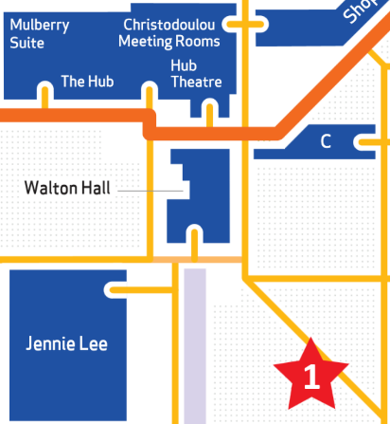
If you suffer from any medical conditions which require on-going treatment you will need to provide your own equipment or medicine when playing.
If you require assistance from the Badminton Club please ensure that you notify us when joining.

Fire alarm
If the fire alarm sounds during a club or match session you must make you way to assembly point 1, as on the map.

First Aid
In the event of injury, OU Security should be contacted to provide First Aid or emergency support. The standard contact number is 01908 653666, and the emergency contact number is 01908 653333.

