The HANDBOOK of the Open University Club for Nations, manchester & nottingham

Index Page

- Purpose of the Handbook 2

- OU Club Structure 2

- Roles and Responsibilities 2-3

- Financial Processes /Bidding for funds 3-4

- Bank Accounts, Natwest 4

- Prevent 4

- Insurance 5-7

- Websites 7

- Health & Safety 7

- Freedom of Information Act 7

- Equality and Diversity 7

- Data Protection 8

- Purpose of the Handbook

This handbook has been created for Nations, Manchester and Nottingham Social Clubs to utilise as a quick and helpful information tool. It shall be a point of reference for the day to day running of your Club.

- OU Club Structure

- OU Club Committee Organisation Chart
Director of Estates
OU Club Committee
Club Co-ordinator
Business Services
Manager
Estates

- OU Club Constitution

The current constitution is available to view on the OU Club Web site.
http://www.open.ac.uk/ouclub/

- OU Club Committee AGM Dates

The date for the OU Club’s Annual General Meeting shall normally fall on the first Thursday in July each year.

Your Club is required to provide at least one representative, who shall be a member of that club, and who shall not represent any other club, at The Open University Club’s Annual General Meeting.

- Roles and Responsibilities for a social committee

All the Nations, Manchester, and Nottingham Social Clubs
will require three Executive Officers as outlined below and
will be elected at your Annual General Meeting.

The Nations, Manchester, and Nottingham Social Club
Chair shall:

- Chair all Committee and General Meetings.

- act as a co-signatory for on Social Club’s Bank Accounts.

The Nations, Manchester, and Nottingham Social Club Secretary shall:

- be responsible for taking the minutes at all meetings.

- be first point of contact.

- act as co-signatory for Social Club’s Bank Accounts

The Nations, Manchester, and Nottingham Social Club Treasurer shall:

- be an ordinary member of The Open University Club as detailed in the OU Club Constitution.

- attend meeting of The Open University Club Finance committee, if requested.

- present to The Open University Club a copy of the accounts and financial statements after the Nations, Manchester, and Nottingham Social Clubs AGM, or as requested by the OU Club Committee.

- present to The Open University Club a budget of expenditure and anticipated income for the forthcoming year as requested by the OU Club Committee.

- act as co-signatory for the Nations, Manchester, and Nottingham Social Club Bank Accounts.

- Financial Processes

Full record of transactions, showing income and expenditure for the Nations, Manchester, and Nottingham Social Clubs shall be kept by the appointed Treasurer. These accounting records must, clearly show any monies received from the OU Club and how it was spent.

These accounting records should be presented to the Nations, Manchester, and Nottingham Social Clubs AGM along with receipts and a latest bank statement. After the AGM these accounts must be included with the AGM minutes and a copy sent to the OU Club Office.

All financial transactions and bank accounts e.g. cheques require the signature of two officers of the Nations, Manchester and Nottingham Social Clubs.

Bidding for funds.

The OU Club will contact the Nations, Manchester, and Nottingham Social Clubs prior to the beginning of the OU financial year with the relevant forms for requests in the coming year. This is the main time for bids. The Nations, Manchester, and Nottingham Social Clubs are able to bid at other times of the year if necessary, but the main bulk of the bidding process is carried out at this time.

Note: Bids at other times are considered at the next OU Club committee meeting which are normally held on a monthly basis.

Any bid for OU Funds should be accompanied by the latest copy of the accounts and the latest copy of a bank statement.
Full details of the bidding procedure can be requested from the club office.

Financial Contracts

All financial contracts are required to be co-ordinated through the OU Club Office. Contracts entered into between OU staff and Social Clubs are required to follow specific payroll specification. Please contact the Club Office for further details.

- Bank Accounts, Natwest

The OU Club has negotiated free banking with the Natwest for all Nations, Manchester and Nottingham centres. However, overdraft rules will apply. Clubs are encouraged to obtain an account with them to take advantage of this agreement. Metro bank also offers charity/community accounts, however, there is a maximum number of transactions allowed with this account.

- OU Prevent Principles

  - “The OU-Club recognises and abides by the OU Prevent Principles and expects that all Affiliated Clubs should follow these principles”
  - If an Event includes topics of extreme ideology, including for example, those motivated by religion, politics, nationalism, environmentalism or animal welfare, or you have concerns about safety and security of speakers or attendees, please refer to the Code of Practice for OU Events for guidance.” http://intranet6.open.ac.uk/estates/main/events-room-booking

- Insurance
The Open University holds Public Liability to a £10,000,000 limit which includes The Nations, Manchester, and Nottingham Social Clubs - see Confirmation letter below.

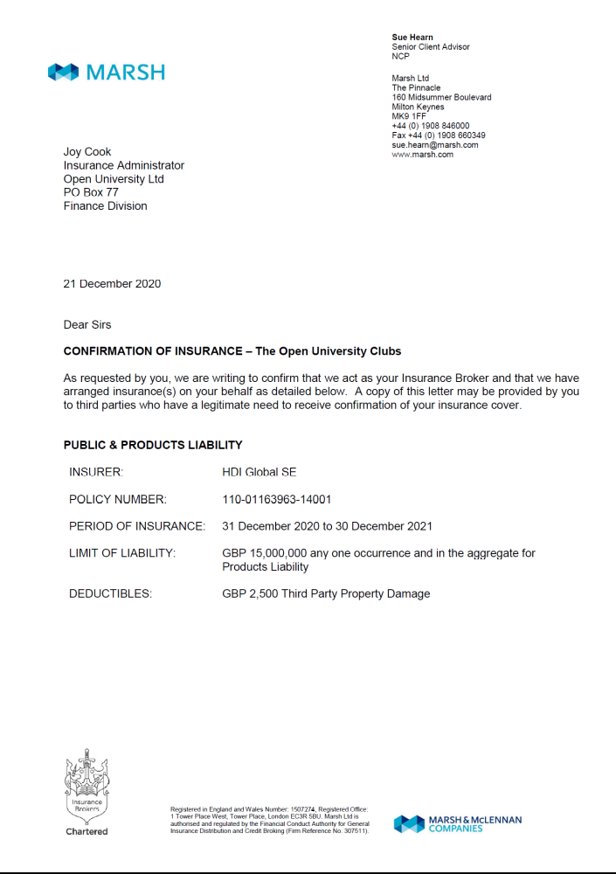

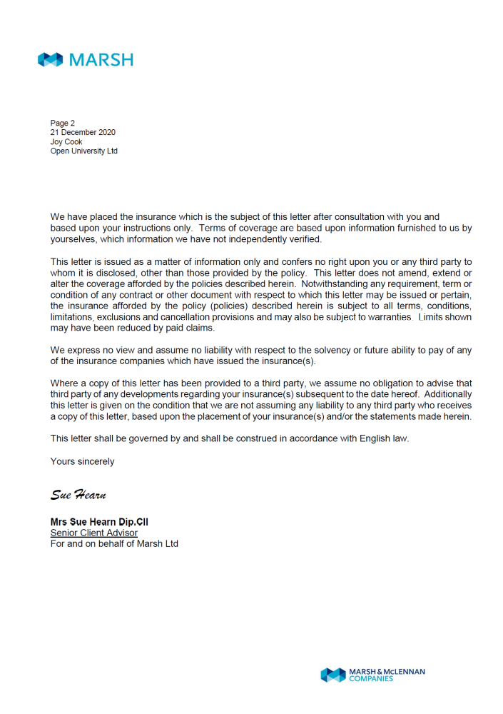

The Confirmation letter can be provided to owners of third party venues, for example, Leisure Centres, who may require evidence that such cover is in place. The Public Liability Insurance covers legal liability to pay damages and costs following accidental bodily injury and/or accidental loss of or damage to material property of members of the public arising out of the activities of the Club including products sold or supplied, where negligence has been proven.

Property of Affiliated and Regional OU Clubs is included under the University's Property Cover, which has a policy excess of £10,000. In the event of any claim under the Property policy, please contact the Insurance Officer in the Finance Division for details via http://intranet.open.ac.uk/finance/p11.asp .

For asset register purposes, records should be maintained and made available to the OU Club Office on request.

- Websites

You may wish to build a website to promote your club or to keep your members informed about what is happening with your club. All websites should comply with brand regulations and may be audited.

- Health & Safety

Procedures relevant to your office are to be implemented. For further information on the University’s current Health & Safety policy visit http://intranet6.open.ac.uk/estates/main/health-and-safety

- Freedom of Information Act

The Freedom of Information Act enables people to gain access to information held by public authorities, for current guidelines visit http://intranet6.open.ac.uk/governance/freedom-of-information/

- Equality and Diversity

For further information on the current equality and diversity policy visit http://www.open.ac.uk/equality-diversity/

- Data Protection

Data Protection and OU Clubs and Societies

Notification
Processing of personal data by non-profit organisations for the purposes of maintaining membership or support are exempt from the notification (registration) provisions of the 1998 Data Protection Act.

Information to be given to members
- All the Membership should know what personal data are processed and the fact that the data are only used for Club administration and Club related activities. Members should be provided with a list of:
- What the Club actually does with the data (i.e. the purpose of the processing)
- Who gets the data (e.g. Club officials)
- What information is actually processed (e.g. name, address etc).
- On application forms, insert the paragraph described above (e.g. “I understand that my data will be used by the Club for …….”).
- Inform members that they can object to any part of the processing (e.g. can withhold home contact details).
- There should be no use or disclosure of the personal data for a purpose unrelated to those declared to members (unless pursuant to a statutory obligation or with the consent of a member concerned).

In accordance with the Data Protection Act 1998, information is held in a secure manner and will not be used for any other purpose than contacting you regarding your Affiliated Club. For further information on the Data Protection Act go to:
http://intranet6.open.ac.uk/governance/data-protection/

