
Editor: Joseph Hanlon | Publisher: Adriano Nuvunga | News Editor: Borges Nhimire
_______________________________________________________________________________________________________________________________________________________________________________________________

Number 25 - 3 May 2018
Published by CIP, Centro de Integridade Pública (Public Integrity Centre),
Rua Fernão Melo e Castro, nº 124, Maputo. eleicoes@cipmoz.org http://www.cipmoz.org:9000/elecs2018
To subscribe in English http://eepurl.com/cY9pAL and in Portuguese http://eepurl.com/cYjhdb.
To unsubscribe in English http://ow.ly/Sgzm30ekCkb and in Portuguese http://ow.ly/ErPa30ekCru.
Material can be freely reproduced; please mention the source.
_______________________________________________________________________________

Fewer people registering to vote
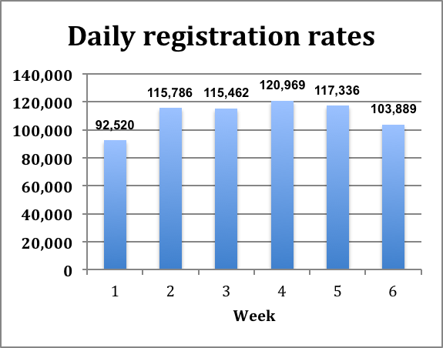
nly 58% of potential voters have registered at the end of the 6th of 8 weeks of registration. And the rate of registration is falling, from 121,000 per day in week 4 to only 104,000 per day in week 6.
O
The three provinces with the lowest registration rate are Niassa (41%), Maputo Province (45%) and Maputo (49%). Lowest cities are Lichinga (35%), Quelimane (38%), and Matola (38%). The provincial table is below, the district table is on http://bit.ly/2w76aYC
Maputo and Matola are normally important supporters of Frelimo, and President Filipe Nyusi speaking in Matola on Friday 27 April said it was worrying that less than 40% of possible voters there have registered.
Election officials are also concerned at the drop in the rate of registration. The president of the National Elections Commission (CNE), various commission members, and the head of the technical secretariat STAE all began to work in Maputo city and province yesterday (2 May)..
Província | Número de Autarquias | Previsão | Inscritos | %
Niassa | 5 | 568.293 | 234 785 | 41,31%
C.Delgado | 5 | 502.481 | 414 846 | 82,56%
Nampula | 7 | 1.206.596 | 735 445 | 60,95%
Zambézia | 6 | 1.242.320 | 703 111 | 56,60%
Tete | 4 | 589.795 | 352 948 | 59,84%
Manica | 5 | 647.530 | 351 795 | 54,33%
Sofala | 5 | 663.290 | 434 866 | 65,56%
Inhambane | 5 | 322.367 | 231 186 | 71,74%
Gaza | 6 | 482.262 | 343 847 | 71,30%
Maputo Prov | 4 | 1.042.083 | 467 519 | 44,86%
Maputo C. | 1 | 796.965 | 391 378 | 49,11%
 | 53 | 8.063.879 | 4 661 726 | 57,81%
Officials stress that the registration cannot be extended because of the tight schedule set out in the law before the local elections.

Ongoing problems
A further 550 solar panels have been distributed to rural areas where lack of electricity has slowed registration. But other problems continue.

Equipment breakdowns
2018 Local Elections is part of the
Votar Moçambique programme

Our correspondents continue to report equipment problems.
In Alto-Molocué district, brigades at primary schools Sede, Pedreira, and Mulutxasse stopped work for two days last week because of computer problems, according to the area supervisor, Avertino Cláudio.
In Mandimba district at Samora Machel, and Ngame primary schools, constant equipment breakdowns slowed registration to the point where people gave up waiting and went home, supervisor Fonseca Armando Mucurupa said.
In Nampula city at the sports stadium, registration was suspended on Sunday 29 April because of equipment failures.
In Mandimba, registration was suspended at 14.30 on Sunday at Samora Machel secondary school and Filipe Samuel Magaia and Ngame primary schools because of repeated equipment breakdowns. Staff said equipment would not run for long periods of time.
In Milange at posto 7 de Abril, registration was interrupted on 15 April when printers started printing voters cards in black and white, even though new coloured ink had been installed. Signatures were also being rejected.
Staff problems
Our correspondents report that there continued to be problems with brigade members in some places.
In Massinga district it was taking 10 minutes for a voter to obtain a card, three times as long as it should, resulting in long queues at Escola Secundária de Massinga, Escola Profissional de Massinga, Kape Kape, and Matingane.
In Maputo city at 7 April primary school, only two people were working and they closed on 28 April before 13.00.
Nampula parties want extension
At separate press conferences in Nampula on 26 April, two parties called for the registration period to be extended - MDM (Mozambique Democratic Movement, O Movimento Democrático de Moçambique) and AMUSI (United Actin for Integral Salvation, Acção do Movimento Unido para Salvação Integral).
Both parties also complained that both brigades and neighbourhood secretaries were demanding bribes to allow people to register. The claim was made by Luísa Marovica, organising head of MDM and Ussene Martinho, provincial delegate of AMUSI. This was denied by the Nampula district election commission (CDE) president, Marcelino Martinho, who went on to accuse party delegates in registration posts of improper behaviour..
Questions about Frelimo parallel registration
On Ilha de Moçambique questions have been raised about a parallel registration being carried out by Frelimo. A Frelimo representative told our local correspondent that it was an attempt to rebuild party cells and list party members who had registered. The form is below.

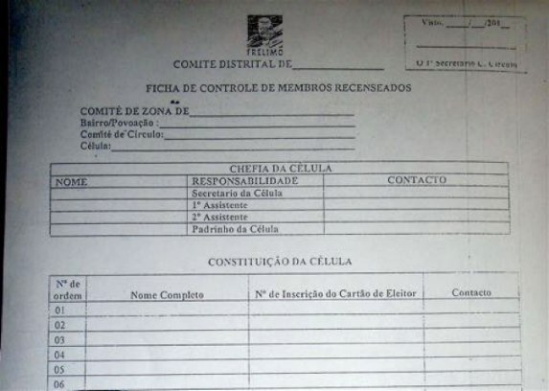

But local people complain that civil servants are being forced to sign the lists, even if they are not Frelimo supporters, and that Frelimo is going to workplaces and homes of civil servants.
Detailed coverage of 2018 municipal and 2019 national elections is again being provided by the Mozambique Political Process Bulletin, which has covered all of Mozambique's multi-party elections.
Elections newsletters are distributed on the "Mozambique News Reports and Clippings" mailing list.
If you do not want to receive the elections newsletter,
simply send a note to j.hanlon@open.ac.uk with the subject line "no election".
The elections newsletter is also in Portuguese; para subscrever http://eepurl.com/cYjhdb
Previous issues are available on http://cipmoz.org:9000/elections2018/

